

Date: 4 December 2018

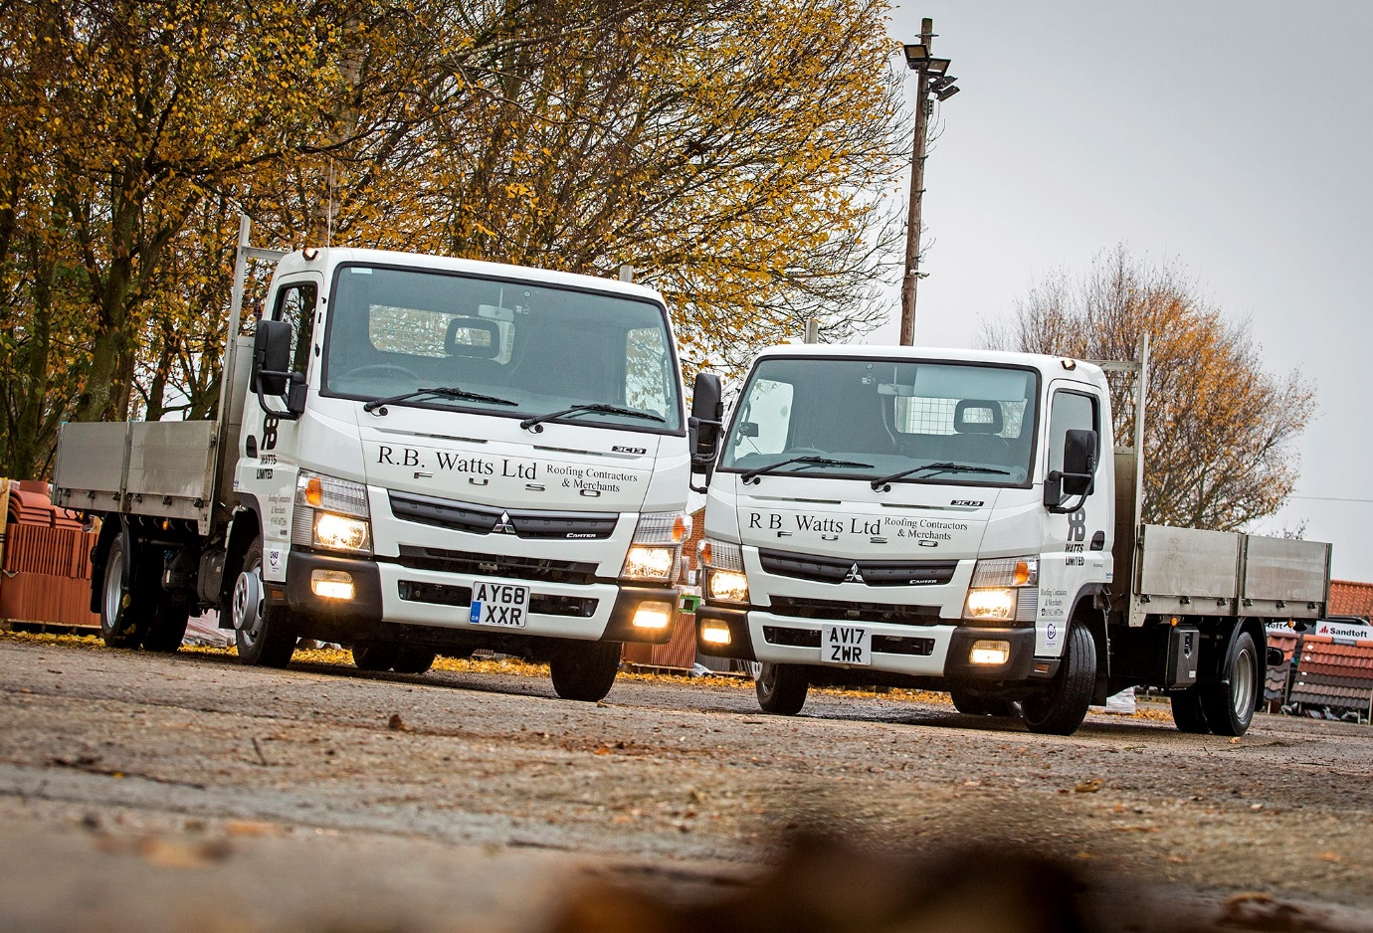

New 3.5-tonne FUSO Canters impress RB Watts

Norfolk-based roofing specialist RB Watts was so pleased with the first FUSO Canter it acquired less than six months ago, that it has already returned for a second.

The popular Canter light truck range is sold and supported exclusively by Mercedes-Benz Dealers in the UK – like its predecessor, RB Watts’ new 3.5-tonner arrived via Orwell Truck & Van, which represents the three-pointed star in East Anglia.

RB Watts operates from headquarters in the village of Longham, near Dereham. Its Canters are fitted with aluminium double dropside bodies by Commercial Bodies, of Norwich. Both are 3C13 variants, and powered by fuel-efficient 3.0-litre engines which generate 96 kW (130 hp).

They differ in one key aspect, though. The first transmits its power to the rear wheels via a DUONIC dual-clutch automated transmission which, as well as an Eco Mode, features Park and Creep functions for easy low-speed manoeuvring. The latest, however, employs a standard five-speed manual gearbox.

Chris Watts, Managing Director of the company established by his father more than 40 years ago, recalled: “We were looking for a new vehicle back in June, and decided to try Orwell Truck & Van’s Canter demonstrator.

“Although outwardly similar in design to the vehicle we were standing down, the Canter was a lot more impressive. It was apparent from the outset that the vehicle is built to a very high standard, with a strong chassis and comfortable cab, yet it also offered a competitive payload, and was well received by our drivers too. In fact, we liked the truck so much that we bought it.”

Mr Watts continued: “Our first Canter has performed very well, and the customer service we’ve received from Orwell Truck & Van has been exemplary, so we had no hesitation in returning for another.

“Having already experienced the DUONIC system, however, we wanted to try the manual gearbox this time, so we can compare the two in operation. We’ll be looking to see if there are any significant differences in fuel economy, while also gauging the reaction of the teams who use the vehicles.”

The two Canters are now working alongside RB Watts’ four other commercial vehicles, and supporting both sides of its business – as well as working as a roofing contractor on commercial and residential projects of all sizes, the company sells and delivers a wide range of new and reclaimed roofing materials to others in the trade.

The Canter boasts a class-leading safety specification, which includes an engine brake, ABS anti-lock brakes with Electronic Brakeforce Distribution, the ESP anti-skid system and a RISE (Realised Impact Safety Evolution) safety cell.

The vehicle’s cab-forward layout means it is also exceptionally manoeuvrable. “The Canter has a tight turning circle, while visibility from the driver’s seat is excellent,” added Mr Watts. “These attributes are proving really useful when we’re getting on and off construction sites, where access can be very tight.”

The FUSO Canter light truck range encompasses models with gross weights of up to 8.55 tonnes. Three versions of the 3.0-litre diesel engine are available, as is the diesel-electric Canter Eco Hybrid; the first fully-electric eCanters are also now in service with selected operators in London.

Like all FUSO Canters acquired from an official Mercedes-Benz Dealer, RB Watts’ new trucks are backed by three-year, unlimited mileage warranties, and came with reassuring, round-the-clock emergency roadside assistance cover.

www.rbwatts.co.uk
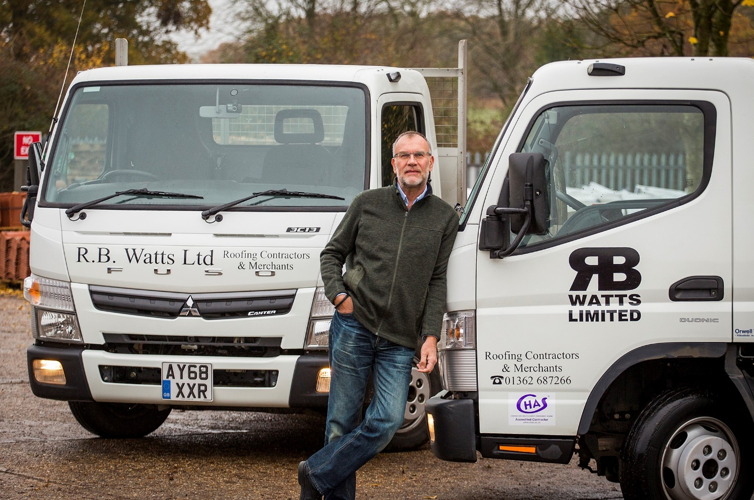

Pair of aces: Chris Watts with his company’s two FUSO Canters

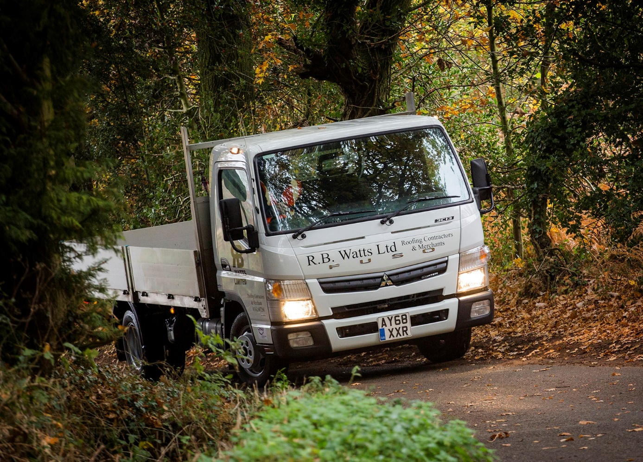
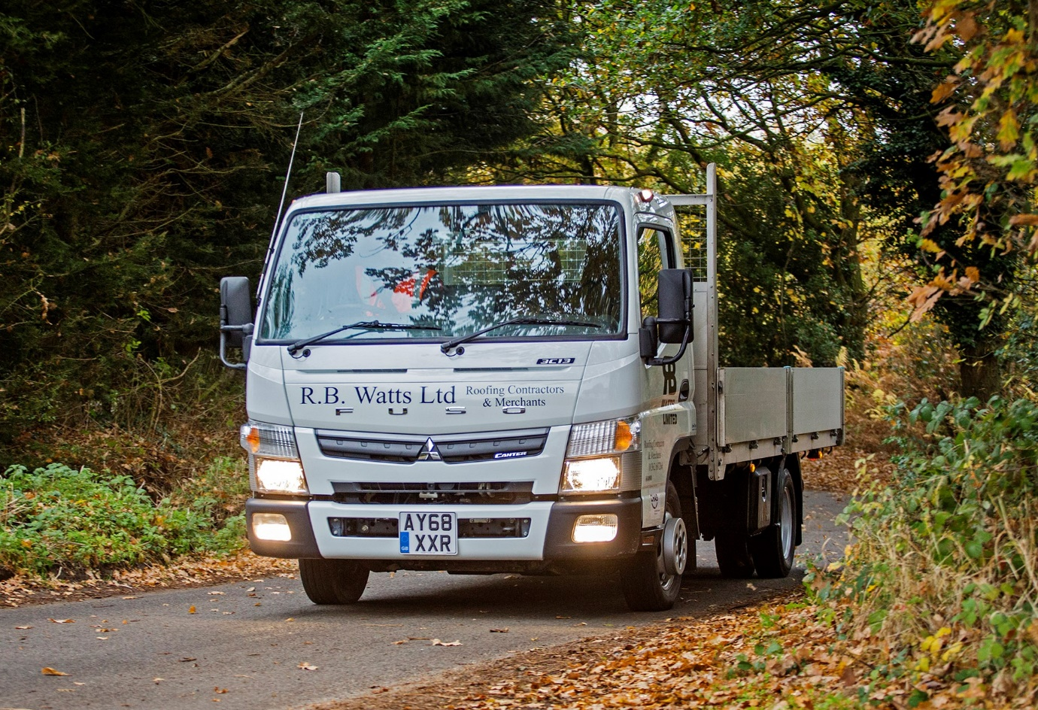

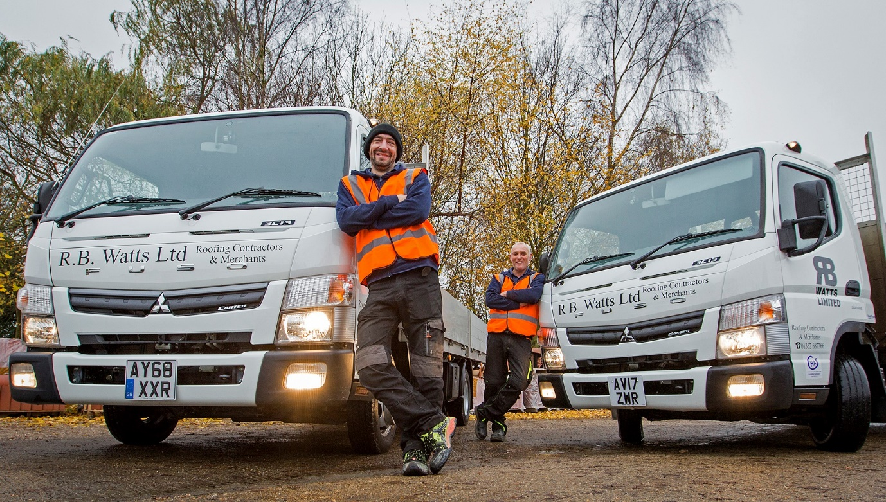

Canter fans: Drivers Richard Dack and Andy Cooper love their new FUSO light trucks

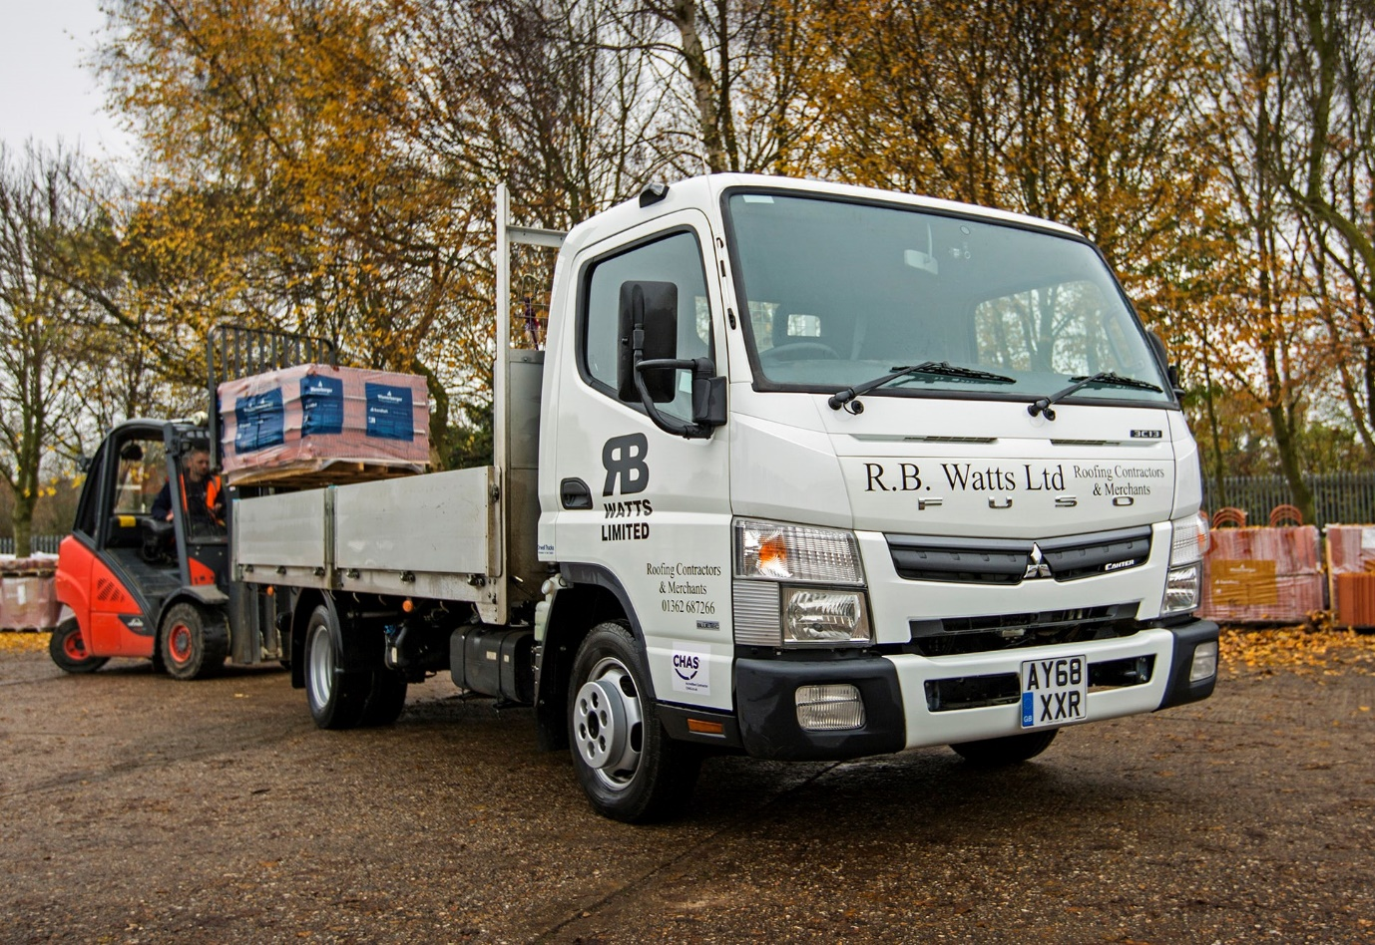

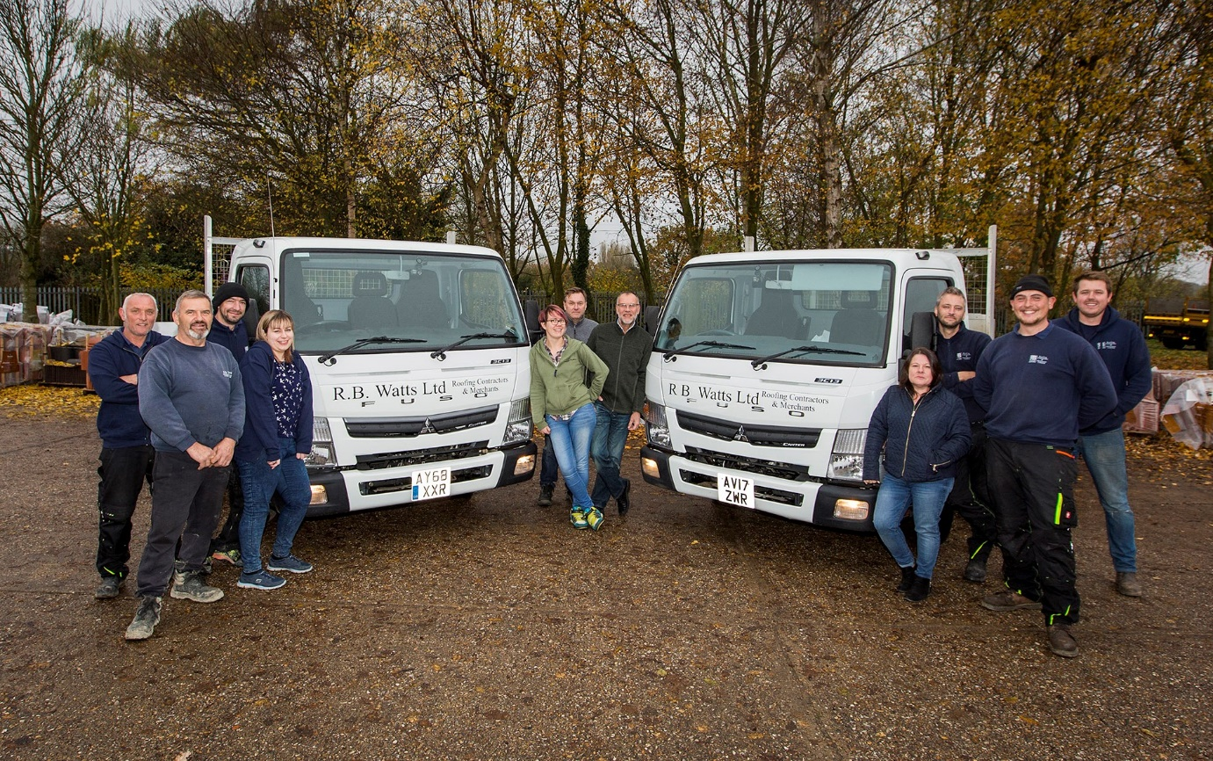

Team players: RB Watts colleagues with their FUSO Canter delivery trucks

ends

For more information, or to request bigger/higher-res image files, please contact:
John Ripley or Steve Warren
Impact Communications, 01926 842126
John: 07771 484595, john@impactcom.co.uk
Steve: 07770 470251, steve@impactcom.co.uk

