

Date: 23 April 2019

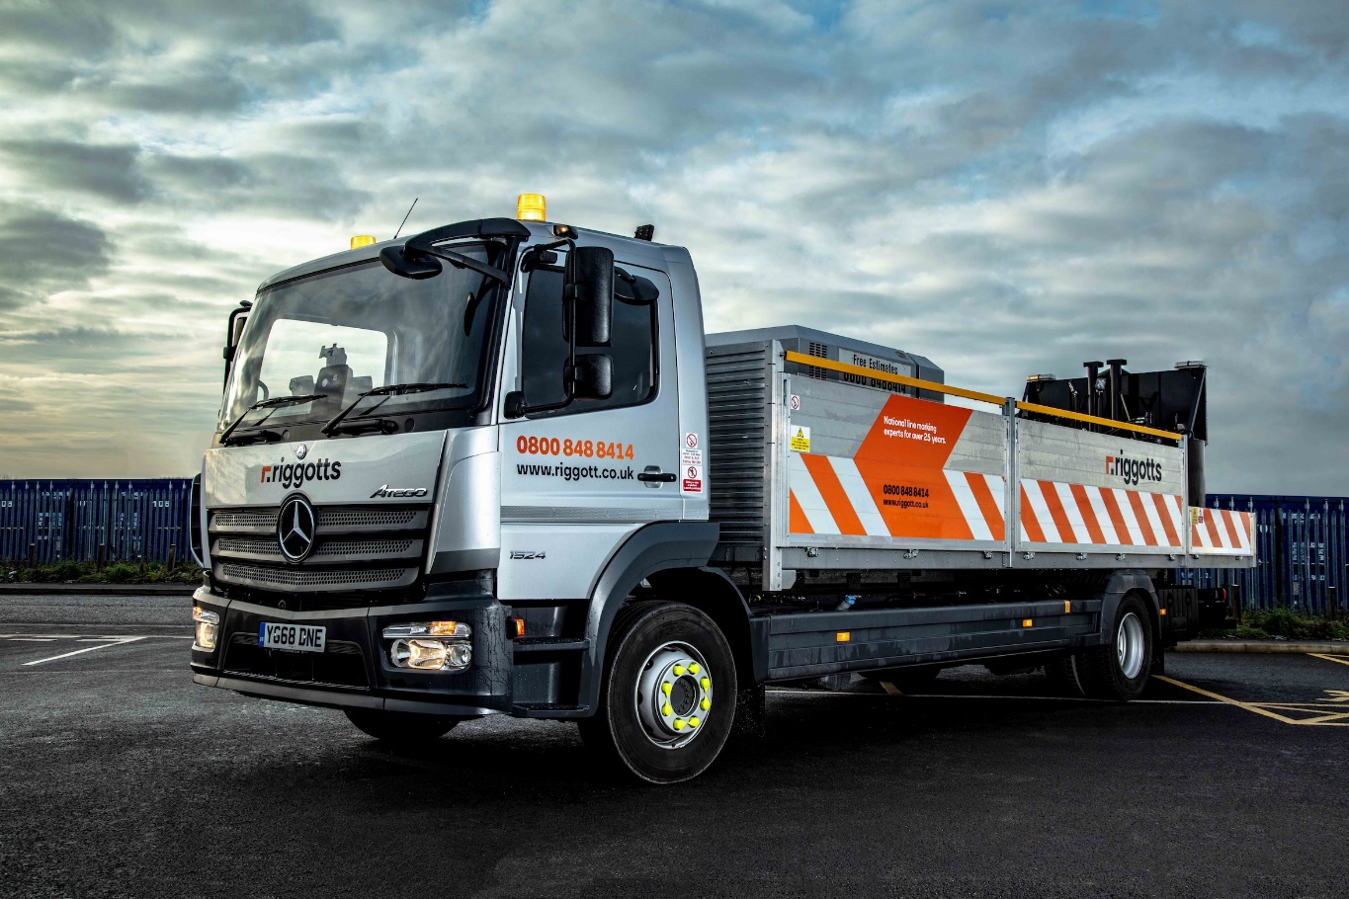

Mercedes-Benz Atego keeps Riggotts on the right lines for environmental compatibility and safety

The environment and well-being of its crews were top priorities for an award-winning line marking firm when it invested over £500,000 in its first Euro VI Mercedes-Benz trucks.

Riggotts National Line Marking Services has commissioned six new 15-tonne Atego, which offer enhanced fuel-efficiency and reduced emissions, as well as exemplary levels of safety and comfort.

A long-standing operator of vehicles bearing the three-pointed star, Riggotts is based in Tuxford, near Ripon, Nottinghamshire. Its latest trucks are all 1524L models with S- ClassicSpace day cabs and economical, high-torque 7.7-litre straight-six engines that produce 175 kW (238 hp) and are paired with smooth, efficient Mercedes PowerShift 3 automated transmissions.

Supplied by Northside Truck & Van, which was recently crowned Mercedes-Benz Trucks Dealer of the Year for the third time running, their purpose-designed dropside bodywork is by Alloy Bodies, of Manchester. Both companies are owned by The Anderson Group.

Joint Managing Director Nick Riggott said: “We’re always looking for ways to move with the times and stay ahead of the game. By replacing older, Euro V vehicles with these Euro VI-engined Atego, we’ve taken another important step on the road towards a ‘greener’ Riggotts. Not only are we looking forward to reductions in our fuel bill, but by producing fewer emissions these new trucks will also help us to protect the environment and improve air quality.”

Established in 1994 by Mr Riggott and his brother Darren, the operator offers a comprehensive portfolio of services covering everything from road, car park, airfield, warehouse and sports court line marking, to surface signage, anti-skid technology, specialist cleaning services and creative floor graphics.

Riggotts has won a string of industry awards, including five Gold Medals from the Royal Society for the Prevention of Accidents (RoSPA) in recognition of its commitment to health and safety. Covering the entire United Kingdom, it works for an impressive roll call of ‘blue chip’ businesses, including major supermarkets.

Smartly finished with metallic silver cabs and 25.5 ft bodies with brushed aluminium dropsides which are lower towards the back ends of the trucks, Riggotts’ new Atego are fitted with compressors and pre-heaters that melt the state-of-the-art thermoplastics, resins, epoxy and chlorinated rubber products used to mark surfaces.

Its 48 crew members are also trained in new marking technologies such as Ultra-Line (an innovative UV activated paint), which offers clients a greener alternative to more conventional solutions, and underlines Riggotts’ forward-thinking ethos.

Optional features on each of its new vehicles include a centre seat, allowing the company to transport a chargehand and two operatives, and a pair of additional 100-litre fuel tanks, supplementing the standard 180-litre tank.

Nick Riggott confirmed: “From day one we pitched our company at the premium end of the market, which is why we’ve always favoured Mercedes-Benz trucks. This is a potentially dangerous business, but the Atego offers the well proven safety and reliability we need.”

Riggotts has been sourcing its vehicles from Northside Truck & Van for the last decade. Acquired with competitive funding support from Mercedes-Benz Finance, are now being inspected and maintained at the Dealer’s Doncaster workshop under Complete Service Contracts.

Riggotts’ friendly team provide clients with a round-the-clock service, and strive to ensure that projects are completed on time and to budget. Mr Riggott continued: “We’re committed to making sure that our activities are always as environmentally responsible as possible. That’s why we hold the ISO 14001:2015 award.

“Meanwhile, our OHSAS 8001 accreditation reflects the fact that health and safety has been, and always will be, a top priority for Riggotts. Working on a national scale means our crews can travel hundreds of miles in a single day. Ensuring that they are safe and comfortable while they’re on the road is just as important as ensuring they’re safe on site.”

Nick Riggott added: “Northside Truck & Van Truck Sales Executive Richard O’Brien arranged for us to meet and work through the specification of our latest Atego with a representative of Alloy Bodies. As a result, they are our best trucks yet, and perfectly tailored to our operation.”

Purpose-designed for light- and medium-duty distribution work, the Mercedes-Benz Atego range offers advanced truck technology for the 6.5 to 16 tonnes segment, with outstanding dynamics, comfort, safety and manoeuvrability.

www.riggotts.co.uk.

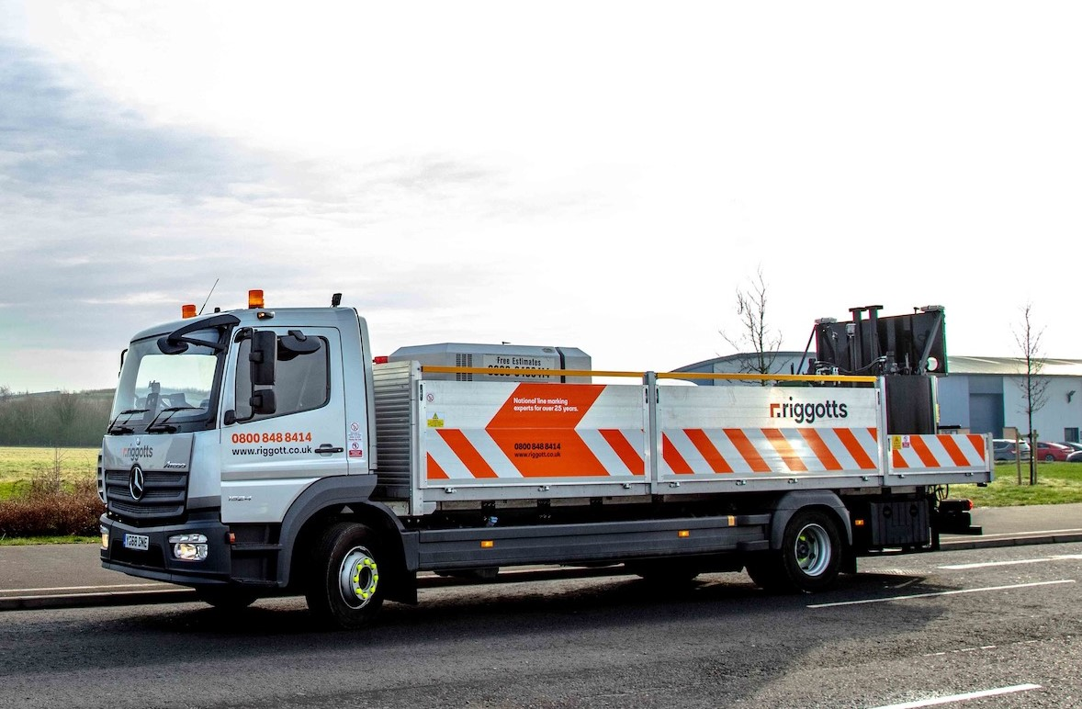

ends

For more information, please contact:
Steve Warren or John Ripley
Impact Communications, 01926 842126
John: 07771 484595, john@impactcom.co.uk
Steve: 07770 470251, steve@impactcom.co.uk

For more information on Riggotts, please contact:
Josh Peet, Aperture Marketing, 07583 742894 josh@aperturemarketing.co.uk

