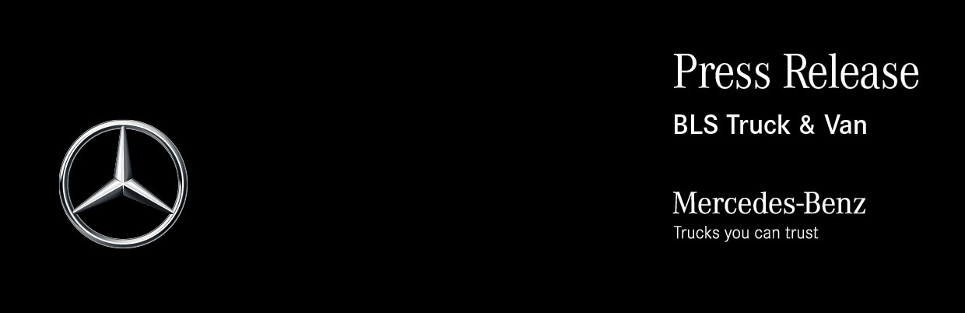

Date: 18 August 2021

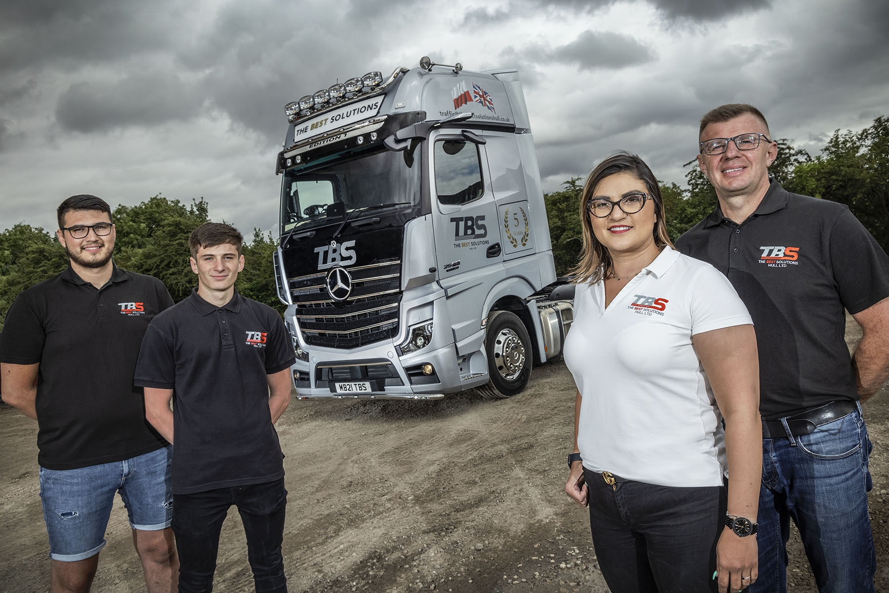

Family values: Olaf, Jakub, Aga and Karol Dziewirz with their new Actros Edition 1

The Best Solutions returns to BLS Truck & Van for anniversary Mercedes-Benz Actros Edition 1 flagship

Family-owned haulier The Best Solutions has celebrated its fifth birthday by treating itself to a very special Mercedes-Benz Actros Edition 1 tractor unit.

Supplied by Dealer BLS Truck & Van, the limited-edition model is the 25th vehicle purchased by the Hull-based operator since it was established by Karol and Aga Dziewirz in 2016. All but a couple wear the three-pointed star of Mercedes-Benz.

Karol is a driver with more than 20 years’ experience behind the wheel. He and wife Aga are supported in the business by their sons Olaf and Jakub, as Transport Manager and Operations Manager respectively. Their company transports cargoes arriving at the port of Hull, throughout the UK.

“We’ve faced Brexit and the Covid-19 Pandemic, and were concerned that both could have hit our fledgling business,” said Aga. “Thanks, though, to the loyalty of our customers and the dedication of our tightly-knit team, demand for our services has continued to grow. This explains why we’ve been able steadily to increase the size of the fleet.”

Looking back to the acquisition of The Best Solutions’ first truck, Olaf recalled: “We needed a vehicle that would be affordable in terms of running costs as well as purchase price. Dad had driven for a company whose fleet included some Actros, and he knew they returned consistently good fuel figures, as well as being reliable and well-liked by his colleagues.”

BLS Truck & Van represents Mercedes-Benz in the north of Scotland, and operates from headquarters in Aberdeen. “We approached a few potential suppliers but BLS Sales Executive Chris Dyer was the most receptive,” continued Olaf. “The Dealer was prepared to back us as a new start-up and put together an excellent package, with a service contract that represented very good value for money.

“Chris has looked after us so well since then, that we have stuck by him. He has delivered all 23 of our Actros, including our fantastic new Edition 1, and has become an important friend to our business.”

Just 400 Actros Edition 1s were built, and of these only 35 were made available to UK customers. The exclusive model is instantly recognisable thanks to its gloss black grille, darkened headlamp covers and rims, and branded sun visor which incorporates extra LED headlamps.

Like most examples, The Best Solutions’ truck is powered by a range-topping 15.6-litre in-line six-cylinder engine that produces a potent 460 kW (625 hp). In addition to the many innovations that come as standard in the latest Actros – MirrorCam, Active Brake Assist 5, and enhanced Predictive Powertrain Control technology, for example – it is also loaded with additional equipment.

Highlights include an upgraded version of Mercedes-Benz Trucks’ radical new dashboard, which replaces traditional switchgear with stylish and intuitively operated twin screens. The Multimedia Cockpit, interactive incorporates a larger, 12in primary colour display, and offers extra functionality.

The black leather-trimmed cab interior features door handles with contrasting topstitching, and a polished and brushed aluminium dashboard badge that confirms it as ‘One of 400’. Driver can also choose from eight colours of ambient ceiling lighting.

The keys to the Edition 1 have gone to one of The Best Solutions’ most experienced drivers, Tadeusz ‘Ted’ Danielewski. “Ted has been with us almost since the start,” said Olaf Dziewirz.

“We reckon that after 40 years in the job he must have driven at least three million miles. He’s a consummate professional who takes great pride in looking after his vehicles to an extremely high standard.

“Over the years Ted has driven most brands of vehicle but he says the Edition 1 is the best of the lot… by a margin. He’s also a fan of MirrorCam, as are the drivers of the other six Actros on our fleet that are equipped with this technology. They tell us it’s very easy to use and offers clear benefits in terms of visibility and safety.”

Mercedes-Benz Trucks’ ground-breaking replacement for conventional mirrors, MirrorCam’s roof-mounted cameras relay images to screens mounted inside the cab, on the A-pillars, The system offers improved rear vision that is particularly helpful when reversing with a trailer, and eliminates the forward-facing blind spots caused by mirror housings. MirrorCam also boosts fuel-efficiency – Mercedes-Benz estimates by up to 1.5% – through reduced wind resistance from the compact and streamlined camera housings.

Ted Danielewski added: “I drove the first Actros on the fleet and have always liked the trucks. Our highly specified, flat-floored cabs are great for drivers; we appreciate having so much storage space, and the really good beds. The Edition 1 is in another league altogether though – it’s stylish, incredibly comfortable, and offers all the power I could ever wish for.”

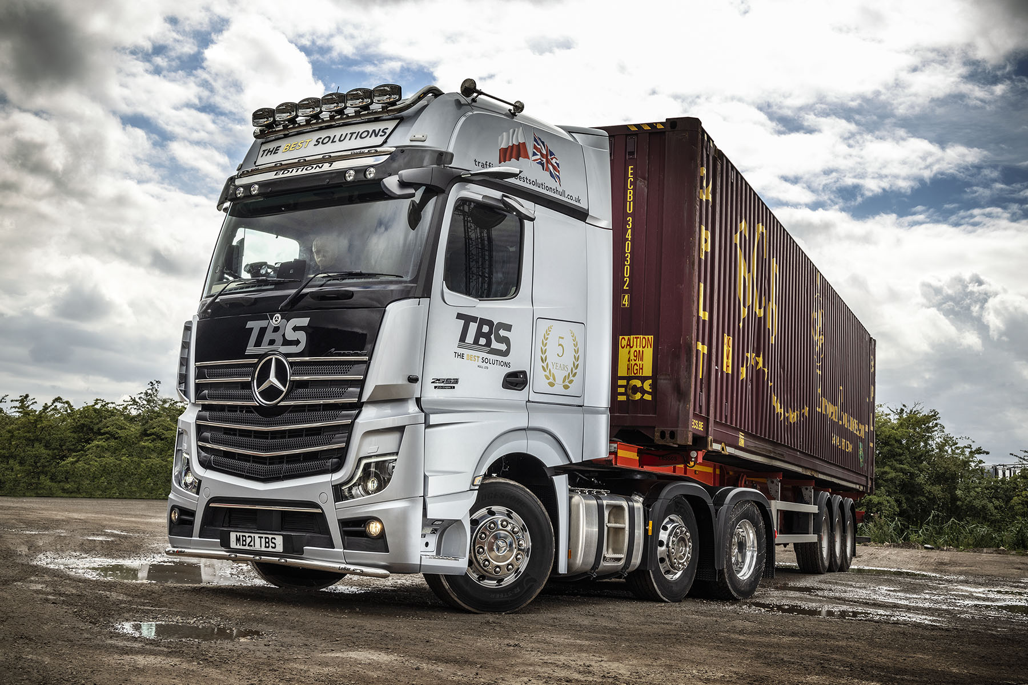

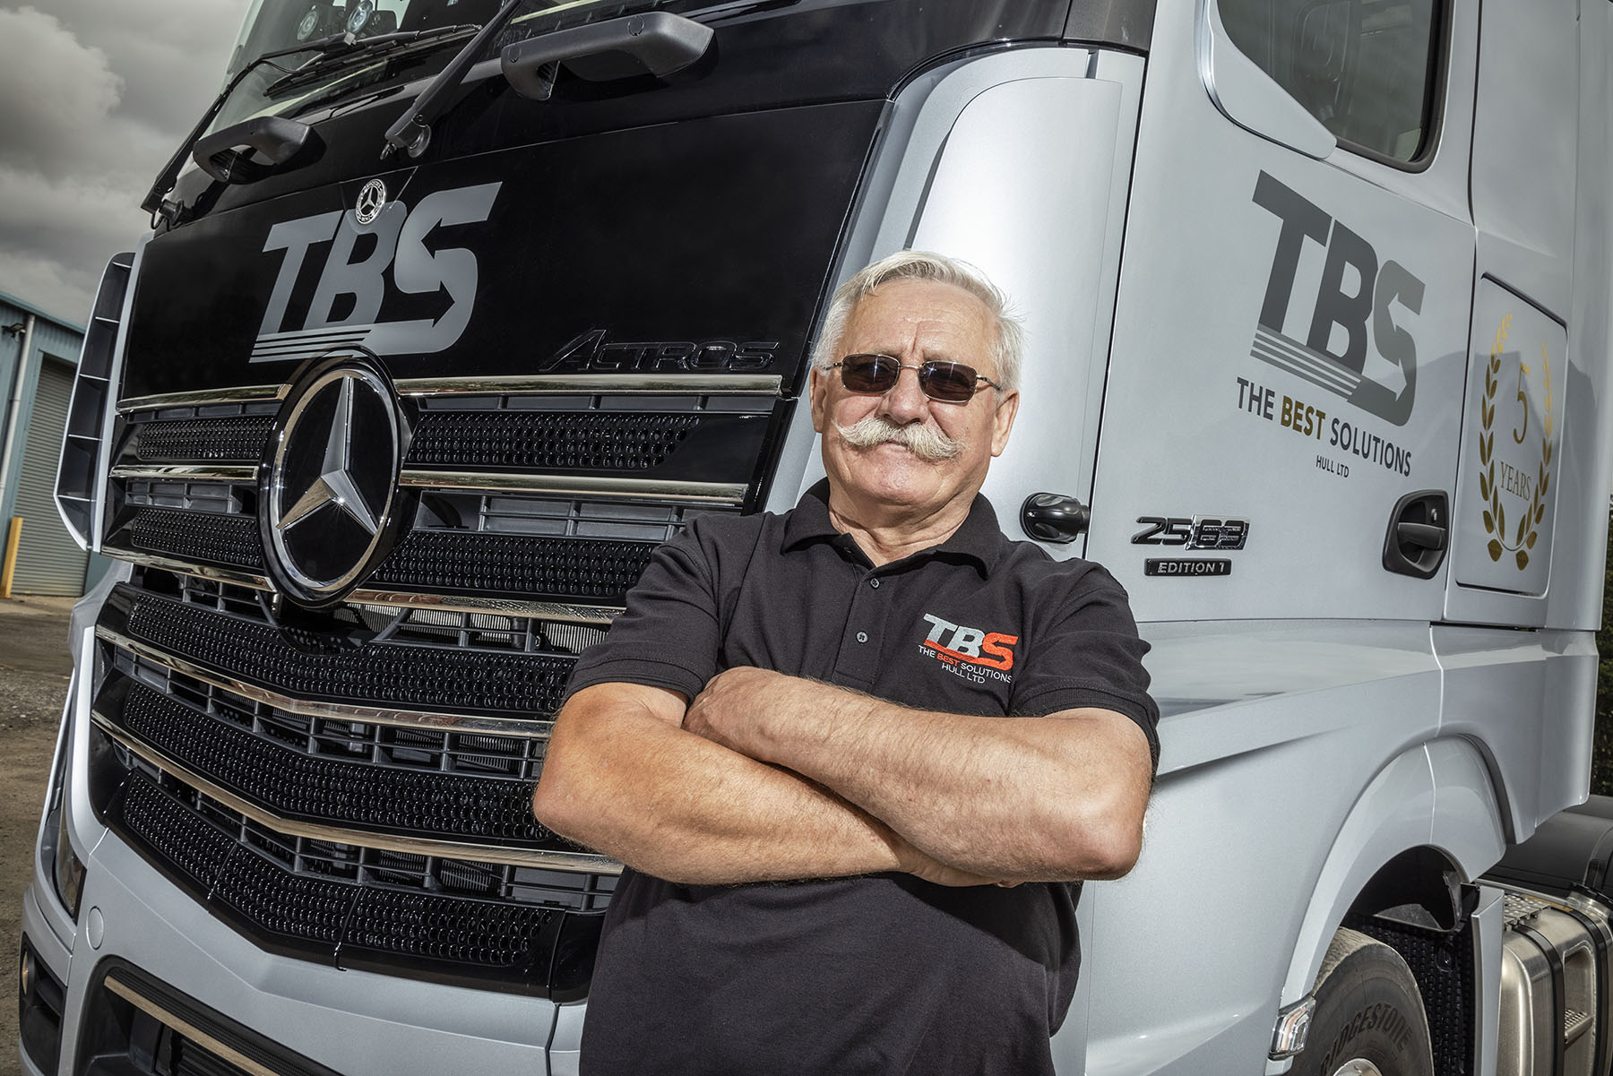

Shining star: Driver Tadeusz ‘Ted’ Danielewski says the Actros Edition 1 is the best truck he’s driven

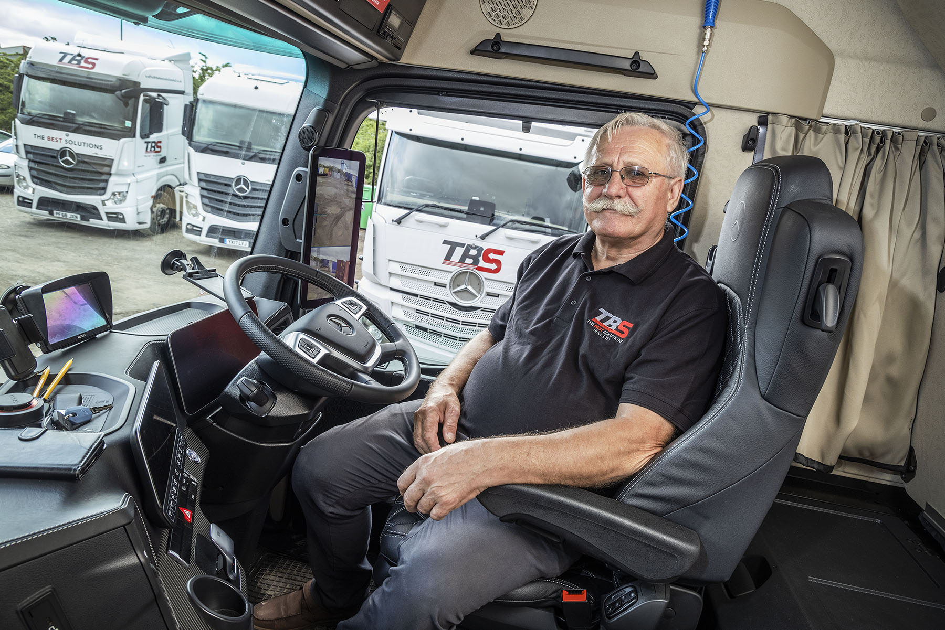

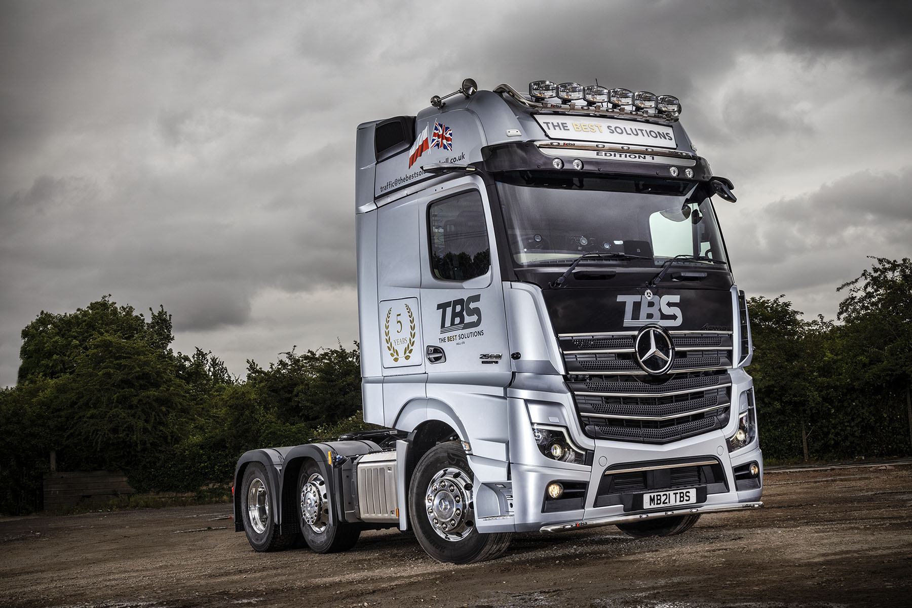

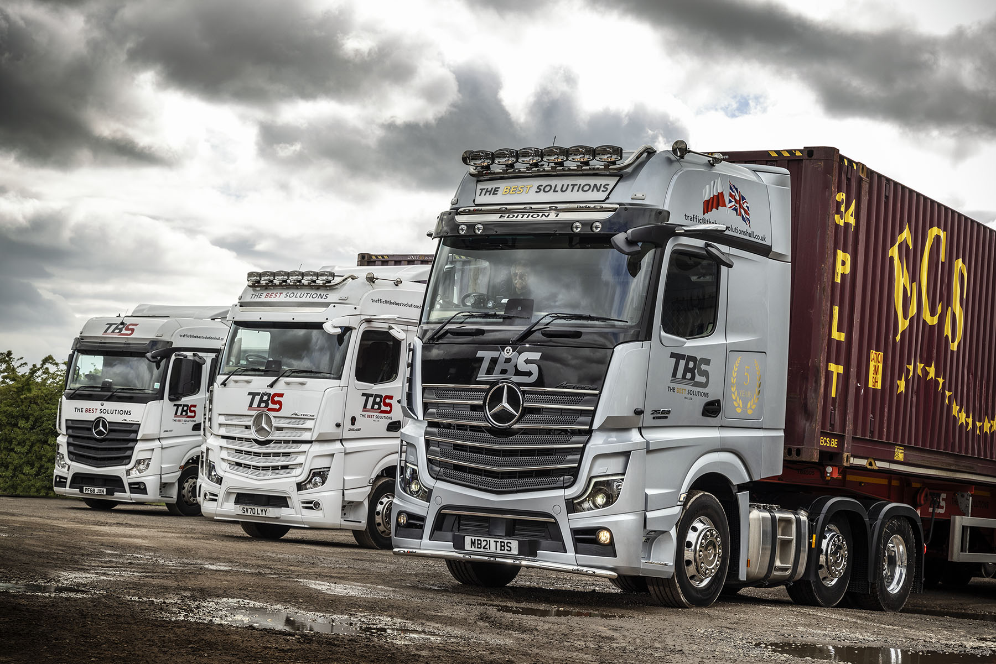

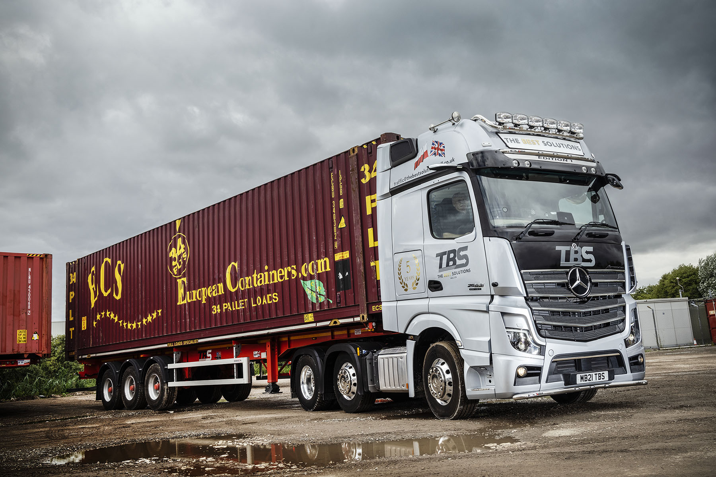

ends

For more information, or to request bigger versions of image files, please contact:
John Ripley or Steve Warren
Impact Communications, 01926 842126
John: 07771 484595, john@impactcom.co.uk
Steve: 07770 470251, steve@impactcom.co.uk



