

Date: 28 February 2025

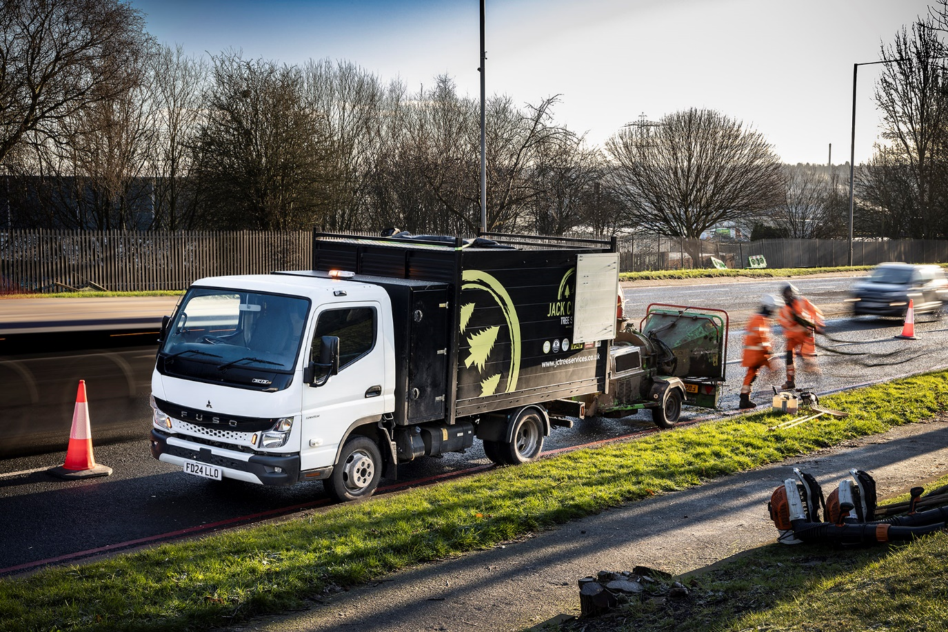

FUSO Canter takes root in Jack Cotterill Tree Services fleet

They’re tough as a truck but no bigger than a van – that’s why the FUSO Canter was the perfect choice for Jack Cotterill Tree Services.

The Droitwich-based operator sourced its new vehicles from Dealer Mertrux Truck & Van’s Derby outlet, after a search that started with scrolling through social media. All are 3.5-tonne 3C13 models with specialised arboricultural bodies – featuring large lockable toolboxes and high-sided tippers – by Brooks Engineering, of Darley Dale.

Jack Cotterill recalled: “We’d been running a pair of van-based vehicles and a 4x4 pickup but they had become unreliable, so I was looking to replace them with something better suited to our work. I already knew the FUSO Canter was a popular choice in our industry and when I came across some adverts on my phone I could see it was exactly what I was looking for.

“It has the rugged ladder-frame chassis I wanted and although I also considered another model the Canter’s cab-forward design, which allows for a smaller overall footprint, was a clear advantage.

“What really sealed the deal, though, was a speedy and efficient response from Mertrux. Sales Executive Tom Hall was very professional in his approach and quoted us a very competitive price without a prohibitively long lead time, so I was happy to place our order with him.”

He continued: “Tom also handled all the liaison with the bodybuilder, and kept us fully informed throughout the process. The result is that we have trucks built exactly as we wanted them, with the benefit of cover from a dedicated national network of commercial vehicle specialists, and the price for vehicles of this quality is unbeatable.”

The three new vehicles are all powered by well-proven, fuel-efficient 3.0-litre turbodiesel engines each producing 96 kW (130 hp) and 350 Nm of torque. The compact exhaust system means the vehicles also meet the EURO VI – STEP E emission standard. They have been hard at work since arriving – their first week on the job saw them working as far afield as Essex.

“The trucks are every bit as well suited to our needs as I’d hoped,” added Mr Cotterill. “They’re often loaded up to maximum payload, and pulling another 3.5-tonne on a trailer, but are never short of power. They’re super-manoeuvrable too, which makes life easier as the sites we have to work on often have tight access points. I’m delighted with the choice we made, and would not swap these trucks for anything.”

Jack Cotterill Tree Services provides high-quality arboricultural care to residential and commercial clients nationwide. Established in 2014, the company has a team of experienced and certified arborists and offers a wide range of services including pruning, felling, stump grinding, hedge trimming, vegetation clearance and emergency tree removal.

“We’re known for our commitment to safety, efficiency, and environmental responsibility,” said Mr Cotterill. “That means adhering to industry best practices and using state-of-the-art equipment – such as our FUSO Canter trucks – to ensure that every job is completed to the highest standard.”

www.jctreeservices.co.uk

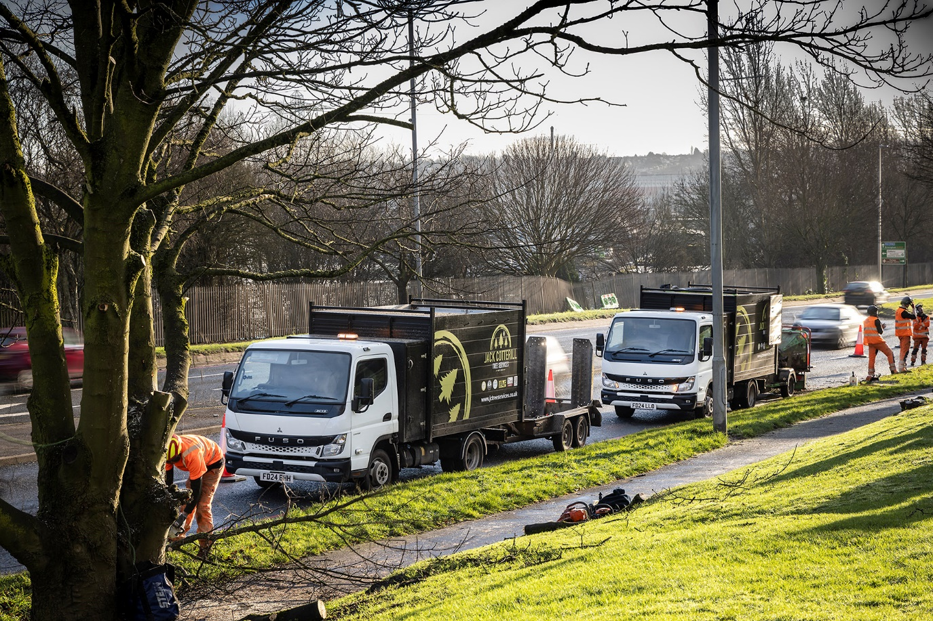

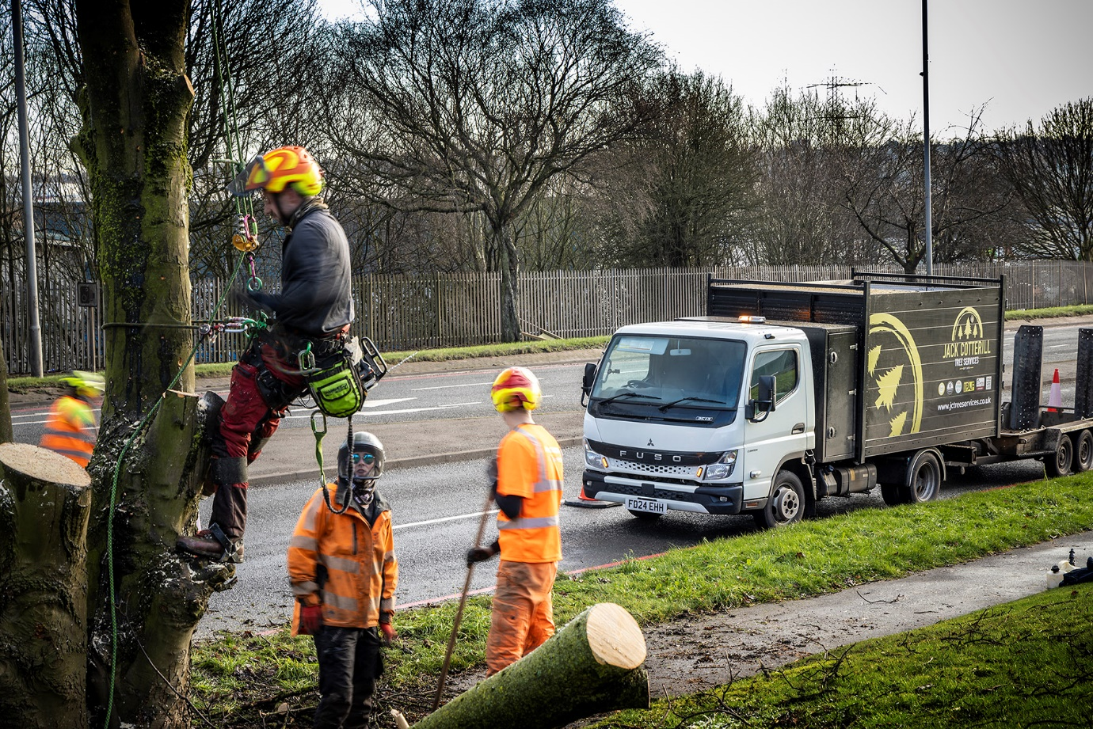

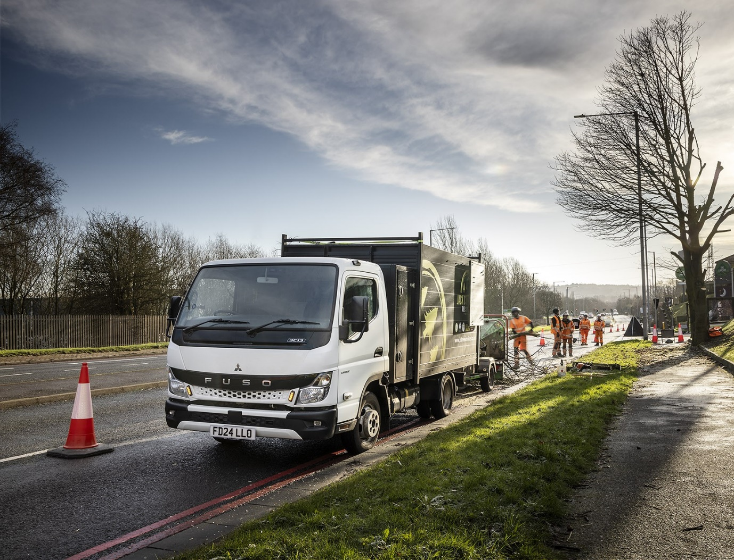

ends

For more information, or to request bigger/higher-res image files, please contact:
John Ripley: 07771 484595, john.ripley@loopagency.co.uk



