

Date: 22 November 2019

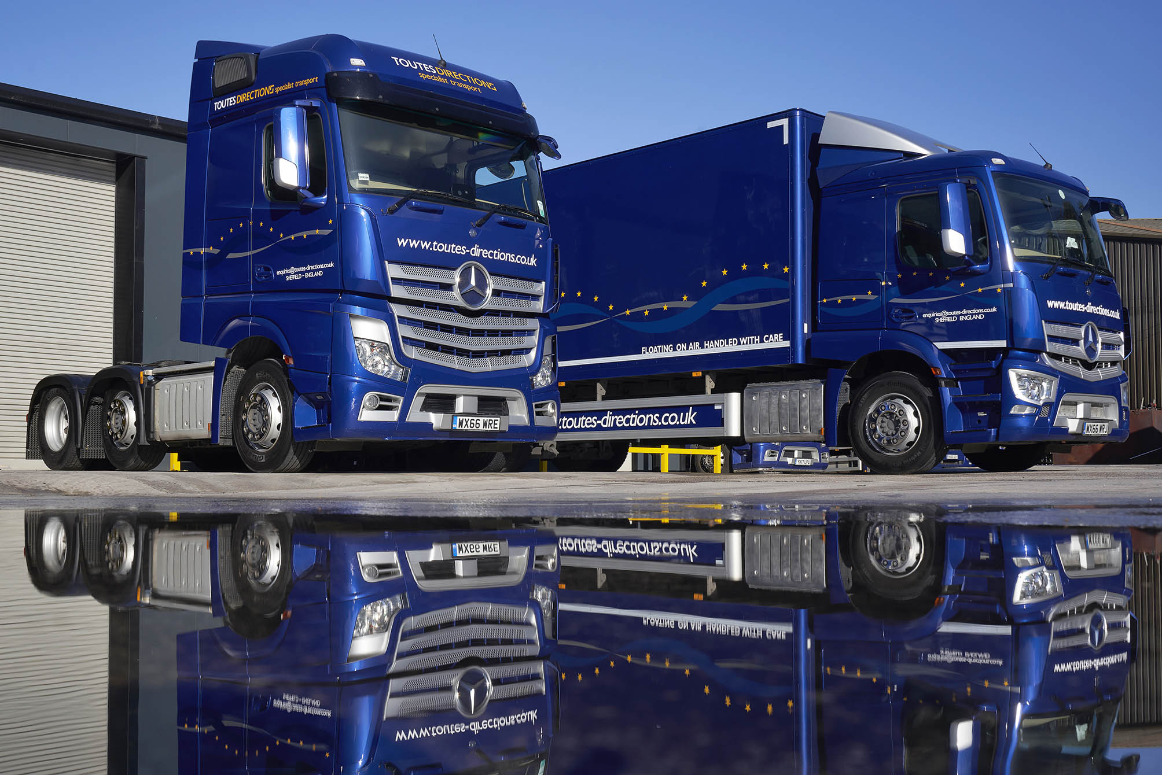

For top-quality used Mercedes-Benz trucks, Toutes Directions lead to City West Commercials

When Sheffield-based haulier Toutes Directions needs another used truck bearing the three-pointed star, its first call will always be to the manufacturer’s representative in the south-west, City West Commercials.

Toutes Directions purchased its first pre-owned vehicle from the Dealer’s Used Truck Sales Specialist Tim Sutcliffe, in the autumn of 2017. An ex-demonstrator, the Actros 2545 StreamSpace had just 62,000 km on the clock.

Since then the family-owned operator has returned to City West Commercials for another five Actros, four more 2545 tractors and an 18-tonne 1824. Beautifully finished in its distinctive metallic blue-and-silver livery, they work alongside nine other trucks and six vans, every one of which wears a three-pointed star.

Toutes Directions was established by Mark Harrison in 1978, initially to move catering equipment, but quickly carved out a niche for itself as a specialist transporter of mainframe computers. As the name suggests – Toutes Directions is French for All Directions – European assignments accounted for a major part of its turnover from the outset.

Today, the core business entails delivering and installing all sorts of high-value equipment, for customers from the IT, medical, catering, and other sectors. Although now less frequent, Continental work still accounts for about 30% of the total.

Mark Harrison, meanwhile, has begun ‘winding down’ and is gradually passing on responsibility for the day-to-day running of the business to his two sons. Tom is Transport Manager and oversees the planning desk, while Oliver, a fully-qualified technician who served a Mercedes-Benz apprenticeship, runs the workshop in which the vehicles are maintained.
“Given the profile of the client base we serve, image is very important to us,” explained Tom Harrison. “Our modern premises are always clean and tidy, and the same is true of our fleet.
Mercedes-Benz is a premium brand, which is why we’ve been running its vehicles for more than 25 years. Not only are they reliable, fuel-efficient, popular with our drivers, and well supported both here in the UK and in Europe, but they also look fantastic and help us to convey the right impression.”

Toutes Directions regularly purchases new trucks, but for certain applications prefers pre-owned vehicles sold under the Mercedes-Benz Approved Used banner. “It’s all about ‘horses for courses’,” continued Tom Harrison.

“In addition to specialist transport, we carry a fair amount of time-critical air freight. The vehicles assigned to this work are not as highly specified, and can quickly rack up substantial mileages – over five years we can easily put a million kilometres on one of these trucks. For this work, therefore, we prefer to pick up a nearly new chassis on which someone else has taken the initial ‘hit’, then paint it up so it looks nice and smart.”

All Approved Used trucks retailed by Mercedes-Benz Dealers undergo multipoint inspections and are presented to an exceptionally high standard. To qualify for this ‘stamp of quality’ vehicles must be less than seven-years old and have covered fewer than 700,000 km. They also come with a minimum of six months’ MoT and mechanical breakdown insurance cover.

So pleased was Toutes Directions with its first Approved Used Actros from City West Commercials that it returned last winter for three low-mileage 66-registered units with BigSpace cabs. The box-bodied rigid with ClassicSpace sleeper cab and 56,000 km under its belt entered service in May, and is on UK and European exhibition work.

Completing the picture, Tim Sutcliffe – winner last year of Mercedes-Benz Trucks’ Used Truck Sales Executive of the Year award – responded to his customer’s urgent request in July by sourcing, preparing and delivering another Actros 2545 StreamSpace, this a 15-plate model which had covered 181,000 km, within just four days!

“Tim’s brilliant, and we’ve come to think of him as a trusted partner,” confirmed Tom Harrison. “He tends to stock the kind of very clean, low-mileage trucks that we’re looking for, and if he sees something which he thinks might fit the bill will always let us know.

“Tim also pulled out all the stops with our last used Actros, and despite the very short timeframe couldn’t have made the acquisition process any easier. All told, we’re delighted with his service, and with the vehicles supplied by City West Commercials.”

www.toutes-directions.co.uk

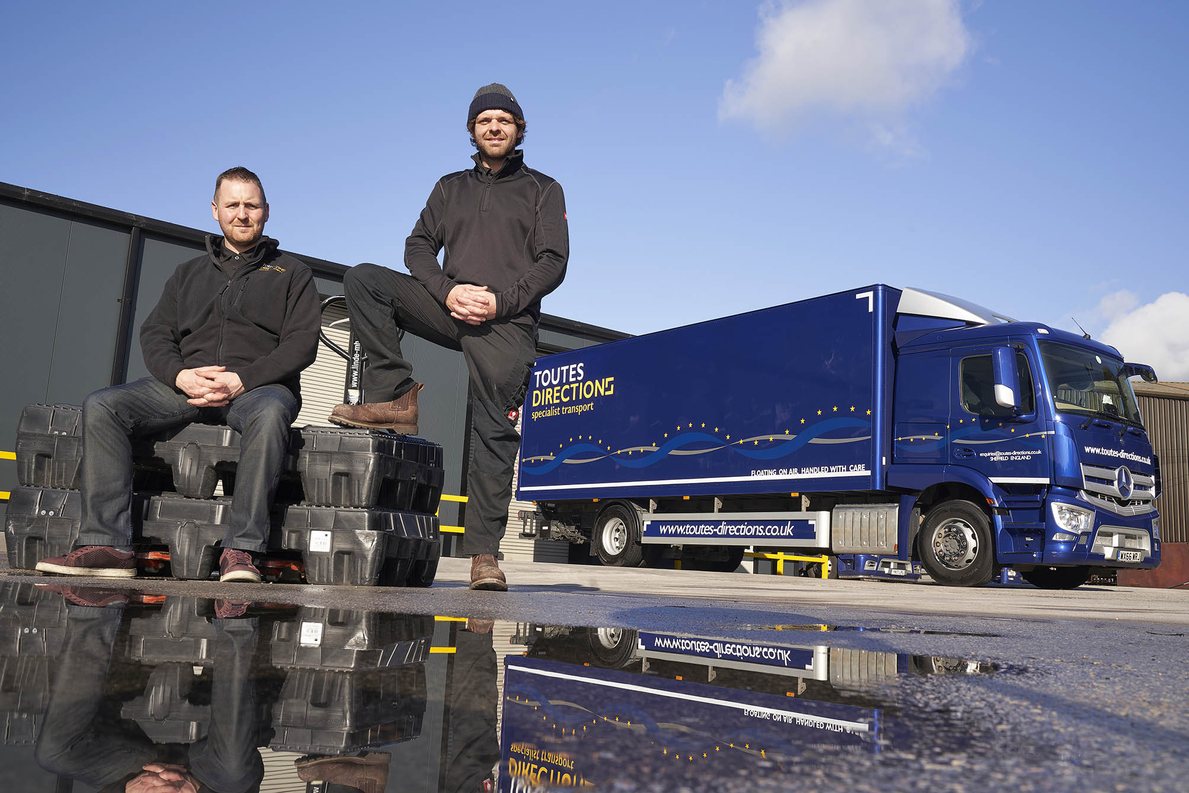

Brand of brothers: Tom, left, and Oliver Harrison, with the Mercedes-Benz Actros 18-tonner supplied by City West Commercials last May

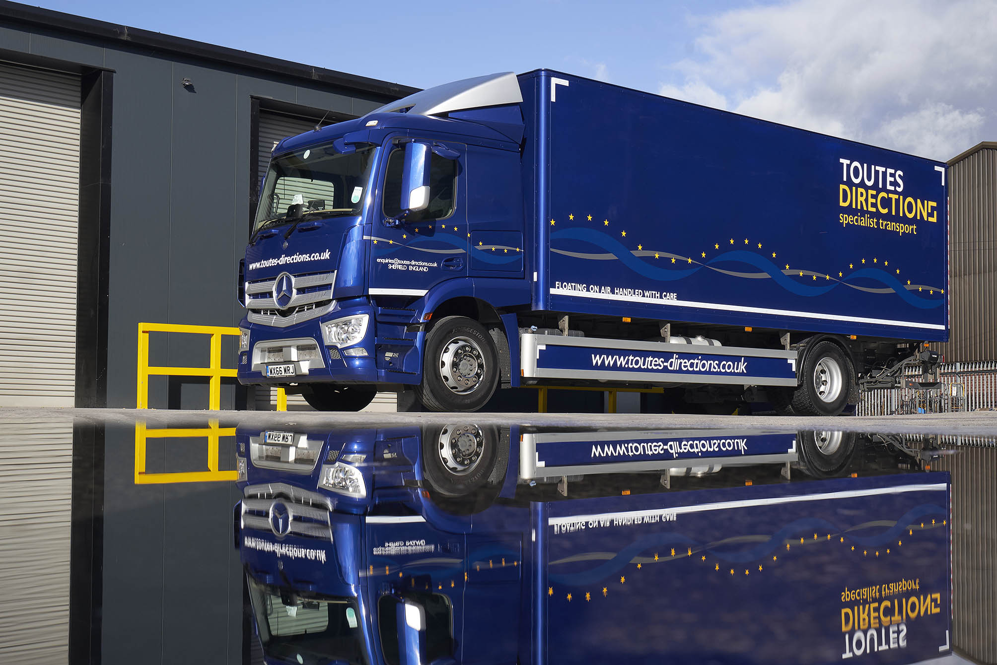

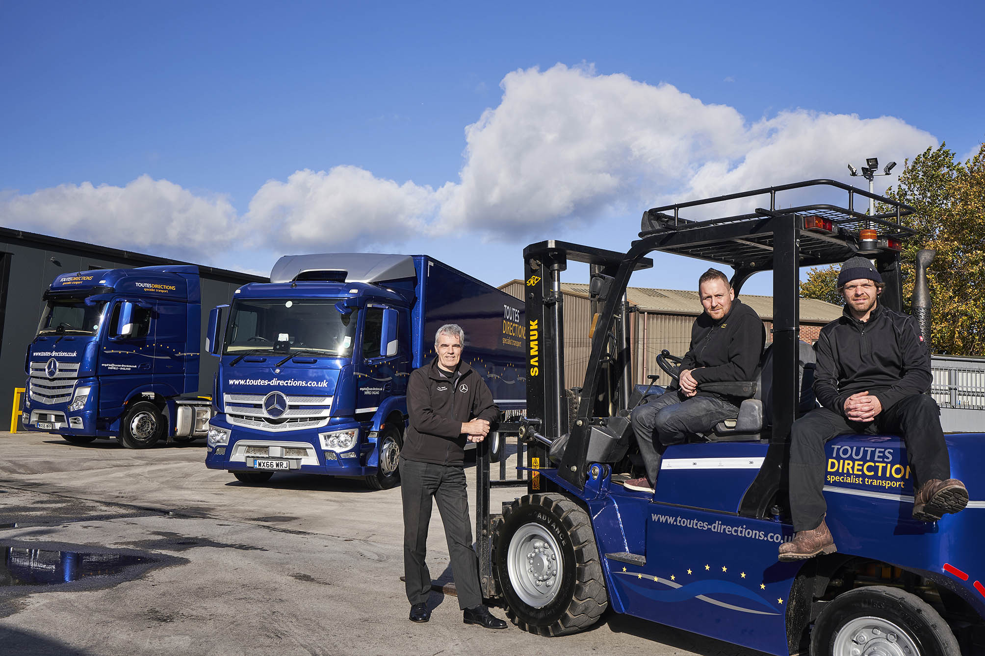

Trusted partner: City West Commercials Used Truck Sales Specialist Tim Sutcliffe, left, is pictured with customers Tom, centre, and Oliver Harrison, of Toutes Directions

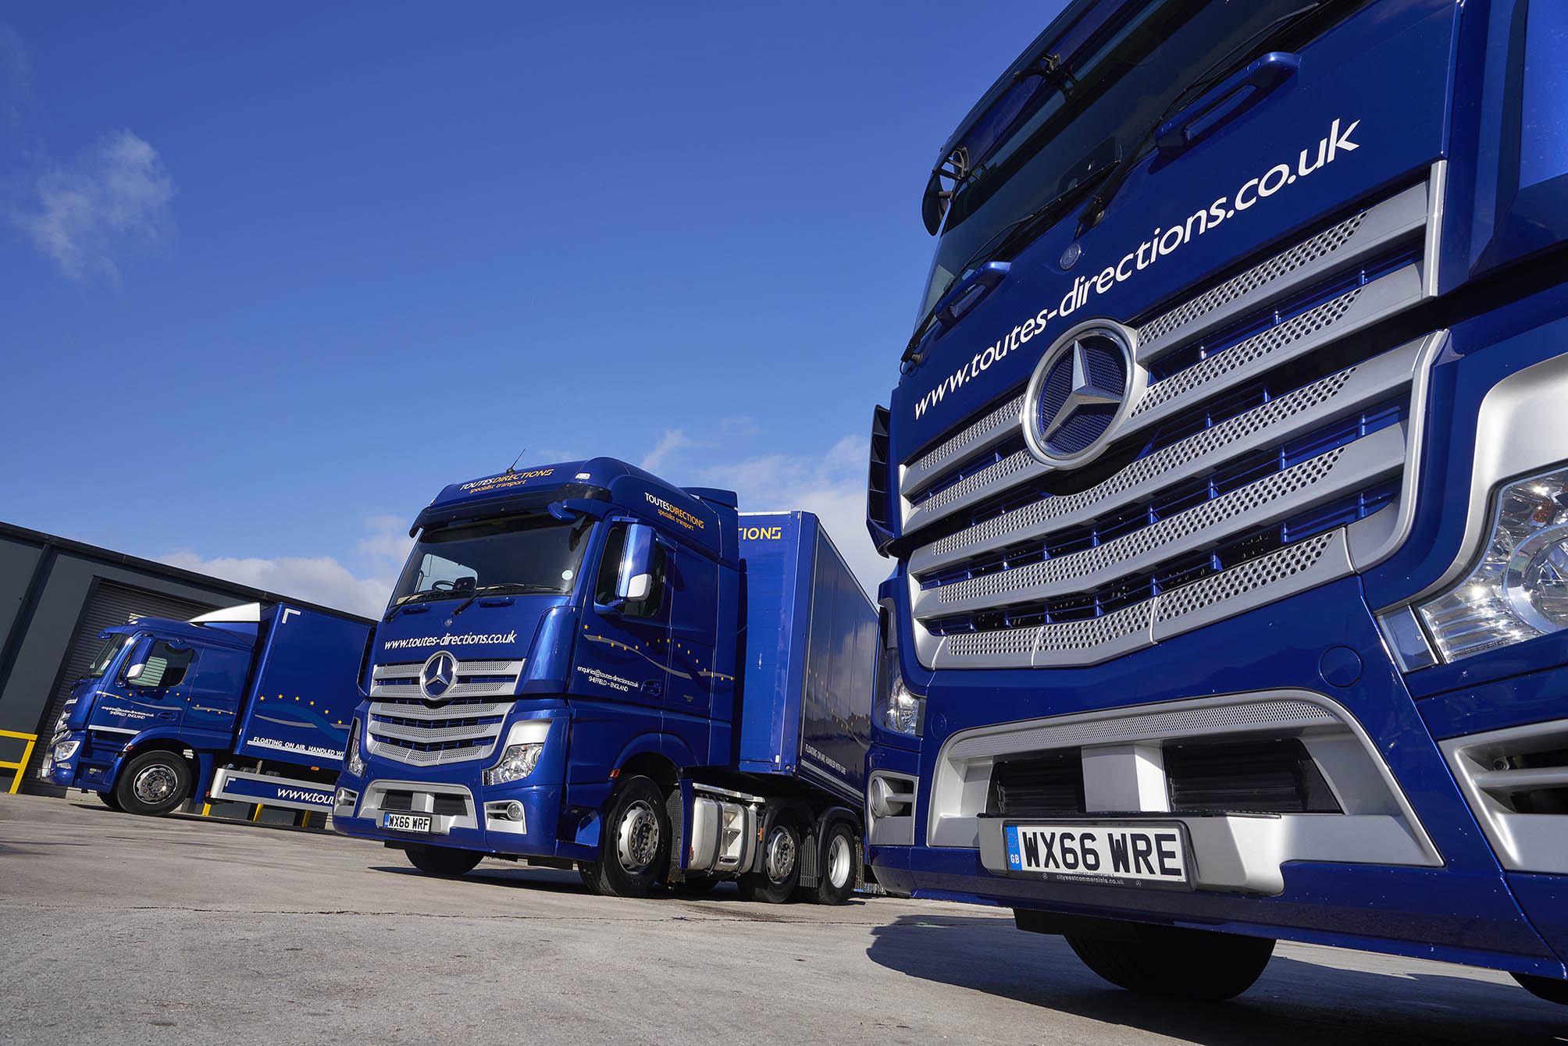

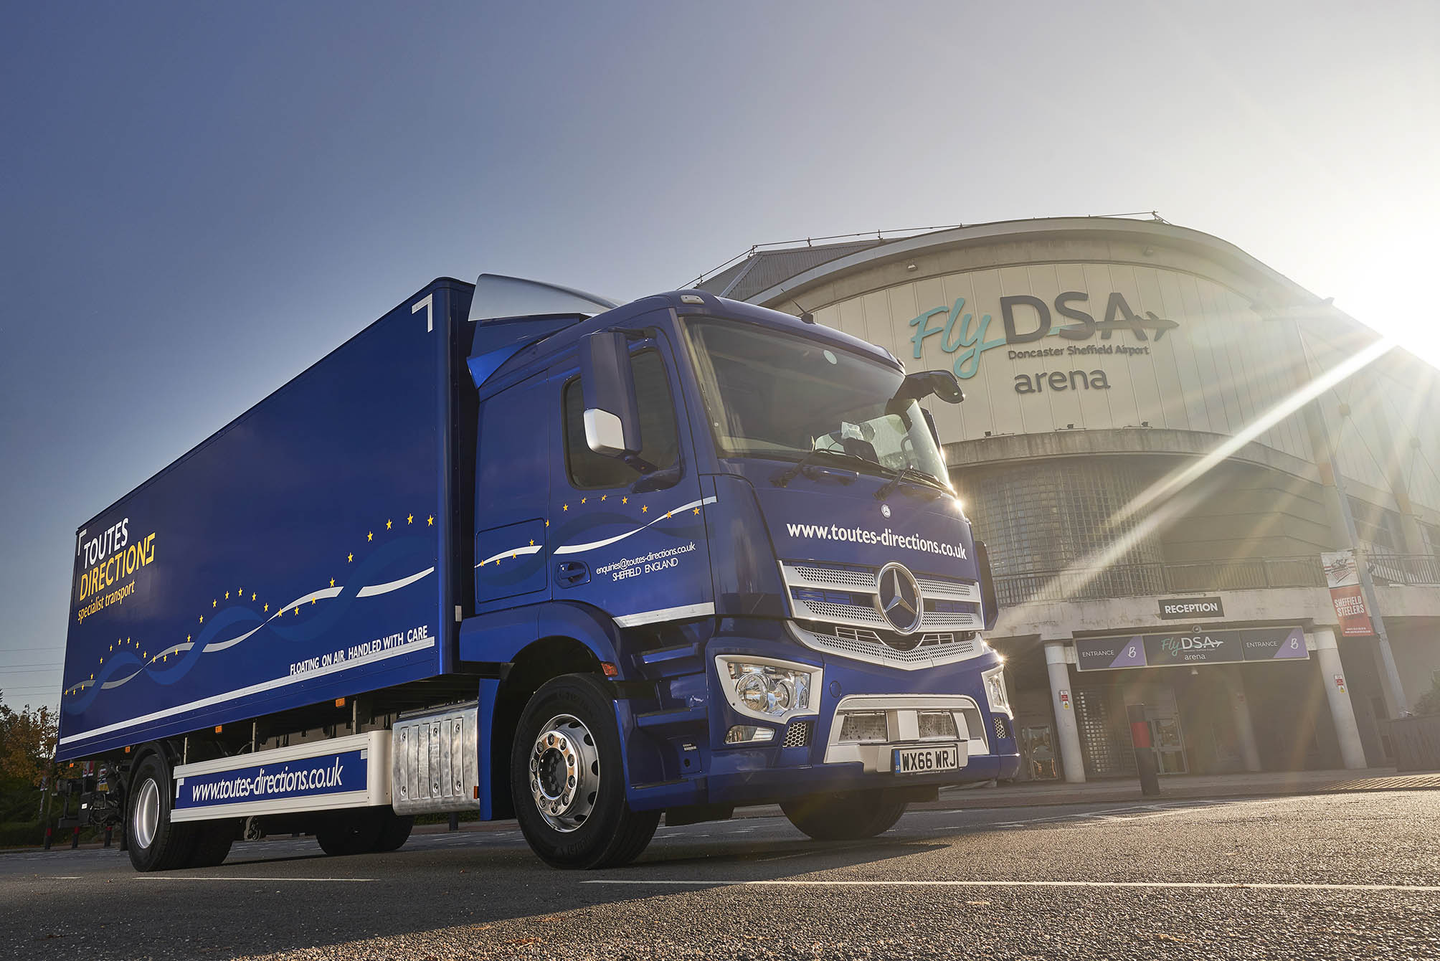

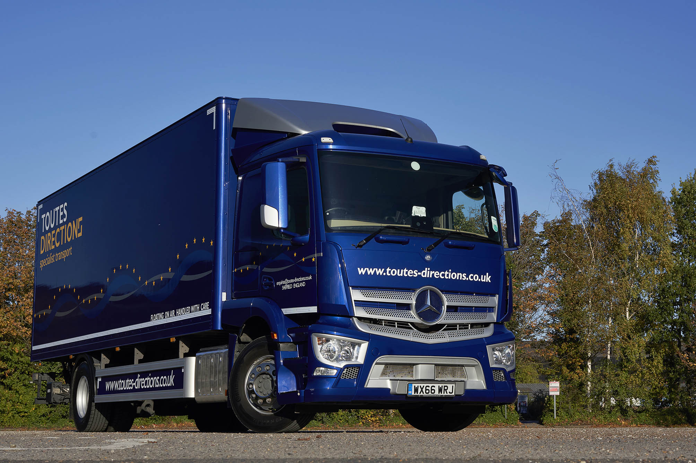

ends

For more information, or to request bigger/higher-res image files, please contact:
Steve Warren or John Ripley
Impact Communications, 01926 842126
Steve: 07770 470251, steve@impactcom.co.uk
John: 07771 484595, john@impactcom.co.uk

