

Date: 9 November 2022

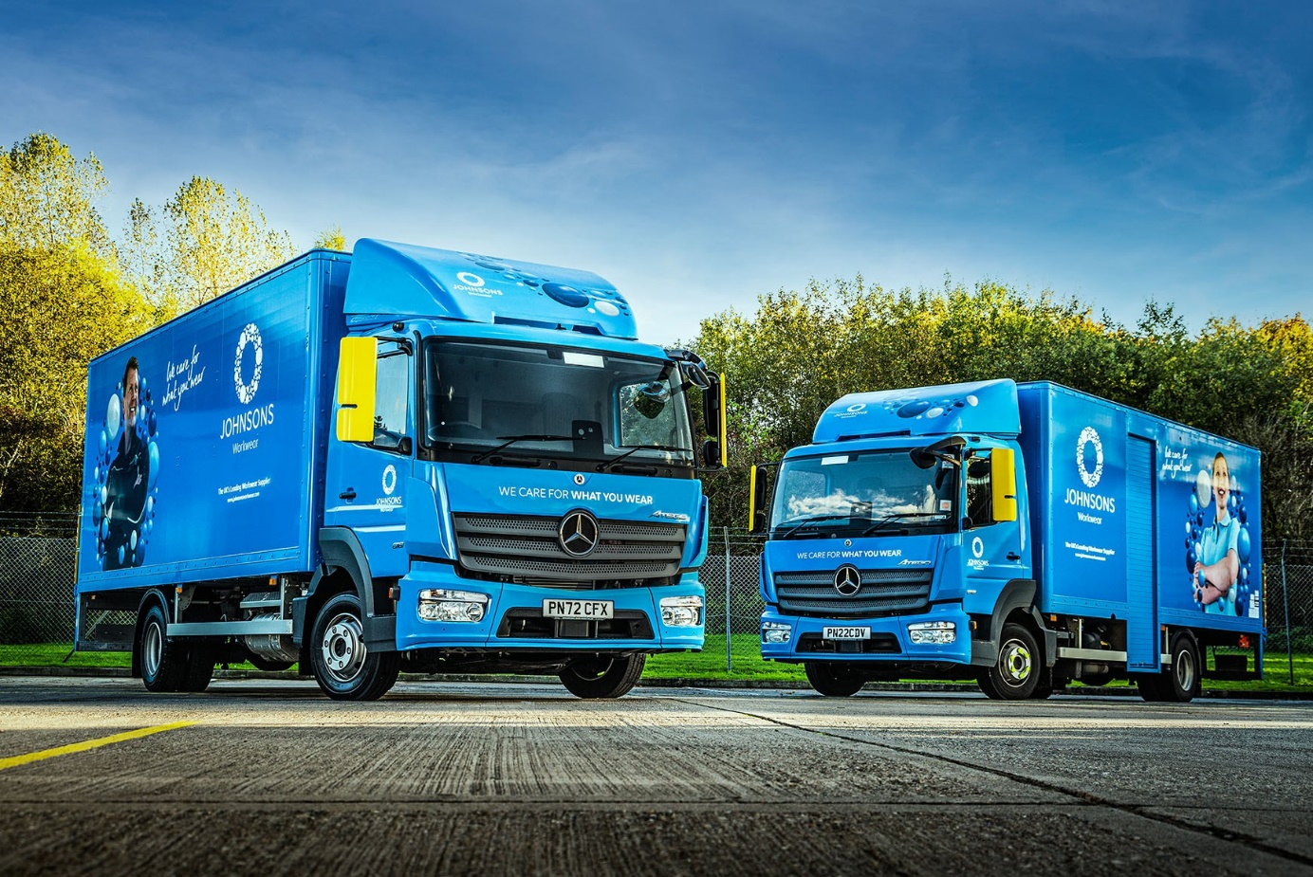

Johnsons Workwear freshens up its fleet with another 60 Mercedes-Benz trucks

A leading workwear specialist has broken with its previous policy of sourcing trucks from more than one manufacturer by placing a single, landmark order for vehicles from the Mercedes-Benz Atego light- and medium-duty distribution range.

Johnsons Workwear is already running the first dozen of the 60 new trucks that Ciceley Commercials is supplying. Not only does the operator’s revised acquisition strategy mean that for the first time every truck it has ordered this year will wear a three-pointed star, but forward planning means the same holds true for 2023 as well.
“Mercedes-Benz already laid claim to more than half of our fleet of over 250 trucks, and has been gradually strengthening its hold,” said the company’s National Logistics Manager Ian Greatrex. “This latest acquisition represents a continuation of that process.”

The Atego offers precise handling with exceptional ride comfort, and is renowned for its reliability and durability. This reputation is borne out by Johnsons Workwear’s experience.

“We’re leaning towards Mercedes-Benz because we’ve found that when it comes to longevity the Atego is definitely superior to the competition,” reported Mr Greatrex. “We typically run our trucks for up to 10 years. The mileages aren’t huge, but they are worked hard with a lot of stop-start driving. Our Atego stand up to the punishment with far fewer problems than most others we’ve tried.”

Johnsons Workwear is part of the Johnson Service Group, which operates from headquarters in Preston Brook, Cheshire, and employs more than 5,000 people. It provides textile rental and related services across a range of sectors throughout the UK.

The Workwear division processes over one million garments per week. As well as transporting branded and protective clothing for a huge variety of commercial and industrial customers, the new trucks will carry related items such as mats and hygiene products.

Most of the vehicles ordered by Johnsons Workwear are 7.5-tonne Atego 818 variants, with 5.1-litre engines that produce 130 kW (177 hp) and drive through six-speed Mercedes PowerShift 3 automated manual transmissions.

The exceptions are six 15-tonne Atego 1523s, which employ 170 kW (231 hp) versions of the same four-cylinder powerplant, and a single 18-tonne Actros 1824, with 7.7-litre 175 kW (238 hp) ‘straight six’.

All will have ClassicSpace S-cabs and specialised bodies that are being built to Johnson’s own design by AG Bracey, of Bristol – features include internal hanging rails and access doors with internal steps on the nearside.

They are replacing trucks that are being stood down from a fleet in which three other brands are represented. The first nine 818s and a trio of 1523s are now in service, with a further 13 vehicles scheduled for delivery by Ciceley Commercials before the end of the year. The remaining trucks will be supplied in 2023.

Working from Johnsons Workwear’s national network of main branches in Birmingham, Exeter, Gateshead, Leeds and Perth, and satellite depots, the new Atego will serve customers nationwide.

Ian Greatrex continued: “Back-up is also particularly important over a long service life, as any vehicle will give you issues if it’s not properly looked after. Because these trucks are based all over the country we use local suppliers for planned maintenance.

“Whenever we’ve had to call on Ciceley Commercials, though, whether for urgent parts, technical advice or any warranty issues, they’ve always been first-rate; I can’t fault them. The same is true of Ciceley’s Fleet Sales Executive Peter O’Grady, who managed our large order very professionally.”

Archie Jeffrey, General Manager at Johnson Service Group’s Perth depot, added: “The Atego cabs are comfortable, ergonomically designed and well-built, with durable materials, which helps to explain why they are so popular with our drivers.”

www.johnsonsworkwear.com

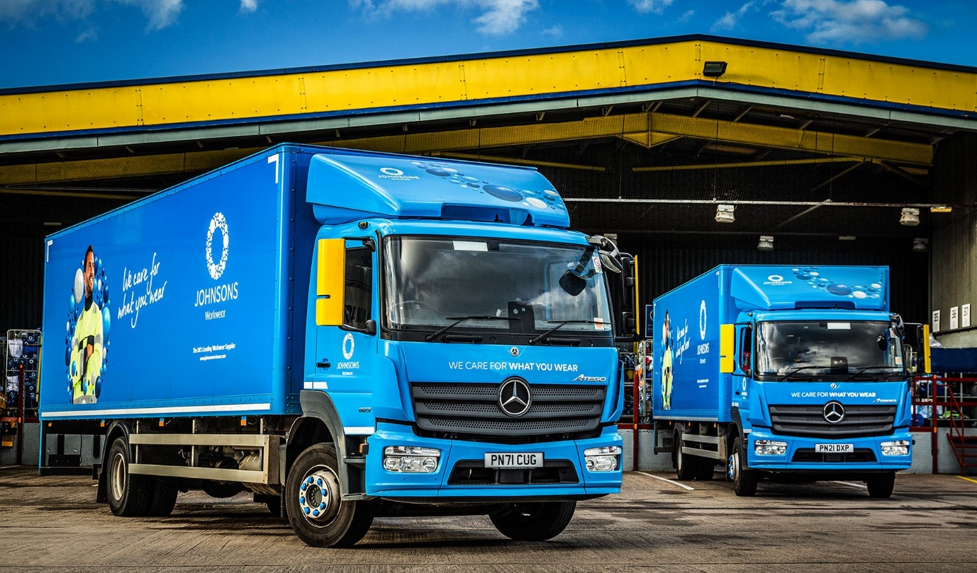

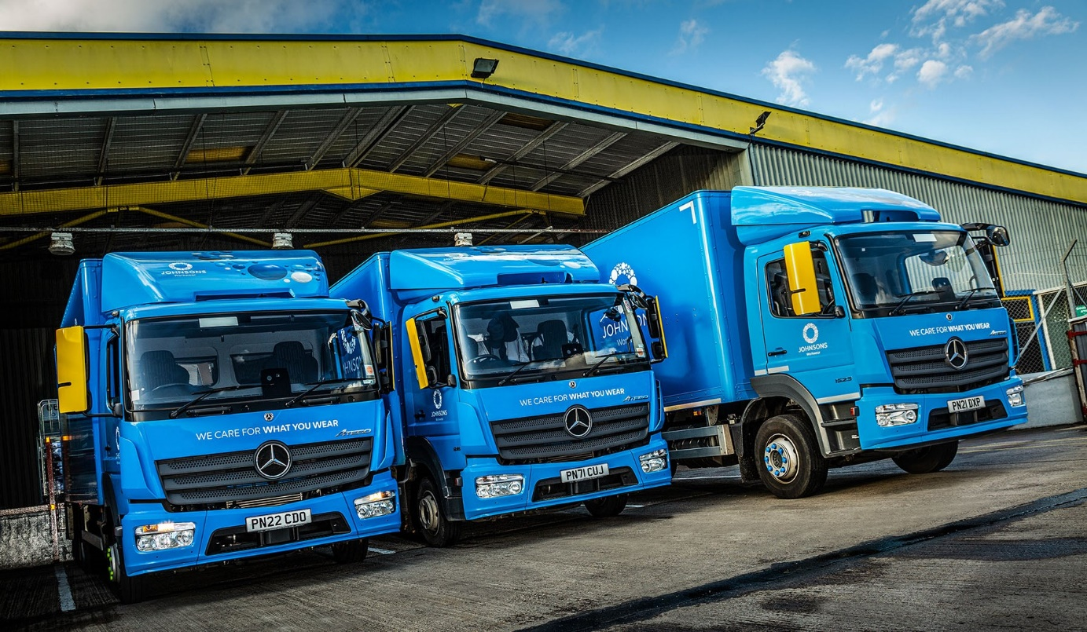
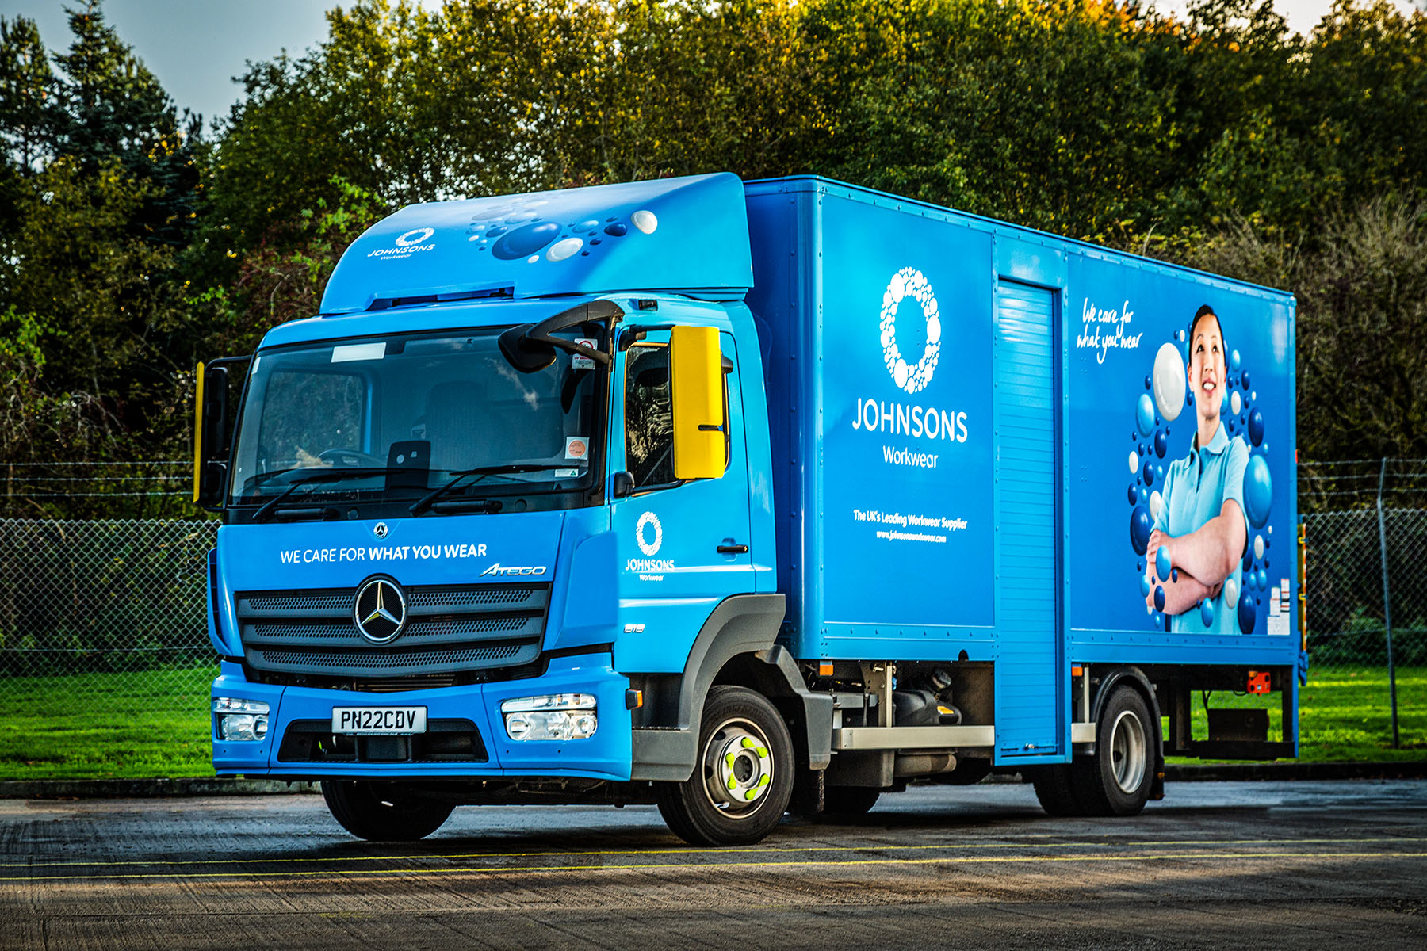

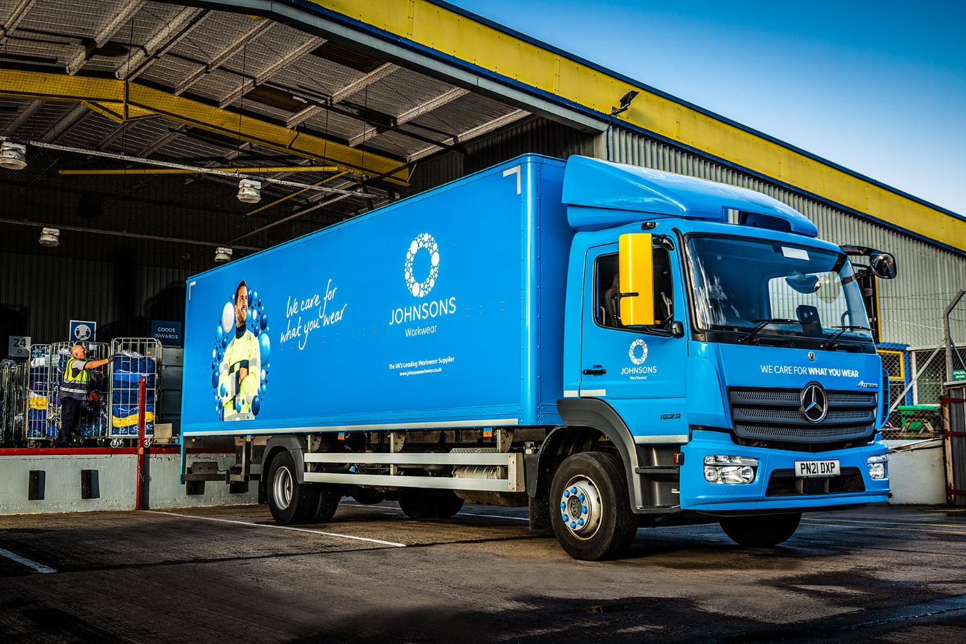

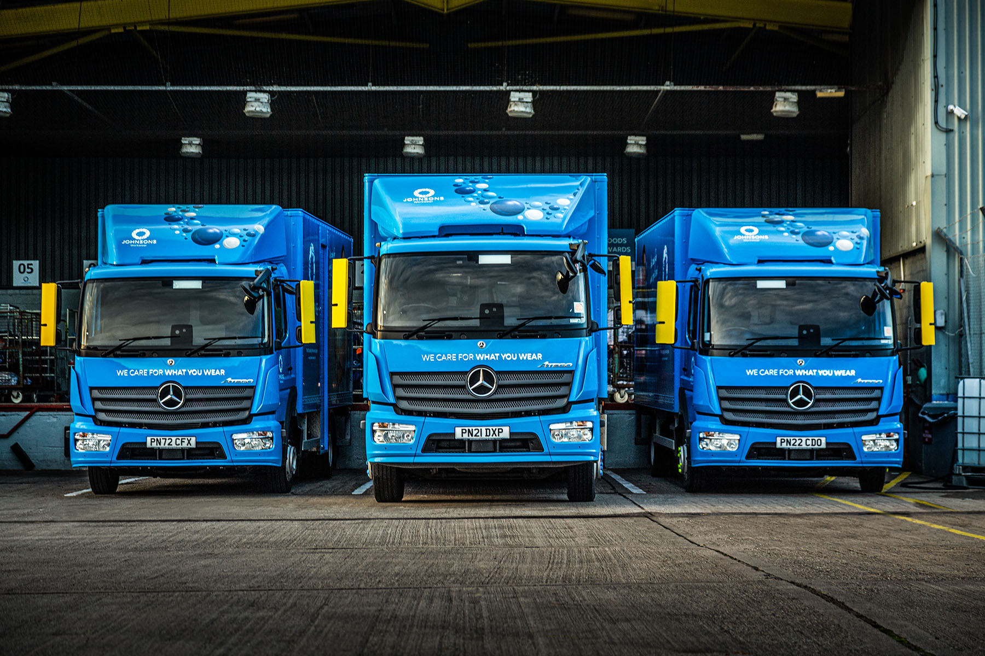

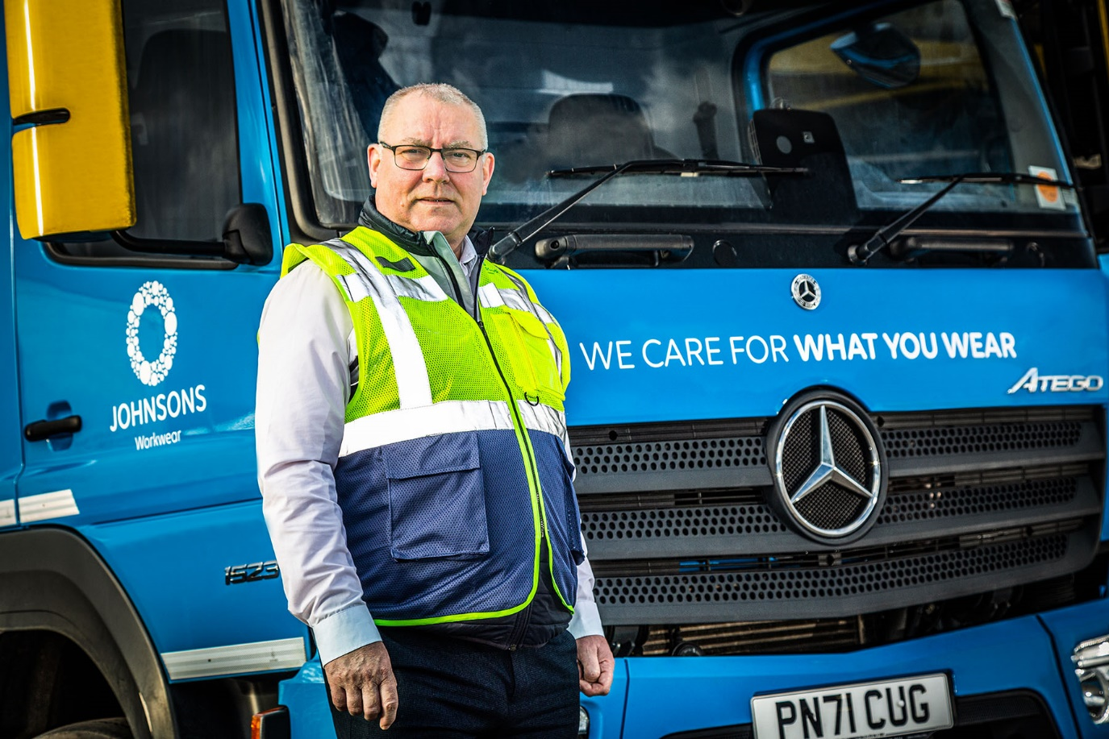

Cab comfort: Johnson’s Archie Jeffrey said his drivers were very happy with their Atego trucks

ends

For more information, or to request bigger/higher-res image files, please contact:
John Ripley or Steve Warren
Impact Communications
John: 07771 484595, john@impactcom.co.uk
Steve: 07770 470251, steve@impactcom.co.uk



