

Date: 18 December 2019

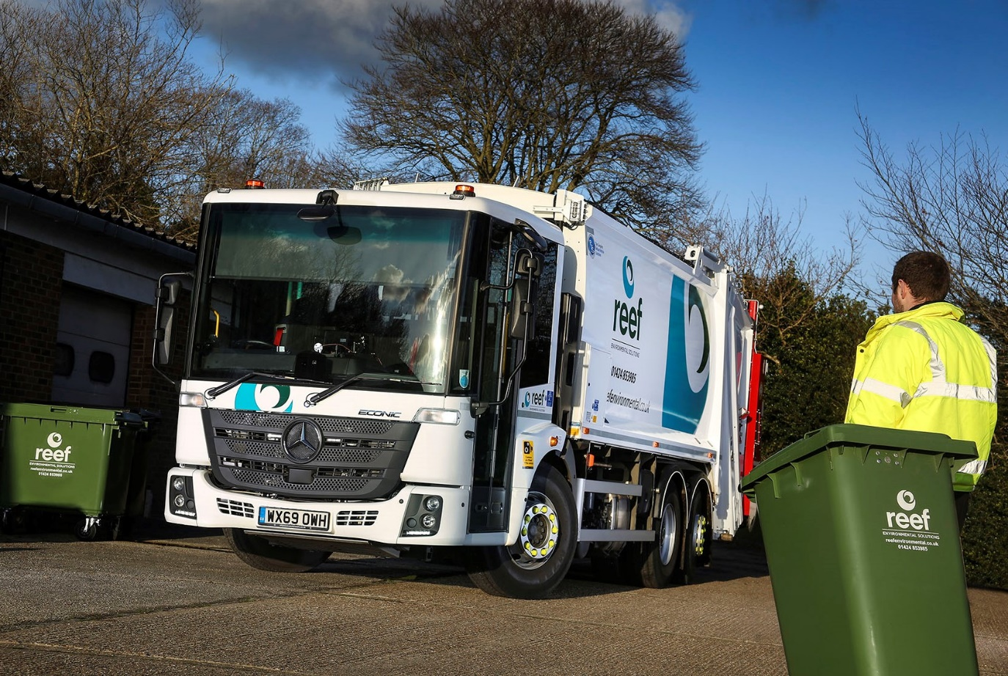

Reef Environmental rides the RVS wave with pre-bodied Mercedes-Benz Econic refuse collection vehicle

East Sussex-based Reef Environmental has become the latest waste and recycling operator to acquire a new Mercedes-Benz truck, pre-bodied and ready to work, from specialist provider Refuse Vehicle Solutions (RVS).

Based on a low-entry Econic chassis supplied by City West Commercials, the 26-tonner is fitted with a single compartment Dennis Olympus compacting body and Dennis Beta bin lift purpose-designed for trade and heavy domestic collections.

RVS has been buying Mercedes-Benz vehicles since 2005 and enjoys a successful partnership with City West Commercials. This year alone RVS has acquired 18 new Econic chassis from the Dealer, added bodies and bin lifts, then marketed them to customers through its RediTruck scheme.

Reef Environmental has headquarters in St Leonards-on-Sea, and provides waste management and recycling services, including confidential paper shredding, to a broad range of businesses and public sector clients across Kent and Sussex. It also caters for households which generate additional waste.

The Econic is the first truck on the Reef Environmental fleet to wear a three-pointed star, although the independently owned company’s directors have had positive experiences of running Mercedes-Benz products in previous roles.

A 2630 model, it is powered by a 7.7-litre, 220 kW (299 hp) straight-six engine, which drives through a fully automatic six-speed Allison transmission. The truck’s lifting rear axle can also be steered, significantly enhancing manoeuvrability in areas where access is restricted.

The Econic’s air-conditioned, flat-floored cab, meanwhile, is noteworthy for the deep, panoramic windscreen and full-height glazed side door which has earned it a five-star Direct Vision rating from Transport for London. Safety is further enhanced by features such as the Active Brake Assist emergency braking system, which comes as standard.

The RediTruck programme introduced by RVS in 2015 provides customers with a quick and easy way of avoiding long body manufacturer lead times. Like a previous vehicle acquired by Reef Environmental via the same scheme, the Econic is the subject of an RVS contract hire agreement.

“We are delighted with our new Mercedes-Benz,” confirmed Reef Environmental Director Paul Mintern. “This is the second brand new vehicle we’ve taken from RVS, and we’ve selected the Dennis Olympus again as we consider it the best body available.

“However, we’ve opted for the Econic chassis this time because it is purpose-designed for the waste management industry, so more suitable for our operations. The truck’s low-entry cab, great turning circle and all-round visibility are particularly important features. It also has a superior gearbox and offers impressive performance. What’s more, our local Mercedes-Benz workshop is only 20 minutes’ drive away, so very convenient for maintenance purposes.”

Mr Mintern added: “RVS is a family business and prides itself on good customer service. It’s reassuring to know it is supporting our fleet, and that in the unlikely event the vehicle suffers a serious breakdown it can provide a replacement quickly.”

RVS offers the entire range of refuse vehicle services, including new or quality used vehicles for sale, vehicle remanufacturing, a substantial hire fleet, a preventative maintenance service, repairs, breakdown support, parts, finance and vehicle transportation. The company operates from a site with seven-bay workshop and two-storey parts department at Cam & Dursley, near Stroud.

The RediTruck solution is particularly attractive to operators that have to start work on a recently won contract at relatively short notice. RVS also purchases, refurbishes and in some cases modifies, then retails pre-owned refuse vehicles – all are subjected to rigorous quality checks and services, and supplied with 12-month MoTs.
Refuse Vehicle Solutions Managing Director Spencer Law commented: “Reef Environmental is well known for its excellent customer service and reliability, and is a great company to work with. We are proud to provide and maintain refuse vehicles which maximise its operational efficiency and facilitate the delivery of its services.

“In the five years since we launched our RediTruck service City West Commercials has supplied us with in excess of 100 new chassis. The Dealer’s after sales service is great and we consider it an excellent vehicle partner.”

www.reefenvironmental.co.uk

www.refusevehiclesolutions.co.uk

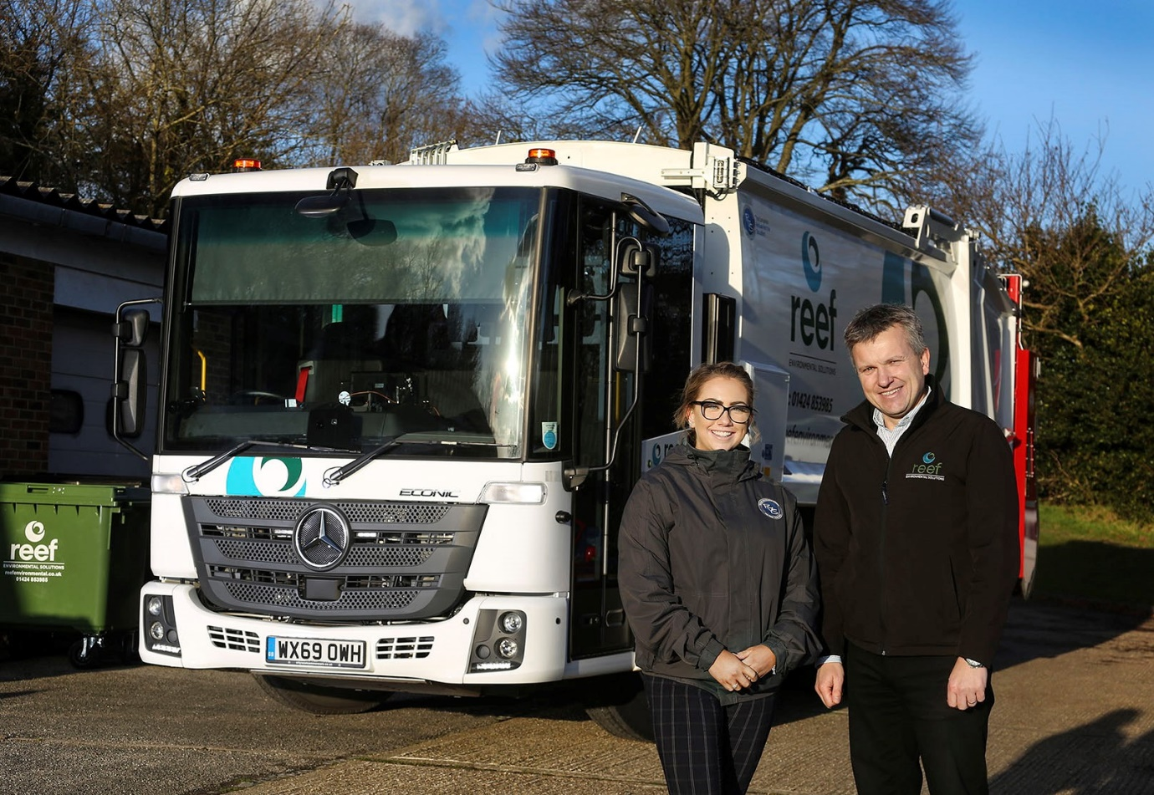

Reef Redi: Hannah Mason, Sales & Marketing Administrator at RVS, is pictured with Reef Environmental Director Richard Taylor, and his company’s new Mercedes-Benz Econic

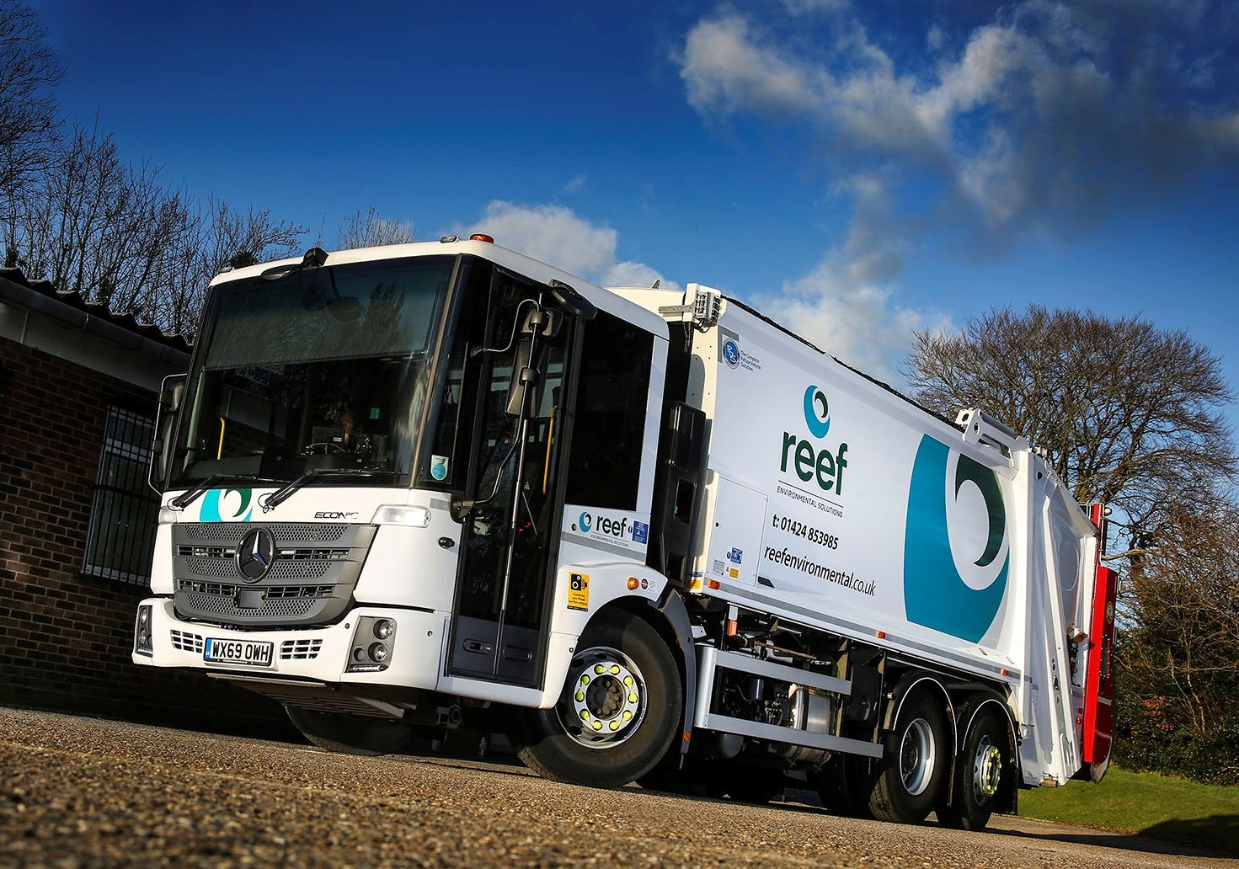

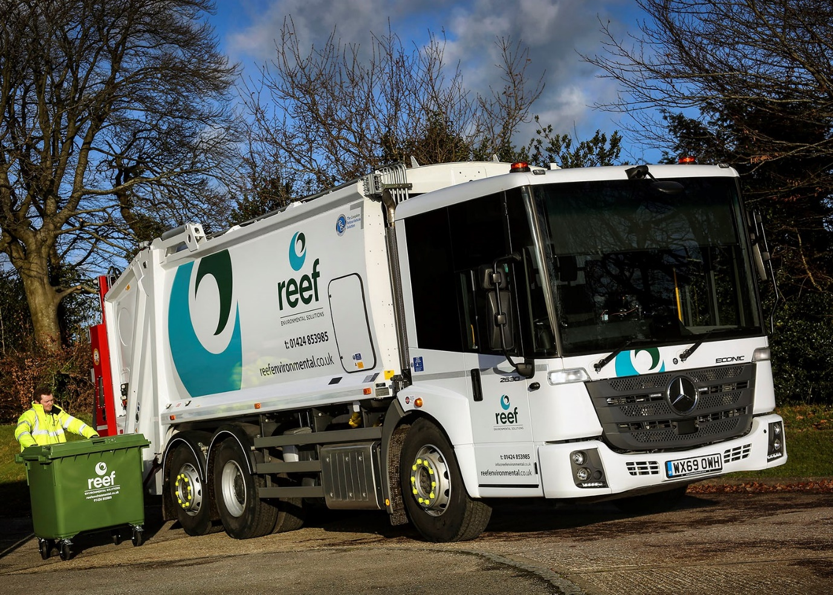

ends

For more information, or to request bigger/higher-res image files, please contact:
Steve Warren or John Ripley
Impact Communications, 01926 842126
Steve: 07770 470251, steve@impactcom.co.uk
John: 07771 484595, john@impactcom.co.uk

