

Date: 25 April 2019

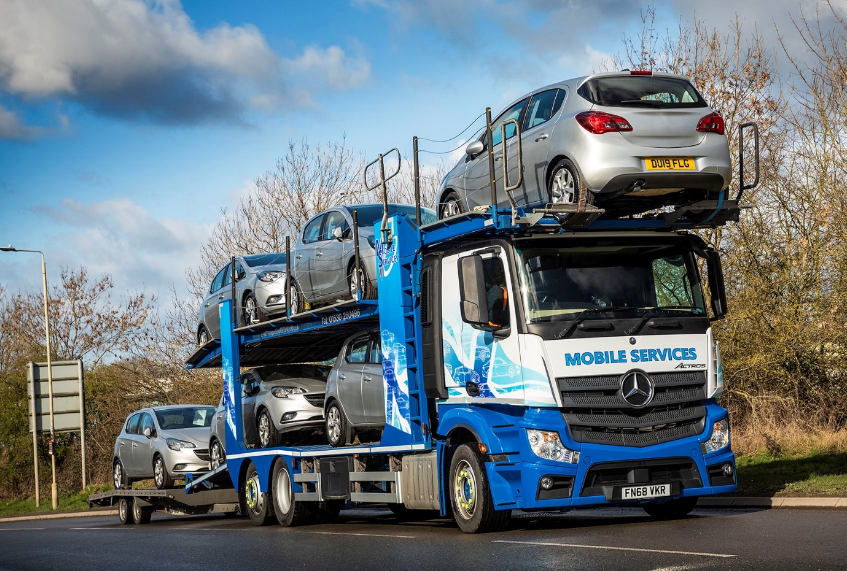

Low-riding Mercedes-Benz Actros walks tall for Mobile Services

East Midlands Dealer Mertrux Truck & Van has won praise from vehicle logistics specialist Mobile Services, after supplying the Leicestershire-based operator with its latest
Mercedes-Benz.

The low-framed 26-tonne Actros 2535 LnR ENA has made an excellent start, returning promising fuel figures and earning positive feedback from its driver. Powered by a 7.7-litre straight-six engine generating 260 kW (354 hp), the truck has a 2.3m-wide, low-roofed CompactSpace sleeper cab with 170mm engine tunnel.

Mobile Services Director Tony Bradbury explained: “We wanted a chassis that could carry the five-car transporter body we’d removed from a previous vehicle, with minimal alterations.

“We’re always looking for improvements, though. In our job, every reduction we can make in the overall height of a transporter gives us added flexibility in terms of the loads it can carry.”

Mr Bradbury said he and his colleagues were impressed with the care taken and the time committed by Mertrux Sales Executive Mark Sheppard, to come up with the right specification for their specialised application.

He recalled: “Mark ensured that he fully understood what we were looking for. He made several visits and was able to show us detailed diagrams of the Actros chassis, so we could see exactly how the body would match up. He was extremely knowledgeable about the product and his input was invaluable in ensuring we made the correct choices.”

Established more than 30 years ago, Mobile Services operates from headquarters at Ellistown, near Coalville. As well as moving cars and commercial vehicles for manufacturers, dealers and fleet operators, the company runs a busy workshop which maintains its own trucks and third-party vehicles.

Its latest order represents a breakthrough for Mertrux, as Mobile Services’ fleet of 85 trucks is dominated by Swedish brands. Most of these are ‘short-long’ drawbar combinations of a prime mover which carries three cars, and a longer trailer, but 11 are six-wheeled rigids of similar size to the Actros.

“We’ve had some used Mercedes-Benz chassis from Mertrux before, but this is the first new vehicle it’s supplied for several years and we’ve very pleased with the result,” continued Mr Bradbury.

“The Actros sits 100 mm lower than the Mercedes-Benz Axor to which the Belle Trailers body was fitted previously, which means it can carry higher vehicles, such as large vans. It also loads and drives well, while we know from experience that Mercedes-Benz trucks are reliable and robust.

“Fuel economy is looking good, too. Returns are already averaging 9.9 mpg, but we expect this figure to improve as the Actros beds in – Mertrux Driver-Trainer Dave Stevens spent some time with our own trainer Richard Ratcliffe, to familiarise him with the truck, and will continue to provide on-going support to ensure we get the best performance and value.”

Mr Bradbury added: “On this evidence, we’ll be looking to convert our remaining rigid transporters to new Actros models as they fall due for replacement.”

www.mobileservicesltd.co.uk

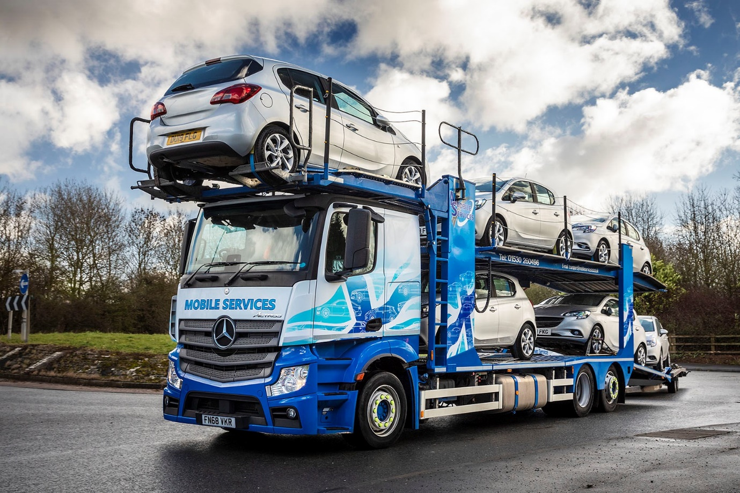

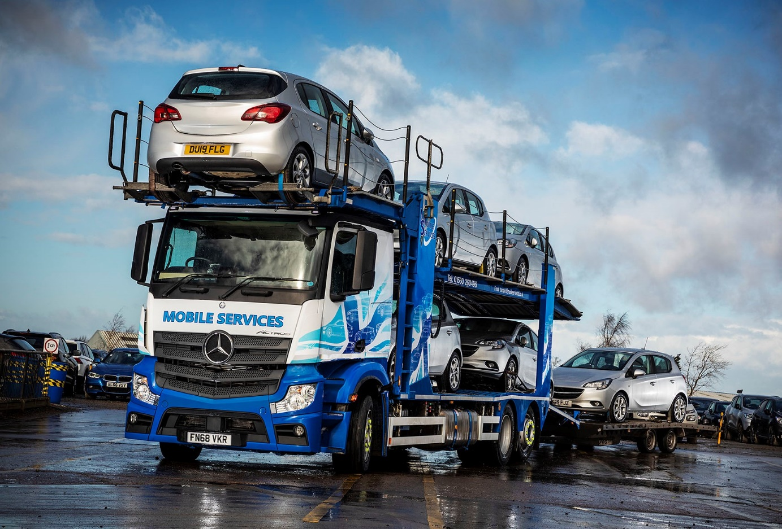

ends

For more information, or to request bigger/higher-res image files, please contact:
John Ripley or Steve Warren
Impact Communications, 01926 842126
John: 07771 484595, john@impactcom.co.uk
Steve: 07770 470251, steve@impactcom.co.uk



