

Date: 24 September 2021

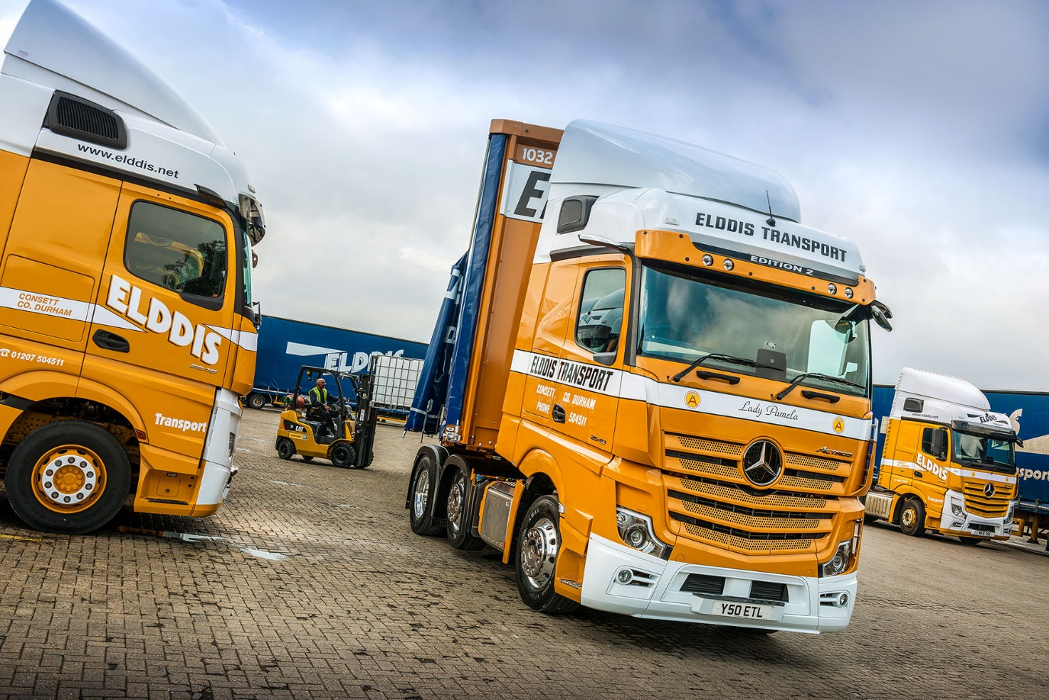

In with the new: The traditionally-finished Actros Edition 2 is pictured with some of Elddis Transport’s other new Mercedes-Benz trucks, which wear its modern livery

Elddis celebrates a half-century of success with a ‘gold star’ Mercedes-Benz Actros Edition 2

One of Mercedes-Benz Trucks’ most loyal customers has marked 50 years in the haulage industry by commissioning an exclusive Mercedes-Benz Actros Edition 2 tractor unit that combines cutting-edge technology with an evocative anniversary livery.

In recent years Elddis Transport has set a succession of specially-finished Actros on the road to mark various milestones, charity initiatives or customer associations. Its latest tractor unit stands proud, though.

The Edition 2 represents a new dimension in comfort, safety and design. Just 400 are being built, with a dozen coming to UK operators.

Elddis Transport’s new flagship arrived via Bell Truck and Van, a trusted and long-established supplier to the Consett-based operator. The truck’s ‘retro’ livery mirrors the appearance of Elddis trucks dating from the company’s inception in 1971, with traditional hand-painted signwriting by Hogarth Coachworks, of Birtley.

It is also one of only four vehicles on Elddis Transport’s Mercedes-Benz dominated fleet of 150 trucks to bear the name of a member of the company’s founding family – in this case Managing Director Nigel Cook’s mother, Pamela.

To complete the eye-catching look Lawrence David constructed a pair of bespoke curtainside trailers, also in 1971-vintage colours, and the combination rolls on Goodyear tyres – like Bell Truck and Van, both companies have been suppliers to Elddis since its earliest days.

Despite its traditional finish, there is no mistaking the fact that this truck is bang up to date. The limited-edition model’s sun visor incorporates four additional LED headlights, above which is a deep black panel with EDITION 2 lettering.

Other external highlights include an illuminated Mercedes-Benz three-pointed star in dark chrome, with a black closed cover, stainless steel entrance steps, three more LED headlights behind the cab, and a chassis frame cover.

Edition 2s are being built as rigids as well as tractor units in 4x2, 6x2 or 6x4 configurations, with GigaSpace or BigSpace cabs, and either 15.6- or 12.8-litre in-line six-cylinder engines with a combined total of eight power ratings.

Elddis chose a 2548 BigSpace version with 350 kW (476 hp) output. Its Edition 2 is now working alongside a further 10 Actros 2548 BigSpace units, all of which entered service this month (September).

Nigel Cook enthused: “All of our new Actros look smart but the anniversary unit is amazing. This special unit pays fitting tribute to the closeness and quality of our relationships with the manufacturer and its local representative, as well as to our own history and track record in the industry.”

Since 1998 members of Bell Truck and Van’s factory-trained Service team have inspected and maintained the Elddis fleet at the operator’s Consett workshop. “We’ve been very well served over the years by our Mercedes-Benz trucks, while the support we’ve received from Bells has been first class,” reported Mr Cook.

The Actros Edition 2 raises driver appeal to a new level, thanks to a cab interior that is every bit as eye-catching inside as the exterior. An abundance of stitched black Nappa leather contrasts with dashboard components in carbon. There is a sliding and tilting sunroof, eight colours of ambient lighting, and a driver’s suspension seat that incorporates climate and massage functions, while at 900 mm-wide and with its own, cosy topper, the comfort mattress is a dream for any driver. A brushed and polished aluminium badge on the co-driver’s side hails this Edition 2 as “One of 400”.

Edition 2 drivers also benefit from the upgraded interactive version of the radical, twin-screen Multimedia Cockpit, which boasts a larger, 12in instrument panel and comes with extra functionality, including satellite navigation, together with Proximity Control Assist, Bi-xenon headlamps with a cleaning system, and LED tail lights.

All of this equipment, and much else besides, is bundled into the Edition 2’s Driving, Comfort, Media, Stowage, Safety and Sight Packages, and ExtraLine design, to create a vehicle with an unmistakable “Wow!” factor.

Other high-tech aids providing increased safety, efficiency and comfort are standard equipment across the Actros range. These include MirrorCam, Mercedes-Benz Trucks’ pioneering alternative to conventional mirrors, and the latest version of Predictive Powertrain Control, which manages gear changes to optimise fuel economy. Active Brake Assist 5, meanwhile, outperforms rival emergency braking systems, particularly in its responses to pedestrians stepping into the vehicle’s path.

Although Elddis Transport has reached its 50th year, the family’s roots stretch back much further. Mr Cook’s great-grandfather Thomas Cook set up in business with a single horse and cart in the late 1800s, while his son Siddle C. Cook famously ran one of the country’s best-known heavy haulage firms in the 1950s and ’60s. Nigel Cook’s father Geoffrey established the current business.

Elddis has built on its family ethos and retains a high level of loyalty from customers and long-serving staff. Today, while working across a broad range of sectors, it is highly regarded for its expertise in the demanding FMCG market, providing transport, warehousing and distribution services across the UK.

www.elddis.net

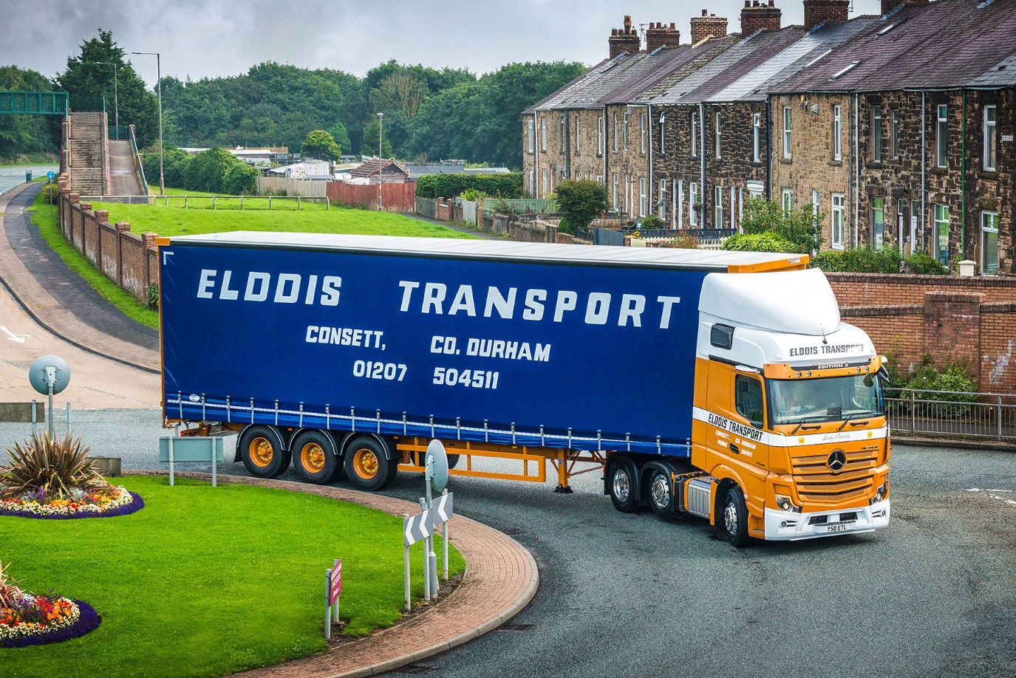

Turning back the clock: The Actros Edition 2 and its Lawrence David trailer wear traditional Elddis livery

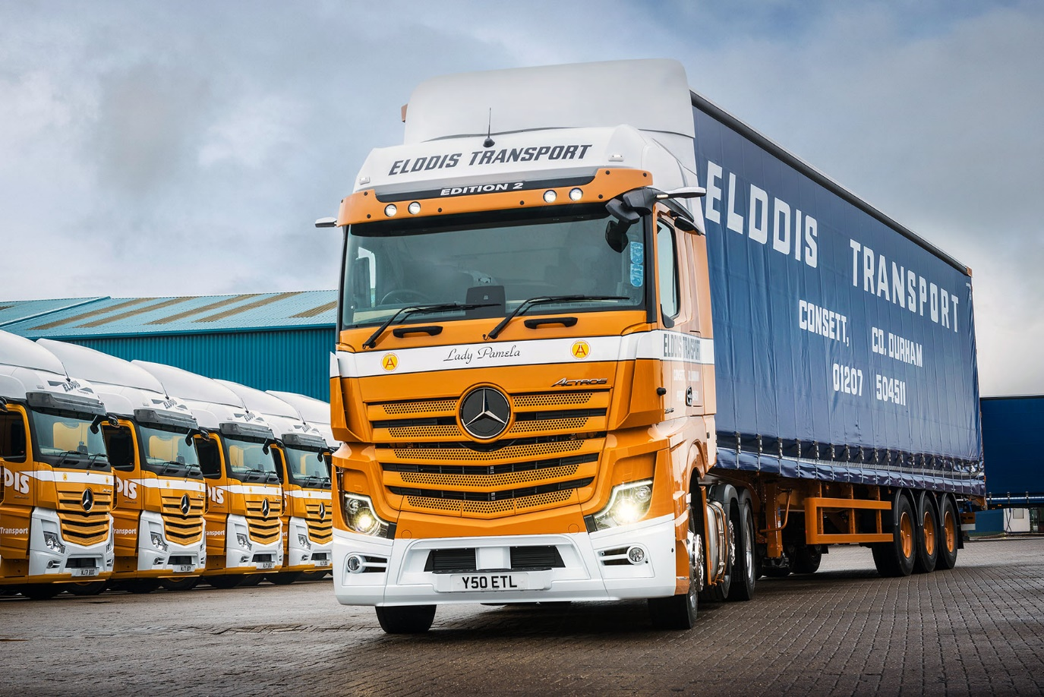
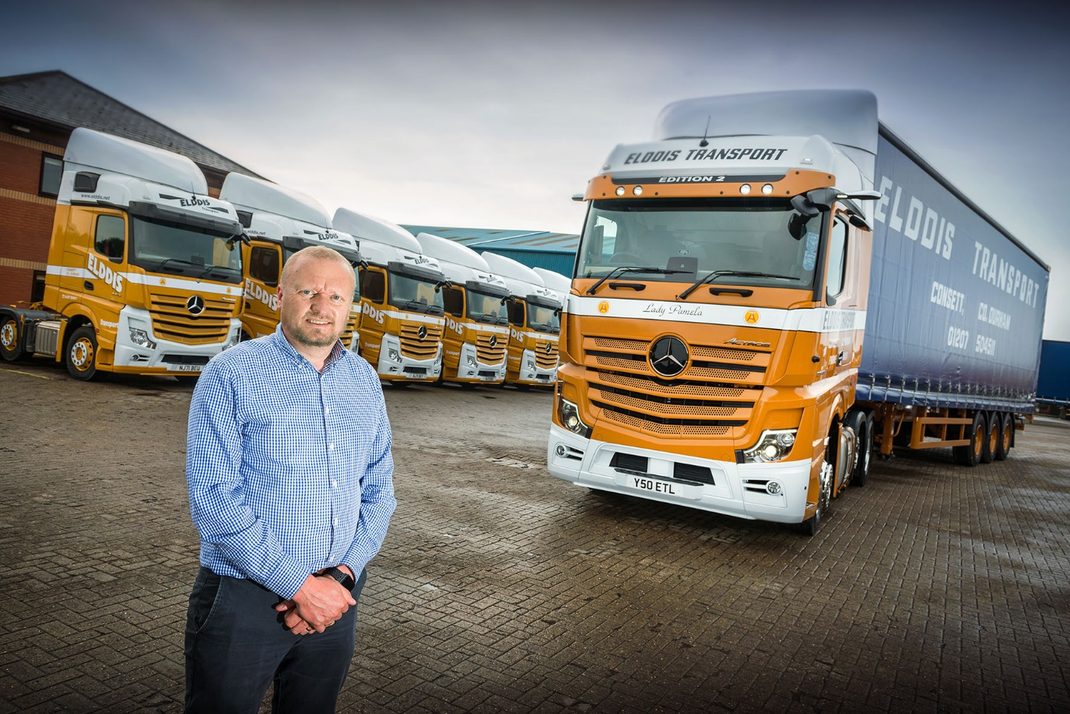

Actros advantage: Nigel Cook has been an enthusiastic proponent of the Mercedes-Benz tractor unit for many years

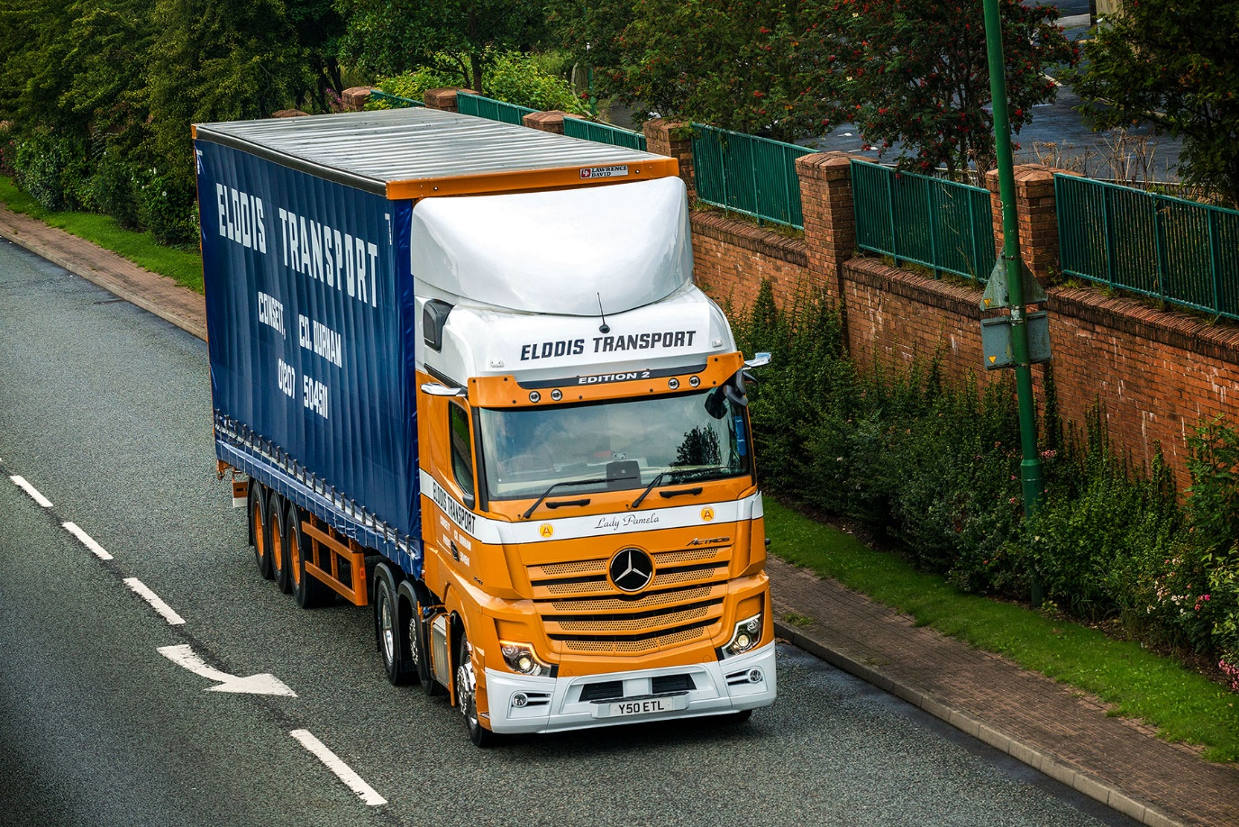

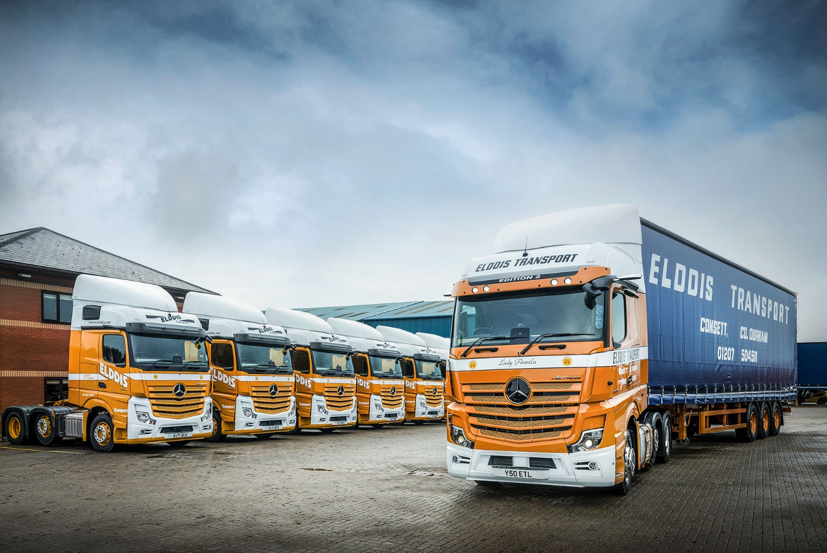

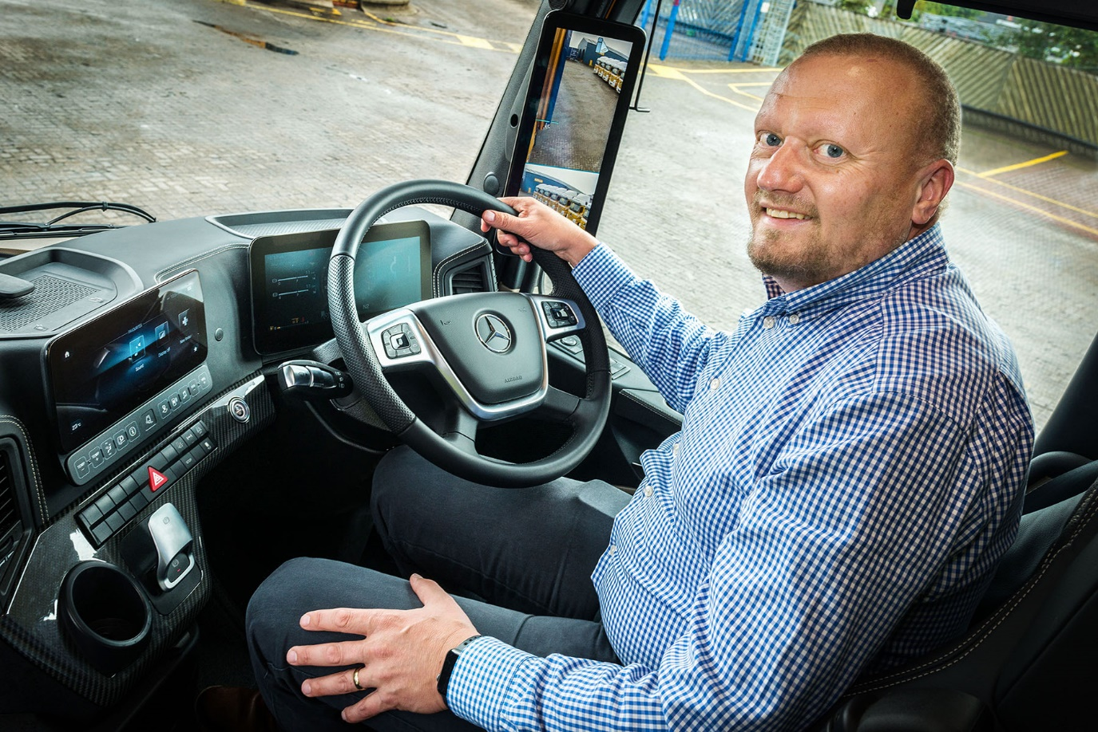

Seat of power: Elddis Transport Managing Director Nigel Cook at the wheel of his new Actros Edition 2

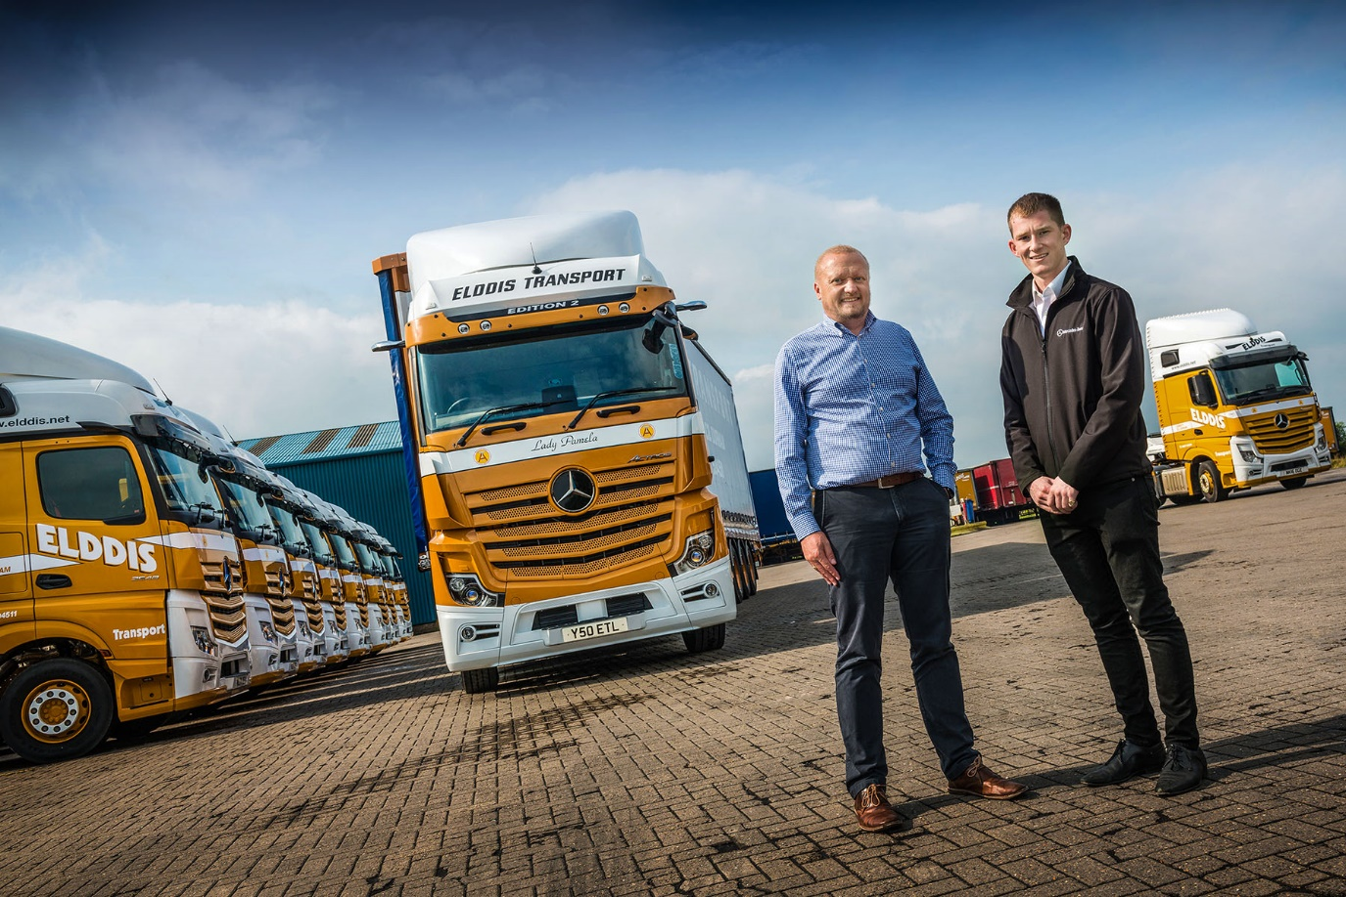

Professional partnership: Elddis Transport Managing Director Nigel Cook, left, with Bell Truck and Van Sales Executive Alex Wordsworth, who delivered the operator’s 11 new Actros tractors

ends

For more information, or to request higher-res image files, please contact:

Jamie Fretwell at Mercedes-Benz Trucks UK Ltd
07712 519230, jamie.fretwell@daimler.com

or

Steve Warren or John Ripley
Impact Communications, 01926 842126
Steve: 07770 470251, steve@impactcom.co.uk
John: 07771 484595, john@impactcom.co.uk

