

Date: 29 May 2025

Investment by Midlands Truck & Van fuels Oxalis win

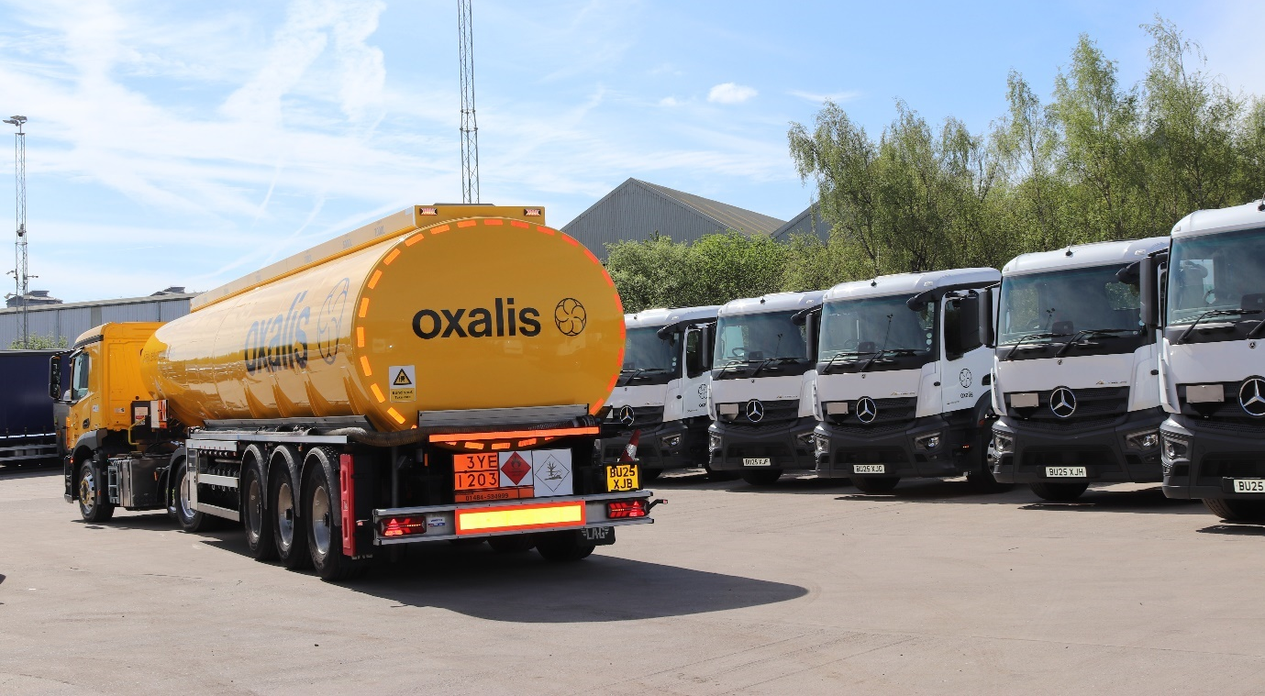

Tanker operator Oxalis has given its vote of confidence to Mercedes-Benz Trucks and its Dealer of the Year, Midlands Truck & Van, by placing an order for 10 Actros tractor units.

“This shows our faith not only in the vehicles, but in the investment in people, training and facilities made by Midlands Truck & Van at its Birmingham site,” said Oxalis Fleet Engineer Paul Harrison.

“I know from previous experience that the Actros is a superbly reliable truck, very cost-efficient in operation, and loaded with the very latest safety and driver assistance technology. Meanwhile our drivers are delighted with the well-appointed, comfortable cabs.

“Equally importantly though, Managing Director Steve Hunt and Service Manager Dean Bennett have given us all the evidence we could ask for that the demanding level of back-up required for vehicles in our industry will be there whenever we need it.”

The trucks are Actros 2446 models, powered by 10.7-litre six-cylinder engines that each produce 340 kW (460 hp). They feature small-wheeled (17.5in) mid-lift axles which offer a weight saving of approximately 300kg compared to the standard version with 22.5in wheels, while also freeing up valuable space on the chassis. More weight has been saved by choosing 2.3m-wide ClassicSpace cabs, the narrower of the two widths available, and alloy wheels.

Oxalis was formed in 2024 but was already a market leader in the transport of fuel, gas and bitumen across Europe – it had previously been a division of the Hoyer Group. The company operates across Europe and beyond and runs a fleet of more than 600 trucks in the UK.

The first of the new Actros units will join that line-up and be used for deliveries of petrol and diesel to filling station forecourts across the country. Another 10 trucks, ordered as sleeper cabs, will shortly join Oxalis to work on a contract to deliver liquid petroleum gas (LPG).

Paul Harrison continued: “For us, decisions on which trucks to buy are largely driven by the availability of service cover. Our trucks typically work out of fuel terminals, where we don’t have a workshop of our own on site, so we need a reliable partner.

“That provider needs to be able to look after our trucks and tank trailers, and to have the staff training and equipment to meet the demanding ADR standards that govern our industry. So, realistically, we can only buy trucks from suppliers who can give us that level of cover.

“Midlands Truck & Van have invested a huge amount in creating a workshop at their Birmingham site that can deliver everything we need. Steve Hunt and Dean Bennett spent a lot of time and effort convincing us that they could step up to this challenge and when I went to visit their facility I could see, immediately, that they were serious.

“Fleet Truck Sales Manager Richard Mason was also integral, putting together a package that meant our decision to invest in these 10 Actros tractor units was an easy one to take.”

He added: “Although I’ve worked with Actros trucks in the past these vehicles are of a newest generation, and feature many technological innovations – so, to a certain extent, they have a job to do to prove their worth in our fleet. If they, and the back-up from Midlands Truck & Van, are as good as I expect then there’s every opportunity for this partnership to grow.”

Nicola Dainter-Kemsley, Key Account Manager Daimler Truck UK commented: ‘It’s been a pleasure working with the Oxalis team to deliver their first Mercedes-Benz Trucks. It’s fantastic that Oxalis recognise the value that Daimler Truck and our dealer network offer, as well as our collective growing commitment to the ADR sector in the UK. I look forward to continuing a successful partnership into the future.’

www.oxalis-logistics.com

ends
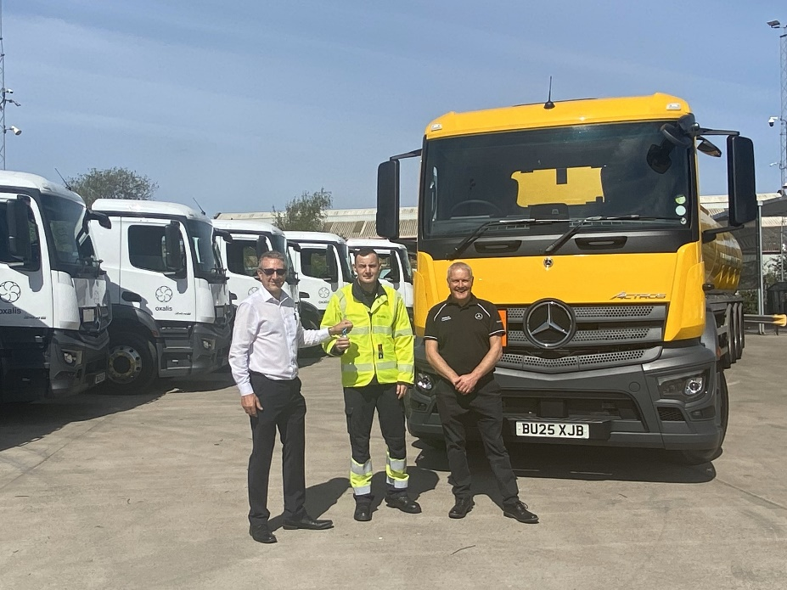
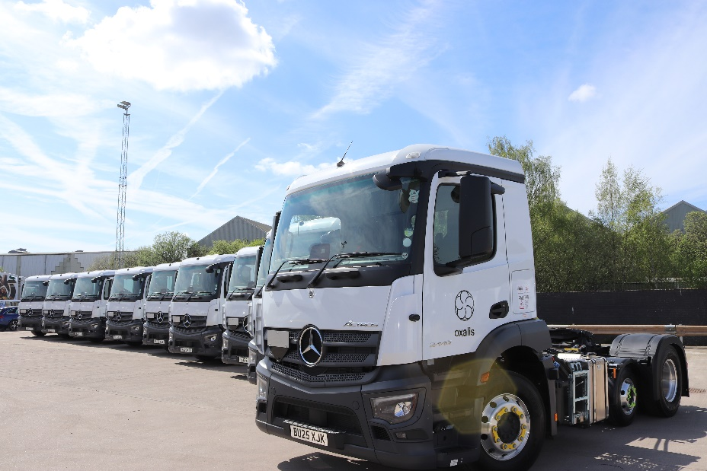

For more information, or to request bigger/higher-res image files, please contact:
John Rawlings: 07847 371486, john.rawlings@loopagency.co.uk



