

Date: 14 May 2021

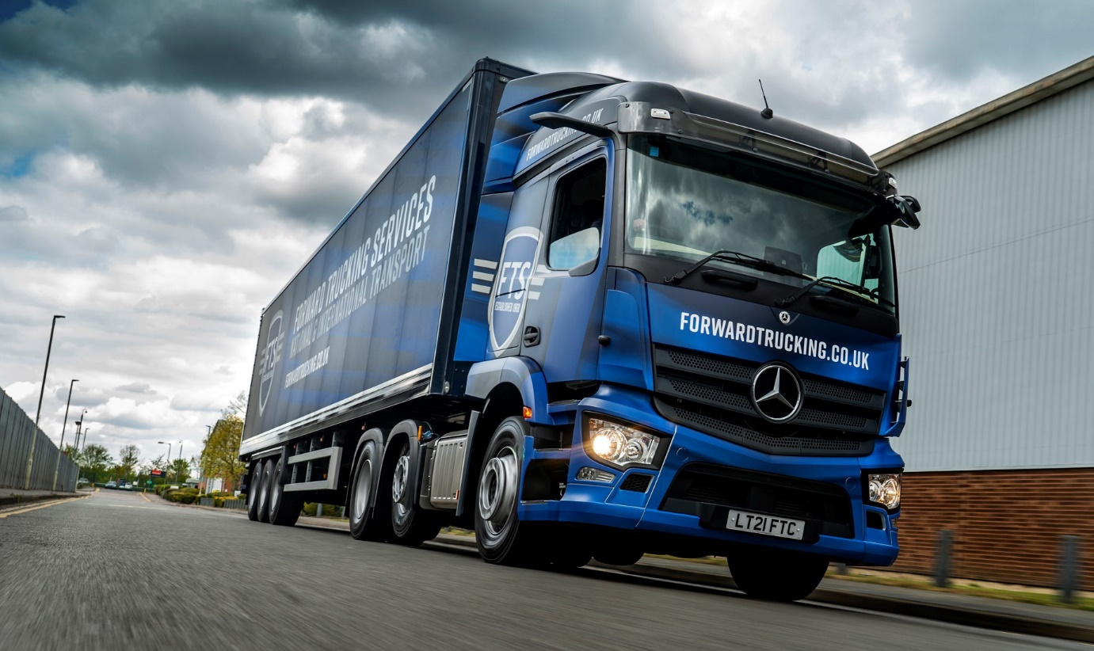

Sight management: Forward Trucking Services’ first MirrorCam-equipped Actros wear a smart new livery and provide drivers with impressive direct visibility

FTS Group capitalises on Mercedes-Benz Trucks’ safety leadership with 21 four DVS star-rated Actros from S & B Commercials

Safety and compliance are top priorities for Forward Trucking Services, so given that its trucks work regularly in and around London the Hertfordshire-based operator chose a new fleet of Mercedes-Benz tractor units that achieve four Direct Vision Standard stars “straight out of the box”.

Economy is crucial, too. Not only was an Actros demonstrator supplied by Dealer S & B Commercials significantly more fuel-efficient than vehicles already in service, but over the two-month trial period it also consumed little more than half as much AdBlue – indeed, the operator has estimated that in the next five years the 21 new trucks will save it £100,000 in costs for the emissions-cleaning additive alone.

Forward Trucking Services is standing down its established trucks, which are by another manufacturer, to make way for its latest Actros. All are 2546 variants with 10.7-litre in-line six-cylinder engines that produce 340 kW (460 hp).

Their 2.3m StreamSpace cabs – the narrower of the two widths available – have 320mm engine tunnels with correspondingly low floor heights. This specification, together with the standard-fit MirrorCam technology that replaces conventional mirrors, gives the tractor units their exceptionally high four-star rating.

In Direct Vision terms, the benefits of MirrorCam have nothing to do with how much more drivers can see behind, and everything to do with what they cannot see in front – huge mirrors that create blind spots which get bigger as distance from the truck increases.

Transport for London’s new standard, which came into force in March, means trucks over 12 tonnes GVW now require a Direct Vision safety permit to enter or work in Greater London. The zero- to five-star rating system measures how much an HGV driver can see directly through their cab windows. This indicates the level of risk to cyclists and pedestrians in particular.

Importantly, ratings reflect how vehicles left the production line – with the sole exception of additional door windows, they take no account of aftermarket safety systems. Depending on the star rating, permits are valid for up to 10 years.

Only vehicles with at least one star are now allowed to operate in the capital without additional safety equipment – for those with zero stars, operators must prove they have fitted the cameras and sensors needed to achieve compliance and secure their permit. By 2024, meanwhile, trucks will require a three-star rating to be granted a safety permit; again, those whose vehicles do not meet this standard will have to take extra steps to work in London.

With its latest order for Mercedes-Benz trucks, Forward Trucking Services has ‘future-proofed’ its business and underlined its commitment to the protection of vulnerable road users, as well as its own drivers – new Actros boasts a market-leading safety armoury that also includes the Active Brake Assist 5 emergency braking system with enhanced pedestrian recognition.

Part of the FTS Group, a third-generation family business which operates from headquarters in St Albans, Forward Trucking Services offers a comprehensive portfolio of same- and next-day transport solutions that includes ‘one-off’ loads, as well as scheduled transport and contract logistics.

The FTS Group can trace its roots back to 1968, when George Mackay Senior established Forward Traffic Services in 1968 in Islington, north London, to deliver steel and concrete paving throughout the capital. His son George Junior took the helm in the early 1980s and led the business over the next three decades through a period of sustained growth.

Following the death of their father in 2018, ownership passed into the hands of Stephen and Jane Mackay. Today, under the day-to-day direction of Managing Director Pete Samuel and Operations Director Andrew Bull, it continues to go from strength-to-strength.

In addition to Forward Trucking Services, the FTS group includes FTS Logistics, which focuses on dedicated palletised freight distribution, and FTS Events, which provides specialised support throughout Europe for the exhibition, entertainment and conference sectors. Completing the portfolio is Stand & Deliver Transport, the Watford-based operator it acquired in 2018, which is currently relocating to a new site with an additional 40,000 sq ft of warehousing, next door to the St Albans HQ.

Forward Trucking Services’ latest Actros are the subject of a Mercedes-Benz Finance contract hire agreement under which each will cover 130,000 km per year. Smartly finished with colour-coded bumpers and the operator’s newly redesigned livery, as applied by Wrap Cube, of Tolworth, Surrey, they are being supplied, like its previous Mercedes-Benz trucks, by S & B Commercials Sales Executive Steve Jenkins.

Having previously bought low-mileage, highly specified Approved Used vehicles for their outstanding value, the operator acquired its first new Mercedes-Benz tractors three years ago. Both are 2548 Big Space models in a special gold colour scheme, commissioned to mark the company’s 50th anniversary.

The FTS Group now runs 115 trucks, 70% of them tractor units, across its various operations. The overwhelming majority of these vehicles wear three-pointed stars. Pete Samuel explained: “We’ve moved progressively towards Mercedes-Benz over the years, because the trucks have always proved reliable and cost-effective to run, and because Steve and his colleagues at S & B look after us very well.”

He recalled: “We set out last summer to investigate replacements for a batch of five-year-old vehicles we’d been running, and invited Dealers representing all of the major truck brands to submit demonstrators for evaluation.

“Cost was a factor, but our matrix also included criteria such as reliability, fuel-efficiency, driver feedback and, of course, safety. We’re based on the edge of the M25 and a lot of our work takes us into London, so the fact that the Actros came straight out of the box with a four-star DVS rating weighed massively in its favour. None of the other manufacturers could match it, and some put forward products with only one or two stars.

“The Mercedes-Benz was also up there with the best on economy. These vehicles spend most of their time carrying parcels, so gross combination weights rarely exceed 30 tonnes. The Actros returned 13 mpg and above, whereas the vehicles that had been doing the same work were in the high 10s and low 11s. What’s more, I reckon we’ll save around £100,000 over the next five years simply because the Actros consumes half as much AdBlue.”

The new trucks are Forward Trucking Services’ first with Mercedes-Benz Trucks camera-based alternative to mirrors. “There was a bit of nervousness initially, particularly from some of the older drivers,” reported Mr Samuel. “We shared the demonstrator around, though, and once they’d got the gist of MirrorCam, and realised how much better the visibility is, they all came to like it.”

Most of the new trucks are now being inspected and maintained at S & B Commercials’ Welham Green workshop and Hatfield Vehicle Maintenance Unit. Others are outbased at various locations and serviced by the most conveniently located Mercedes-Benz Dealers. “It’s all been organised and will be managed by S & B, which makes things very simple for us,” added Mr Samuel.

www.forwardtrucking.co.uk

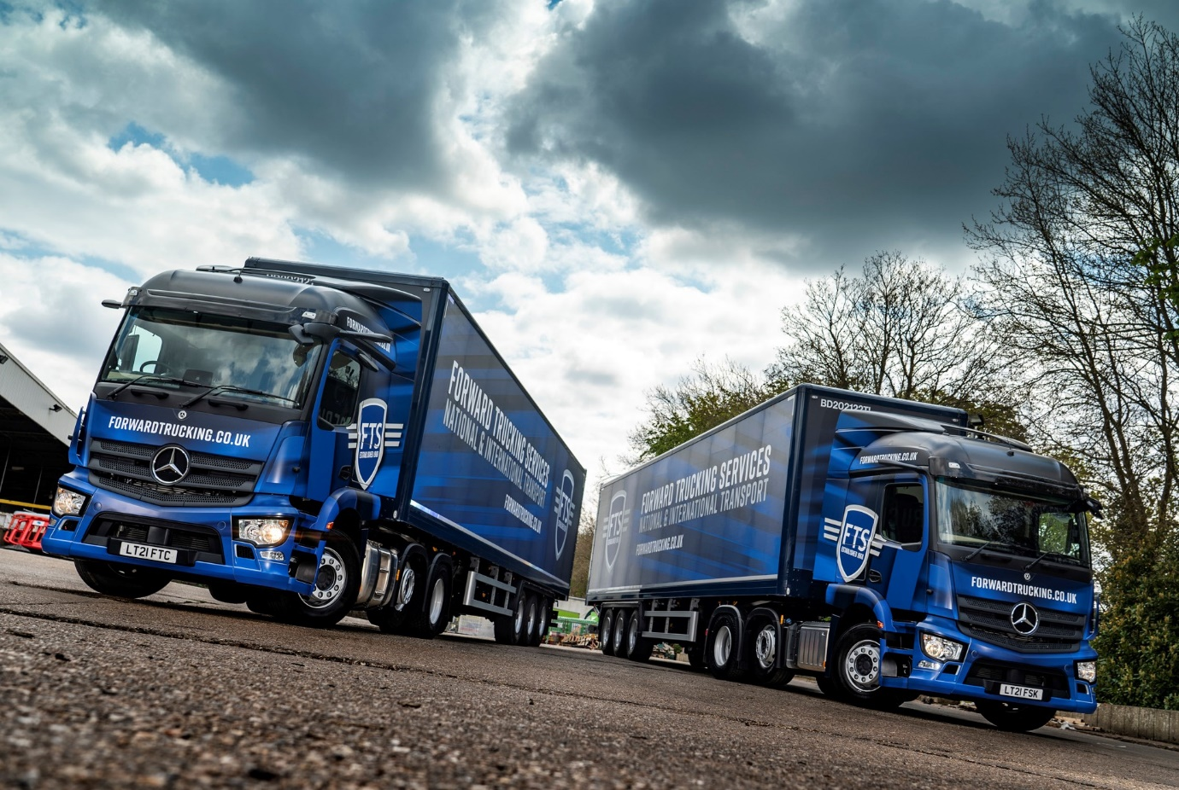

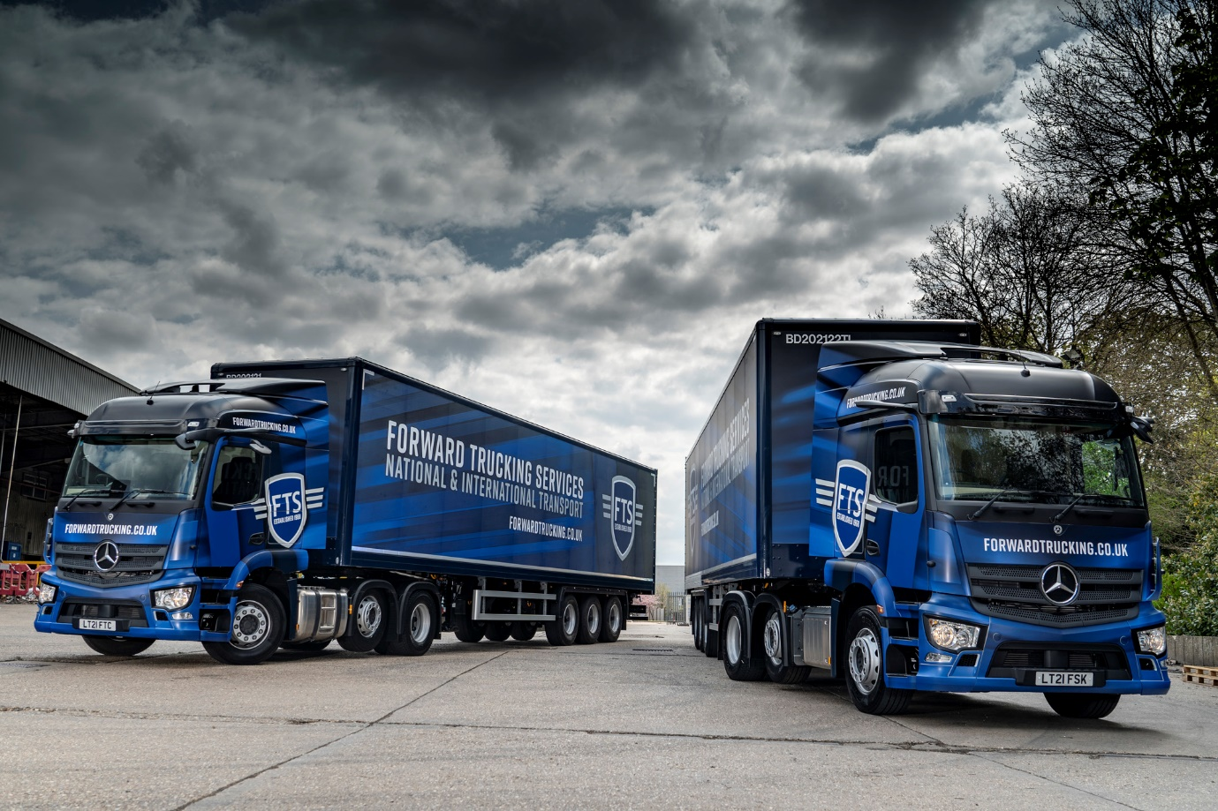

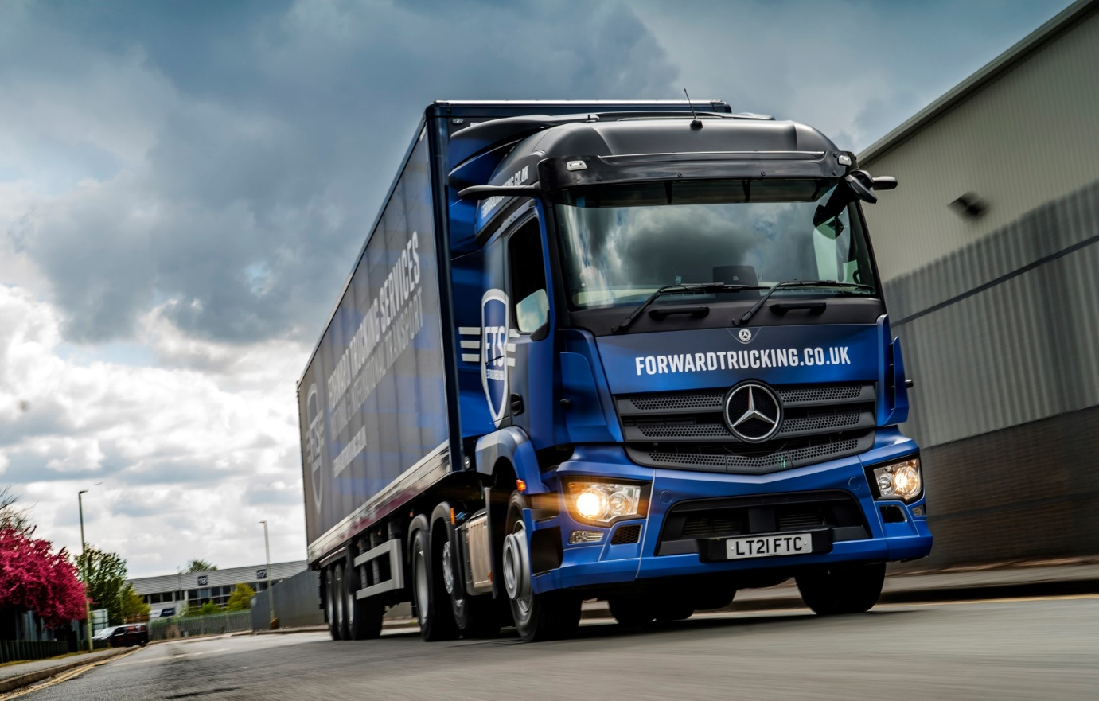

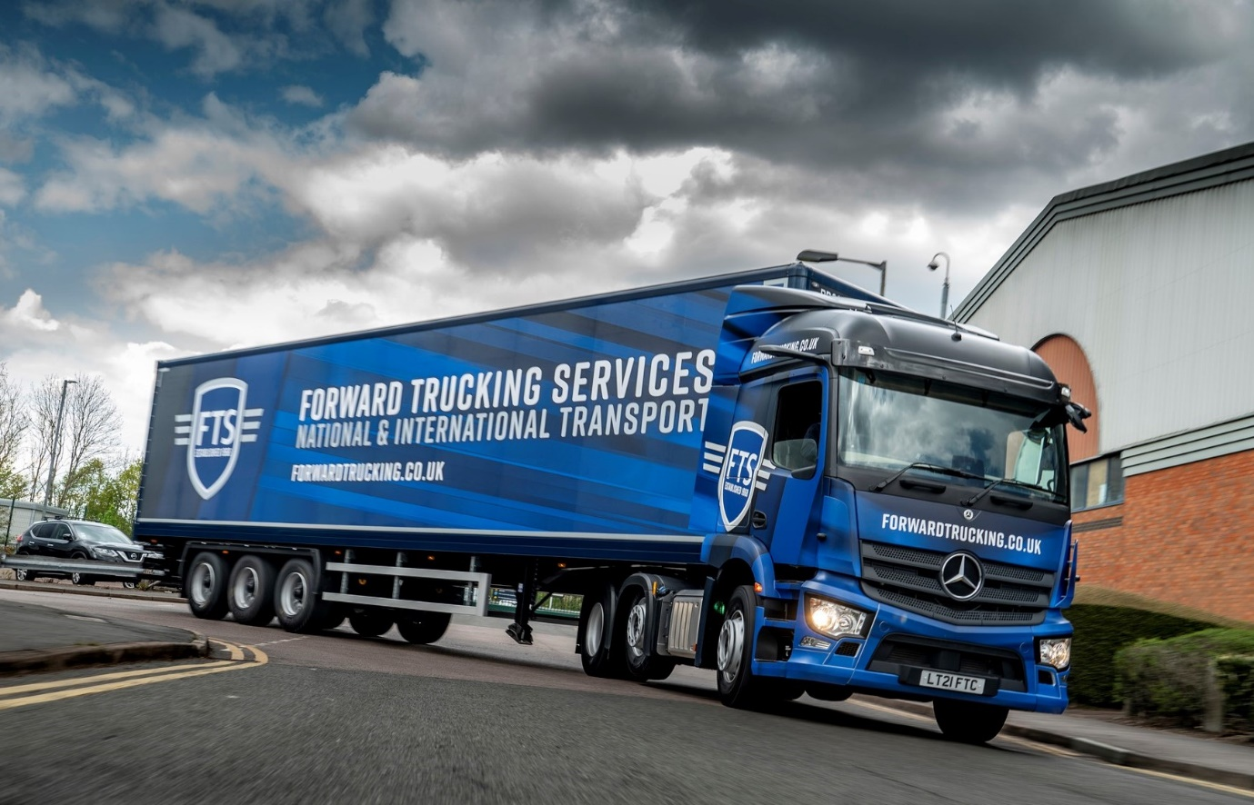

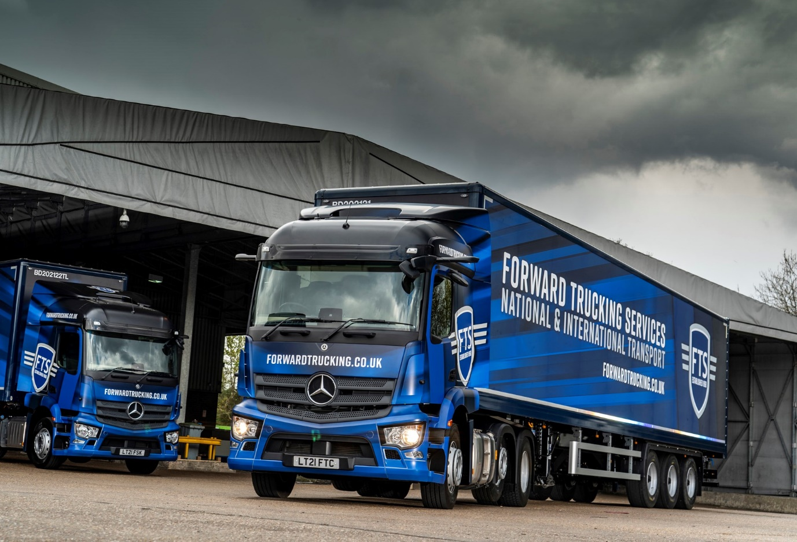
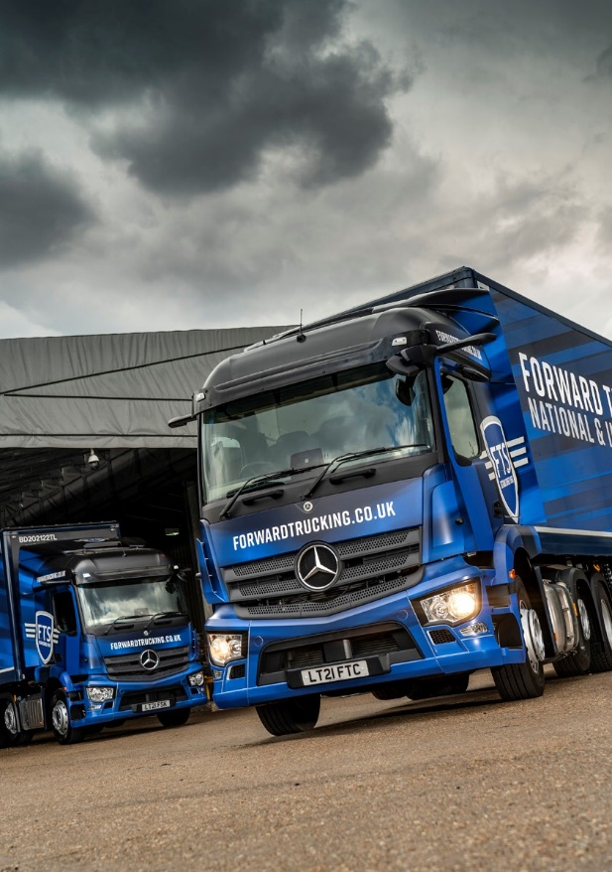

ends

For more information, or to request bigger/higher-res image files, please contact:
Steve Warren or John Ripley
Impact Communications, 01926 842126
Steve: 07770 470251, steve@impactcom.co.uk
John: 07771 484595, john@impactcom.co.uk

