

Date: 19 June 2020

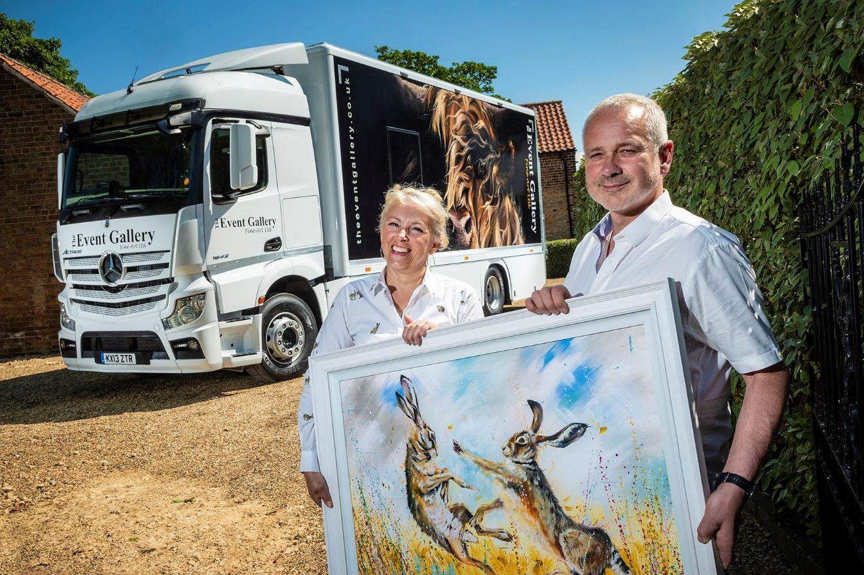

Picture perfect: The Event Gallery’s David Ball and Kay Johns, one of the country’s foremost wildlife and livestock artists who is particularly well known for her depictions of hares, as well as horses and dogs

The Event Gallery’s Mercedes-Benz Actros is an Approved Used work of art

All dressed up but nowhere to go – well, not for the time being at least. That how things stand for the beautifully finished, pre-owned Mercedes-Benz Actros delivered to The Event Gallery Fine Art shortly before the imposition of Covid-19 lockdown restrictions.

Based in the picturesque Lincolnshire village of Threekingham, the company is one of countless nationwide to which the pandemic poses a serious threat. It planned to attend some 30 shows, fairs and festivals throughout the country this year, to retail its framed original and limited-edition prints. As with so many other outdoor events, though, this programme has been decimated by the coronavirus.

With their eye-catching Mercedes-Benz now ‘furloughed’ on the drive, directors David Ball and his ‘artist in residence’ partner Kay Johns are nevertheless determined to make the best of a bad situation, and to keep smiling while waiting for better times to return. For now, their focus is on generating online sales via their website, where enchanting paintings of wildlife and livestock – many of them by Kay – are showcased.

At first glance The Event Gallery’s 18-tonner appears to be brand new. Look closer, though, and the 13-registration plate tells a different story. In fact, the Actros 1842 with StreamSpace cab and 310 kW/421 hp) Euro V engine has a little over 440,000 km under its belt, having spent its ‘first life’ working with a demountable body and drawbar trailer in the colours of a leading fitted kitchen, bedroom and bathroom manufacturer.

The truck was one of approximately 30 returned by that company last year, on completion of their contracts. They were then offered for sale by the Mercedes-Benz Trucks’ Wentworth Park Approved Used Trucks centre in Barnsley.

On seeing them advertised, David Ball arranged a visit, took a test drive, and agreed a purchase price with Used Truck Sales Executive Steve Holbrook. An Approved Used Mercedes-Benz is the next best thing to a new one, as all undergo multipoint inspections and are presented to an exceptionally high standard. To qualify for this ‘stamp of quality’ vehicles must be less than seven-years old and have covered fewer than 700,000 km. They also come with a minimum of six months’ MoT and mechanical breakdown insurance cover.

Having had its demountable box body equipment and tail-lift removed at Wentworth Park, and been mechanically prepared by factory-trained Mercedes-Benz technicians, the truck was sent to Sheffield-based A&R Motor Services, where it was shot-blasted and refurbished, and the chassis was extended by 200 mm, prior to painting.

The Actros then went to Lawrence David, in Peterborough, which fitted a bonded GRP Boxta Rigid body that has no mechanical fixings to spoil its clean, smooth lines or undermine aerodynamic efficiency. The bodybuilder also installed a roller shutter door and Dhollandia tail-lift, while the underskirting with integral lockers is the work of Advance Body Repairs, of Corby.

David Ball served in the Royal Air Force prior to 2004, when he took on the business established as a partnership by his parents many years earlier. A limited company since 2011, The Event Gallery also owns a Mercedes-Benz Sprinter, and a 13-tonne Atego.

“That was our first truck,” recalled Mr Ball. “It was pre-owned when we bought it in 2013 and has never let us down. However, as the business has grown we found that we needed a bigger vehicle, and given our previous experience we had no reservations about buying another Mercedes-Benz chassis with a few miles on the clock. In normal times we’d probably only do 10,000 miles a year, but we invest a lot of money in attending events, so when we turn the key we need our truck to go.”

The Actros effectively serves as a mobile stock room, and is racked out to transport the hundreds of pieces of art in different sizes and formats that The Event Gallery offers for sale. It also carries marquees and the associated equipment which the company team set up on sites.

With a body which is both longer and higher than that of its predecessor, the Actros has a 5.8m wheelbase, compared to the Atego’s 4.75m. “It’s a bigger truck all round, of course, but as a ‘wagon and drag’ it has a relatively short wheelbase,” explained Mr Ball. “This means I can turn it – but only just – within the space available at our premises, whereas most standard 18-tonners doing this kind of work would have a wheelbase of six metres or more, so wouldn’t get round.”

He continued: “Steve Holbrook was fantastic throughout. The Actros was very attractively priced and his advice and support was invaluable when it came to specifying and modifying the vehicle. He made lots of suggestions but at no stage did I feel under any pressure.”

And he added: “It’s hugely frustrating, of course, that having put so much time and effort into this project we’ve yet to use our Actros for the purpose it was intended. With almost every large event now cancelled, we’ve had to come to terms with the fact that the cornonavirus has wiped out the earnings we were anticipating this year.

“Our sights are therefore firmly set on the spring of 2021, when we look forward to getting back on the road in our stunning ‘new’ Mercedes-Benz Actros.”

www.theeventgallery.co.uk

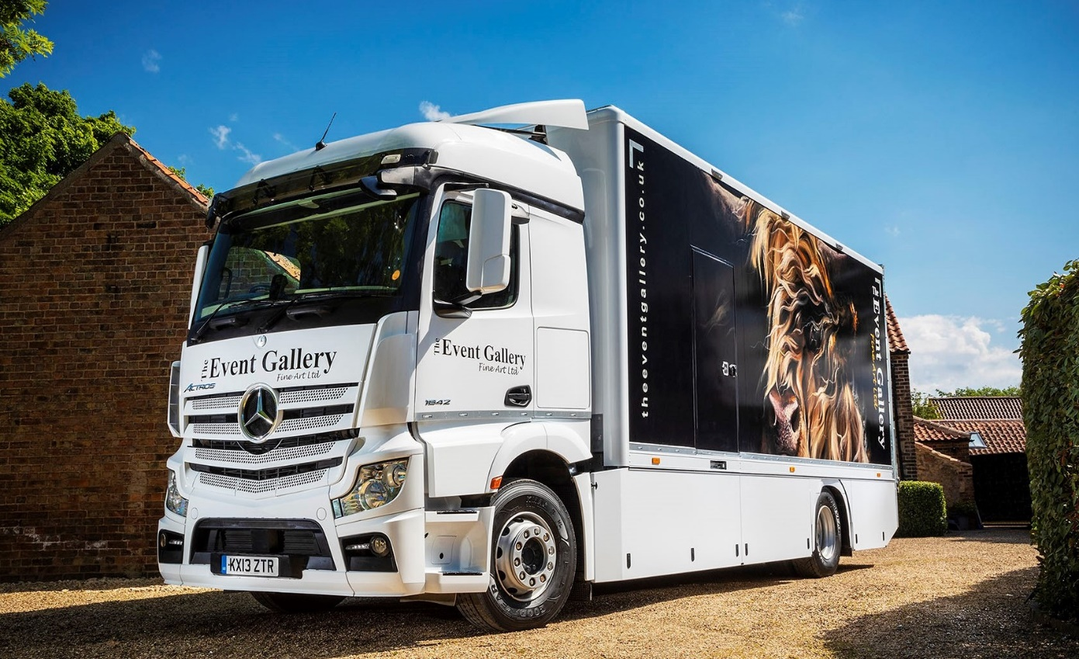
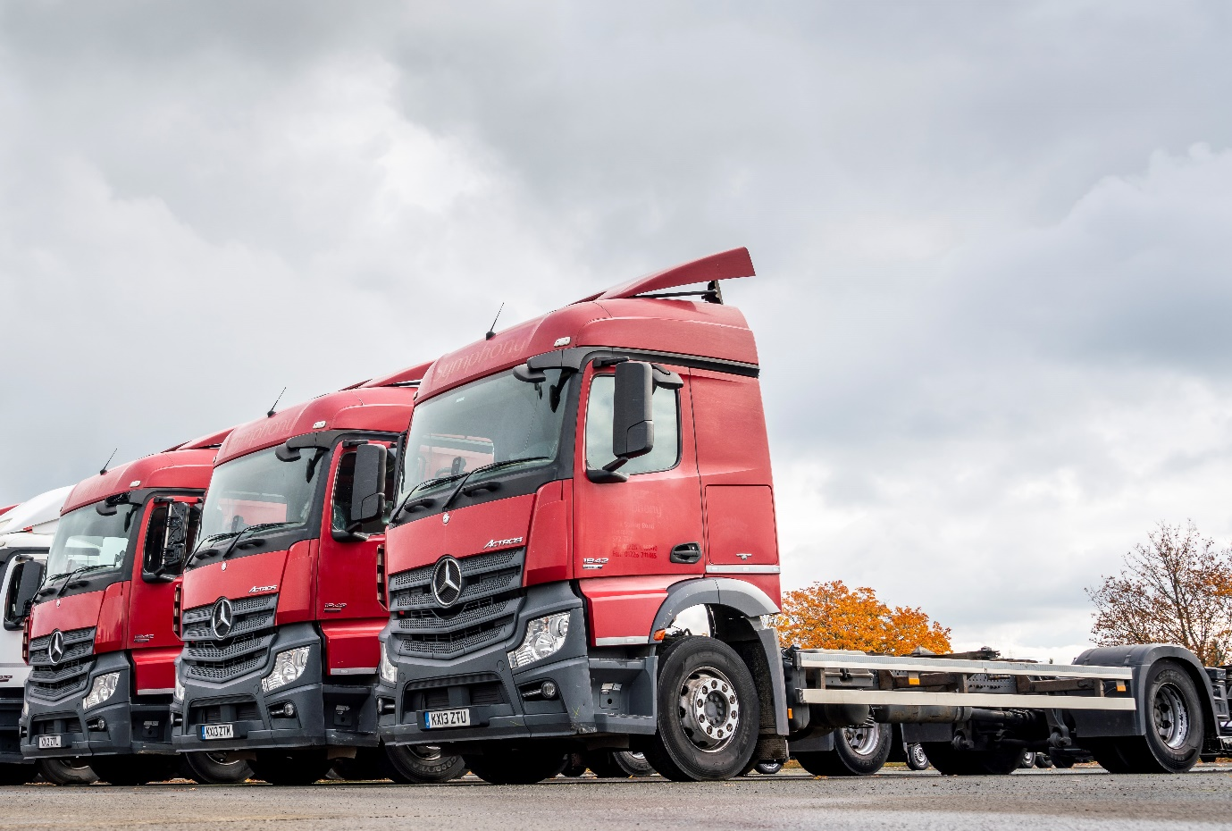

Before: The Event Gallery’s Approved Used Mercedes-Benz Actros drawbar chassis was from the same batch as these, and had covered the best part of half a million km

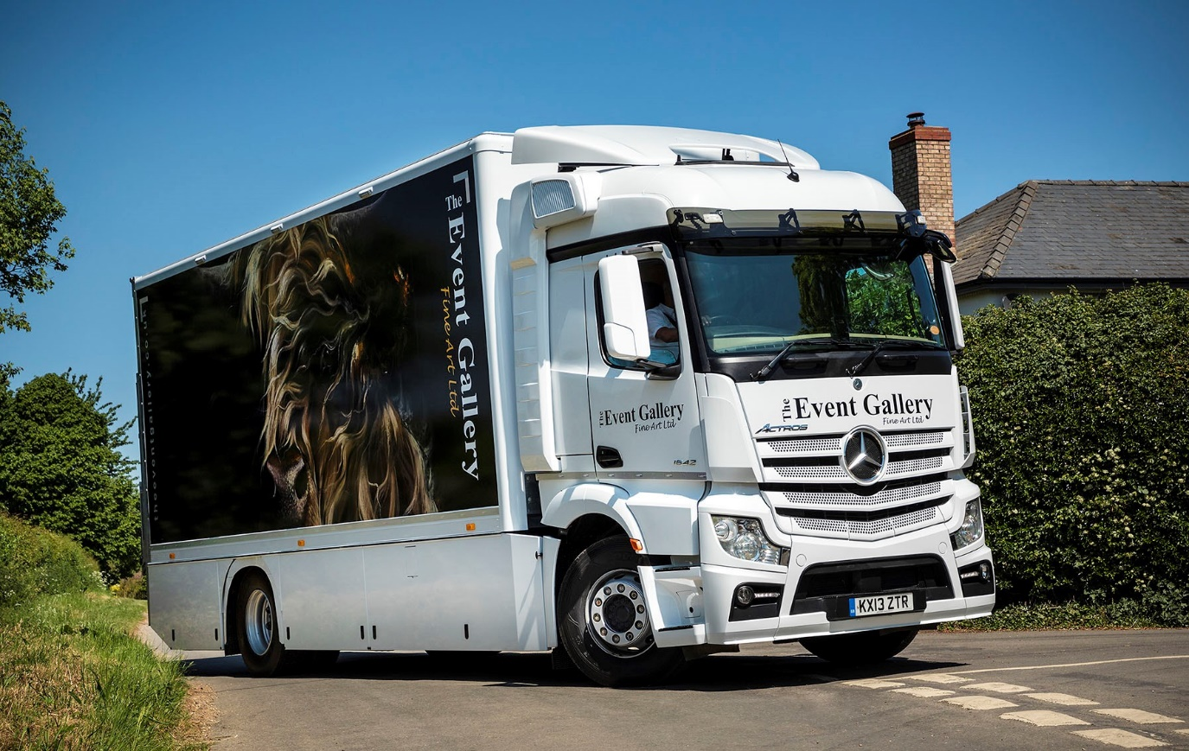

And after: At first glance it’s a brand new truck, and a very smart one at that
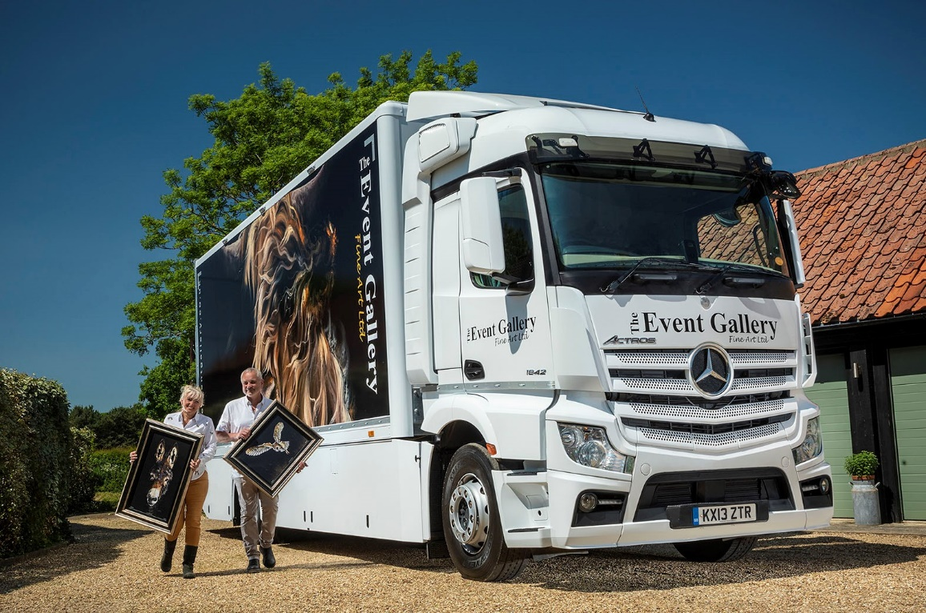

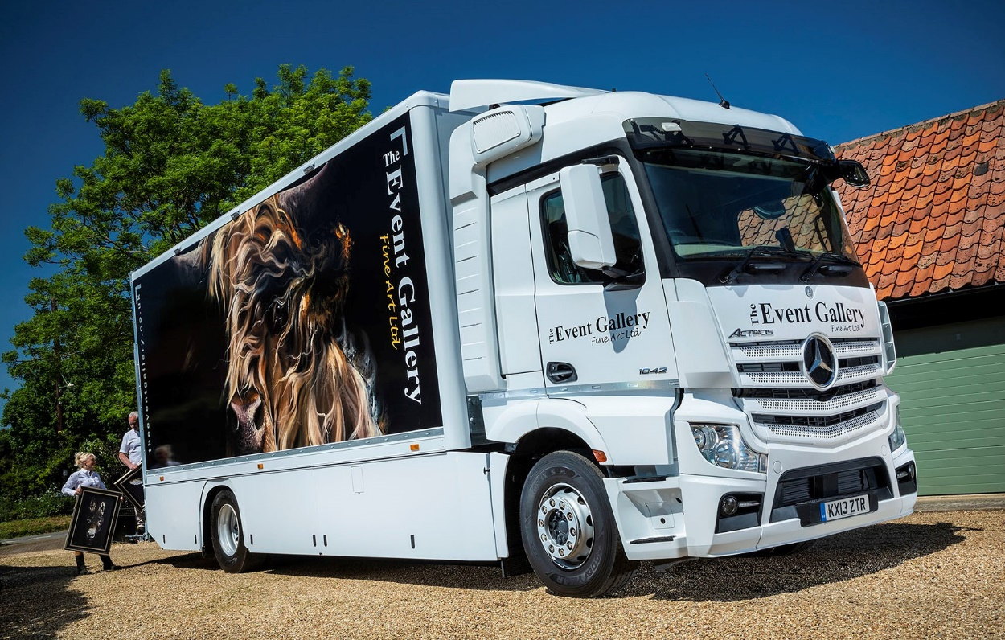

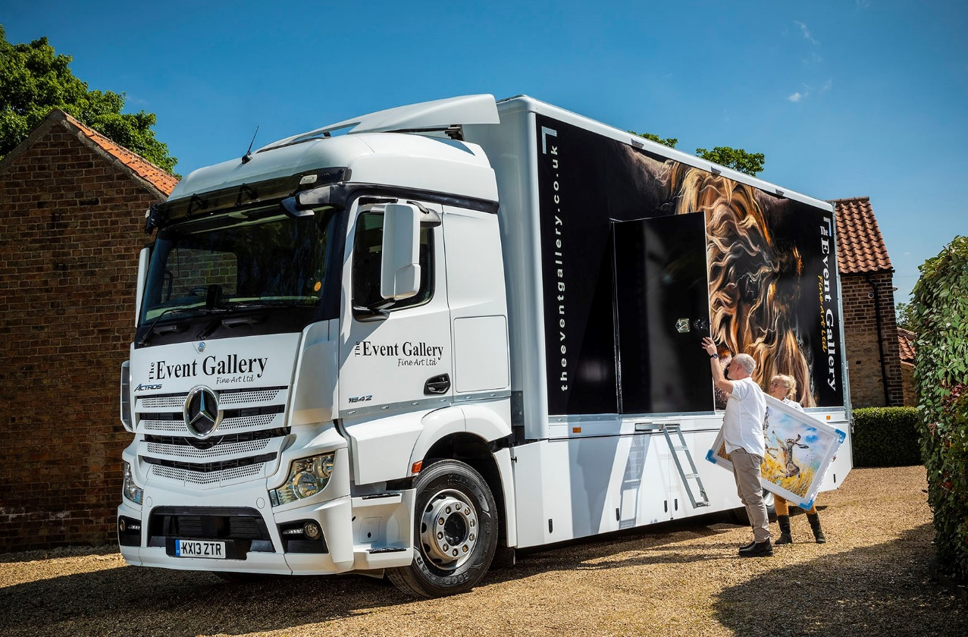

ends

For more information, or to request higher-res image files, please contact:

Jamie Fretwell at Mercedes-Benz Trucks UK Ltd
07712 519230, jamie.fretwell@daimler.com

or

Steve Warren or John Ripley
Impact Communications, 01926 842126
Steve: 07770 470251, steve@impactcom.co.uk
John: 07771 484595, john@impactcom.co.uk

About Mercedes-Benz Trucks UK Ltd
Mercedes-Benz Trucks UK Ltd is the sales and marketing organisation responsible for all Daimler truck products in the UK, including FUSO Canter. In 2019, the company registered 6,963 new trucks.

Mercedes-Benz accounted for 6,188 new trucks registered in 2019, making it the third-biggest truck brand in the UK. Meanwhile, FUSO registrations hit 775 – including 580 new trucks over 6.0-tonnes.

The flagship new Mercedes-Benz Actros which won the 2020 International Truck of the Year award, features seven core innovations including MirrorCam, Multimedia Cockpit and Active Brake Assist 5.

Our premium range of innovative trucks – Actros, Arocs, Atego, Econic and Unimog – draw upon more than 125 years of exceptionally high standards of quality, backed up by our promise of Trucks You Can Trust.

www.mbtrucks.co.uk

