

Date: 23 June 2022

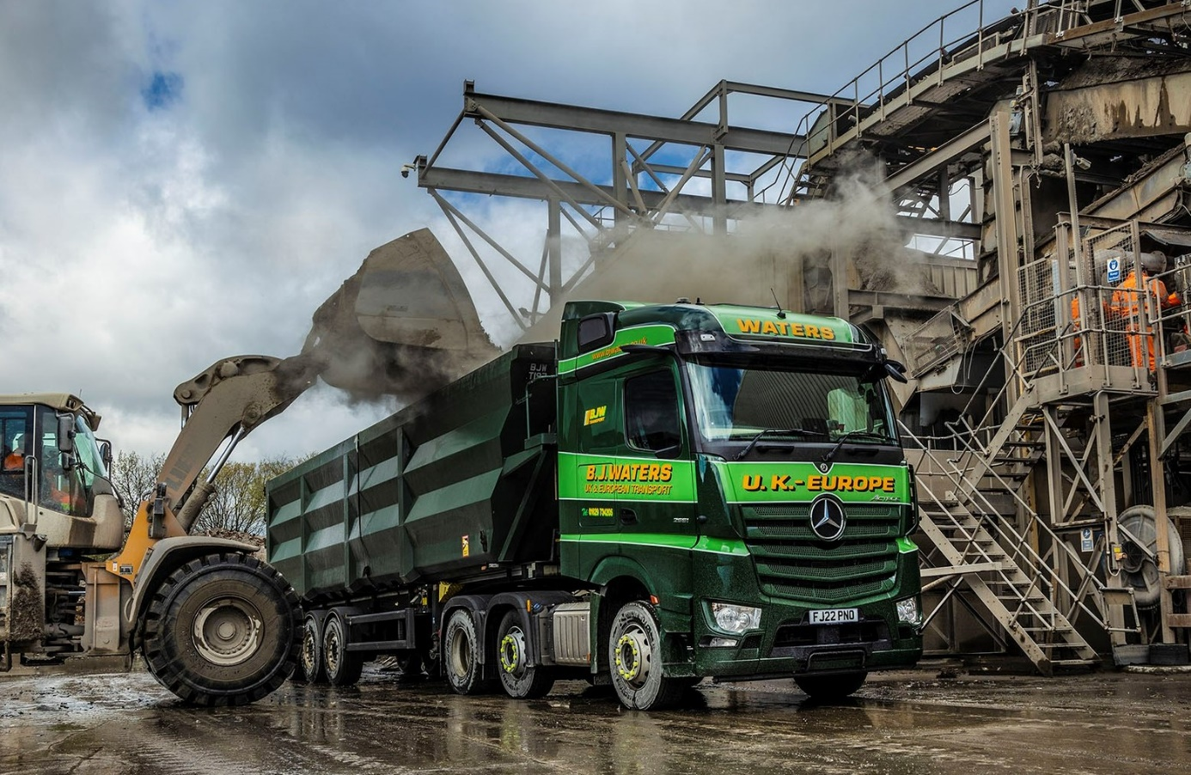

BJ Waters commissions a pair of ‘fit for purpose’ Mercedes-Benz Actros from Mertrux Truck & Van

Bulk tipping and hazardous load specialist BJ Waters is running two new Mercedes-Benz Actros tractor units with resilient steel bumpers and raised ride heights designed to restrict damage when working on rough sites.

The operator is based in Matlock, Derbyshire, and purchased the latest additions to its fleet from East Midlands Dealer Mertrux Truck & Van. BJ Waters has favoured Mercedes-Benz trucks in the past but these are its first since 2015.

Key to the fourth-generation family firm’s decision to renew its association with the three-pointed star was the fuel-efficient performance of a pair of Dealer demonstration units, which also attracted very positive driver feedback.

BJ Waters new trucks are both Actros 2551 variants with flat-floored, aerodynamic StreamSpace cabs – at 2.5m they are in the wider of the two widths available – and 12.8-litre, in-line six-cylinder engines that produce 375kW (510 hp).

By choosing the steel bumper instead of the standard plastic item, and the same straight front axle and headlight arrangement as a flat-floored unit from the Arocs construction range, the operator has endeavoured to restrict repair costs. This option offers up to 85mm (depending on tyre choice) of additional ground clearance, so carries a lower risk of underbody damage caused by ‘bottoming out’ or getting stuck during off-road manoeuvres.

The new trucks came with a full complement of advanced Mercedes-Benz Trucks technology, including MirrorCam, the manufacturer’s acclaimed replacement for conventional mirrors, the latest version of the fuel-saving Predictive Powertrain Control system, and Active Brake Assist 5 with enhanced pedestrian recognition capability.

However, rather than the standard-fit Multimedia Cockpit, which employs intuitively-operated twin screens instead of traditional switchgear, BJ Waters opted for the interactive upgrade – in addition to a larger, 12in instrument panel, this comes with extra functionality, including satellite navigation.

Its new trucks are also equipped with telematics hardware by FleetBoard, which, like Mercedes-Benz Trucks, is a member of the Daimler Truck family. Fleetboard records and processes data from the vehicle, then rates the driver’s style at the wheel. Criteria monitored include speed, braking, stops and idle times with the engine running, and use of the Mercedes PowerShift transmission’s Eco-Roll function.

Operators can use this information to incentivise their drivers and initiate targeted training where shortcomings in behaviour at the wheel are identified. Improvements in driving style lead inexorably to increased fuel-efficiency.

Established in 1927, BJ Waters was originally a general haulier but has evolved over the years and is now heavily focused on transporting a broad range of bulk commodities, including non-ferrous and scrap metals, aggregates, coal, coke and solid fuels, plastics, marble, glass and batteries, as well as hazardous goods, throughout the UK and Europe.

The new Actros work primarily with bulk trailers, for which both were fitted with hydraulic tipping kits by Commercial Vehicle Hydraulics, of South Normanton.

BJ Waters and its sister company Geo Siddall (Transport), which was acquired during the 1960s, run a combined fleet of almost 100 trucks, the overwhelming majority of them 6x2 tractor units, which is currently dominated by two other brands. All of these vehicles wear variations of the operator’s distinctive, two-tone green livery.

Former BJ Waters Managing Director Martin Waters passed away after a short illness last year. Responsibility for the management of the business now rests with his children James and Clare, and their cousins John and Richard, all of whom are Directors.

James Waters explained: “We tried a couple of Actros demonstrators from Mertrux. They did very well on fuel, which didn’t surprise me because our previous Mercedes-Benz trucks were certainly economical.

“Just as importantly given the current climate, though, the drivers were very positive and have really embraced their new Actros. Mercedes-Benz has always been ahead of the game when it comes to innovation, particularly in relation to safety.

“Visibility from the Actros cab is better than you get with other trucks, but we’ve specified the steel bumper and straight axle as an additional precaution against accident damage when working off-road.”

Andy Garton has been driving since 2007, and worked for Eddie Stobart and Wincanton before joining BJ Waters in 2019. “I’ve been an Actros fan for years and had a new one on a 55-plate that I loved,” he recalled. “I’ve driven other trucks, including ones by both Swedish brands, but only in a Mercedes-Benz have I ever been able to get truly comfortable.”

Andy enthused: “I was already familiar with MirrorCam, which is a fantastic system. It allows you to reverse around a corner without ever losing sight of the back of the trailer, while the fact that you don’t have those great slabs of mirror sticking out of both sides means there are no blind spots. I really like that – it’s a massive advantage at roundabouts, and when you’re turning.

“This truck is a joy in so many ways. The dashboard is brilliant, really easy to use, and thanks to Predictive Powertrain Control when I’m on the open road it practically drives itself; you just have to find the setting that suits your driving style.”

The father-of-five typically alternates between spending an entire week away in his truck, and then four nights the following week. He continued: “The cab is beautifully put together and the bed really comfy, so I always sleep well.

“To cap it all, the Actros looks absolutely amazing. When James asked me if I’d like another Mercedes-Benz I told him I’d sell a child for one. I was joking… I think!”

BJ Waters’ new units are now being inspected and serviced under Mercedes-Benz Complete Service contracts, at Mertrux Truck & Van’s Derby workshop. “They go in at times that suit us and the Dealer provides a van for the driver to go home in, so from an aftersales perspective it’s all good,” confirmed James Waters.

“Meanwhile, Mertrux Sales Executive Andrew Bonser has worked hard to win our business and been very proactive. He’s certainly made a positive impression.”
www.bjwaters.co.uk

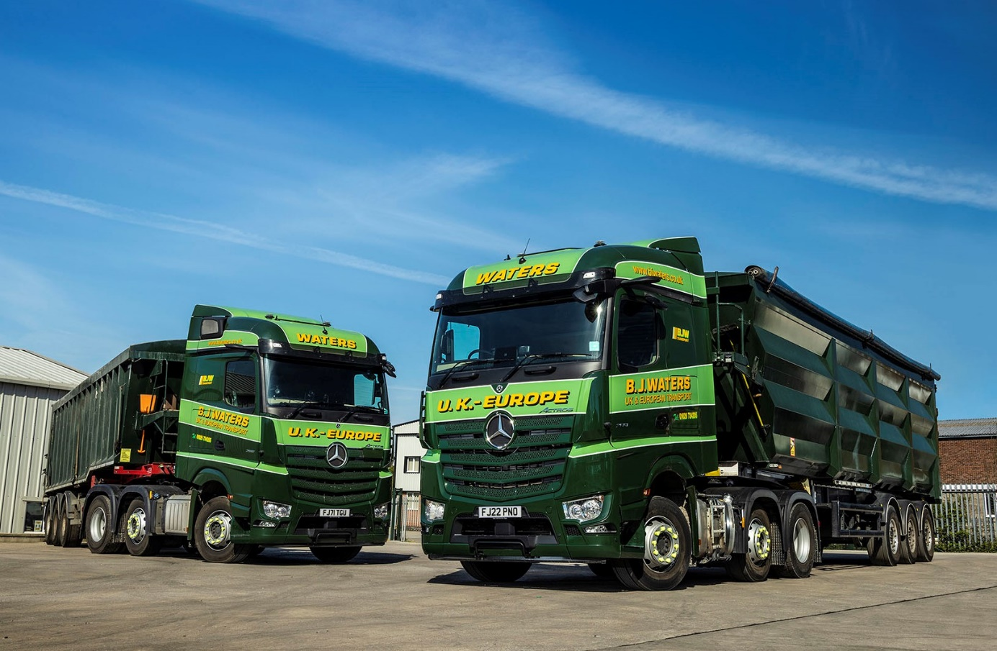

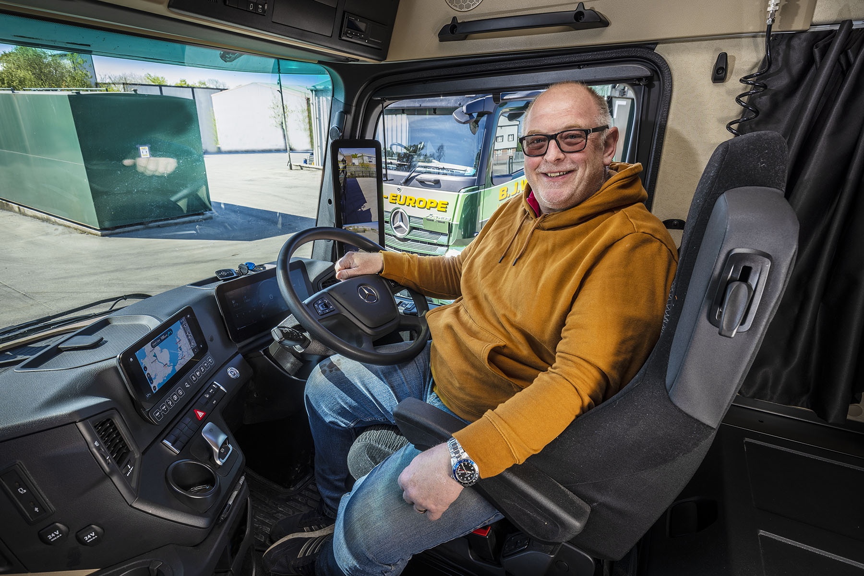

Sweet spot: “This truck is a joy in so many ways,” enthused driver Andy Garton

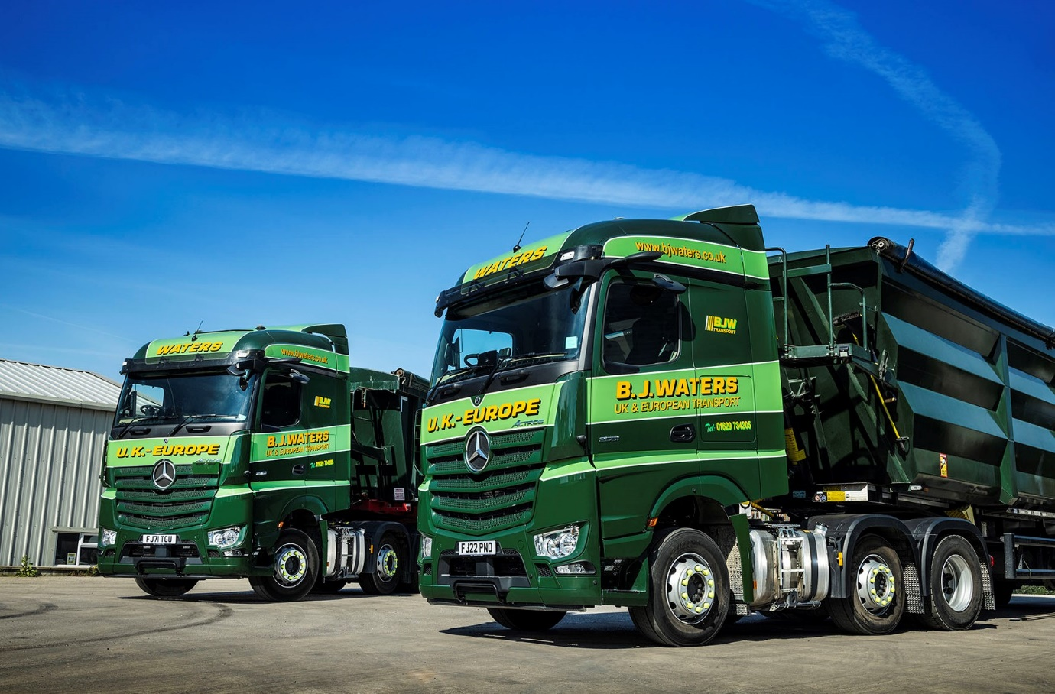

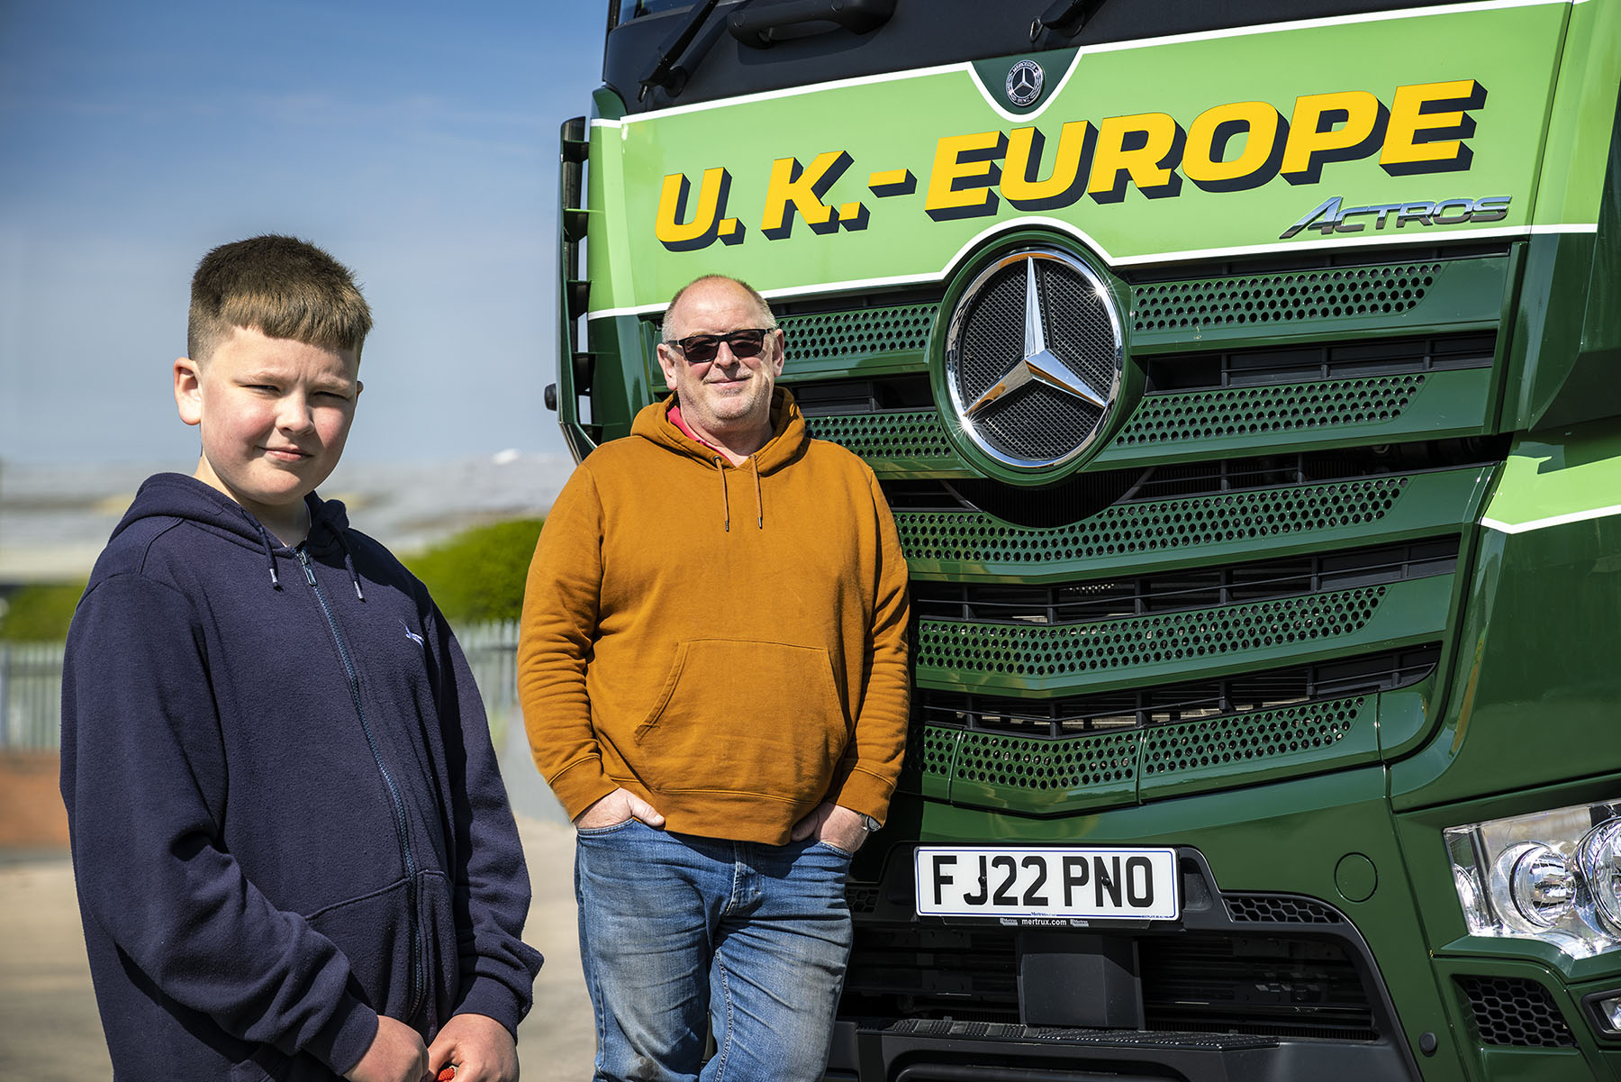

Technology enthusiasts: Andy Garton is pictured with his 11-year-old son Will, who hopes to be a computer programmer and so, unsurprisingly, loves his Dad’s high-tech Actros

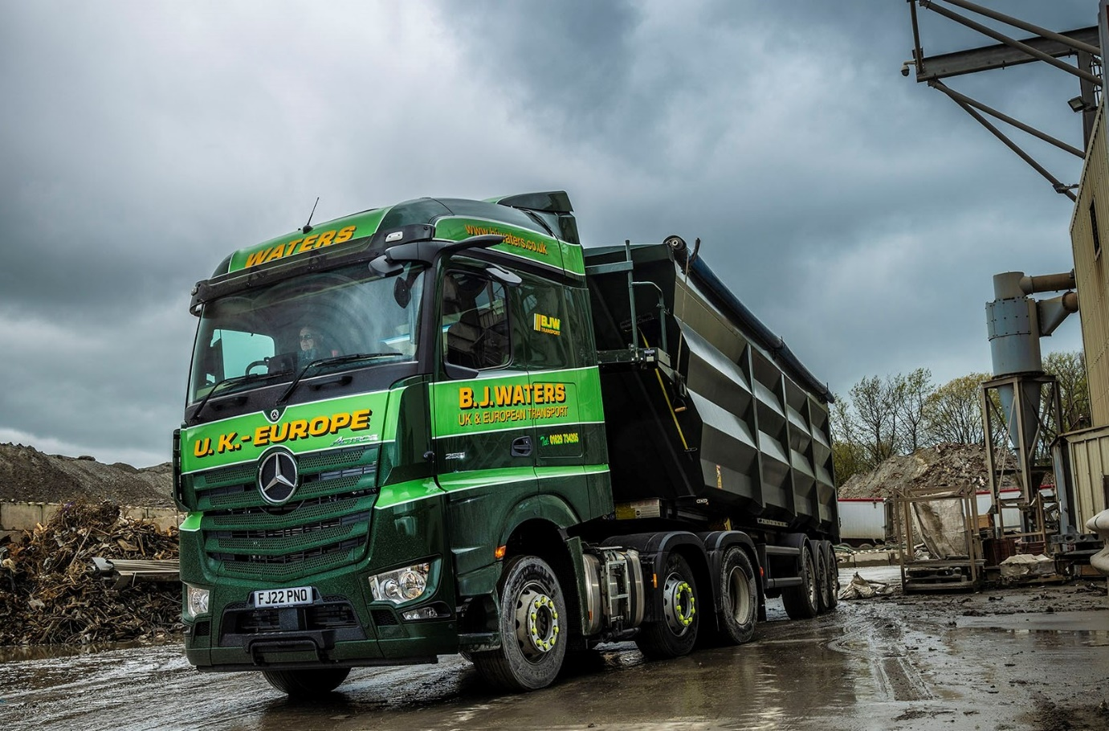

ends

For more information, or to request bigger/higher-res image files, please contact:
Steve Warren or John Ripley
Impact Communications
Steve: 07770 470251, steve@impactcom.co.uk
John: 07771 484595, john@impactcom.co.uk



