

Date: 24 February 2020

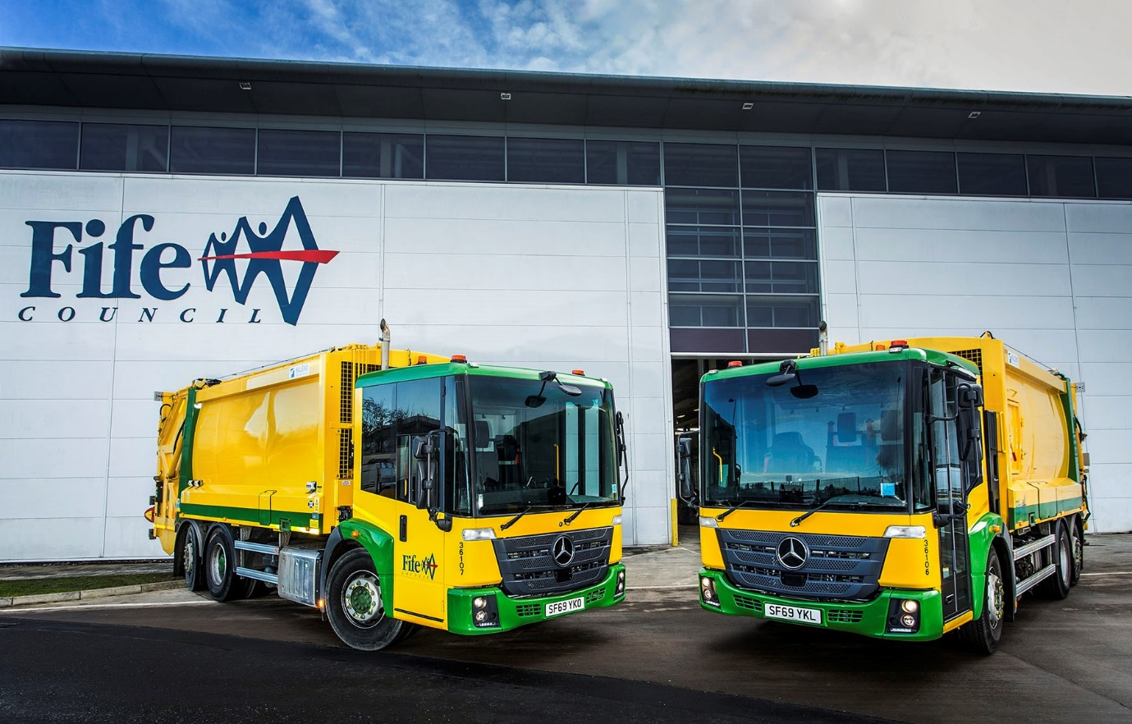

Fife Council gears up for fuel savings with 11 more Mercedes-Benz Econics from Western Commercial

Fife Council’s latest Mercedes-Benz refuse collection vehicles hold out the promise of increased fuel economy, following a trial in which it played a key role.

Supplied by Dealer Western Commercial, the 11 new trucks are all 6x2 Econic 2630L models with 220 kW (299 hp) 7.7-litre ‘straight-six’ engines and rear-steer axles for optimum manoeuvrability. Their compactor bodies are by Farid Hillend Engineering.

With its purpose-designed, extensively glazed cab, exceptional reliability, and highly competitive ‘whole life’ operating costs, the low-entry Mercedes-Benz has been Fife Council’s preferred RCV chassis for more than 15 years.

Like most municipal operators the authority specifies its Econics with the six-speed Allison automatic transmission which is specifically-designed for this type of stop-start application.

Last year Fife Council trialled a retrofit software update from Allison Transmission on two of its older vehicles, which produced mpg gains of more than 8%. Revised ECO programme software is now installed as standard on all Allison-equipped Econics, including the 11 new vehicles – Fife’s trucks are also limited to a top speed of 85 km/h, to improve their fuel efficiency still further.

Fife Council Waste Operations Service Manager Sandy Anderson said: “Fuel returns can vary dramatically depending on the route a truck is following, but that trial was conducted in a controlled manner and demonstrated a clear improvement.

“Increased economy is clearly a very welcome benefit, but the Econic is the best truck on the market for this application in plenty of other respects too. Most of ours are double-shifted for up to seven days a week and they stand up to a long, tough working life extremely well.

“The low floor means the driver and operatives can get in and out of their respective sides of the vehicle very easily, using just one step. Meanwhile the excellent visibility from the driver’s seat enhances safety for other road users as well as our crews, and the fact that the cab is air-conditioned makes a tough job that bit more comfortable and less tiring, particularly during summer.”

The Econic has been awarded a five-star Direct Vision rating by Transport for London. It has a deep, panoramic windscreen, while the full-height, glazed folding side door specified by Fife Council, and low seating position allows the driver to make direct eye contact with vulnerable cyclists and pedestrians at junctions or in traffic queues, a major safety advantage in enabling each to understand the other’s intentions.

Greater Safety is one of the three pillars of Mercedes-Benz Trucks’ all-encompassing RoadEfficiency strategy, and the Econic is equipped as standard with Active Brake Assist 4 emergency braking technology. Programmed to recognise other vehicles at higher speeds, as well as pedestrians when moving more slowly, it is capable of bringing the truck to a complete stop.

Fife Council operates 40 refuse collection trucks, all but three of which wear three-pointed stars. Most of the new Econics replaced older versions which have now been stood down, although in the face of increased volumes it commissioned an extra vehicle on this occasion. Working from main depots in Glenrothes and Dunfermline, six are dedicated to domestic refuse rounds and collect recyclables, co-mingled food and garden items, and residual waste, while the remaining five are on commercial duties.

Fife Council maintains the trucks in its own workshops. Mr Anderson continued: “Our technicians are all fully Mercedes-Benz trained and extremely knowledgeable. Western Commercial keeps us supplied with a comprehensive stock of parts and should we need any technical assistance we know that its expert advice is only a phone call away.

“We’ve also built a strong relationship over the years with the Dealer’s Municipal & Special Products Account Manager Robert Snodgrass. He really understands the way public sector fleets like ours operate, and is extremely knowledgeable about the trucks and their specifications.”

Like all new Econics, the latest additions to the Fife Council fleet are backed by comprehensive three-year/160,000 km manufacturer’s warranties.

Robert Snodgrass also supplied his high-profile customer recently with a pair of 18-tonne gritters based on 4x4 Mercedes-Benz Arocs chassis, with bodies by Econ Engineering. He added: “Fife Council’s fleet is among the most well-managed and maintained in Scotland, which means Sandy and his colleagues won’t accept anything but the best from their suppliers. For refuse collection applications the best, in the form of the Mercedes-Benz Econic, is exactly what Western Commercial offers.”

www.fife.gov.uk



Starring role: Fife Council’s Sandy Anderson knows he can rely on his Mercedes-Benz Econic refuse collection trucks

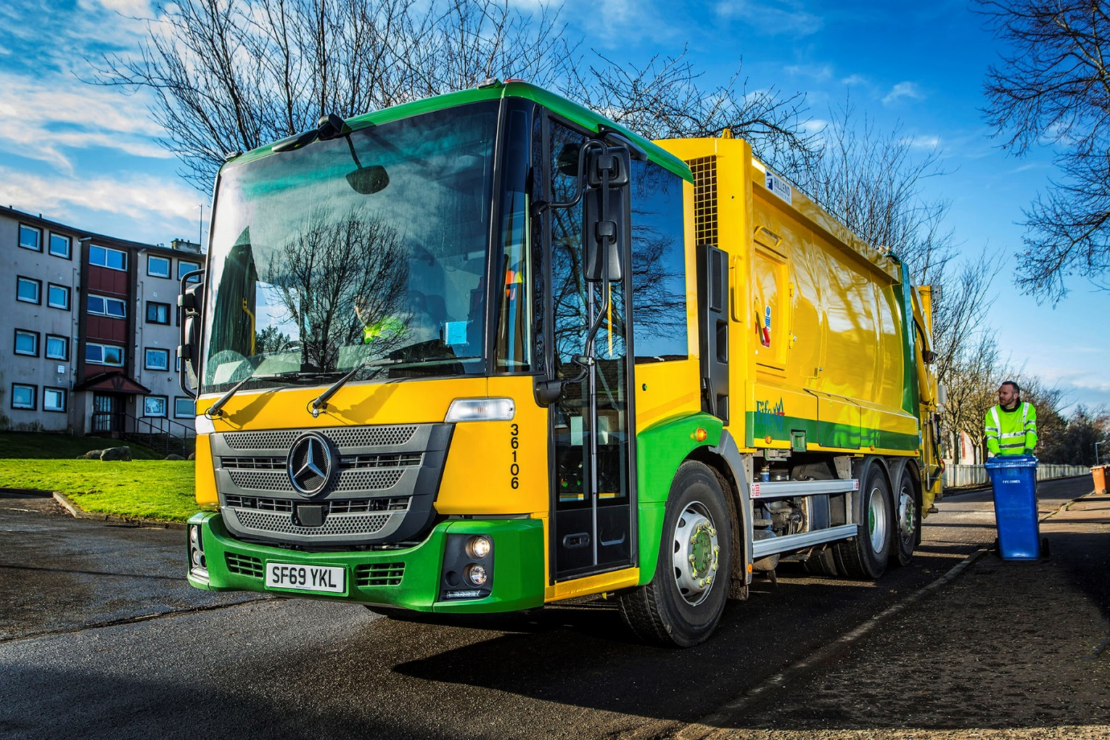

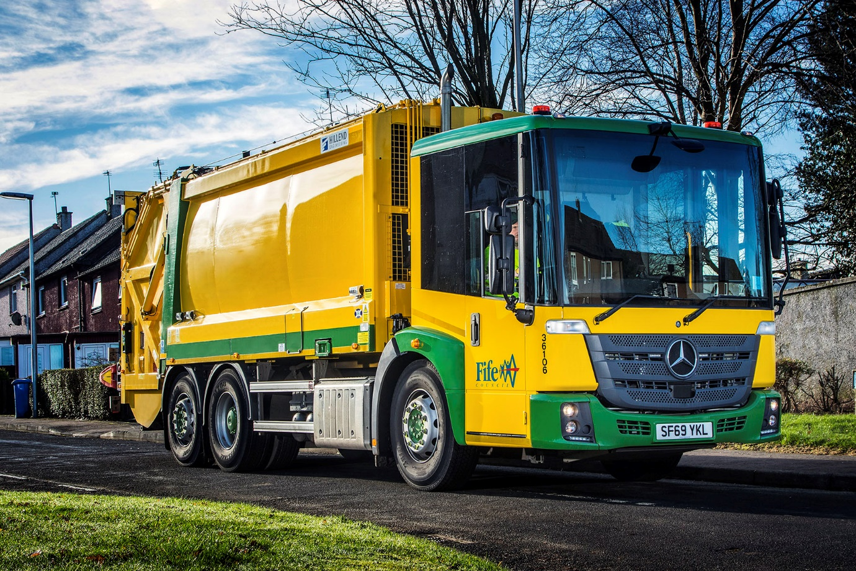

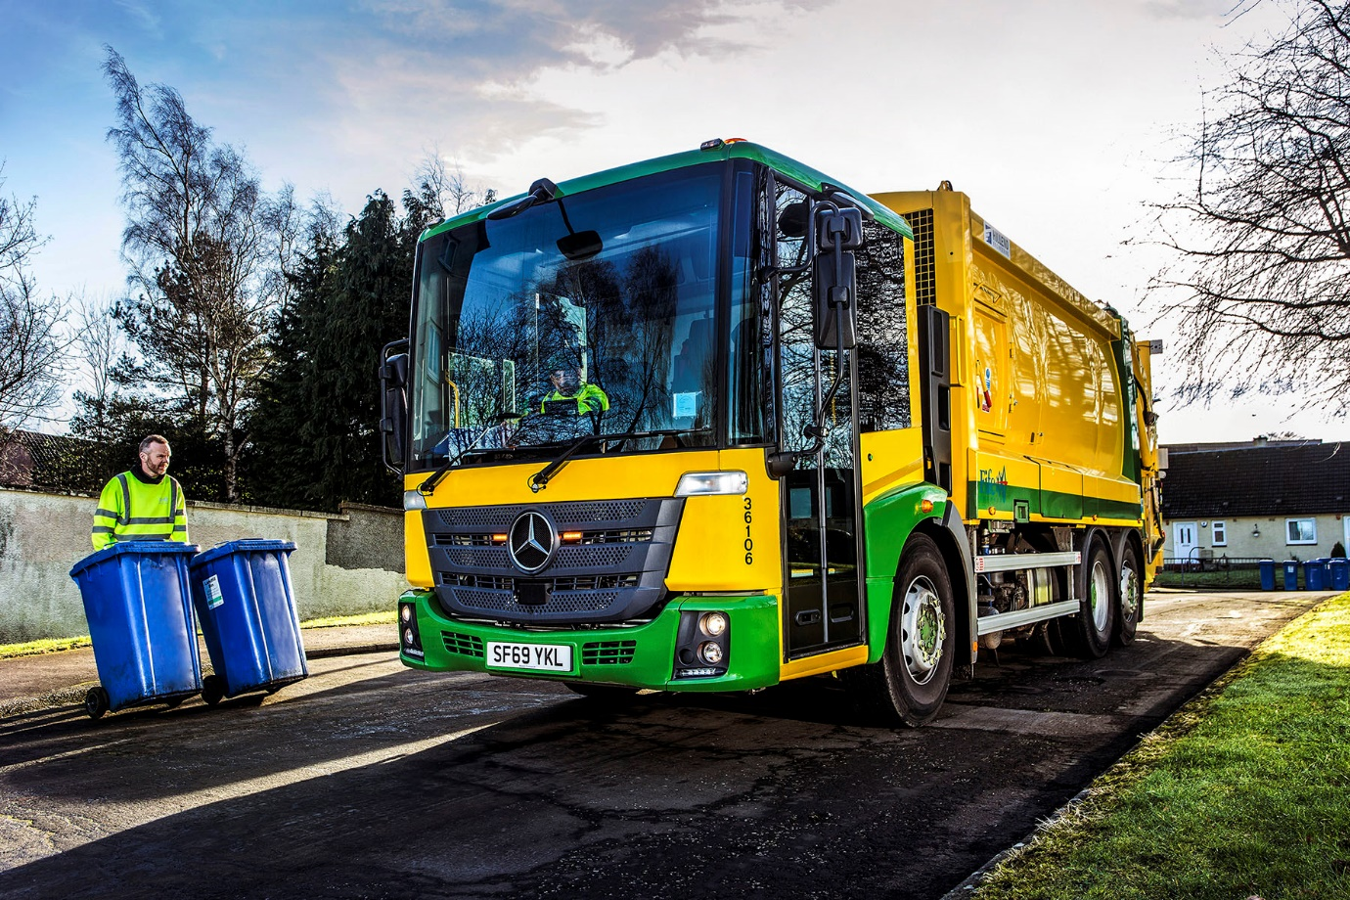

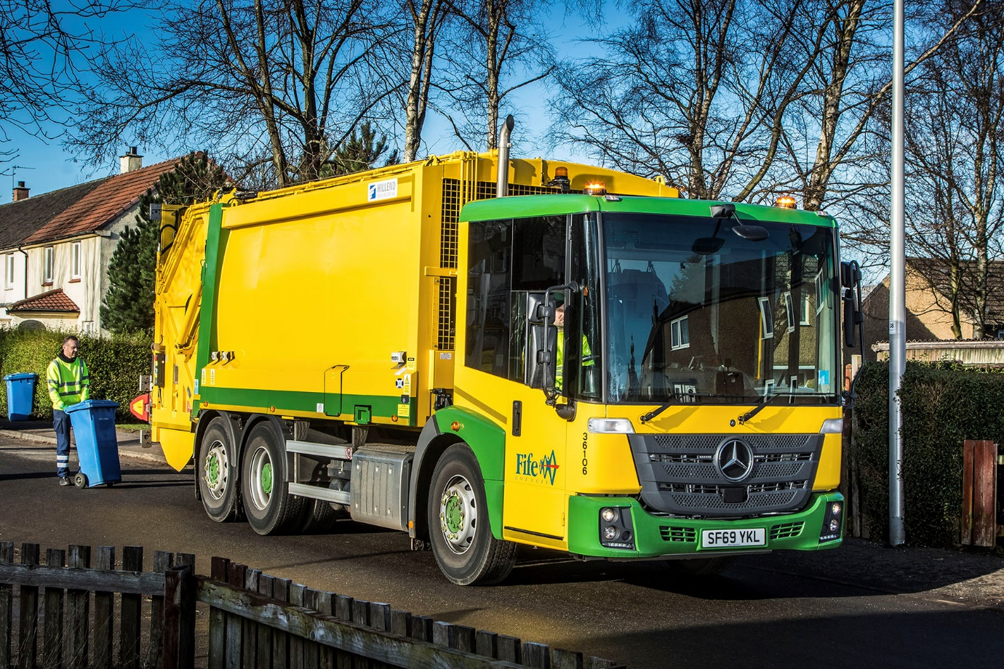

ends

For more information, or to request bigger versions of image files, please contact:
John Ripley or Steve Warren
Impact Communications, 01926 842126
John: 07771 484595, john@impactcom.co.uk
Steve: 07770 470251, steve@impactcom.co.uk

