

Date: 23 August 2021

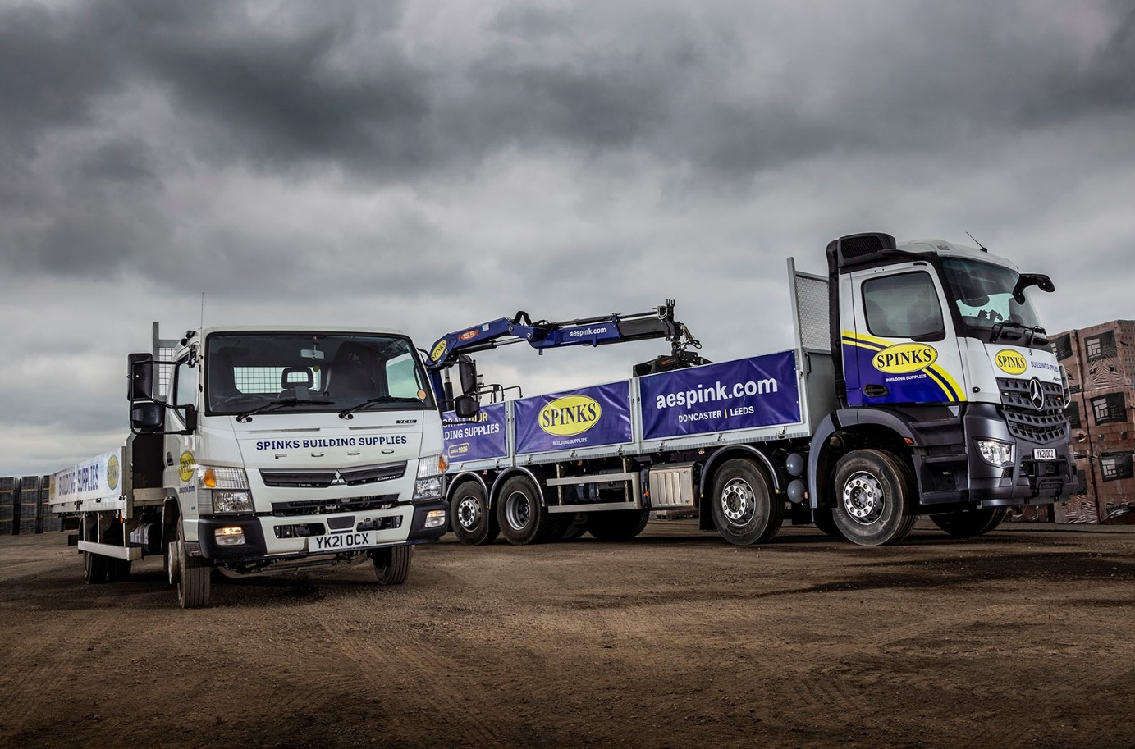

Spinks covers all the bases with Mercedes-Benz and FUSO trucks from Northside

Some 15 years after it began buying Mercedes-Benz vehicles from Northside Truck & Van, Doncaster-based AE Spink has now also become a staunch advocate of FUSO Canters supplied by the same local Dealer.

Spinks, the trading name by which it is well known throughout its Yorkshire and north Nottinghamshire heartland, has been serving tradesmen and retail customers with building, plumbing and heating products since 1926.

The most recent additions to the company’s fleet are an 8x2 Mercedes-Benz Arocs 3248 with rear-mounted PM 15.5 crane, and a 7.5-tonne Canter 7C15 dropsider.

Spinks took three examples of the same Arocs model in the spring of 2020 but the latest is additionally fitted with a VBG coupling and is its first truck to pull a drawbar trailer.

The eight-wheeler has a ClassicSpace S-cab and a 12.8-litre, 350 kW (476 hp) ‘straight-six’. Its dropside body is by Truck Hydraulics, of Thorne, Doncaster, while Micra Truck Bodies, of Wakefield, built the trailer. Spinks has another 8x2 Arocs on order, for delivery in September.

“Business is good and we’re making larger deliveries to more building sites over greater distances,” explained Transport Manager Tony Billam. “The new truck effectively does the job of two, so allows us to operate in the most cost-effective manner.”

The Arocs works at a maximum GTW of 44 tonnes. “We’d typically put 17 tonnes of blocks, bricks and other building materials on the back of one of our eight-wheelers, while the trailer will carry another 16 tonnes,” continued Mr Billam. “If he needs to get in and out of a tight location, the driver can always drop his trailer then go back and pick it up again afterwards.”

That driver is Paul Jacobs, who has worked for Spinks since 2017. Like those supplied by Northside last year, his new Arocs came with a full complement of the latest Mercedes-Benz Trucks technology, including a twin-screen Multimedia Cockpit and MirrorCam, the manufacturer’s ground-breaking replacement for conventional mirrors.

“The new dashboard looks great and is very easy to use, while MirrorCam is a terrific piece of kit,” he enthused. “Rear visibility is better and because there’s no mirror housing you don’t have to contend with the usual front-facing blind spot either. What’s more, when it’s raining normal mirrors get wet and mist up, but that doesn’t happen with MirrorCam. Instead, you get a clear view all of the time, whatever the weather.”

The only vehicles on Spinks’ fleet of 21 trucks that do not wear three-pointed stars are its trio of 7.5-tonne Canter dropsiders – it purchased the first in 2019, and another in January. The popular FUSO light truck range is retailed exclusively by members of the Mercedes-Benz franchised network in Britain.

Like its immediate predecessor, the latest is a 7C15 variant with a 3.0-litre common-rail powerplant producing 129 kW (175 hp) and up to 430 Nm of torque across a broad engine speed range. The truck is used primarily to transport insulation panels, for which Leeds-based West Yorkshire Vehicle Bodies built the body to the maximum permissible 2,550 mm width.

The 7.5-tonne FUSO Canter offers a market-leading body and payload allowance. However, the truck’s compact footprint and agility, as well as the fact that it is supported by
Mercedes-Benz, are what make it such a compelling proposition for Spinks.

“There’s not a lot of weight in insulation panels, so it’s all about the volume of product these vehicles can carry,” said Tony Billam. “We use them for local deliveries – the Canter scores because it’s that bit smaller than a conventional 7.5-tonner, and has an excellent turning circle, too. This makes it highly manoeuvrable and ideally suited to work in residential streets and on sites with restricted access.”

With brothers Nick and Matthew Spinks at the helm, family-owned Spinks serves customers throughout the North and Midlands, providing plumbing and heating supplies from its headquarters and other branches in Leeds, Sheffield and Worksop. Those in Doncaster and Leeds also offer building supplies, while each of its locations with the exception of Sheffield is home to a bathroom, bedroom and home office showroom as well.

While the company’s most recent acquisitions have been of 32-tonne Arocs and 7.5-tonne Canters, the majority of its vehicles are 26-tonners with builders’ merchant-specification dropside bodies and cranes. “Our Mercedes-Benz trucks have always been reliable and economical to operate, and the same is proving to be true of the FUSO chassis now working alongside them,” confirmed Mr Billam.

Spinks’ latest vehicles are now being inspected and maintained under cost-effective Mercedes-Benz Complete Service Contracts at Northside Truck & Van’s workshops in Doncaster, Leeds and Sheffield, all of which are open round-the-clock, seven days a week.

“We have a long-standing relationship with the Dealer, and its back-up is absolutely brilliant,” added Mr Billam. “Scheduled work is always undertaken at night, with the vehicles ready for collection at early the next morning, so we never incur any downtime.

“Its service teams are highly responsive, too. If ever we have an issue – as you always will, with even the best trucks – I know I can rely on them to jump on it straight away and get us back on the road as quickly as possible.”

aespink.com

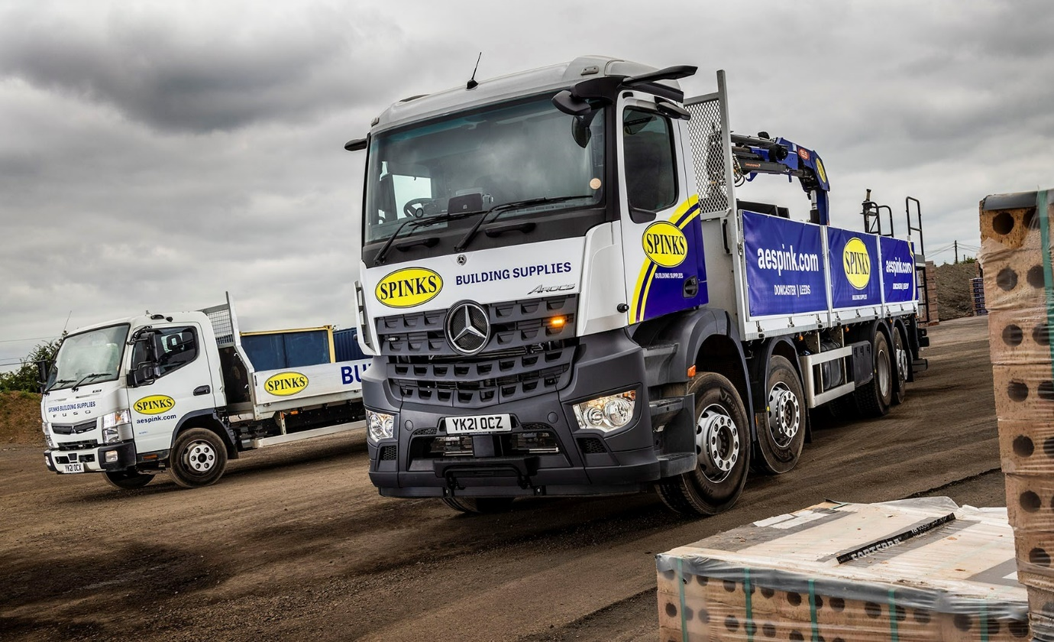
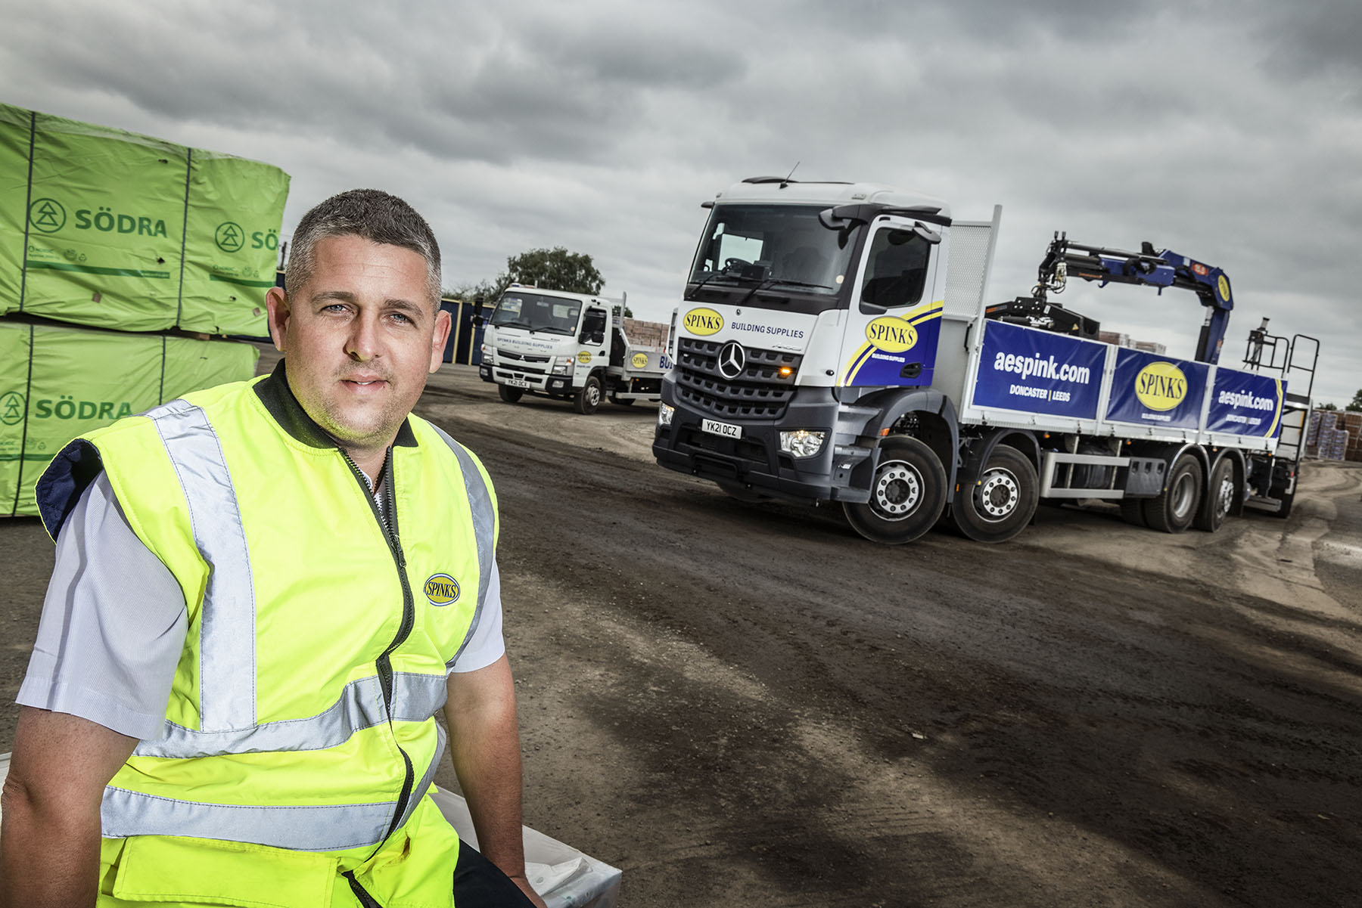

Ticking all the boxes: Mercedes-Benz and FUSO vehicles supported by Northside Truck & Van deliver efficiency and peace of mind for Spinks Transport Manager Tony Billam

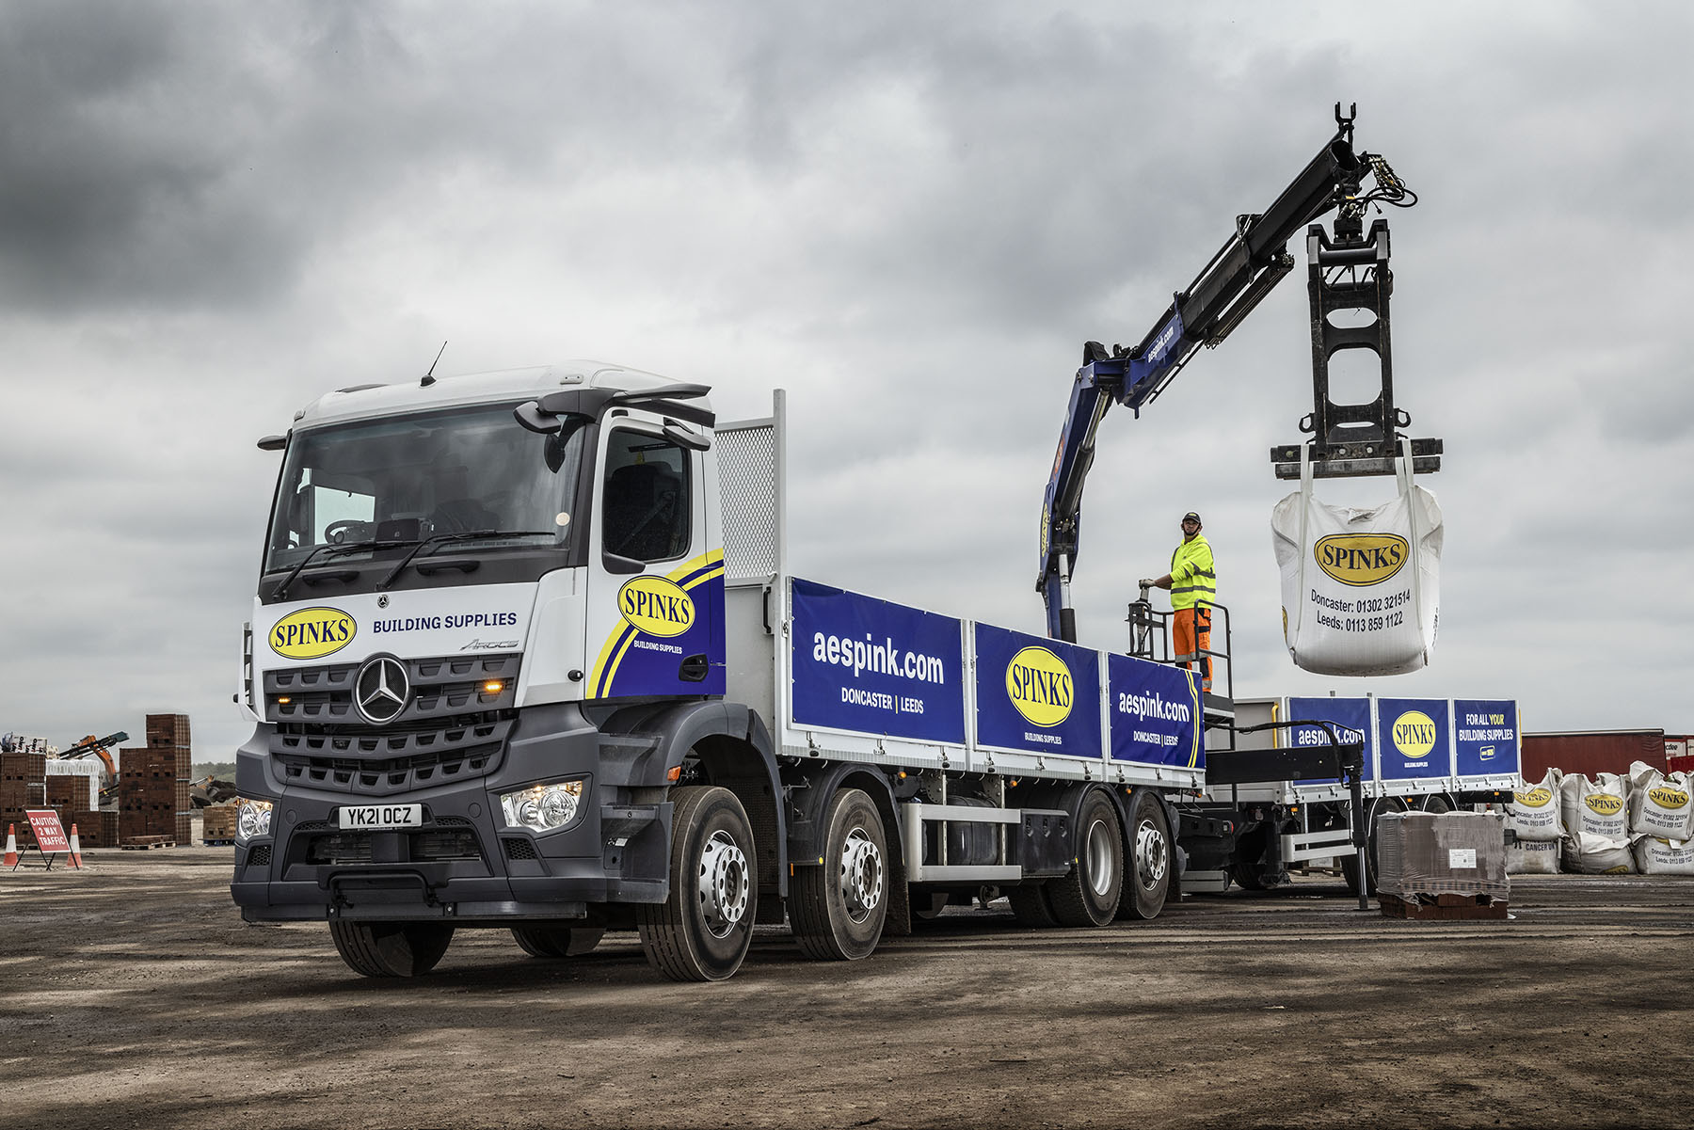

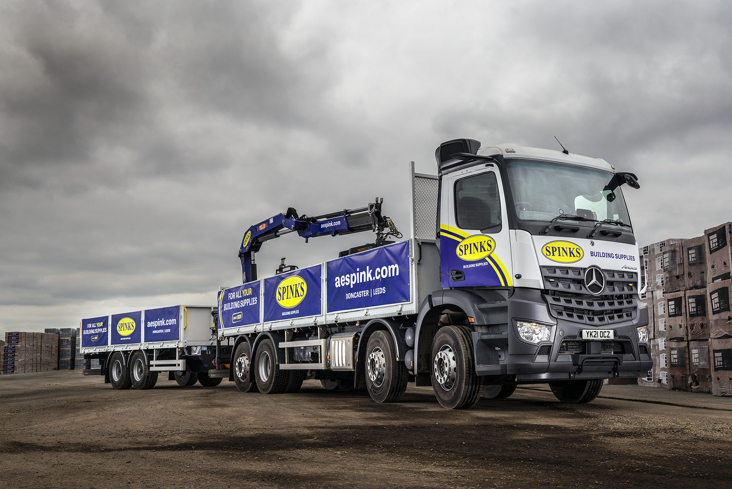

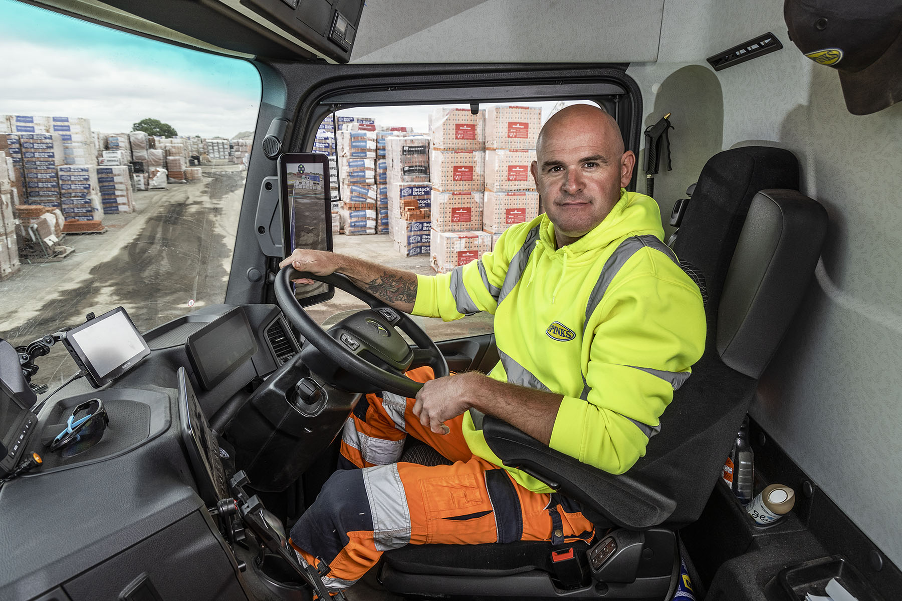

Impressed: Driver Paul Jacobs is a big fan of his new truck’s Multimedia Cockpit and MirrorCam technology

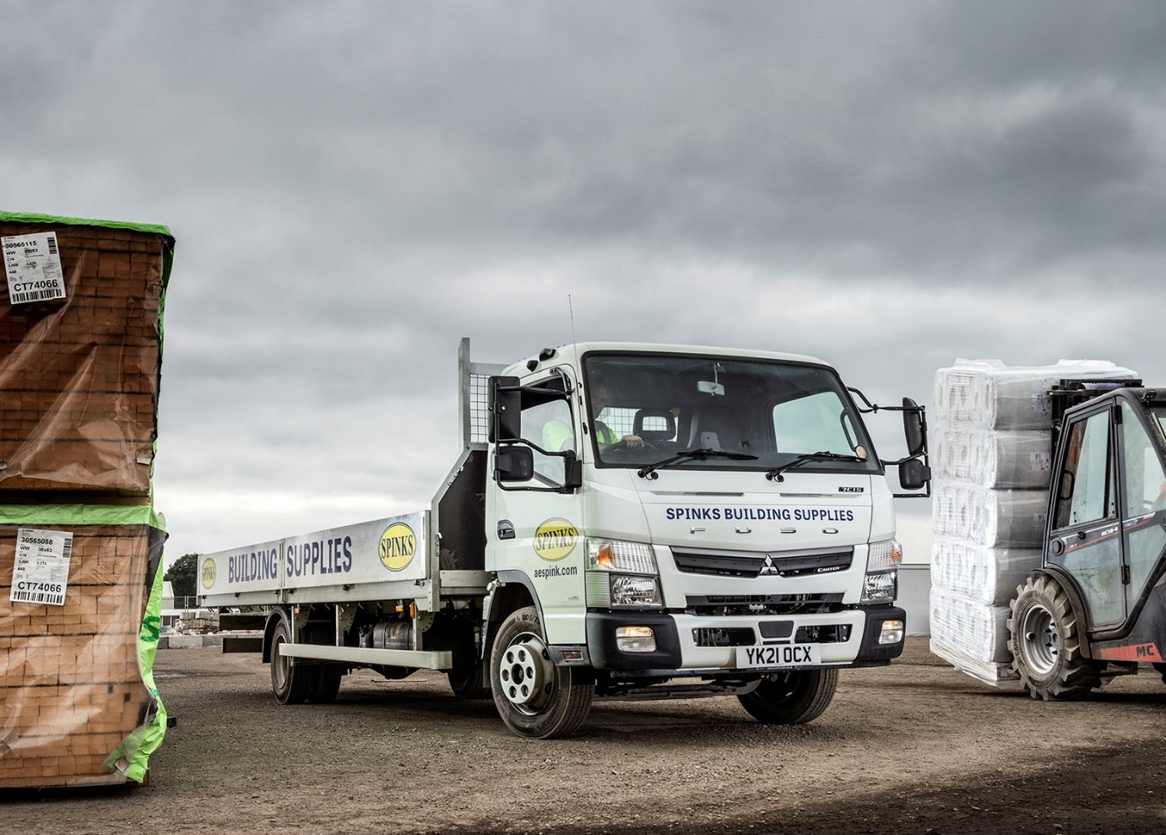

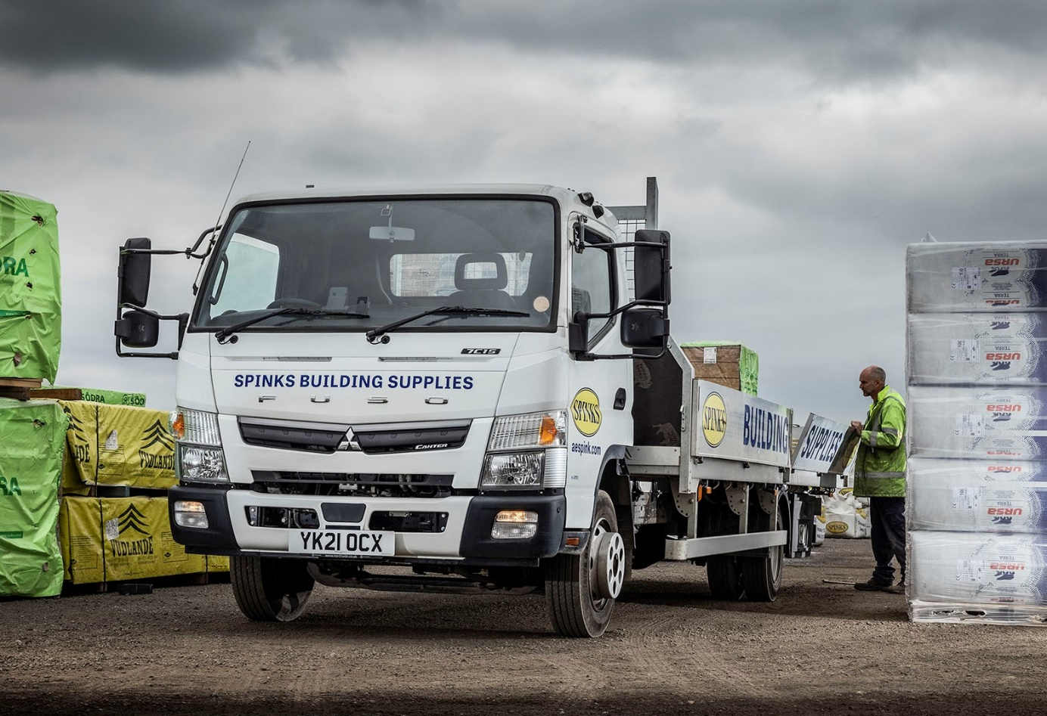

ends

For more information, or to request bigger/higher-res image files, please contact:
Steve Warren or John Ripley
Impact Communications, 01926 842126
Steve: 07770 470251, steve@impactcom.co.uk
John: 07771 484595, john@impactcom.co.uk

