

Date: 17 December 2018

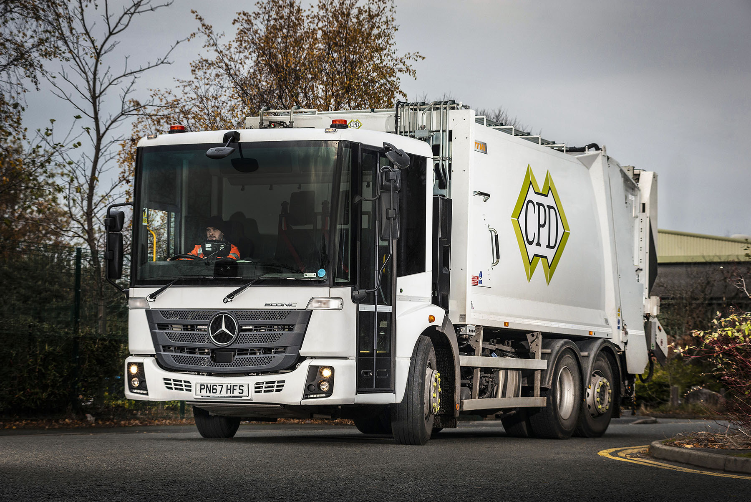

CP Davidson shifts to a new gear with Mercedes-Benz Econic

Leading refuse collection vehicle bodybuilder CP Davidson (CPD) also runs a rental fleet of more than 100 low-entry Mercedes-Benz Econics, to which it adds new trucks at the rate of at least one per month. The latest, however, is its first of a new breed.

Supplied by Dealer Ciceley Commercials, the vehicle is a 26-tonne Econic 2630L model with Euro VI, 220 kW (299hp) engine – no change there, then. However, whereas all of CPD’s previous Econics have had Allison automatic transmissions, the new truck drives through a 12-speed version of the manufacturer’s own automated manual gearbox.

Although well proven in other models bearing the three-pointed star, Mercedes PowerShift 3 was not previously available on the Econic. Its recent introduction reflects the truck’s increasing appeal to safety-conscious operators working across a broader range of applications.

The Allison automatic, which is so well-suited to the constant stop-start of domestic waste collection duties, will continue to be the default choice for many local authorities and their contractors. However, for businesses whose vehicles cover greater distances, and stop less often, Mercedes PowerShift 3 offers a lighter and more fuel-efficient alternative.

CPD’s new Econic is working for Manchester-based Fresh Start Waste, in just such an application. Collecting trade waste from businesses across the city and beyond, it is already returning an average of 8 mpg, which the operator considers “an excellent figure”.

Fresh Start Transport Manager Kirsty Atherton said: “We were running several Econics from CPD already, so we know they are great trucks, especially for work in busy city centres. The cab’s low seating position, deep, panoramic windscreen and full-height glazed passenger door allow the driver to see, and make direct eye contact with, cyclists and pedestrians. This greatly improves safety, not only for other road users, and particularly vulnerable ones, but also for our own staff.

“Thanks to its Mercedes PowerShift 3 transmission, though, the new vehicle adds even greater efficiency and lower operating costs to the tried and tested Econic formula of safety, user-friendly design and Mercedes-Benz reliability. We’re delighted with it.”

CPD Operations Director Robert Davidson agrees. “The addition of a Mercedes PowerShift 3 option to the Econic range has broadened the truck’s appeal still further. We’re taking a constant stream of calls from operators in longer distance applications who can’t wait to try one in their fleets.”

CPD’s fleet of refuse collection vehicles work for local authorities and waste management contractors across the UK, on long-term contract hire and spot-rental. Established in 1956 and always family owned – Robert Davidson is from the third generation – the company provides a range of body options for specialist collections, offers full maintenance cover from its own workshops, and prides itself on excellent customer service.

“Mercedes-Benz and Ciceley Commercials play a crucial role in helping us maintain the highest standards, whether in terms of the vehicles we supply, or the way we support our customers,” continued Mr Davidson.

“We enjoy a great relationship with the Ciceley team, from Dealer Principal Mike Lewis, to sales executive Matt Riley, and those in the Parts and Service departments, who keep us supplied with regular deliveries and are always available to provide technical assistance if we need it.”

cpdavidson.co.uk
www.fswaste.co.uk
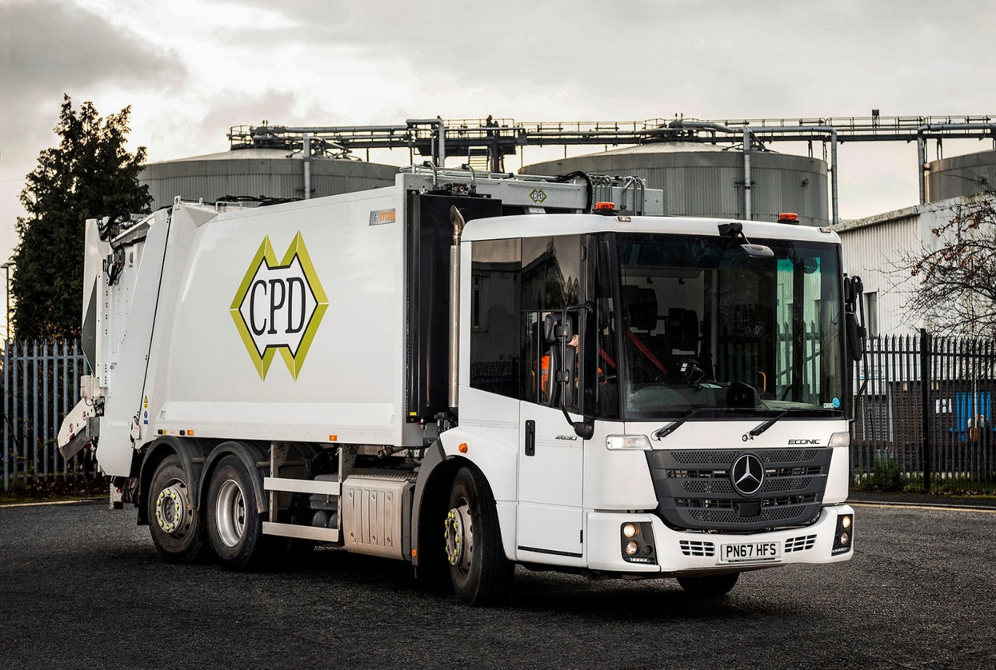

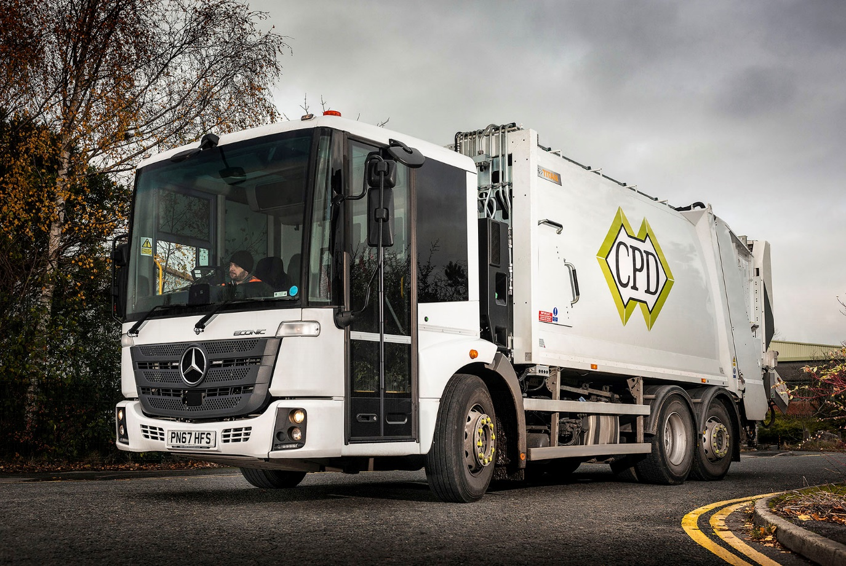

ends

For more information, or to request bigger/higher-res image files, please contact:
John Ripley or Steve Warren
Impact Communications, 01926 842126
John: 07771 484595, john@impactcom.co.uk
Steve: 07770 470251, steve@impactcom.co.uk

