

Date: 20 August 2021

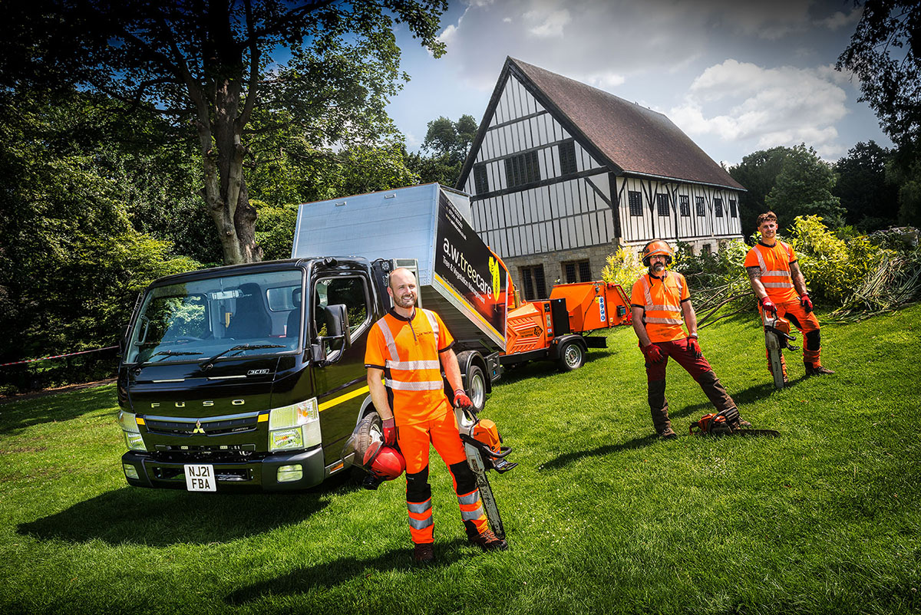

Ground force: Alex Walker, left, with team members Steve Moore and Ashley Bolsover, and their new FUSO Canter

AW Treecare chips in with “fit for purpose” FUSO Canter from Mercedes-Benz Dealer Bell Truck and Van

Arboriculture specialist AW Treecare is running its first truck – and the 3.5-tonne FUSO Canter has quickly taken root for the County Durham company. It was supplied by local Mercedes-Benz Dealer Bell Truck and Van, which, like other members of the manufacturer’s franchised network in Britain, is also responsible for sales and support of the popular FUSO light truck range.

Established nine years ago by proprietor Alex Walker, AW Treecare relied previously on a faithful, but ageing, 4x4 truck to transport members of its team and their tools, and to tow wood-chippers, stump-grinders, and other plant.

However, explained Mr Walker: “We’d reached the stage in the development of the business at which we needed a vehicle that was more closely tailored to our needs.”

He recalled: “I had a set of criteria in mind when I began the search, the most important of which was a worthwhile increase in carrying capacity. The new truck had to be tough enough to stand up to a rigorous working life, and have a comfortable cab able to carry three people without being too cramped.
“A modest footprint coupled with a high degree of manoeuvrability was important, as we often have to get on and off tight domestic driveways, and so, too, was an automatic gearbox. I considered several contenders but it quickly became apparent that none could match the FUSO Canter as an all-round package – it really did tick all our boxes.”

He continued: “I was also very impressed by Bell Truck and Van. Unlike some of the dealers I approached, it’s a dedicated commercial vehicle specialist so set up to serve a business like mine. Sales Executive Alex Wordsworth was attentive and put in a lot of time to properly understand our requirements, then help us come up with the ideal specification.”

The 3.5-tonne GVW Canter shares the same gutsy 3.0-litre common-rail turbo-diesel engine as its conventionally powered 7.5- and 8.55-tonne stablemates. In the 3C15 model as specified by AW Treecare, this powerplant produces 110 kW (150 hp) and an impressive 370 Nm – variable turbine technology ensures that high torque is available from low engine speeds. The smooth-shifting and fuel-efficient DUONIC automated dual-clutch transmission comes with Eco Mode, Parking and Creep functions.

The Canter’s specialised, high-sided tipping body was designed and built to meet Alex Walker’s precise requirements by Euro Truck Bodies, of Shildon, Co. Durham, and incorporates lockable tool and equipment compartments. Importantly, given AW Treecare’s towing requirements, the Canter is also rated to pull trailers with gross weights of up to 3.5 tonnes.

“We’re delighted with the new truck, which is entirely fit for purpose,” confirmed Mr Walker. “The cab is roomy enough to carry three people in comfort, and we also specified air-conditioning, which is very welcome when you’re working in heavy protective gear on a hot day. The engine pulls really well too, even with full loads on the truck and trailer.

“The Canter is purpose-built and allows us to work much more efficiently than ever before, as well as presenting a smart, professional appearance to our customers. It’s the perfect tool for the job.”

AW Treecare undertakes arboricultural and related work for a broad variety of domestic and commercial clients. Most are located in the North-East but it also serves others throughout the country and even overseas.

Remarkably, the company has undertaken a series of assignments in the Jordanian capital of Amman, at the Royal Palace of King Abdullah II. “That opportunity came up almost by accident,” recalled Mr Walker.

“We’ve worked on great houses in England and Scotland for the National Trust, and for members of the British aristocracy, and I’ve built up a network of contacts. One of those individuals took on a senior role looking after the King’s estate, and recommended me to help with an arboriculture project. We’ve since flown out several times to provide supervisory, technical and training support – as you might expect, the experience and hospitality were out of this world.”

www.awtreecare.co.uk

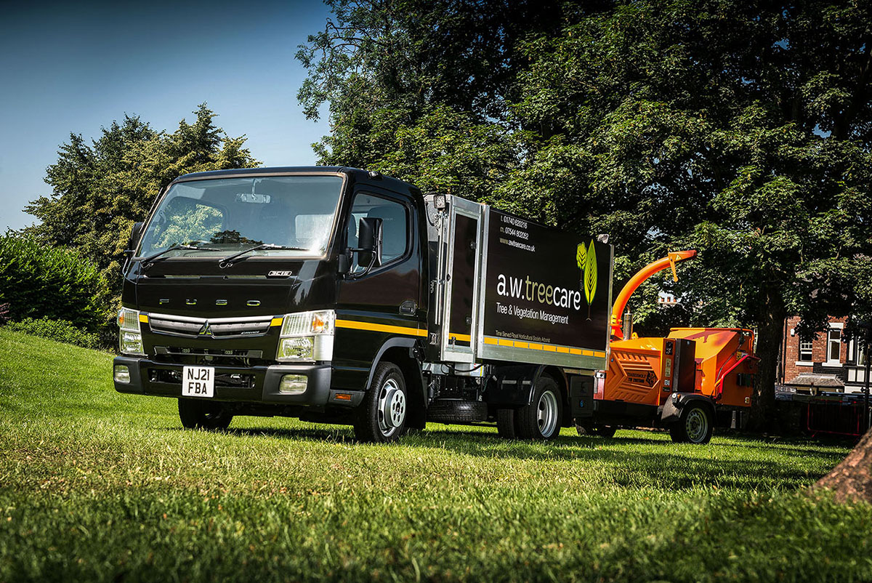

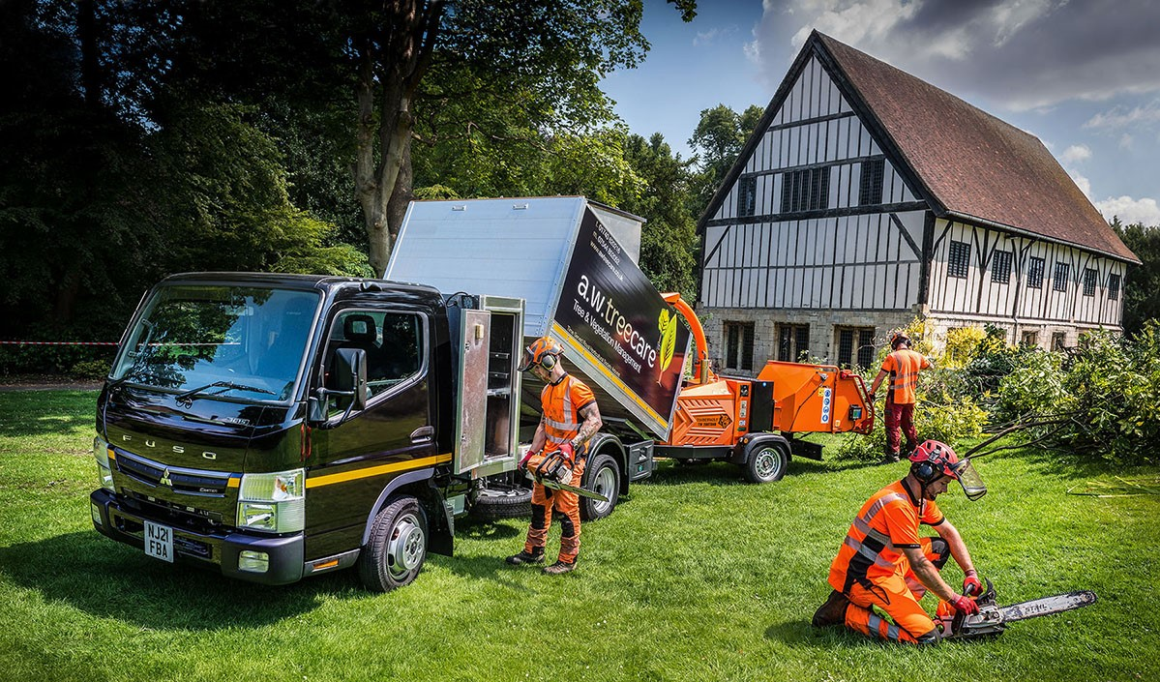
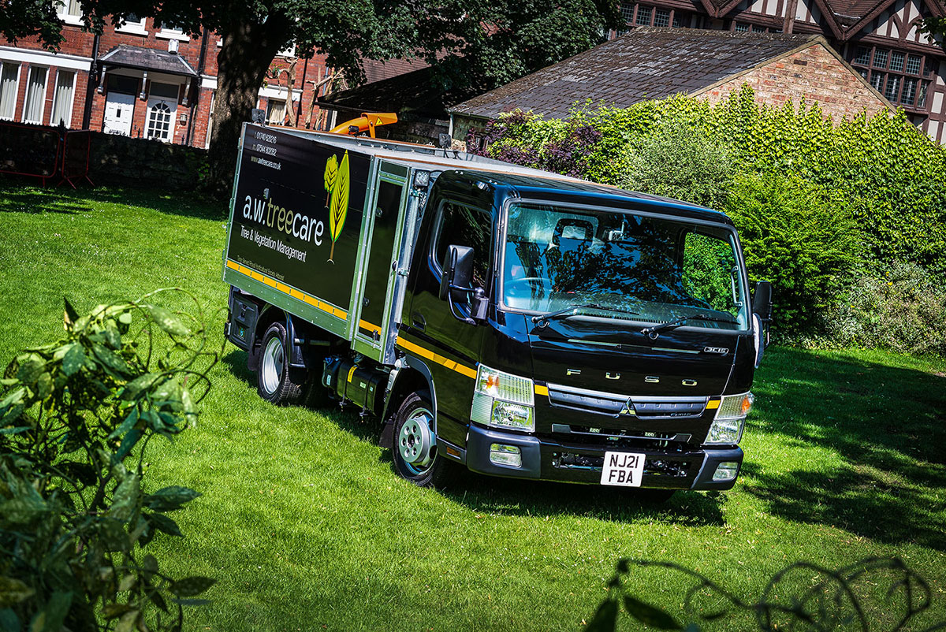

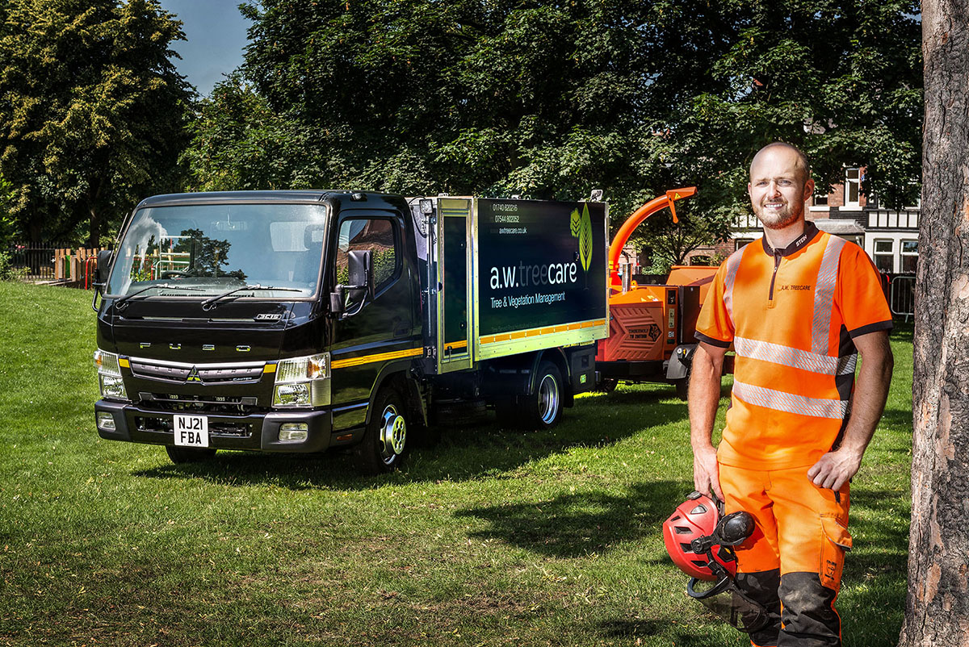

Crown green: Alex Walker’s client list includes King Abdullah II of Jordan!

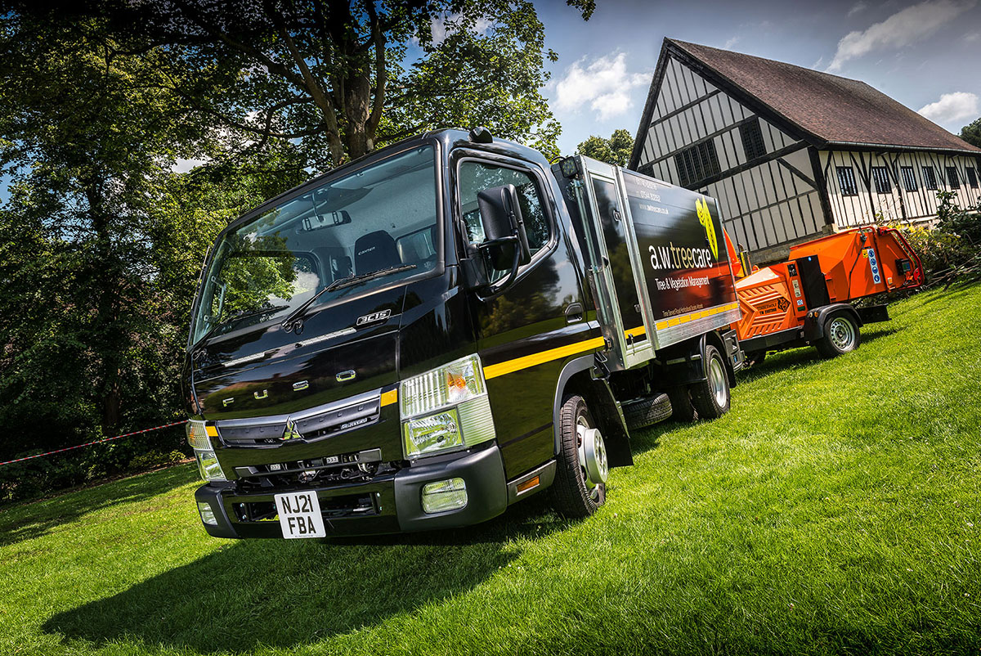

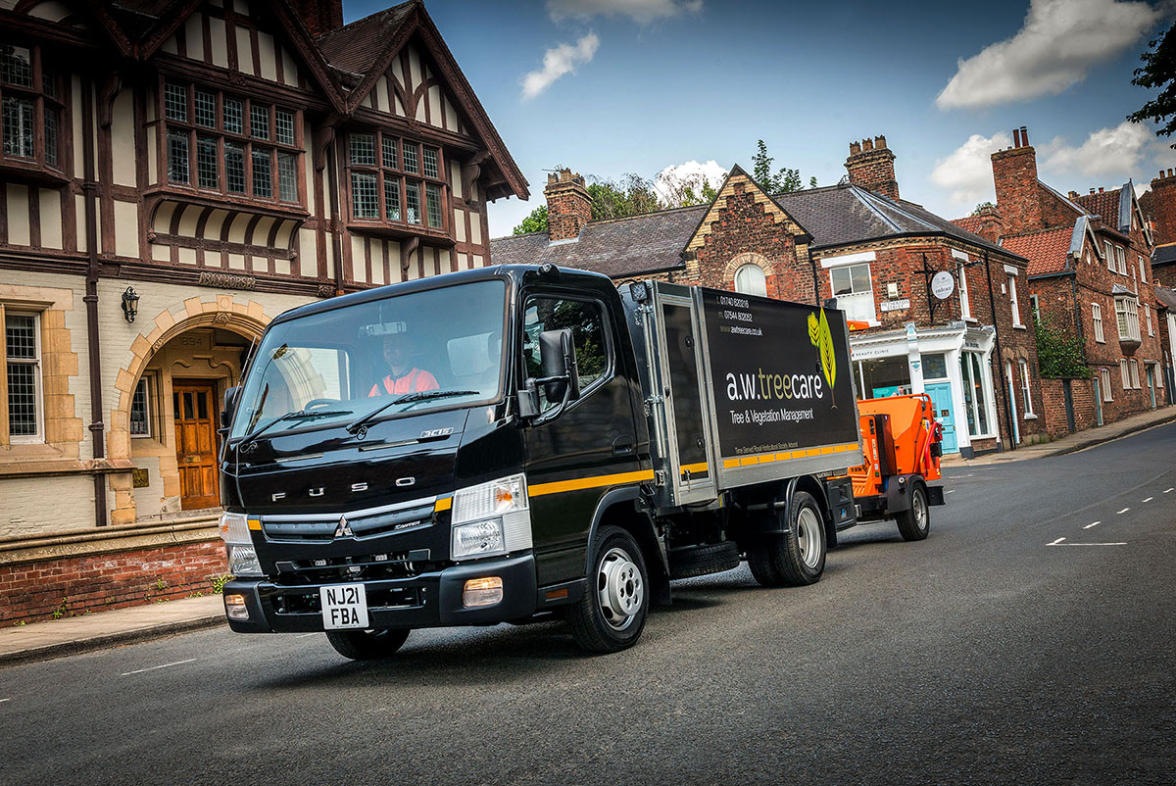

ends

For more information, or to request bigger versions of image files, please contact:
John Ripley or Steve Warren
Impact Communications, 01926 842126
John: 07771 484595, john@impactcom.co.uk
Steve: 07770 470251, steve@impactcom.co.uk



