

Date: 9 December 2019

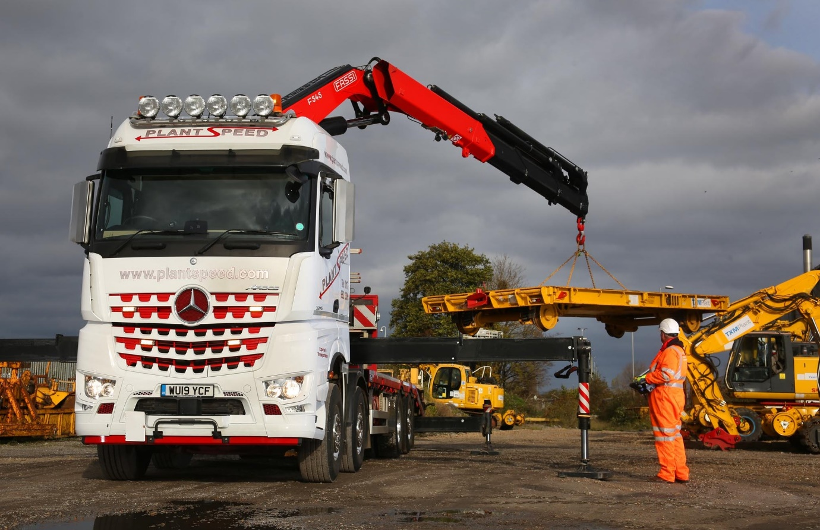

Agile Arocs crane truck lifts Mercedes-Benz to a new high with Plant Speed

Mercedes-Benz can now lay claim to the lion’s share of the Plant Speed fleet, after delivering the Bristol-based operator’s first rigid vehicle to wear a three-pointed star.

The eight-wheeler’s arrival means that Dealer City West Commercials has now supplied nine of the 16 trucks on which its customer relies to move heavy plant and equipment, including out-of-gauge and break bulk consignments, throughout the UK and Europe.

The new 32-tonne Arocs 3246 has a flat-floored BigSpace cab and is powered by the top-rated 340 kW (460 hp) version of the second-generation 10.7-litre OM 470 ‘straight six’. It has a beavertail plant body by Andover Trailers and a 56 tonne/metre Fassi crane, as well as a coupling for pulling drawbar trailers.

The 8x2 Arocs is impressively manoeuvrable thanks to its steered rear axle. It also holds out the promise of valuable fuel savings compared to an 8x4 variant, while the fact that the rear axle can be lifted when the vehicle is running light also allows the operator to save on tyre wear; even when deployed the axle’s turning function reduces scrub.

Plant Speed employs the latest heavy haulage equipment to provide its customers with cost-effective transport solutions. The company also observes the safest and most efficient working practices, and its highly skilled and experienced team of drivers and support staff are capable of handling the most awkward and delicate loads.

City West Commercials delivered Plant Speed’s first Mercedes-Benz in 2013. At the time the mighty 250-tonne Actros Titan was the most expensive truck ever sold by the manufacturer in the UK – the 8x4 tractor and its Scheuerle modular equipment represented a combined investment of more than £1 million!

So pleased was the operator with that truck, and particularly its Turbo Retarder Clutch – the Actros was also one of the first vehicles to be fitted with this ground-breaking system – that it returned in 2015 for a second 250-tonner, this time an Arocs from the Euro 6 SLT range.

Last year City West Commercials supplied Plant Speed with another four tractor units – two double-drive 460 kW (625 hp) Arocs BigSpace models plated for operation at 180 and 120 tonnes GCW respectively, and a pair of 68-tonne 390 kW (530 hp) Actros with range-topping GigaSpace cabs and tag axles. The Dealer then delivered two more, identical 68-tonners earlier this year.

These trucks have all replaced vehicles by other truckbuilders. “We’re favouring
Mercedes-Benz strongly at the moment,” confirmed Managing Director Paul Lomas. “Its products are fairly priced and exceptionally reliable, and our drivers like their big, comfortable cabs.

“Mercedes-Benz trucks are also technologically advanced – the Turbo Retarder Clutch, for example, is a fantastic piece of kit, brilliant for low-speed manoeuvres or when pulling away on a steep gradient, and a lot kinder to the drivetrain than a traditional torque converter.

“The fact that we can specify a broad range of options direct from the factory in Germany relieves us of the additional hassle of dealing with third-party suppliers. This ‘one-stop shop’ aspect of the Mercedes-Benz offer is a big plus for me.”

Mr Lomas continued: “The 68-tonners are our ‘bread and butter’ trucks, and carry out a lot of plant and railway equipment movements. They’re the lightest tractor units we run, but they’ve replaced Swedish-built 65-tonners, and the extra three tonnes is surprisingly useful in terms of increased flexibility.

“The new 32-tonne rigid, meanwhile, has replaced an eight-wheeler from 2005. The Arocs has a much more spacious cab, and a bigger crane. It’s a Swiss Army Knife-type of truck, capable of undertaking all sorts of tasks, and has barely stopped working since it landed.

“We didn’t need double-drive. Instead, we wanted a vehicle that’s economical to operate and agile – the sites this truck has to access can be quite tight, so the rear-steer axle is a big help.”

Plant Speed relies on City West Commercials for technical assistance and parts. “The Dealer provides a very good service,” confirmed Mr Lomas.

www.plantspeed.com

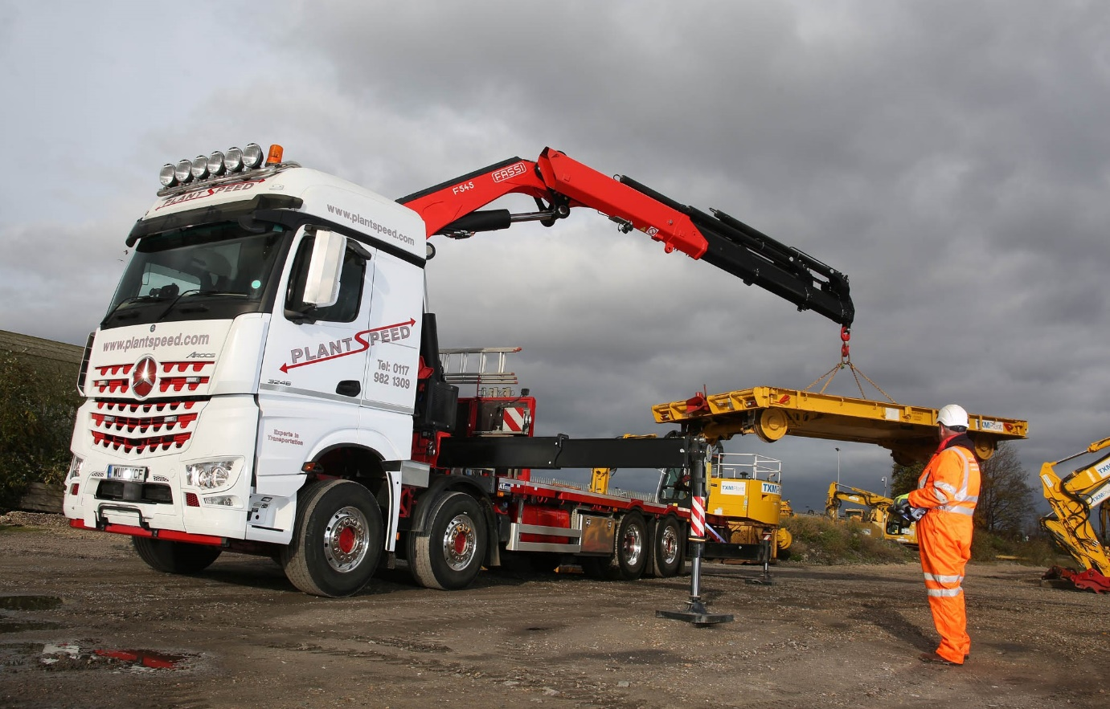

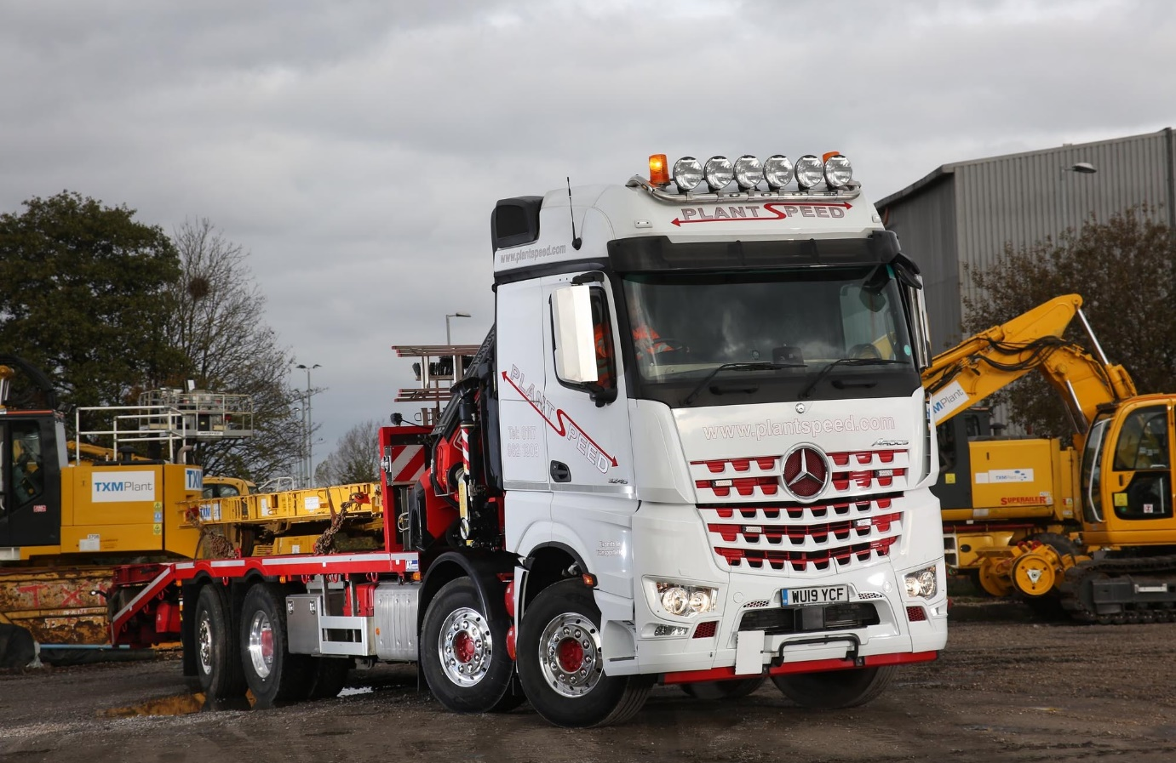

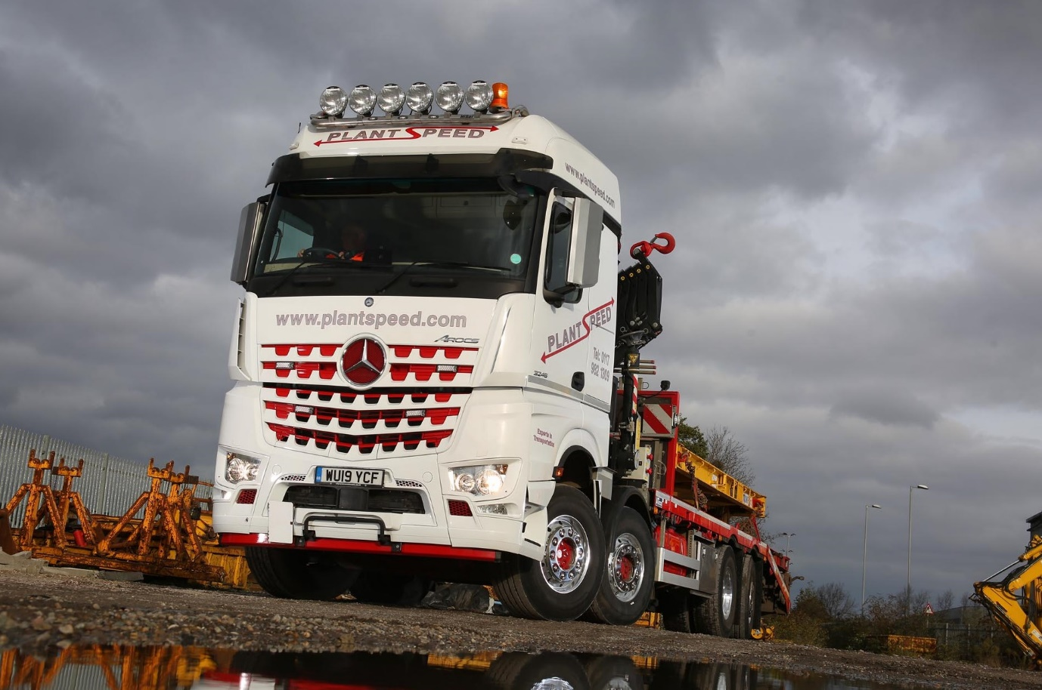

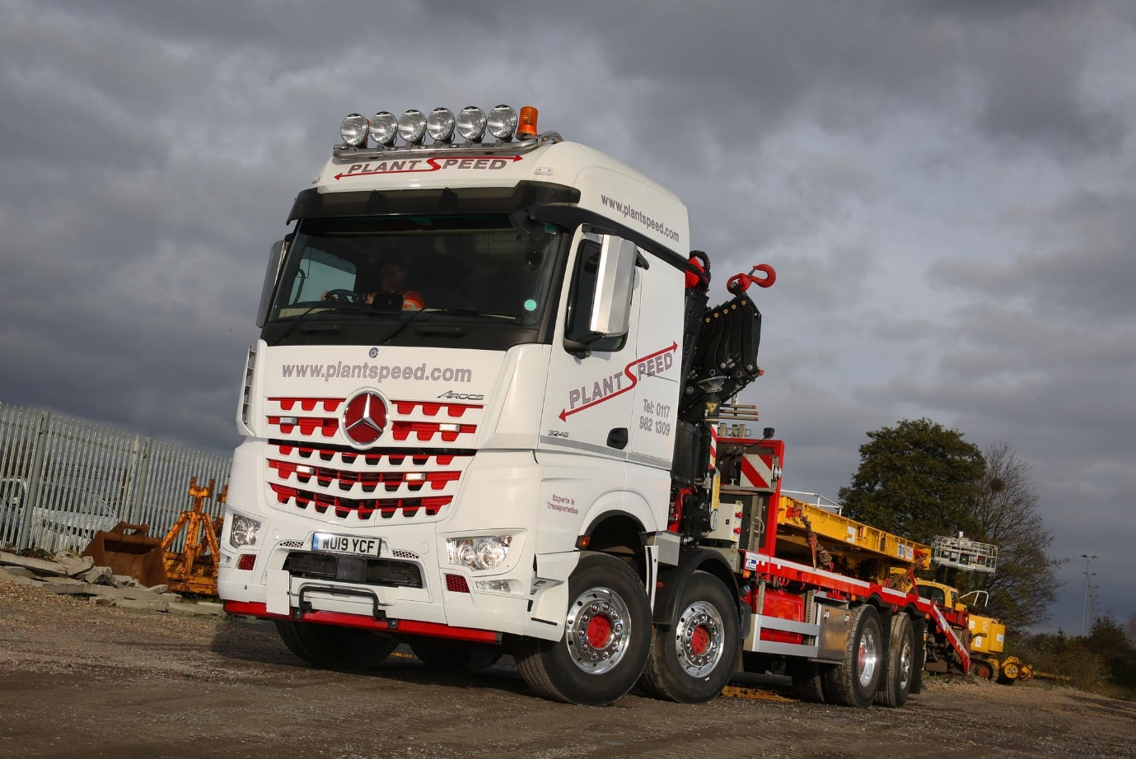

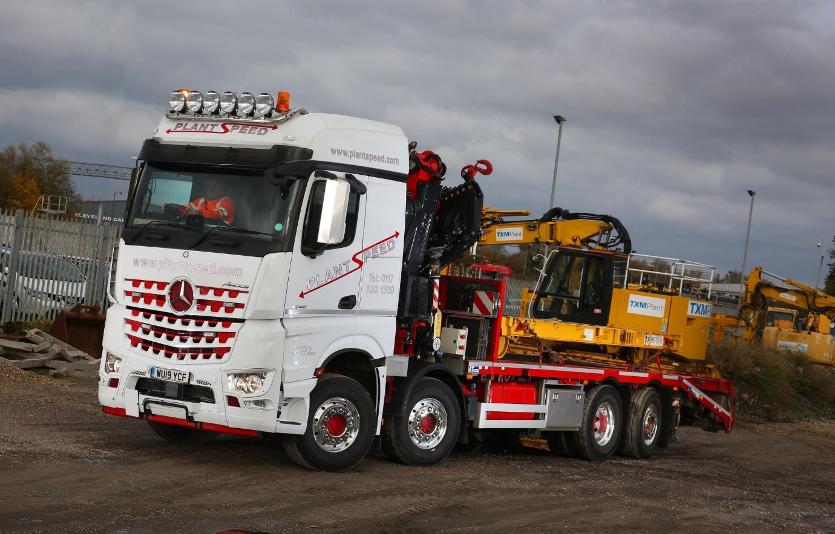

ends

For more information, or to request bigger/higher-res image files, please contact:
Steve Warren or John Ripley
Impact Communications, 01926 842126
Steve: 07770 470251, steve@impactcom.co.uk
John: 07771 484595, john@impactcom.co.uk

