

Date: 13 July 2021

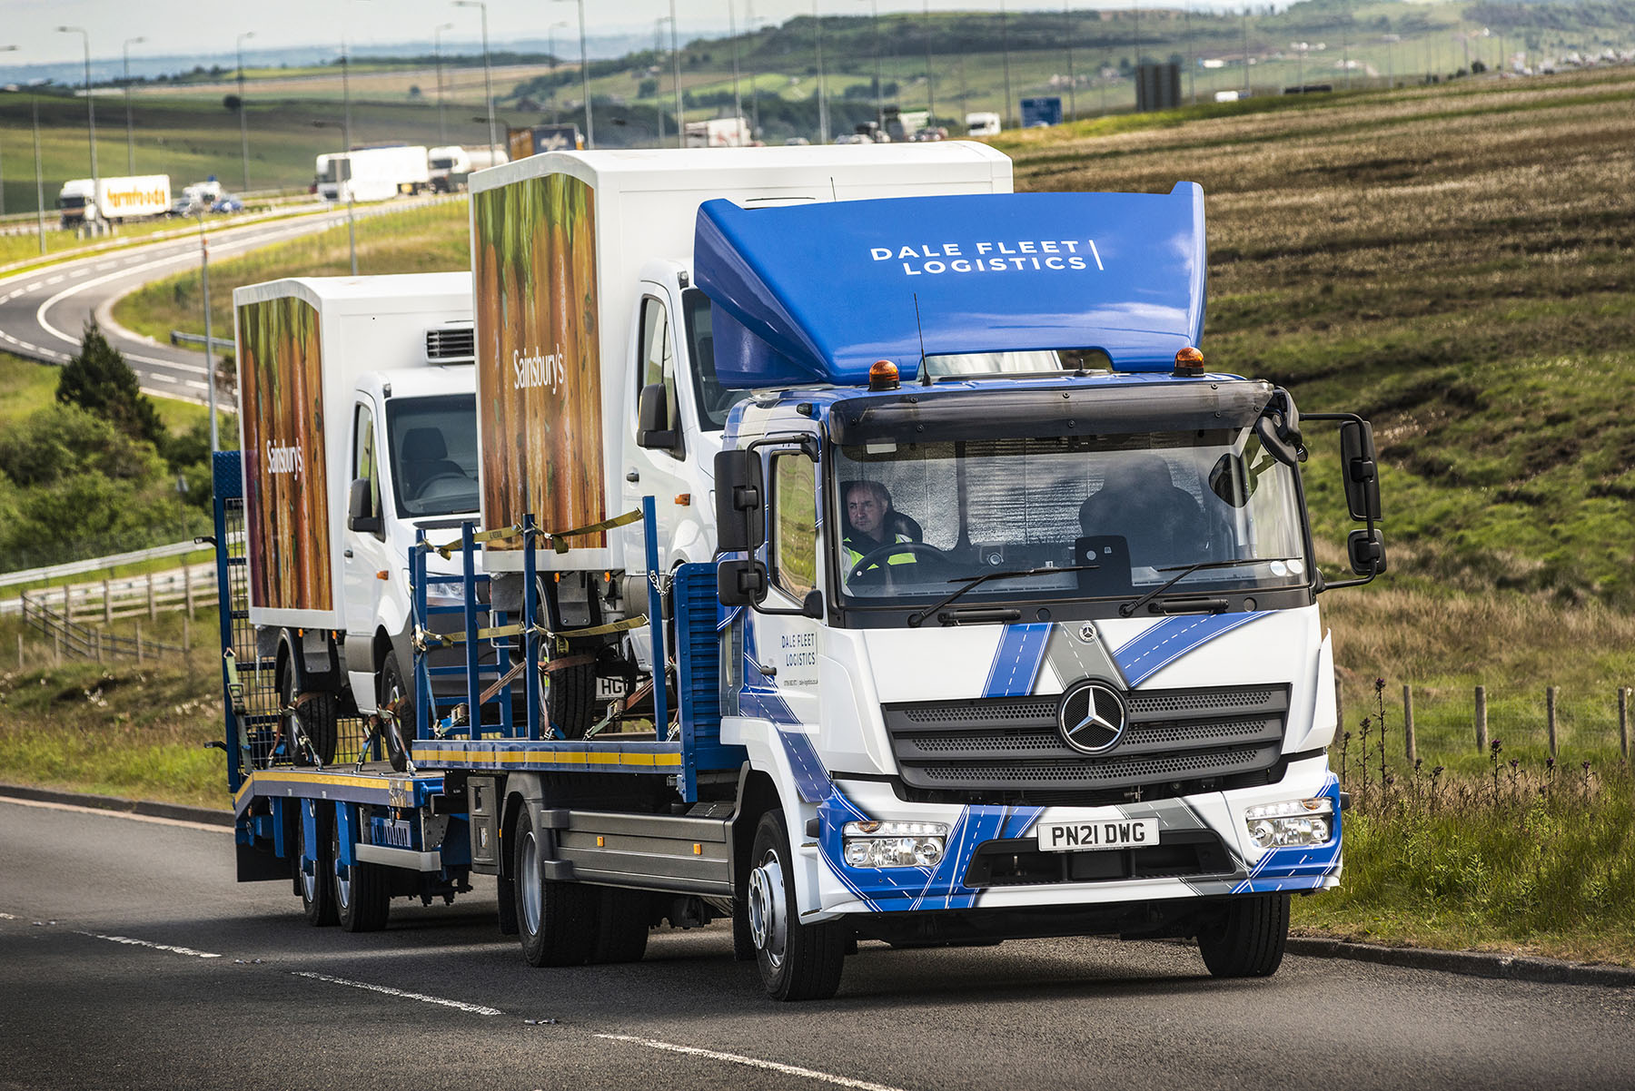

Dale Fleet Logistics’ tough new Mercedes-Benz Atego puts in the hard miles so electric vans don’t have to

The soaring popularity of battery-powered vans meant Dale Fleet Logistics needed a reliable transporter with which to deliver them – cue the arrival of the company’s first Mercedes-Benz truck, which it is also using to stay on top of demand for diesel-engined vehicles from the constantly expanding home delivery sector.

Dale Fleet Logistics operates from headquarters in Newhey, Greater Manchester and acquired the 12-tonne Atego from Dealer Ciceley Commercials, for which it works as a trusted supplier as well. A 1221 model with ClassicSpace L-cab sleeper, the vehicle is powered by a 155 kW (210 hp) 5.1-litre engine.

The company had previously relied exclusively on teams of drivers to pilot diesel-engined vans from manufacturer sites and dealerships to end users nationwide, particularly supermarkets and others operating within the fast-growing home delivery sector.

However, limitations on the distances they are able to travel before needing a recharge meant this was not an option for the electric vans that are now becoming an increasingly viable proposition for so many applications.

A re-think was needed, and the Atego is the result. The truck has a platform body by Fosters Commercials, of Preston, that carries a single van, while a second is towed on a trailer purpose-built for the role by Chieftain Trailers, of Dungannon. This is also used to load the Atego – the first van is driven onto the trailer via extendable ramps, then crosses onto the truck’s platform using a second set that connect the two.

Logistics Manager Matthew Morris explained: “We’ve been in the vehicle logistics business since 2003, and have traditionally driven vans to their destinations around the country. That’s fine for a diesel but doesn’t work for an electric van.

“Most of the distances to be covered exceed the range of the batteries, and in any case customers understandably want their vans delivered with a full charge. The only alternative is to use a transporter.”

For its first foray into this new way of working, Dale Fleet Logistics chose a truck with an unrivalled reputation for being able to stand up to the toughest and most rigorous working regimes without complaint.

“We already run five Mercedes-Benz Vito minibuses, which we use to ferry our drivers to and from their pick-up and drop-off points. These have proved dependable, efficient and comfortable to use,” continued Mr Morris.

“We also enjoy a long established and very successful relationship with Ciceley Commercials, having moved countless Sprinters from its various branches to some of the country’s biggest and best-known home delivery providers.

“These factors, coupled with the availability of a spacious and comfortable sleeper cab, meant the case for the Atego was compelling. A Mercedes-Benz will always be one of the best vehicles you can buy, and I’m in no doubt that we’ve chosen the most reliable and cost-effective truck of its size that the market has to offer.”

The truck will be worked hard and within its first couple of weeks on the road had already been across to Northern Ireland. “We’re delighted with our Atego and with the service we received from Ciceley Commercials,” added Mr Morris.

“Sales Executive Matt Riley arranged the competitive Mercedes-Benz Finance funding and, with the help of his colleagues, ensured that the acquisition process went as smoothly and simply as we could have hoped.”

As well as delivering new vehicles, Dale Fleet Logistics removes those that are being replaced, and offers storage and decommissioning services. The family-run company operates around the clock and all vehicle movements are recorded electronically, for added security.

The Mercedes-Benz Atego range from 7.5-16 tonnes GVW is purpose-designed for light- and medium-duty distribution applications. It offers outstanding dynamics, comfort and manoeuvrability, as well as the durability necessary for intensive, multi-drop delivery work.

www.dale-logistics.co.uk

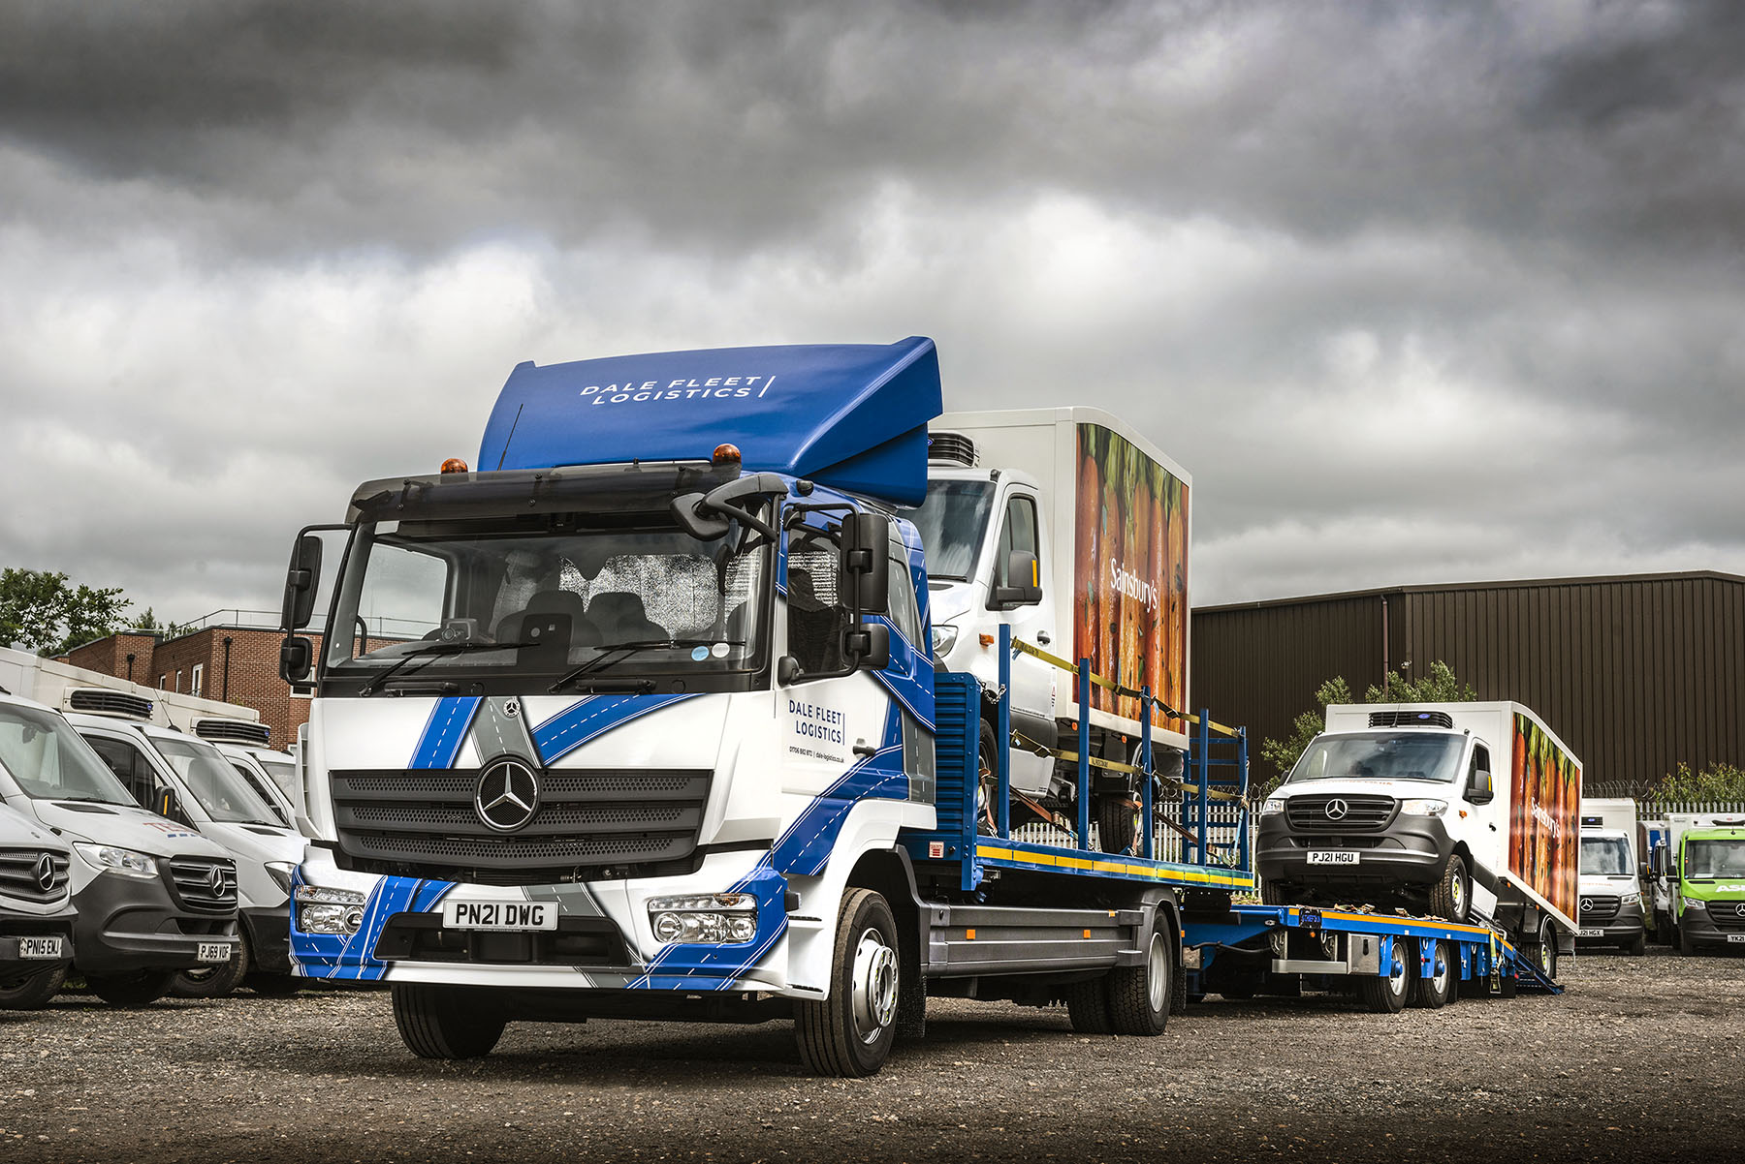

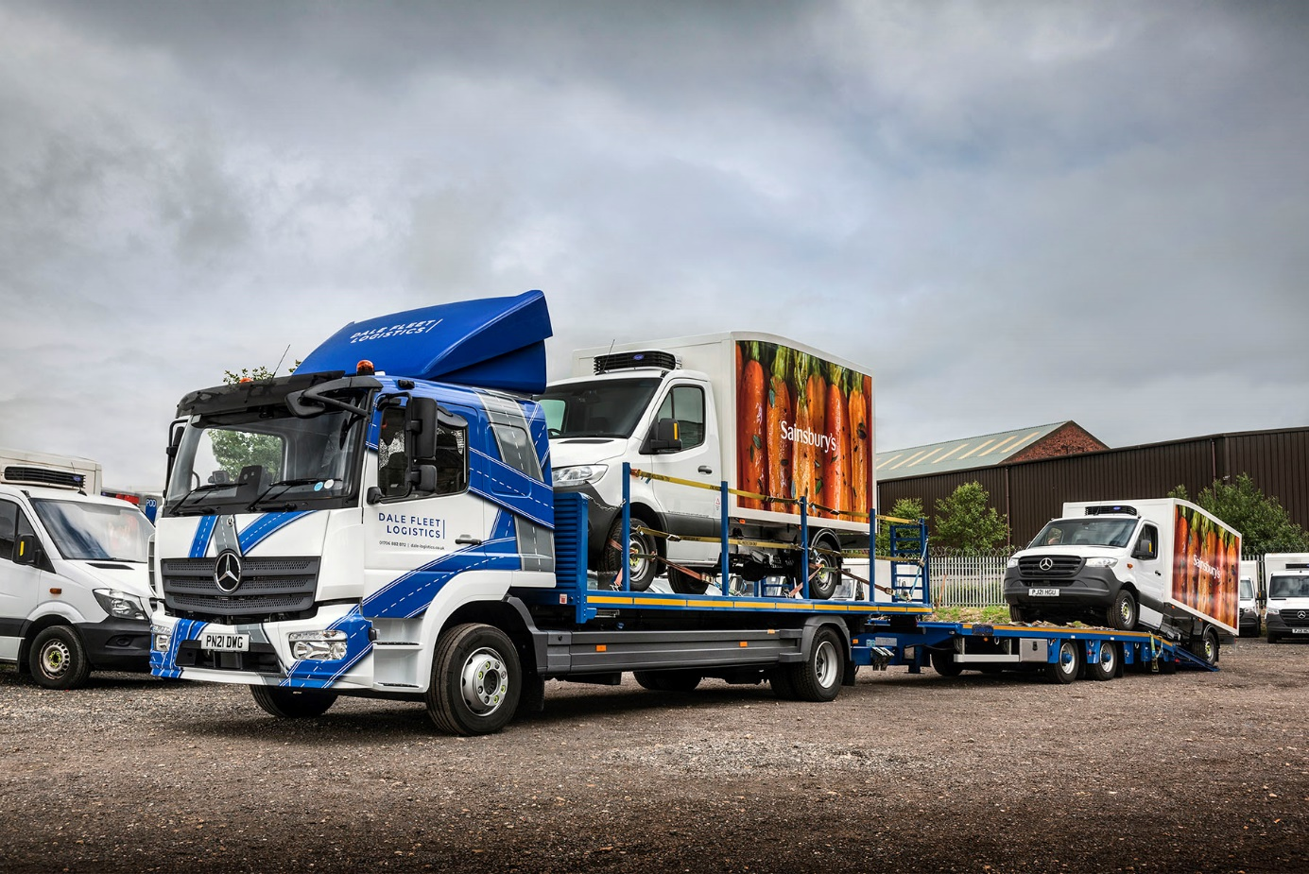

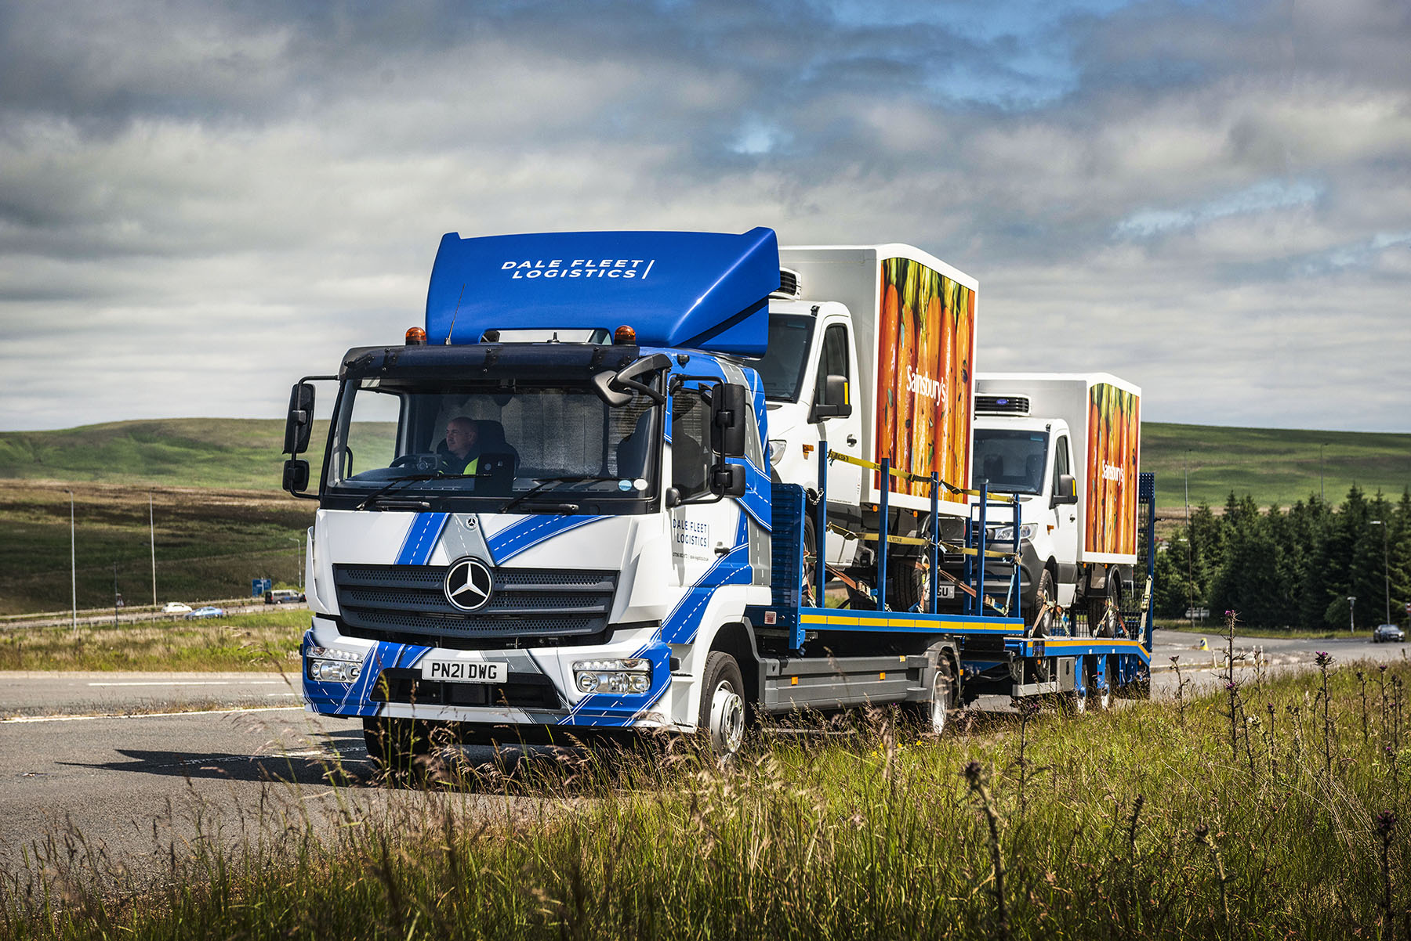

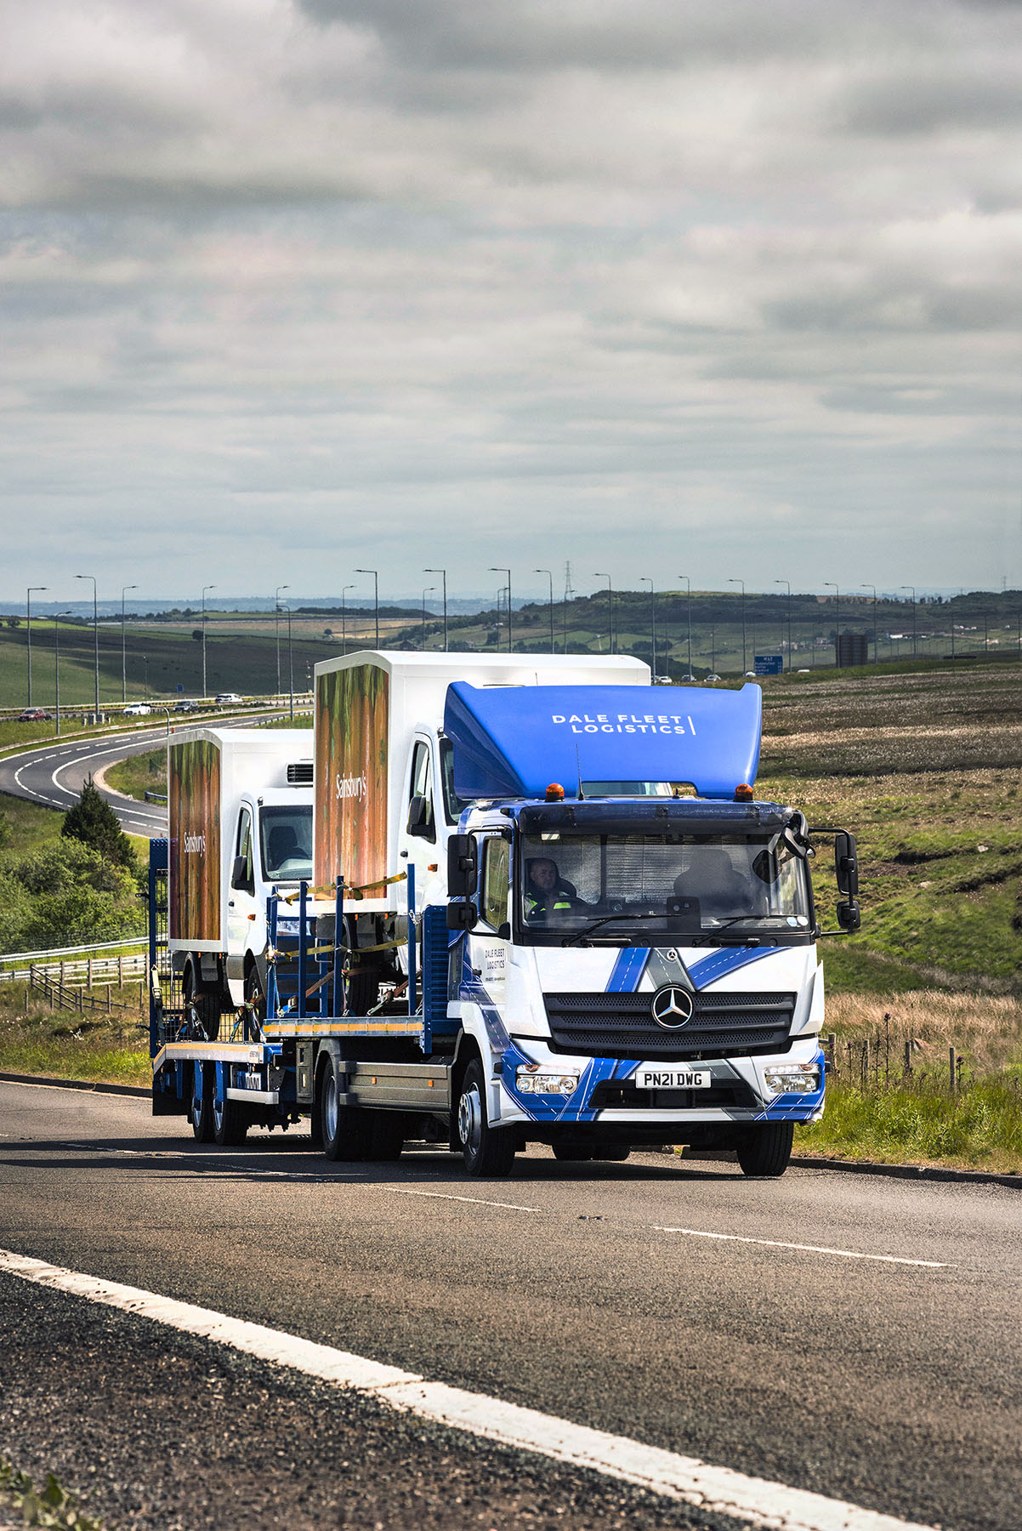

ends

For more information, or to request bigger/higher-res image files, please contact:
John Ripley or Steve Warren
Impact Communications, 01926 842126
John: 07771 484595, john@impactcom.co.uk
Steve: 07770 470251, steve@impactcom.co.uk



