

Date: 18 June 2019

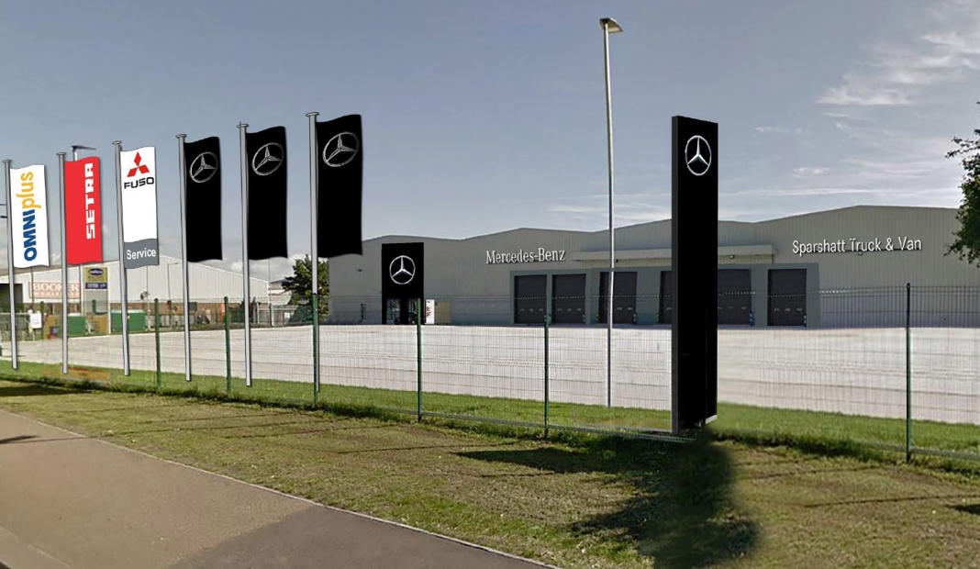

Mercedes-Benz Dealer Sparshatt Truck & Van opens £2m service facility

Commercial vehicle operators in north Kent and south-east London are assured of industry-leading levels of round-the-clock aftersales support at Sparshatt Truck & Van’s impressive new dealership in Dartford.

A leading member of the Mercedes-Benz Trucks Dealer Network, the company has invested some £2 million on refurbishing and equipping the 48,000 sq ft building, which is now up and running.

The new dealership is ideally located in Kennet Road, a stone’s throw from the main A206 – the Sparshatt team had long since outgrown their previous base less than two miles away, on Dartford’s Acorn Industrial Estate.

Like other Mercedes-Benz Trucks Dealers in Britain, Sparshatt Truck & Van is responsible for sales of Actros, Arocs, Antos, Atego and Econic models, all of which bear the three-pointed star, and of FUSO Canter light trucks. It maintains and repairs vans as well as trucks, and, as a Service franchisee of EvoBus (Mercedes-Benz and Setra), buses and coaches too.

A founding member in 1974 of the Mercedes-Benz UK commercial vehicle network, the company operates from headquarters in Sittingbourne, and other branches in Ashford and Tonbridge. In a deal that had the enthusiastic backing of the manufacturer, it was acquired by a new ownership team in March 2018.

Sparshatt Truck & Van is holding an Open Day at its Dartford dealership on Thursday, 11 July, and is inviting commercial vehicle operators to take a tour of the facilities and enjoy the refreshments on offer. Those wishing to attend should register their interest by emailing info@sparshattgroup.com – Marketing Manager Jo Ross will then send them the information they need in order to do so.

The new Dartford dealership incorporates a reception and offices designed to the latest Mercedes-Benz corporate standards, as well as a comprehensively stocked Parts department. Meanwhile, the workshop provides double the capacity for vehicle maintenance and repair operations, compared to the previous branch.

Accessed via six large roller shutter doors, it has 13 truck bays – two of them with pits – and 13 van bays. Crucially, the 1.8-acre site also offers plenty of space for drivers to manoeuvre and park their vehicles, the extensive hard-standing providing ample room even for tractor and trailer combinations.

Sparshatt’s previous Dartford Service department was open 24 hours a day, six days a week, and given the unprecedented levels of demand from customers, the new workshop will also be open round-the-clock from the outset.

Commenting on the development, Dealer Principal Steve Rooney declared: “As a business we are investing heavily to support our growth strategy, and this has been a tremendously exciting project. Our Dartford workshop has been extremely busy for a long time now, and General Manager Sean Bravery and his team have worked heroically in very challenging conditions to ensure that we maintain service levels for operators.

“Colleagues have transitioned seamlessly to their new home, and have been rewarded for their patience and loyalty with facilities that are right up there with the very best in the industry. From the ramps and other tooling in the workshop, to the racking in the Parts department, everything is brand new – we’ve even installed a professionally equipped, in-house gym for use by staff!”

Director Paul Rooney continued: “This very significant investment underlines Sparshatt Truck & Van’s long-term commitment to the Mercedes-Benz Trucks brand, and reflects our determination to provide our valued customers with the very highest levels of service.”

He added: “It has been an extremely challenging time for the team involved in this project and we would like to thank our Group Operations Director Gary Wilson and Project Manager Vicki Ponder for the key roles they have played, as well as the Dartford management team of Sean Bravery, Mark Price and Mark Holland for their support.”

Due to its expansion Sparshatt Truck & Van is actively recruiting to fill a variety of technical, parts and administrative roles. Potential candidates should register their interest by emailing recruitment@sparhattgroup.com, or visit www.sparshattgroup.com and click through to the Careers page.

- Operators interested in attending the Open Day at Sparshatt Truck & Van’s new Dartford dealership on Thursday, 11 July, should register their interest by emailing info@sparshattgroup.com

ends

Note to Editors
Please be advised that having previously done so as Sparshatts Truck & Van, from March 2019 the Mercedes-Benz Trucks Dealer for South-East London and Kent has been trading as Sparshatt (without the final ‘s’) Truck & Van. This very minor change to the company’s name was a legal stipulation, arising from the acquisition of the business completed a year earlier.

For more information, or to request bigger/higher-res image files, please contact:
Steve Warren or John Ripley
Impact Communications, 01926 842126
Steve: 07770 470251, steve@impactcom.co.uk
John: 07771 484595, john@impactcom.co.uk

