

Date: 14 November 2022

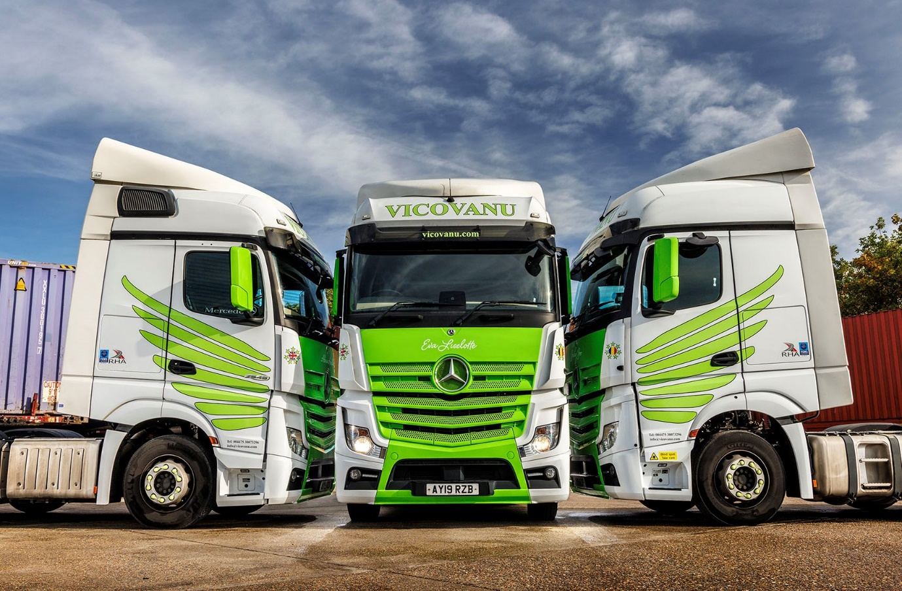

Vicovanu spreads its wings and flies with used Actros from Mercedes-Benz Certified

So impressed was container transport specialist Vicovanu with the fuel returns from its first five Mercedes-Benz tractor units that it returned to Motus Truck & Van shortly afterwards and purchased another three.

All pre-owned Actros supplied under the Mercedes-Benz Certified banner, they wear an eye-catching, high-visibility green and white livery – the ‘wing’ motifs on the sides of the cabs were chosen by proprietor Sergiu Vicovanu to represent the speed with which his company delivers for its customers.

Fast-growing Vicovanu operates from Grays, Essex, and offers a broad range of transport and logistics services, although ports-related work represents the backbone of its business. Its fleet of 30 trucks is dominated by a Swedish brand; in addition to the eight Actros – all of which arrived within three months – it runs seven vehicles from a third manufacturer.

Vicovanu’s Mercedes-Benz units have flat-floored, 2.5m-wide BigSpace cabs, and, as 2545 variants, employ 12.8-litre in-line six-cylinder engines that produce 330 kW (450 hp). Their comprehensive specifications include the optional Proximity Control Assist driver aid, fridges, microwave ovens and sun visors.

First registered in 2019, and always serviced by Motus Truck & Van, the Actros were returned to the Dealer on reaching the end of their contract hire terms with a major fleet operator. Each had covered between 370,000 and 470,000 km.

Launched last spring, the Mercedes-Benz Certified programme provides access to the industry’s finest pre-owned trucks and support packages. It represents a reassuring ‘stamp of quality’ and means customers like Vicovanu can buy with confidence.

Like every truck offered through the scheme, its Actros underwent an intensive, multi-point inspection by expert technicians at the Wentworth Park complex near Barnsley, which is home to Mercedes-Benz Trucks UK’s remarketing operation.

No vehicle offered for sale under the Certified banner is more than five-and-a-half years old, or has covered in excess of 550,000 km. The first service will not be due for at least 20,000 km and tyres will have a tread depth of no less than 6mm.

It will also be at least five months before the truck requires an MOT test and the manufacturer’s warranty will be valid for a minimum of 12 months – Vicovanu has taken out Mercedes-Benz ExtendPlus warranties that provide cover for 20 months. Inspections and servicing, meanwhile, are being undertaken at Motus Truck & Van’s newly refurbished and extended workshop in West Thurrock.

A proud member of the Road Haulage Association, Vicovanu also holds Bronze accreditation from the Fleet Operator Recognition Scheme. Sergiu Vicovanu established his business in 2013, two years after arriving in the UK from his native Romania. On reaching this country he drove trucks, mainly for one of the big supermarkets. “I was 21 at the time, and the youngest driver at every site from which I worked,” he recalled.
Although Vicovanu also buys new trucks, the avoidance of long lead times was key to the appeal of the Mercedes-Benz Certified units. So, too, was the promise of improved economy – the Actros was strongly recommended for its fuel-efficiency by another operator from which Transport Manager Dave Read took soundings.

Before joining Vicovanu, Mr Read spent 33 years working for another company that ran Mercedes-Benz trucks. “It was a positive experience,” he said. “The Mercedes-Benz was always a good tool and well supported by the local Dealer.”

Vicovanu’s latest trucks are certainly living up to their billing: “Our Actros are returning upwards of 8.5 mpg, which is pretty good for container haulage,” confirmed Sergiu Vicovanu. “That puts them comfortably ahead of our Swedish trucks, and on a par with the others, all of which we’ve purchased from new over the last couple of years.”

He continued: “The Actros is a premium product. Ours are well specified and were nicely presented on delivery, so naturally the drivers are very happy with them. Motus Truck & Van’s Sales Executive Steve Jenkins is customer-orientated and provides a great service, while I’m confident that the Dealer will support us when it comes to aftersales back-up.”

vicovanu.com

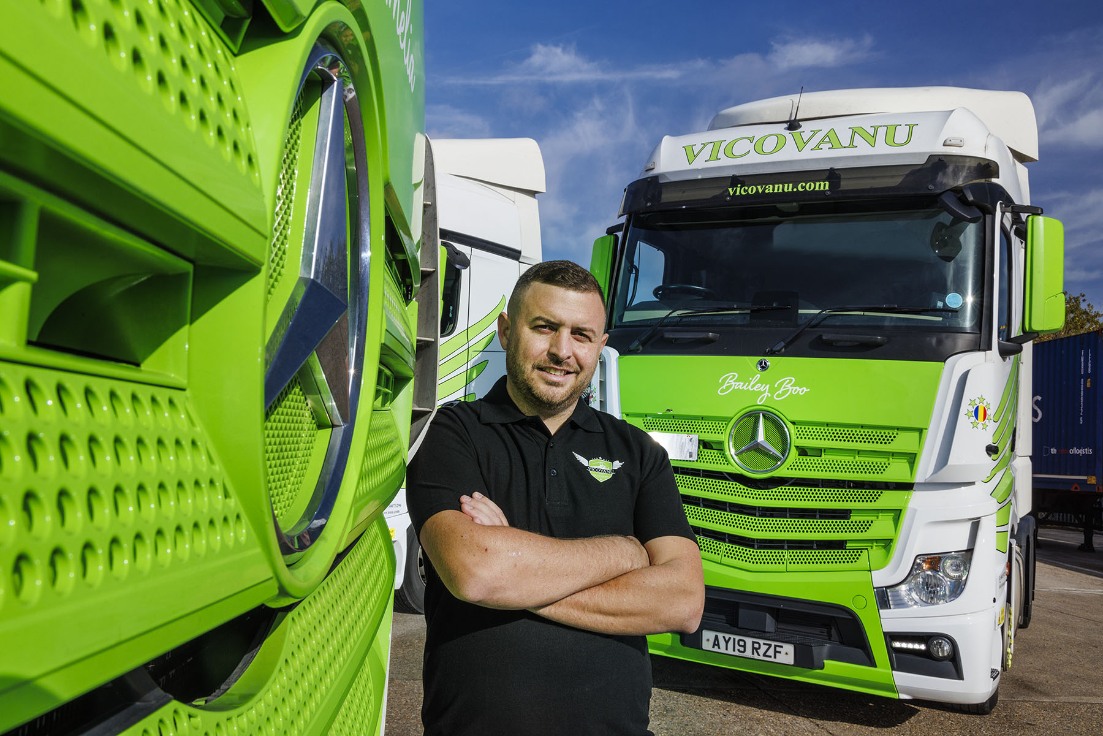

Green is for Go: Sergiu Vicovanu has built a 30-truck business in less than a decade

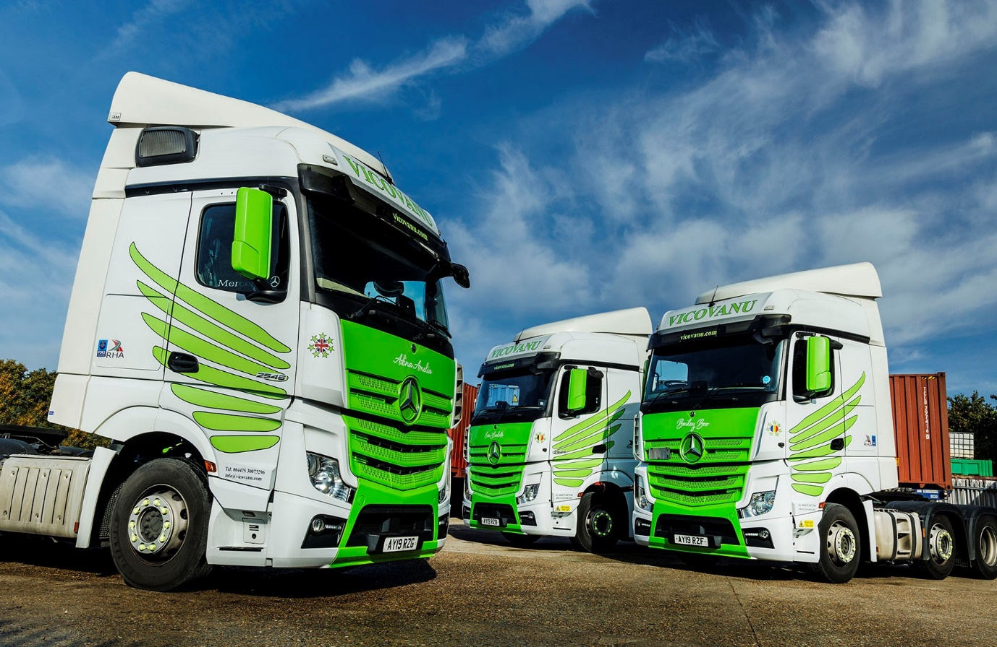

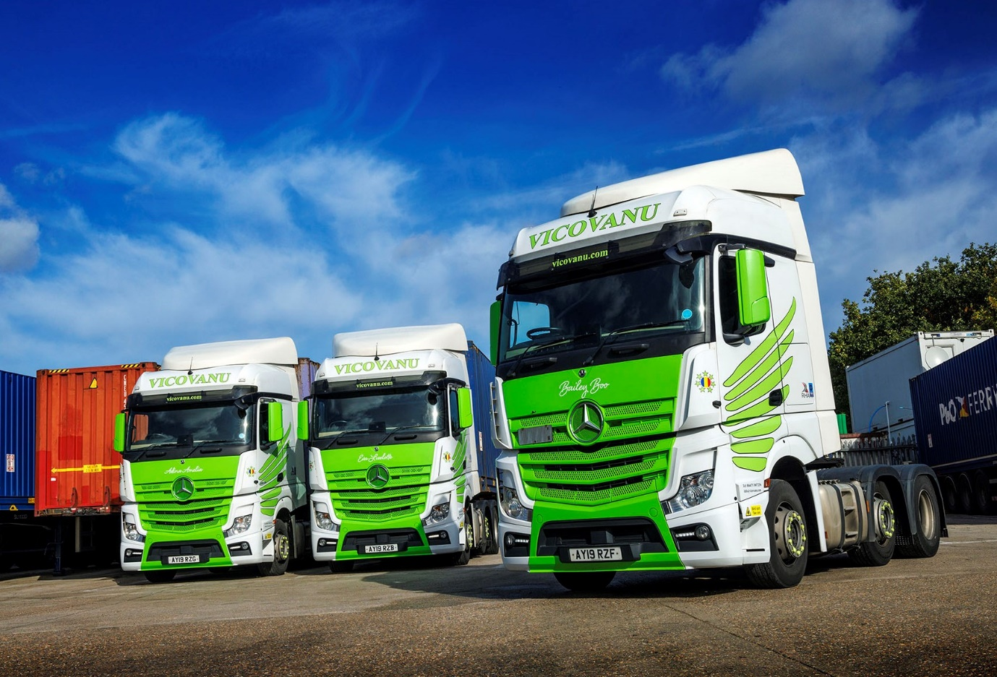

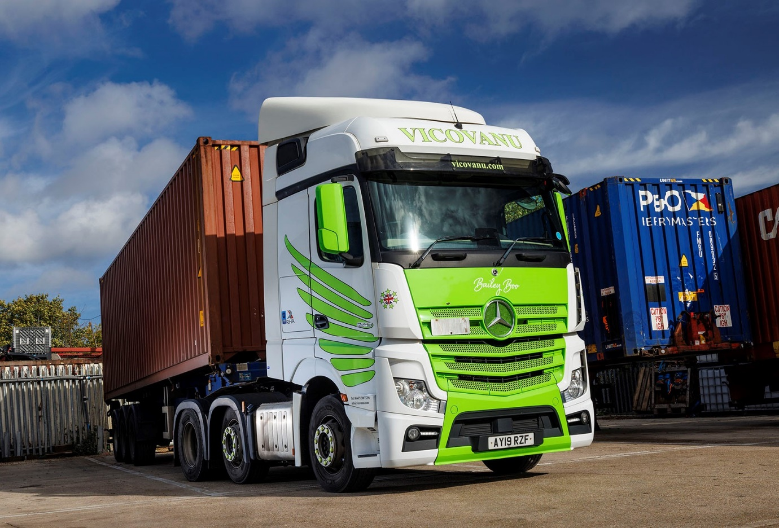

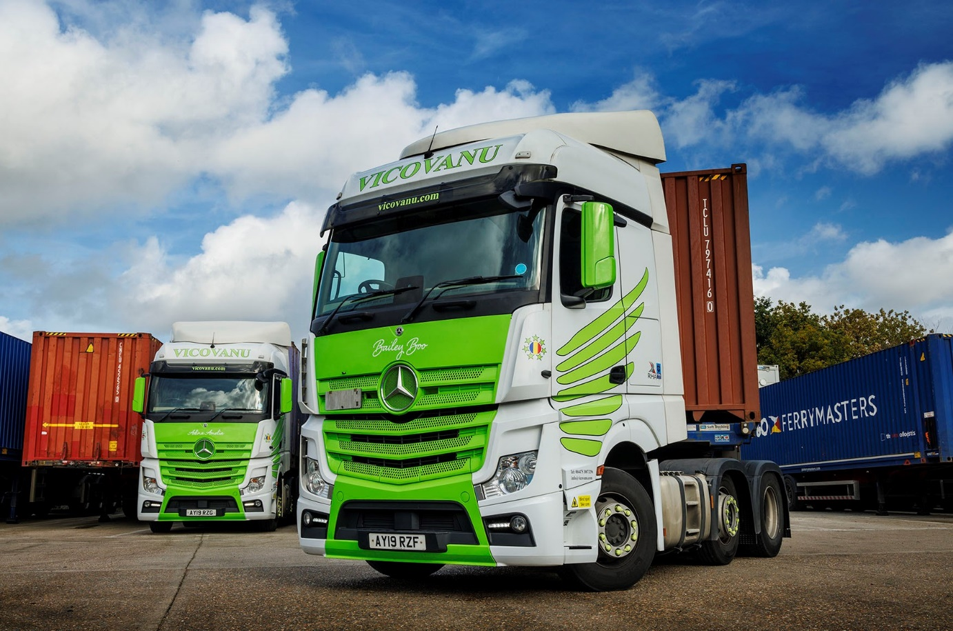

ends

For more information, or to request bigger/higher-res image files, please contact:
Steve Warren or John Ripley
Impact Communications
Steve: 07770 470251, steve@impactcom.co.uk
John: 07771 484595, john@impactcom.co.uk

