

Date: 20 August 2019

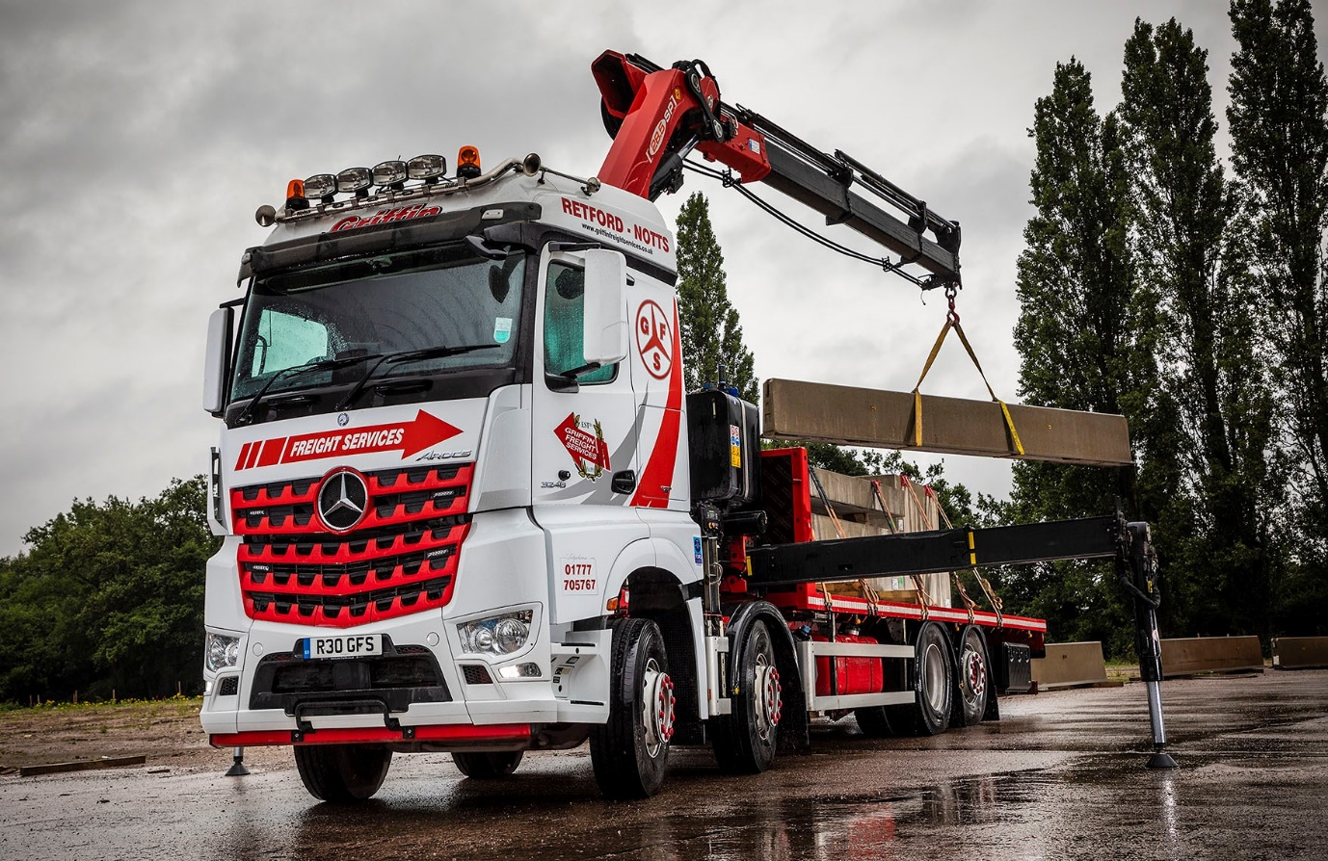

Griffin swoops for another 11 Mercedes-Benz trucks

Nottinghamshire’s Griffin Freight Services has turned once again to trusted supplier Northside Truck & Van for the latest Mercedes-Benz additions to a fleet that now extends to more than 50 trucks and is dominated by the three-pointed star.

The operator, which is preparing to move to a new 23-acre headquarters in its home town of Retford to meet continued growth in customer demand, has ordered 11 more vehicles from the manufacturer’s Truck Dealer of the Year.

The first four are already in service. All 8x2 Arocs 3248 models, they distribute building products, including pre-cast concrete sections, to construction sites nationwide. A fifth eight-wheeler is due to arrive shortly, while six Actros 2545 tractor units will start work as soon as the operator’s eye-catching liveries have been applied.

The Dealer is a preferred supplier to Griffin Freight Services, and has delivered some 80% – more than 50 in total – of the new trucks it has acquired over the last decade. The subject of Mercedes-Benz Complete Service Contracts, its latest vehicles will be inspected and maintained by the workshop team at Northside’s Doncaster branch.

The 32-tonne Arocs have StreamSpace cabs, and are powered by 12.8-litre straight-six engines which produce 350 kW (476 hp) and drive through 12-speed Mercedes PowerShift 3 automated manual transmissions. Their platform bodies are by Truck Hydraulics, of Doncaster, which also fitted one of the chassis with a PM 28 tonne/metre crane. Another carries a Moffett Mounty loader.

The 6x2 tag-axle Actros tractors also have StreamSpace cabs and 330 kW (450 hp) versions of the same engine, paired with 12-speed Mercedes PowerShift 3 transmissions.

Scott Bailey, Griffin Freight Services’ Transport Manager (Rigid & Crane Vehicles) said: “Mercedes-Benz has commanded the lion’s share of our fleet for many years now, because it’s trucks have proved to be reliable, cost-effective, and well able to cope with a tough working life.

“Just as importantly, though, we’ve also built an excellent working relationship with Northside Truck & Van. Its Sales Executive Nigel Hill manages our orders professionally, liaises with bodybuilders, and ensures that the vehicles are always delivered in perfect condition.

“The Dealer provides a very high level of back-up, too. The Service Contracts are competitively priced, and the workshop is open 24 hours a day, from Monday to Saturday. This allows us to keep downtime to a minimum, by getting any maintenance or repair work done outside our own hours of business. Support like that is priceless, and goes a long way towards ensuring that we remain loyal to the Mercedes-Benz brand.”

Griffin Freight’s latest rigids are being assigned to construction-related duties, distributing a variety of precast products to sites. The tractors, meanwhile, will work on including a relatively new contract which entails the delivery of six-metre-long precast concrete sections that form barriers in the central reservations of motorways.

The company was founded in 1991 by father and son Tim and Mick Griffin; Mick’s son Robert, is now also a Director. The owners and drivers take great pride in the smart appearance of their vehicles, which are frequently presented at truck shows across the country.

The current flagship is an Actros 2563, with range-topping GigaSpace cab and 460 kW (630 hp) 15.6-litre engine. Acquired in 2016 to mark its 25th anniversary, the ‘history truck’ is decorated with air-brush images of vehicles Griffin Freight has operated over the years.

www.griffinfreightservices.co.uk

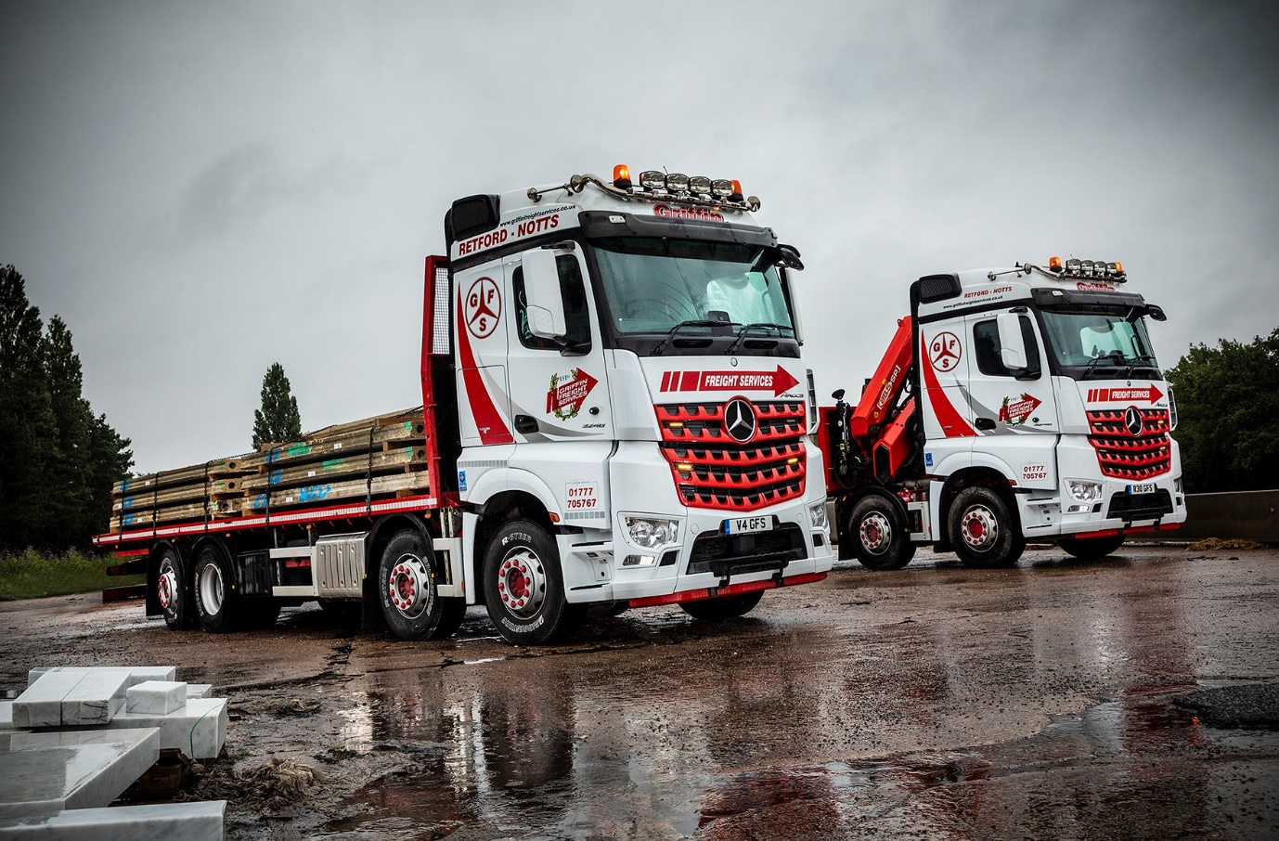

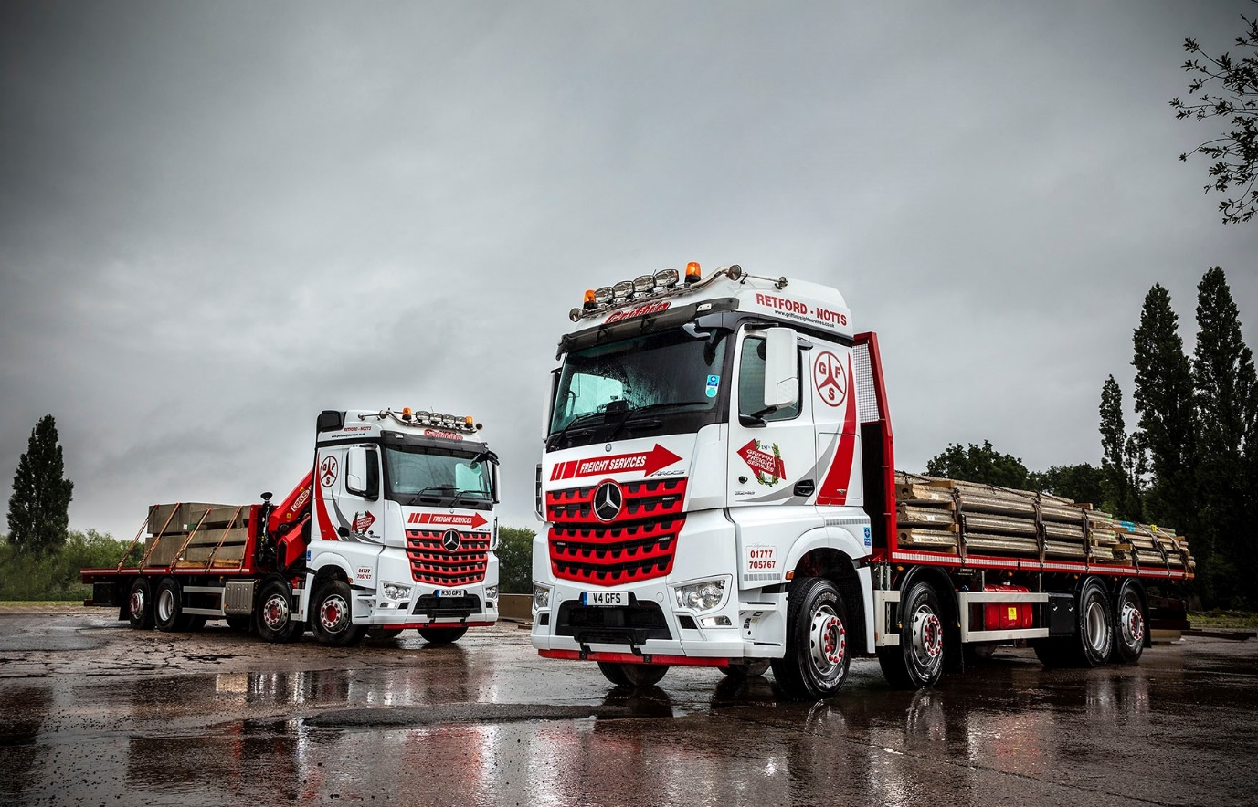

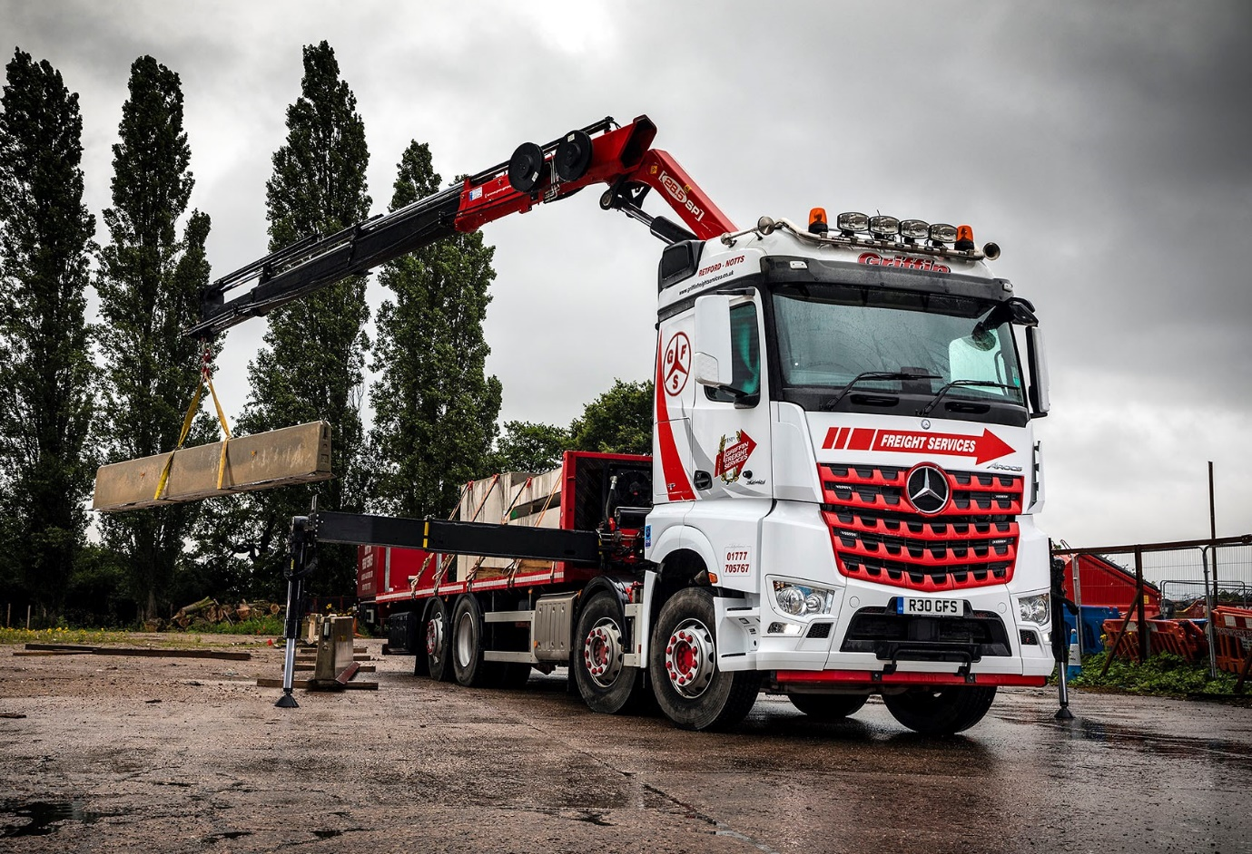

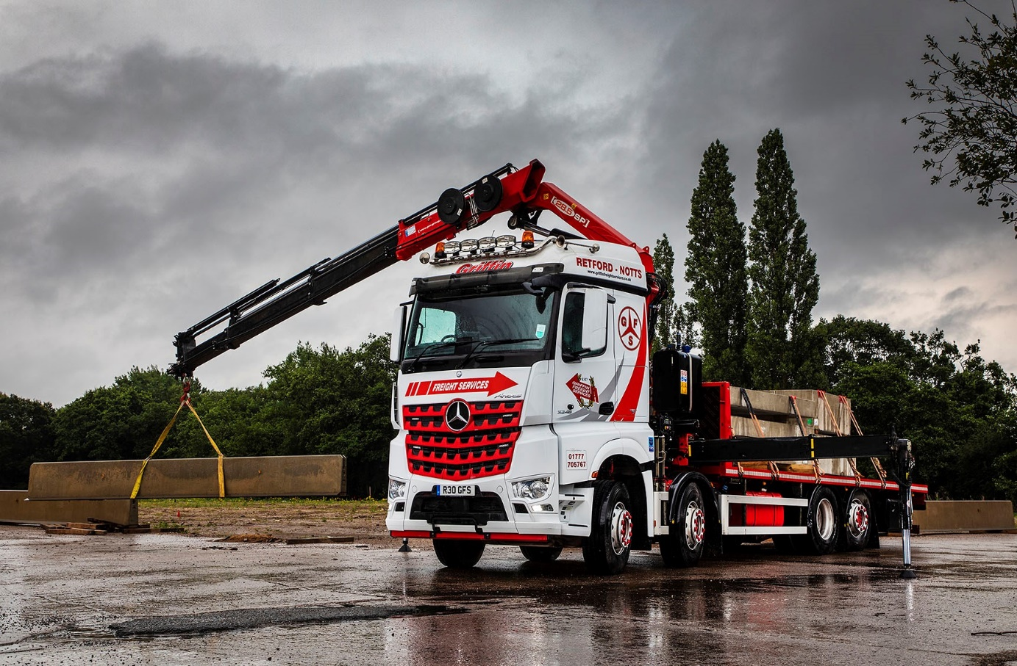

ends

For more information, or to request bigger/higher-res image files, please contact:
John Ripley or Steve Warren
Impact Communications, 01926 842126
John: 07771 484595, john@impactcom.co.uk
Steve: 07770 470251, steve@impactcom.co.uk

