

Date: 19 May 2021

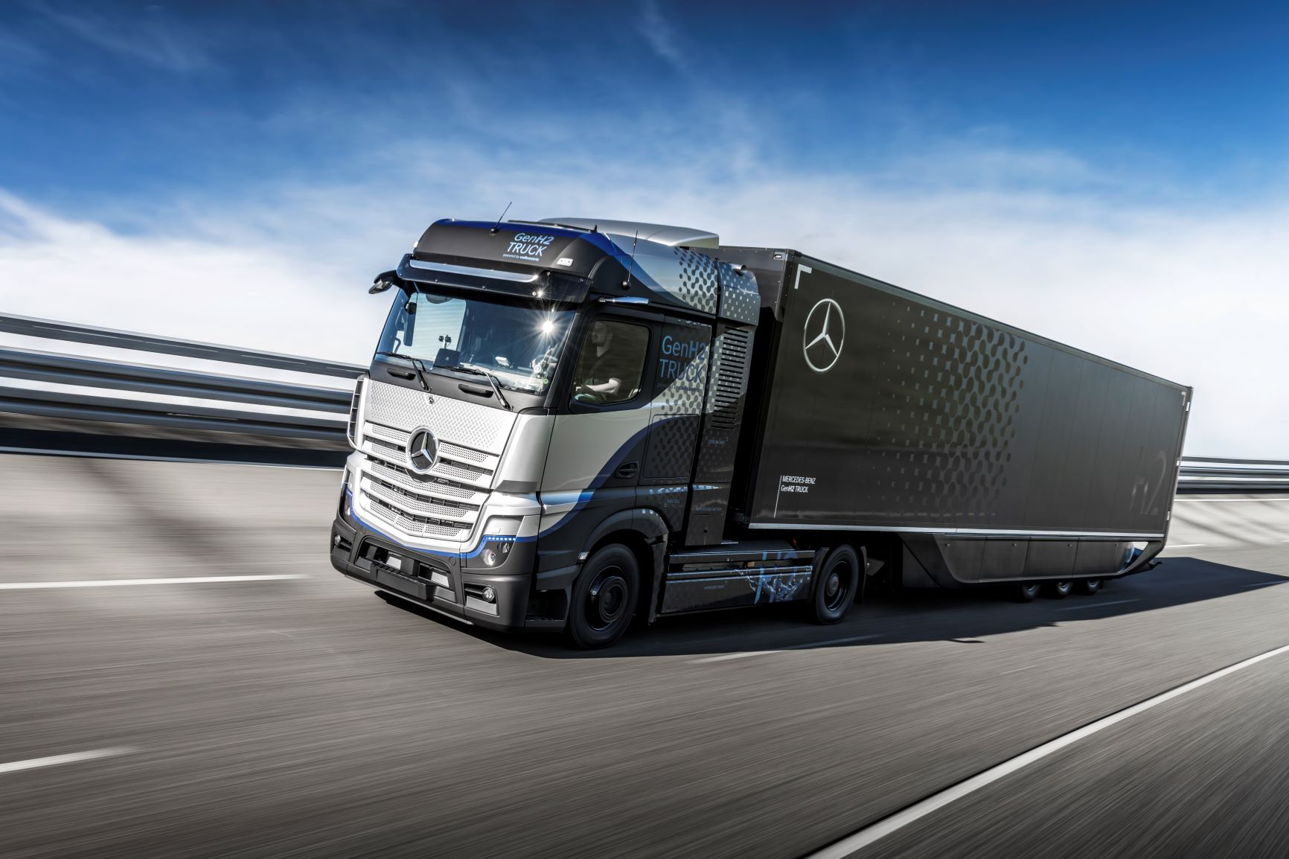

Daimler Trucks begins rigorous testing of its fuel-cell truck

- First enhanced prototype of the Mercedes-Benz GenH2 Truck on the test track since late April
- Wide range of tests are a further milestone on the path to series production
- Tests on public roads to take place this year, customer trials planned for 2023
- Martin Daum, CEO of Daimler Truck AG: “We are consistently pursuing our technology strategy for the electrification of our trucks. We’re right on schedule and I’m delighted that the rigorous testing of the GenH2 Truck has started successfully.”
Stuttgart – Daimler Trucks is focusing on hydrogen-powered fuel-cells for the electrification of its vehicles for flexible and demanding long-haul transport. It aims to achieve ranges of up to 1,000 kilometres and more without any stops for refuelling. In late April, the truck manufacturer began to conduct rigorous tests of the first new enhanced prototype of its Mercedes-Benz GenH2 Truck, which was unveiled in 2020. This marks an important milestone on the path to series production. During these tests, the developers at Daimler Trucks are putting the fuel-cell vehicle through its paces. The extensive series of tests is very demanding for the vehicle and its components, and focuses, among other things, on continuous operation, different weather and road conditions, and various driving manoeuvres.

According to Daimler Trucks’ development plan, the vehicle will also be tested on public roads before the end of the year. Customer trials are scheduled to begin in 2023. The first series-produced GenH2 Trucks are expected to be handed over to customers starting in 2027.

Martin Daum, Chairman of the Board of Management of Daimler Truck AG and Member of the Board of Management of Daimler AG: “We are consistently pursuing our technology strategy for the electrification of our trucks. We want to offer our customers the best locally CO2-neutral trucks — powered by either batteries or hydrogen-based fuel-cells, depending on the use case. We’re right on schedule and I’m delighted that the rigorous tests of the GenH2 Truck have started successfully.”

“The hydrogen-powered fuel-cell drive will become indispensable for CO2-neutral long-haul road transport in the future. This is also confirmed by our many partners with whom we are working together at full steam to put this technology on the road in series-production vehicles. Moreover, considerable momentum is being generated by the clear commitment of national and European regulators to the use of hydrogen for road freight transport. Political support plays an important role in promoting the creation of an infrastructure for green hydrogen and making an economically viable use of fuel-cell trucks possible for our customers,” Daum adds.

Demanding tests for 1.2 million kilometres of operating performance

The development engineers at Daimler Trucks are designing the GenH2 Truck so that the vehicle and its components meet the same durability requirements as a comparable conventional Mercedes-Benz Actros. This means 1.2 million kilometres on the road over a period of ten years and a total of 25,000 hours of operation. That’s why the GenH2 Truck has to complete extremely demanding tests — just like every other new Actros generation. During the first few weeks of testing, the vehicle has already covered hundreds of kilometres under continuous load on a road-to-rig test stand and gone through many extreme situations that are based on real-life operating conditions. Examples include emergency braking and kerbstone drives along the test track.

Completely new vehicle concept and new components

The GenH2 Truck has been newly designed from the ground up. It features completely new components, which the developers are particularly focusing on during the tests. These components include the fuel-cell system, the all-electric powertrain, and all of the associated systems such as the special cooling unit. In addition, the new components’ specific weight and position in the vehicle affect the truck’s handling properties. As a result, the vibrations caused by bumpy roads, for example, and especially by extreme situations, subject the fuel-cell truck to different forces than those in conventional vehicles. In order to obtain extensive information about this at an early stage, the current prototype is loaded during the tests with a payload of up to 25 tonnes for a gross vehicle weight of about 40 tonnes, which is identical with the specifications planned for the series-produced variant of the GenH2 Truck.

Liquid hydrogen offers many advantages

Daimler Trucks prefers to use liquid hydrogen because in this state, the energy carrier has a far higher energy density in relation to volume than gaseous hydrogen. As a result, the tanks of a fuel-cell truck using liquid hydrogen are much smaller and, due to the lower pressure, significantly lighter. This gives the trucks more cargo space and a higher payload. At the same time, more hydrogen can be carried, which significantly increases the trucks’ range. This makes the series GenH2 Truck, like conventional diesel trucks, suitable for multi-day, difficult-to-plan long-haul transport and where the daily energy throughput is high.

The experts at Daimler Trucks are forging ahead with the development of tank technologies for liquid hydrogen on the basis of a predefined development plan. By the end of the year, the engineers plan to have the new prototype tank system sufficiently mature to be used to continue the ongoing demanding tests of the GenH2 Truck. The vehicle tests will then be conducted exclusively with liquid hydrogen tank systems until the series-production stage is reached. Until this can be done, the extensive internal testing of the GenH2 Truck will use a gaseous hydrogen tank system as an interim solution. Daimler Trucks is thus demonstrating that both variants - gaseous and liquid - can be technically implemented.

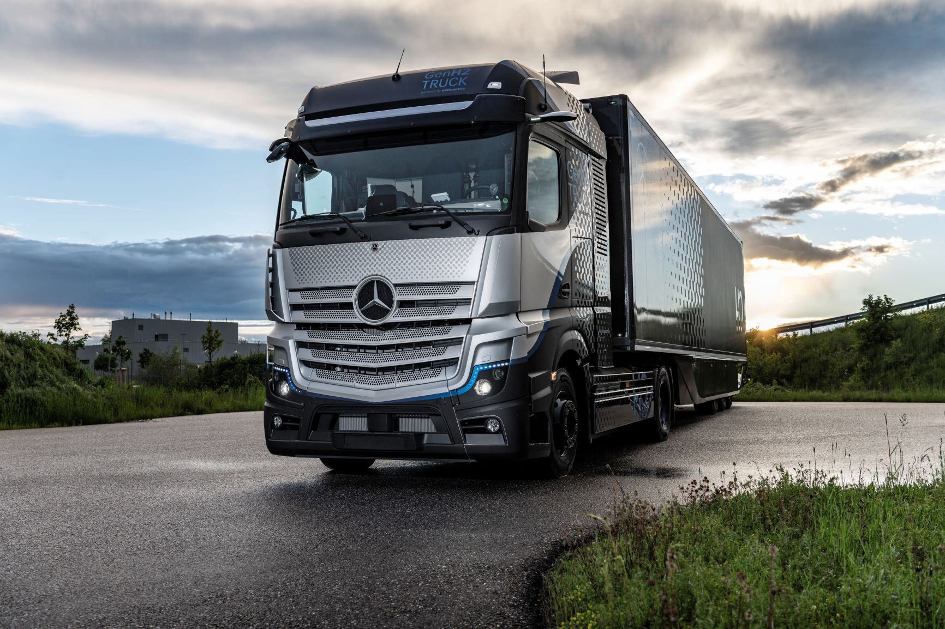
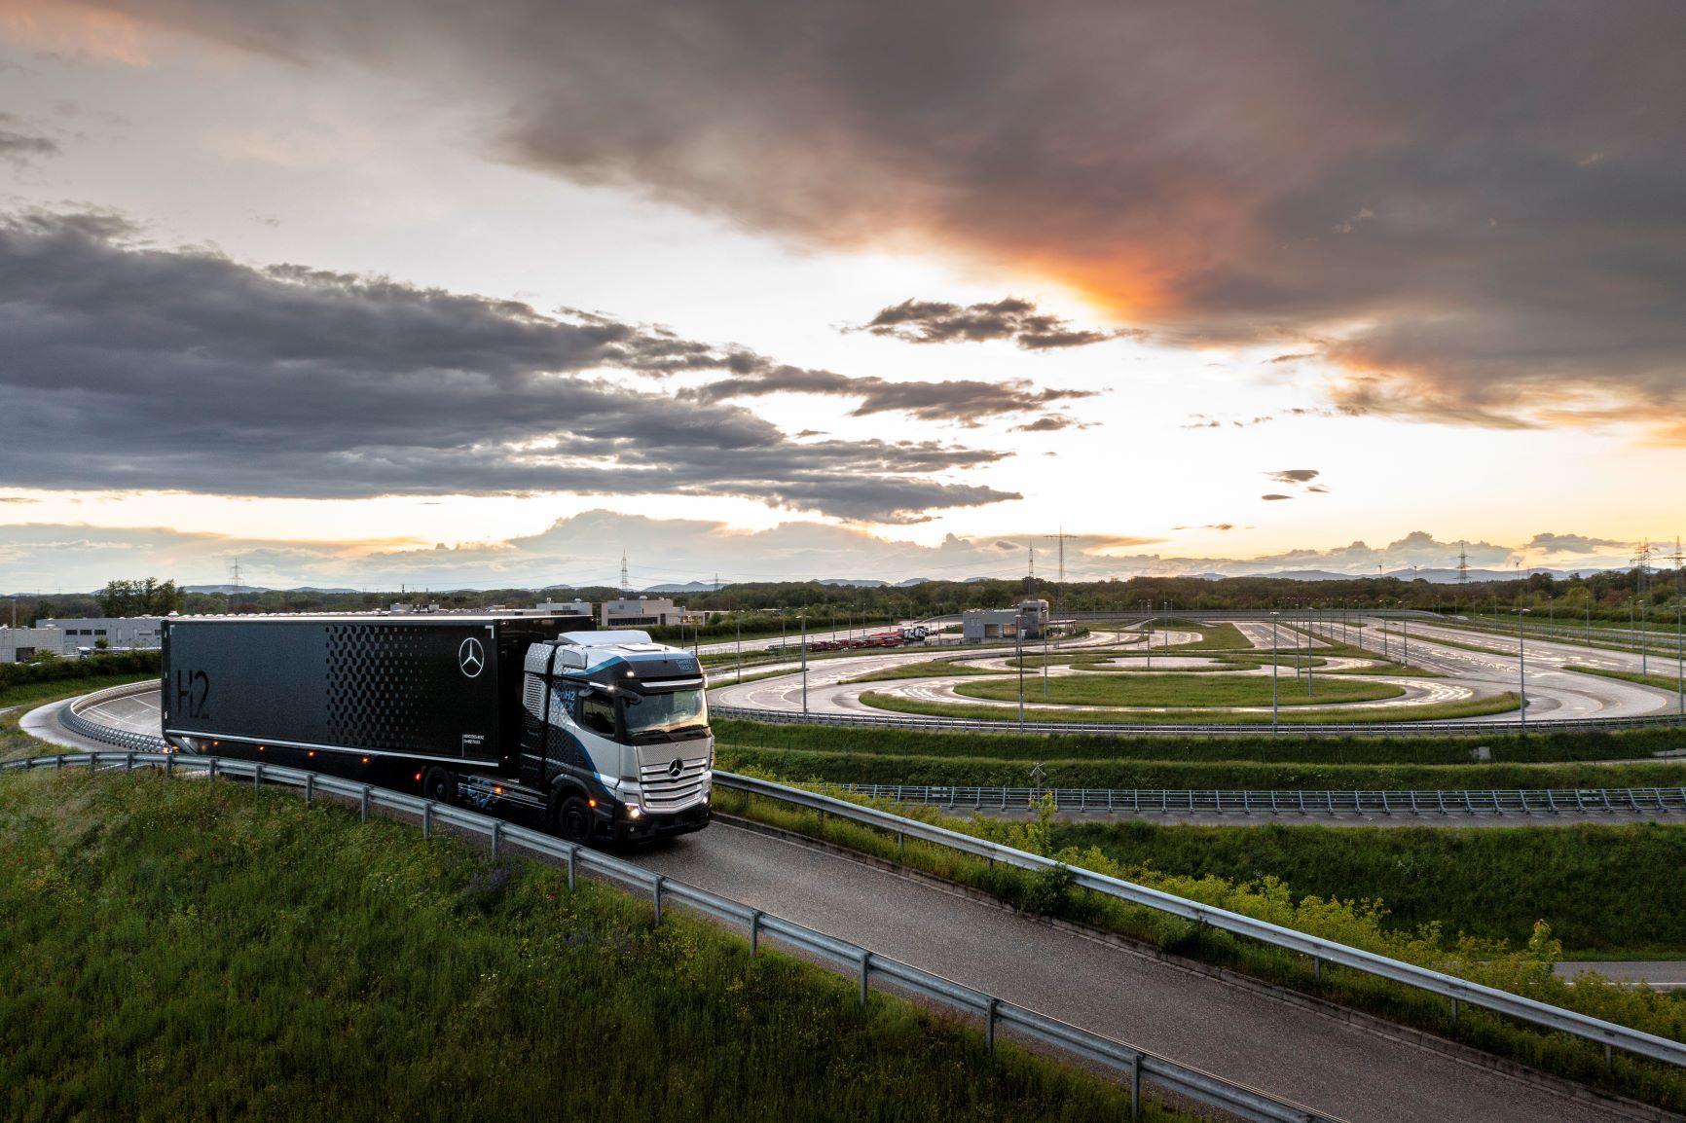

ends

For more information, or to request higher-res image files, please contact:

Jamie Fretwell at Mercedes-Benz Trucks UK Ltd
07712 519230, jamie.fretwell@daimler.com

or

Peter Smodej, +49 176 30936446, peter.smodej@daimler.com
Florian Laudan, +49 176 30930878, florian.laudan@daimler.com
Akim Enomoto, +49 176 30995099, akim.enomoto@daimler.com

Further information on Daimler Truck is available at:
www.media.daimler.com and www.daimler-truck.com

Forward-looking statements:
This document contains forward-looking statements that reflect our current views about future events. The words “anticipate,” “assume,” “believe,” “estimate,” “expect,” “intend,” “may,” ”can,” “could,” “plan,” “project,” “should” and similar expressions are used to identify forward-looking statements. These statements are subject to many risks and uncertainties, including an adverse development of global economic conditions, in particular a decline of demand in our most important markets; a deterioration of our refinancing possibilities on the credit and financial markets; events of force majeure including natural disasters, pandemics, acts of terrorism, political unrest, armed conflicts, industrial accidents and their effects on our sales, purchasing, production or financial services activities; changes in currency exchange rates, customs and foreign trade provisions; a shift in consumer preferences towards smaller, lower-margin vehicles; a possible lack of acceptance of our products or services which limits our ability to achieve prices and adequately utilize our production capacities; price increases for fuel or raw materials; disruption of production due to shortages of materials, labor strikes or supplier insolvencies; a decline in resale prices of used vehicles; the effective implementation of cost-reduction and efficiency-optimization measures; the business outlook for companies in which we hold a significant equity interest; the successful implementation of strategic cooperations and joint ventures; changes in laws, regulations and government policies, particularly those relating to vehicle emissions, fuel economy and safety; the resolution of pending government investigations or of investigations requested by governments and the conclusion of pending or threatened future legal proceedings; and other risks and uncertainties, some of which are described under the heading “Risk and Opportunity Report” in this Annual Report. If any of these risks and uncertainties materializes or if the assumptions underlying any of our forward-looking statements prove to be incorrect, the actual results may be materially different from those we express or imply by such statements. We do not intend or assume any obligation to update these forward-looking statements since they are based solely on the circumstances at the date of publication.

Daimler Truck at a Glance
The Daimler Truck AG is one of the worldʼs largest commercial vehicle manufacturers, with more than 35 primary locations around the world and approximately 100,000 employees. The company brings together seven vehicle brands under one roof: Mercedes-Benz (light, medium and heavy trucks as well as city, intercity and touring coaches) and Setra (intercity, long-distance and premium coaches) are our traditional European brands; our U.S. brands Freightliner Trucks (trucks in weight classes 5 to 8 for a wide range of commercial vehicle applications), Western Star (heavy trucks for specialized and long-haul transports) and Thomas Built Buses (light to medium-duty buses); and our Asian brands Bharat Benz, based in Chennai, India (trucks in the weight classes 10 to 55 t and medium and heavy-duty buses) and FUSO with its headquarters in Japan (trucks and buses for Asia, the Middle East, Africa, Europe and Latin America). This allows the Daimler Truck AG to offer its customers around the globe a broad spectrum of commercial vehicles, ranging from minibuses to heavy-duty trucks for special-purpose transport applications – in short: products and solutions for everyone who keeps the world moving. Gottlieb Daimler and Carl Benz laid the foundation for the modern transport industry 125 years ago. Over the past decades, Daimlerʼs truck and bus divisions have consistently set standards for the entire transportation industry – in terms of safety, fuel efficiency and driver and passenger comfort. It is now time for the next evolutionary step: emission-free, automated and connected driving. Daimler Trucks & Buses is working to bring these important technologies to high-volume series production, across brands, divisions and regions. In this way the company intends to take a major step closer to realizing its vision of CO2-neutral transport and accident-free driving whilst also contributing to the sustainability of global goods and passenger transport. In 2020, a total of 378,500 trucks and buses were delivered. In 2020 the revenue of the individual areas of business amounted to € 35 billion for the Daimler Truck AG. The adjusted EBIT was € 678 million for the Daimler Truck AG.

