

Date: 5 January 2024

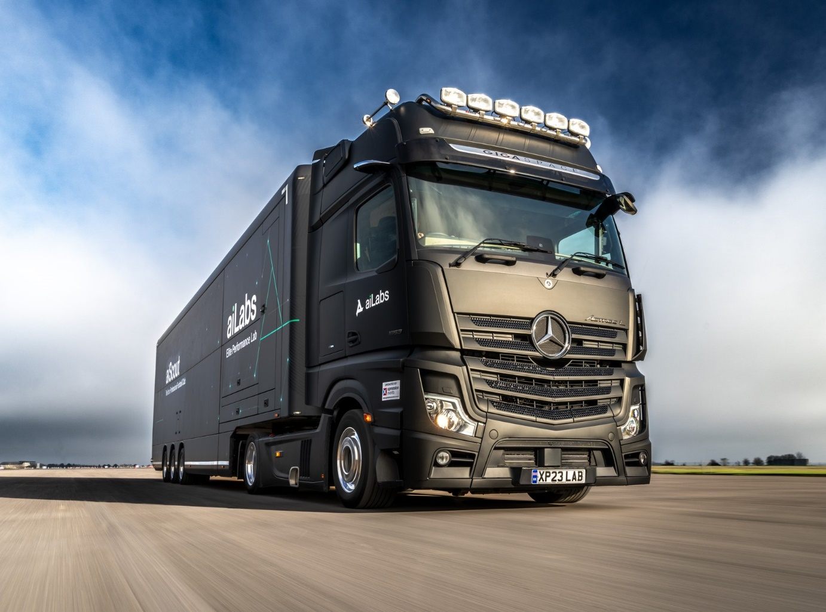

Matt black Mercedes-Benz Actros is Xpression’s shining star

This stunning Mercedes-Benz Actros L rig is now bringing cutting edge artificial intelligence-driven performance analysis to some of the UK’s leading professional sports teams.

Operated by specialist haulier Xpression Event Solutions, based in North Oxfordshire, the Actros L 1853 works with a purpose-designed mobile laboratory trailer owned by sports science contractor ai.io. Trailer and tractor are finished in eye-catching matt black and bear the livery of the company’s aiLabs division.

It was supplied with funding support via Daimler Truck Financial Services by Dealer Sparshatt Truck and Van, who will also maintain the truck under the terms of a Mercedes-Benz Service Contract.

The vehicle visits leading sports organisations – including leading top-flight football clubs – to provide a range of expert services that help teams and individuals to measure, understand and improve their capabilities across a range of metrics.

Although owned by ai.io and staffed by its expert scientists and technicians, the trailer is maintained and transported by Xpression Event Solutions.

“This is a premium service and aiLabs’ customers are some of the biggest names in sport, so obviously when choosing a truck to haul their trailer, quality was of paramount importance,” said Xpression Managing Director Jonathan Hill.

“The Actros L fits the bill perfectly. It has all the presence and brand image we could wish for, backed up with renowned Mercedes-Benz reliability and performance.”

Xpression’s new truck has a range-topping, flat-floored GigaSpace cab and is powered by a muscular 390 kW (530 hp), 12.8-litre in-line six-cylinder engine. Its specification includes MirrorCam rear-facing cameras, in place of traditional side mirrors, which relay their images to screens inside the cab, as well as safety equipment including Active Brake Assist 5 autonomous braking with pedestrian recognition, as well as Attention Assist, Traffic Sign Assist and Proximity Control Assist systems.

“This was our first Mercedes-Benz truck from Sparshatt and we’ve been very impressed with the service,” continued Mr Hill. “Sales Executive Nick Fuller made the whole process smooth and painless, and the workshop set-up looks very professional.

“Meanwhile the truck itself is everything we hoped for. Before setting up Xpression, my fellow Director Paul Mitchell and I both drove for top motorsport teams which used Mercedes-Benz tractors to haul their race transporters and hospitality trailers. We know the Actros is a great vehicle to drive and the roomy GigaSpace cab provides a real home from home.”

Established in 2007, Xpression Event Solutions has grown steadily and now runs a fleet of 18 trucks. These are used to transport hospitality and display trailers to roadshows, exhibitions and sports events throughout the UK and Europe, as well as for general event logistics.

The aiLabs trailer is equipped to offer comprehensive sports analytics solutions to teams and clubs across a variety of disciplines, with testing methods and metrics that can be adjusted to meet specific requirements.

The advanced biometric and cognitive analysis data gathered can help individual and team performance development, as well as supporting recruitment, scouting, tactical planning, management of injury recovery and even engagement with fans and supporters.

“We’re immensely proud to help represent the aiLabs brand and this Mercedes-Benz Actros is the perfect reflection of the high standard of service we pledge to provide,” added Mr Hill.

www.xpressionevents.co.uk
www.ai.io/ailabs

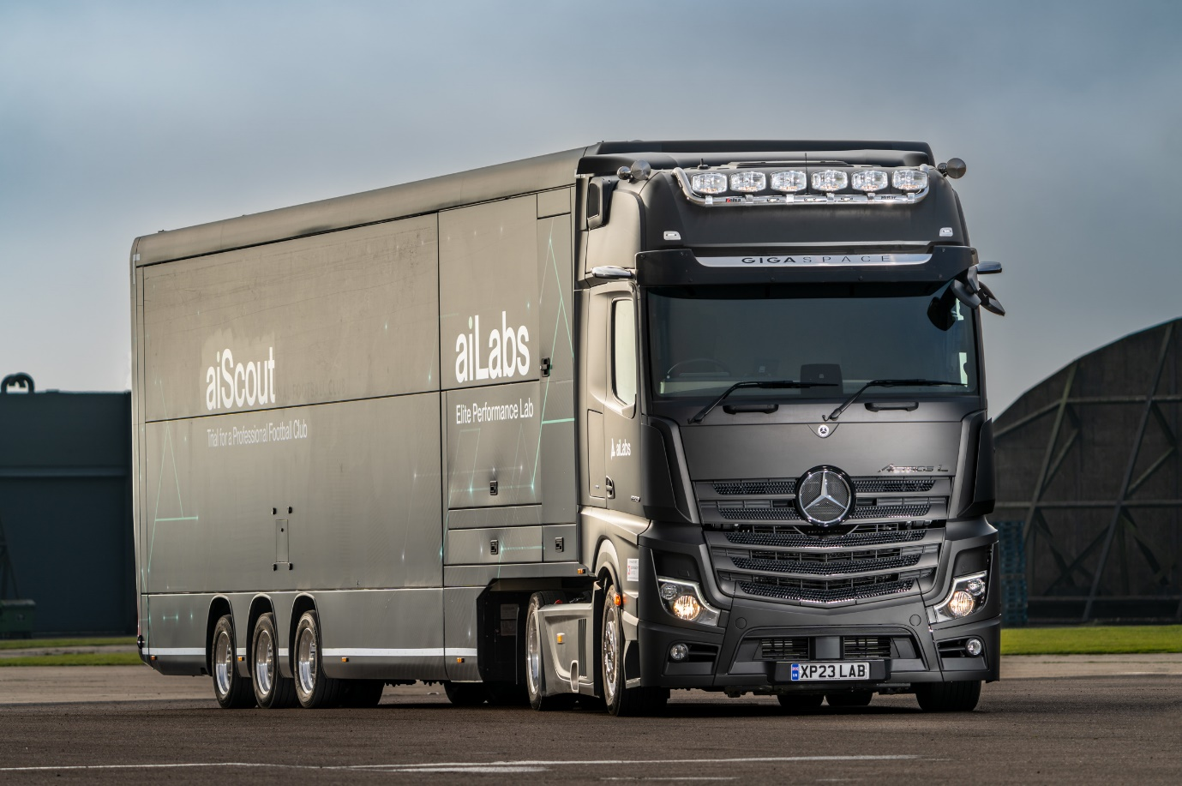

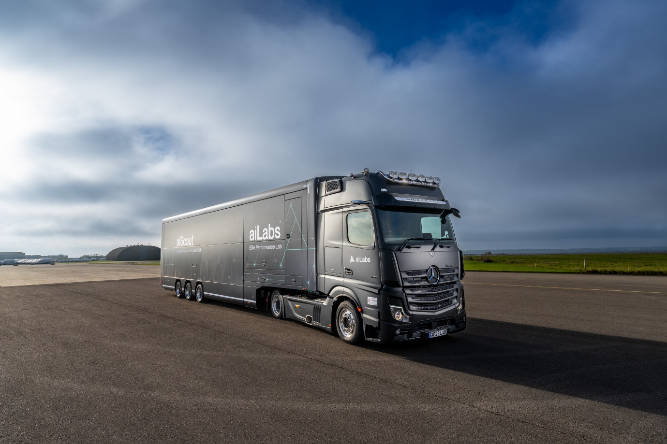

ends

For more information, or to request bigger/higher-res image files, please contact:
John Ripley: john@loopagency.co.uk 07771 484595

