

Date: 11 November 2024

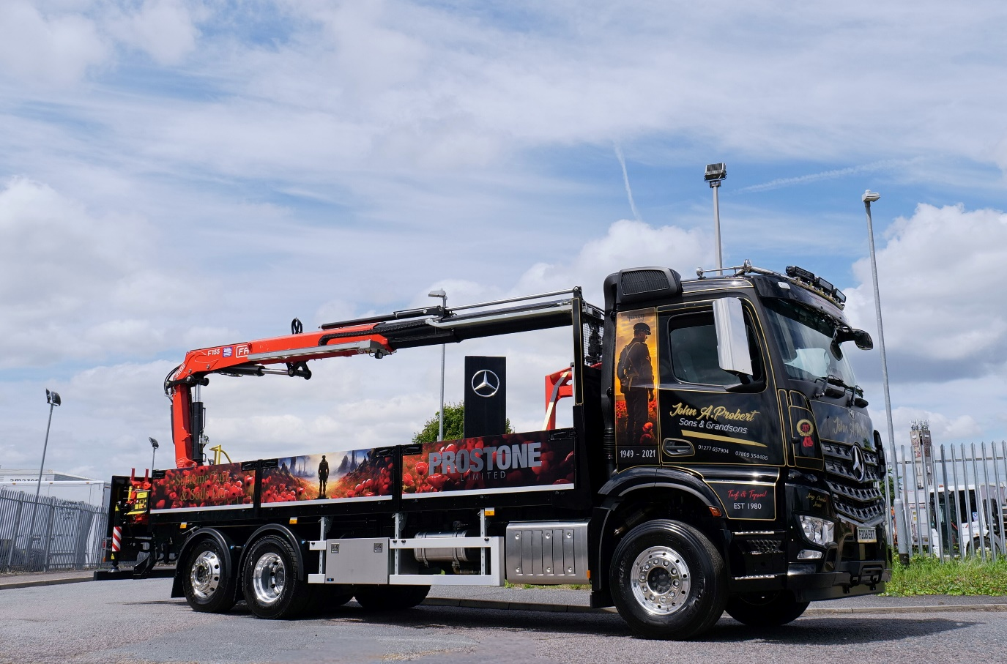
Memorial Mercedes-Benz Arocs blooms on poppy day

As the nation remembers its fallen heroes on Armistice Day, one Mercedes-Benz truck operator has created a stunning tribute to both his father and the Royal British Legion’s Poppy Appeal.

The latest Arocs to join the fleet of Essex-based family firm John A Probert, Sons & Grandsons is decorated with flowing fields of poppies along its full length, while an airbrushed soldier stands guard on either side of the cab.

Proprietor Joe Probert explained: “We wanted to do something special with this vehicle to reflect our ongoing support of the Poppy Appeal. We make a big effort to promote the campaign every year and we hope this truck will help to focus attention on a very worthy cause, not just on and around the 11th of November, but for the rest of the year too.”

Joe’s grandfather, Alf, served in the Army and was wounded during World War II, while his father, John, set up the family business in 1980. Known to many of his customers simply as ‘Turfy’, John was a life-long supporter of charities for ex-service personnel, so the Arocs also bears his nickname and the years of his life, 1949-2021.

“My Dad started the business, supplying turf and topsoil, with a wheelbarrow and a spade,” Joe continued. “I joined him as soon as I left school and then took over when he retired. We now run six trucks, three of which are from Mercedes-Benz. In 2002 we set up a separate business trading as Supreme Turf, and five years later we added a paving and hard landscaping division, Prostone.

“Dad was a huge supporter of the Poppy Appeal and since he died, we’ve continued that effort in his memory. So, the new truck and its livery are our way of paying tribute to Dad as well as to the former soldiers that were so close to his heart,” Joe added.

Supplied by Dealer Motus Truck & Van, the 6x2 Arocs 2532 has a ClassicSpace L-cab and dropside bodywork, and a rear-mounted Fassi F155 crane with Kinshofer grab. It is powered by a 7.7-litre in-line six-cylinder engine with an output of 235 kW (320 hp).

“We’ve spent a lot on this vehicle, but I have to say it looks fantastic,” added Joe. “The Arocs is a real workhorse too, and well proven to be reliable and cost-effective. Motus Truck & Van look after us very well – Sales Consultant Steve Jenkins understands our business and always helps us get the specification of both the chassis and all ancillaries just right. We couldn’t be happier.”

ends

For more information, please contact:

John Rawlings, Account Director, Loop
07847 371436 john.rawlings@loopagency.co.uk

