

Date: 9 July 2024

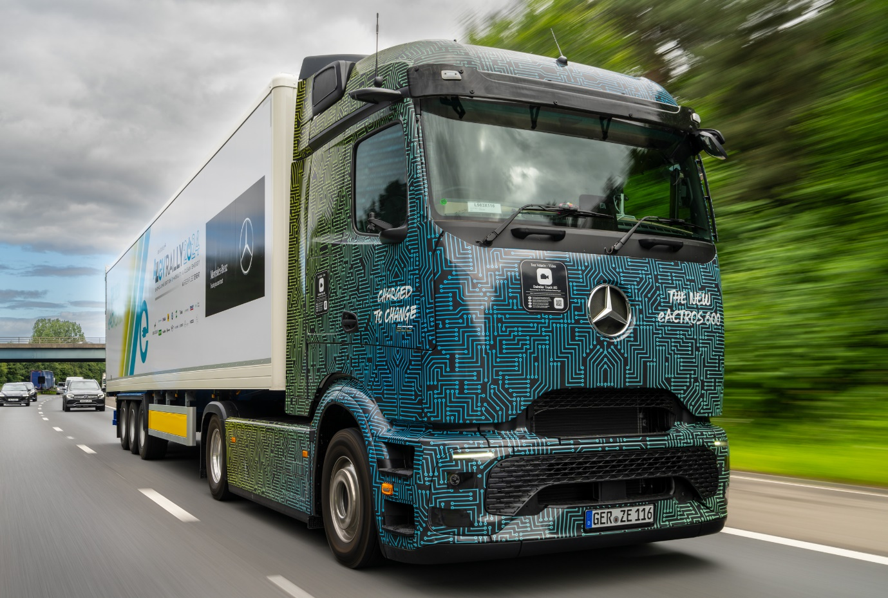

Mercedes-Benz eActros 600 completes EV Rally tour around the A-Z of Britain

A battery-powered Mercedes-Benz eActros tractor unit has proved its readiness for work in the UK by completing a gruelling five-day, 1,400-mile journey around the country.

Hauling a standard road trailer, and fully freighted at 40 tonnes GVW, the eActros 600 easily saw off the challenge of this year’s EV Rally event.

Held from July 1-5, EV Rally 2024 saw 50 vehicles of varying sizes and types set off from Oldbury in the West Midlands, on a tour that took in visits to 26 locations corresponding to every letter of the alphabet – albeit with some creative licence when it came to the letters x and z.

Although the event was open to all electric vehicles, just two trucks took part and the eActros was the only tractor unit. Day one involved a 258-mile drive via five intermediate checkpoints to finish in Carlisle. Day two’s route covered 285 miles, ending at the Daimler Truck UK complex at Wentworth Park, near Sheffield.

Day three held the longest single day’s drive, at 366 miles on a circuitous route to Cambridge, while the fourth instalment saw participants cover 315 miles to Exeter. Finally, the last stint of 265 e-miles brought the participants through Wales to the finish line in Chester. The eActros also visited many of the national network of Mercedes-Benz truck dealers on its journey around the country.

Daimler Truck UK Head of Future Sustainability, James Venables, was among the eActros driving team. He was interviewed at the end of day two by Sara Sloman, of the EV Rally Media Crew, who observed: “You’ve definitely stolen the show this year – whenever the eActros turns up, heads turn.”

James agreed and added: “The truck is big, bold and exciting and taking part in this event has been great fun but, more importantly, we’ve proved that our engineers are right when they say the truck can cover 500 km on a single charge.

“The EV Rally is all about showcasing today’s electric vehicles and the fact that a multi-day marathon journey is very much achievable, using the current network of charging points. As the national infrastructure develops that will only get easier.

“With its fantastic range ability, potentially boosted even further by energy recovery through recuperation, we believe our eActros 600 could have completed each day’s course without the need for any additional recharging – but in the spirit of the event, to show how easy it is to top up during a day’s work, we did stop at some of the designated charge points. Using a 350 kW charger we were able to top up to 60% in about an hour, which was very impressive.”

James continued: “What we demonstrated, without doubt, is that the eActros 600 is perfectly capable of slotting into most UK road transport applications seamlessly, offering an option that’s entirely free of exhaust emissions while also being exceptionally smooth, quiet and comfortable to drive.”

The Mercedes-Benz eActros 600 is available to order now through the manufacturer’s national Dealer Network, with production starting in December.

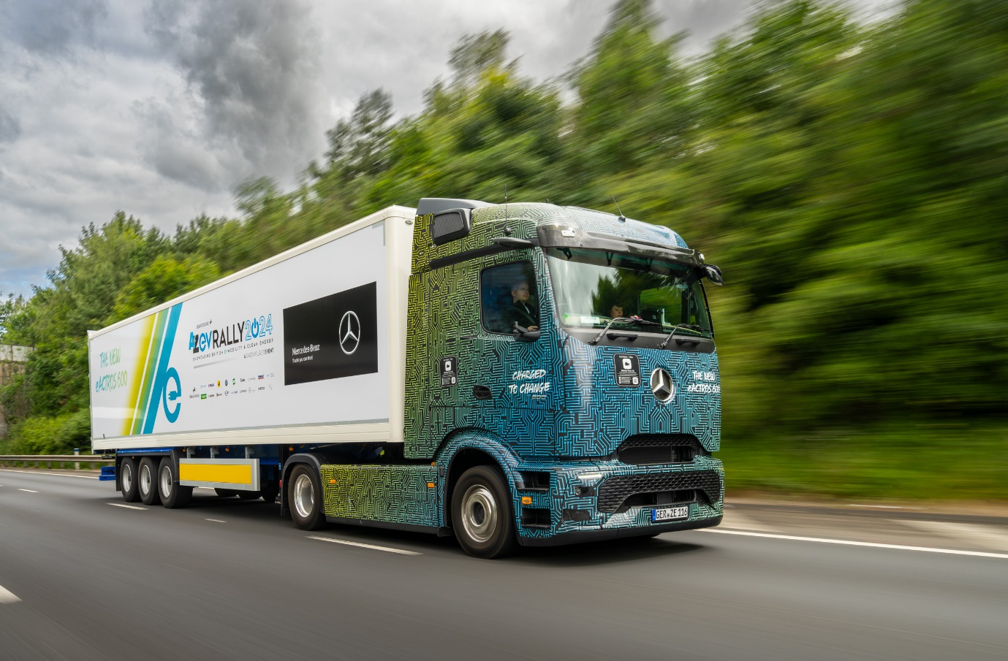

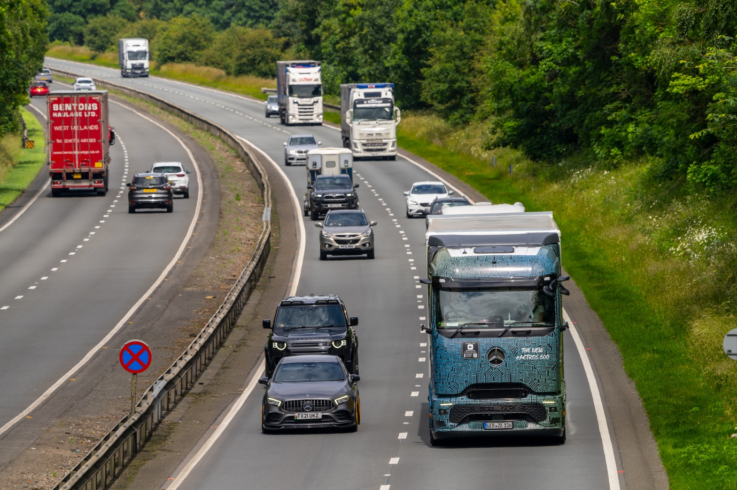

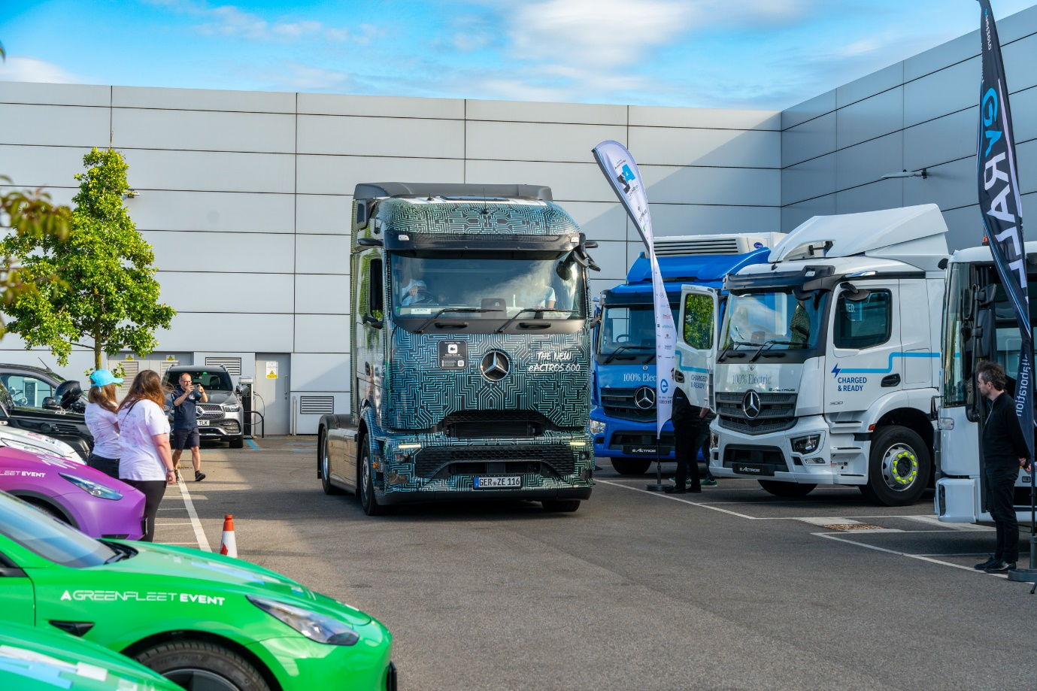

Home run: the eActros 600 arrives at Wentworth Park
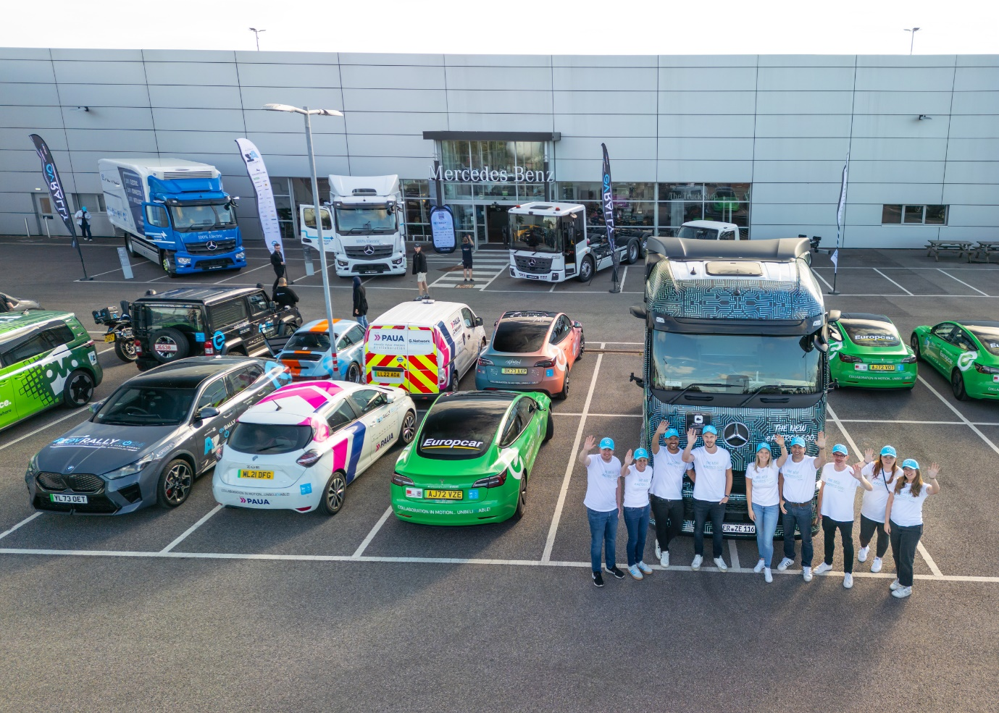

Tour de force: the Mercedes-Benz eActros 600 and support team

ends

For more information, or to request higher-res image files, please contact:

Dominic Dawes at Daimler Truck UK
07864 600148, dominic.dawes@daimlertruck.com

or

John Ripley: 07771 484595, john.ripley@loopagency.co.uk

