

Date: 10 July 2020

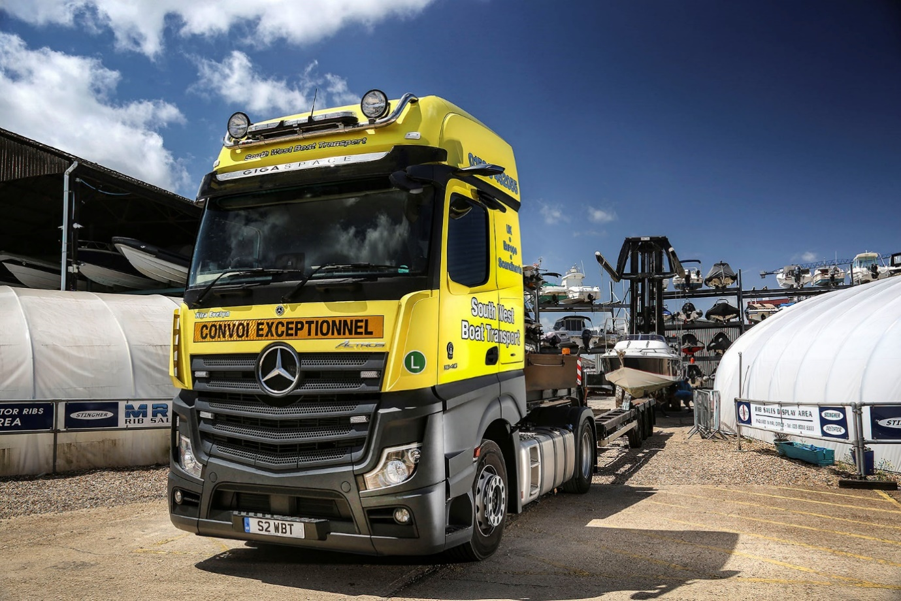

Boat transporter rides the crest of a technological wave with new Mercedes-Benz Actros from Marshall

“Bulletproof” reliability on regular runs into southern Europe meant that when the time came to replace his first Mercedes-Benz Actros, boat transport specialist Michael Whelan charted a course straight back to his local Dealer for a new-generation version of the same truck.

With bases in Lymington, on The Solent, and Plymouth, South West Boat Transport serves boat builders, marinas and yacht brokers, as well as private individuals. Its 4x2 tractor units move motor cruisers and sailing yachts on air-suspended boat trailers with adjustable supports, throughout the UK, Continental Europe and Scandinavia.

Mr Whelan established his business in 2005, and for the next eight years ran trucks by another manufacturer. “It turned into a bit of a nightmare, though,” he recalled, “as we suffered a series of breakdowns.

“I acquired my first Actros in 2013 and was so pleased with its performance that I added a second two-and-a-half years ago. Our trucks typically cover 100,000 km each year, but I’ve not had one breakdown since I switched to Mercedes-Benz.

“As well as being bulletproof when it comes to reliability, the Actros is competitively priced, good on fuel, and extremely comfortable. Week in, week out, these vehicles do the job I need them to do, so there’s absolutely no reason for me to change.”

Mr Whelan drives the new unit, which arrived via the Southampton branch of Dealer Marshall Truck & Van. An 1848 model, it is smartly finished in South West Boat Transport’s favoured Sulphur Yellow.

The range-topping GigaSpace cab sports a roof-mounted Kelsa beacon bar with additional spotlights, while the contemporary StyleLine interior features aluminium-look and chrome trim, and is equipped with a pull-out fridge and a microwave oven.

A ‘special order’ chassis, the Actros is also fitted with long-range tanks that carry up to 820 litres of fuel and 90 litres of AdBlue. Its second-generation 12.8-litre in-line six-cylinder engine produces 350 kW (476 hp) and drives through a 12-speed Mercedes PowerShift 3 automated manual gearbox.

The absence of wing mirrors confirms that South West Boat Transport’s new flagship is from the fifth-generation Actros range launched in the UK last year. Instead, MirrorCam relays images to screens mounted inside the cab, on the A-pillars. Not only does this ground-breaking system provide much-improved rearward vision, but it also eliminates the blind spots created by conventional mirrors.

Safety is further enhanced by new Active Brake Assist 5 emergency braking technology, which employs a combination of radar and cameras, and provides dramatically improved responses at speeds of up to 50 kph. It can apply full braking – as opposed to the 50% achieved previously – if it detects a pedestrian crossing the truck’s path.

Mr Whelan is particularly pleased with his new truck’s fuel efficiency. Over its first few weeks on the road, during which assignments included a five-day, 3,000-mile round trip to Málaga, in southern Spain, to collect and bring back to the UK a 37ft powerboat, the Actros averaged 12.6 mpg. This puts its more than a mile per gallon ahead of its predecessor. The company’s other Actros averages 10.9 mpg, although this unit tends to be used to transport bigger, heavier boats.

The latest version of Mercedes-Benz Trucks’ well proven Predictive Powertrain Control (PPC) system is key to the reduced fuel consumption – up to 3% on motorways and 5% on country roads – achieved by the reigning International Truck of the Year. PPC works by ‘reading’ GPS and mapping data so it can manage gear changes for optimum economy on hilly main routes, but now factors in the curvature of the road as well, making it ideal for use on rural roads. MirrorCam also cuts diesel costs by an estimated 1.5%, because the cameras’ compact, streamlined housings create far less wind resistance than mirrors.

“The fuel savings are very welcome indeed,” said Michael Whelan. “I really like the new Multimedia Cockpit too. I very quickly got the hang of it, and now find the twin screens clear and intuitive to operate, a definite leap forward compared to a traditional dashboard.

“Thanks to MirrorCam, the visibility is also much better, while the cab is just a really nice place to be, even at night – the bed’s excellent, so I always get a great night’s sleep. For my money, Mercedes-Benz has taken the best truck on the market, and made it a whole lot better.”

The subject of a Mercedes-Benz Finance operating lease, South West Boat Transport’s new Actros is being inspected and maintained, like its stablemate, at the new facility opened by Marshall Truck & Van on Southampton’s Nursling Industrial Estate late last year.

Developed on a two-acre site at a cost of some £4 million, it is immediately opposite the Dealer’s former premises, which it had outgrown. The comprehensively equipped, much larger workshop remains open round-the-clock from Monday mornings until Saturday lunchtimes, while the two-storey Parts department holds wider and deeper stocks than was previously possible.

“It’s a very impressive set-up,” added Mr Whelan. “Marshall Truck & Van’s workshop team are very good, and will always get our trucks in overnight, which suits us perfectly.”

Boat owners themselves, the South West Boat Transport team provide a comprehensive and expert service that includes arranging relevant paperwork and permissions, and laying on escort vehicles for particularly wide loads.

www.boat-transportation.co.uk

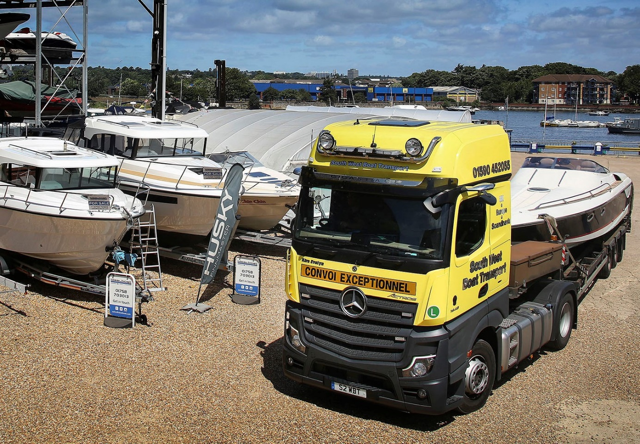

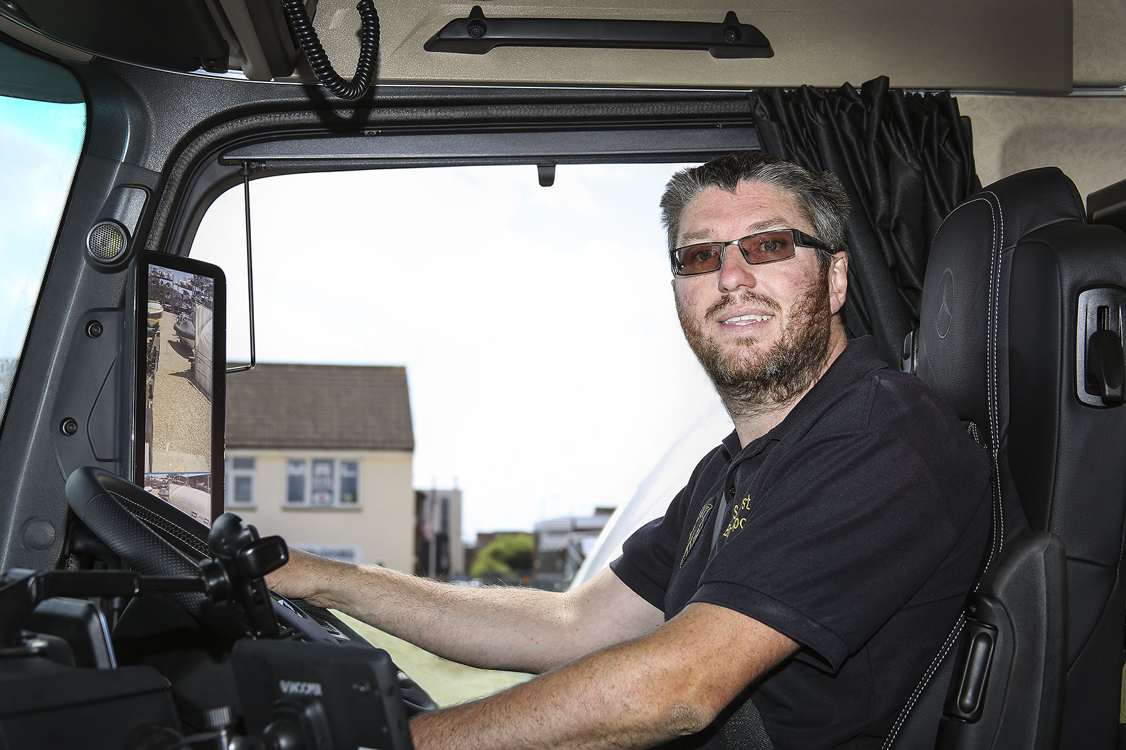

Cruise control: Michael Whelan has certainly had the wind in his sails since he took delivery of his new Mercedes-Benz Actros

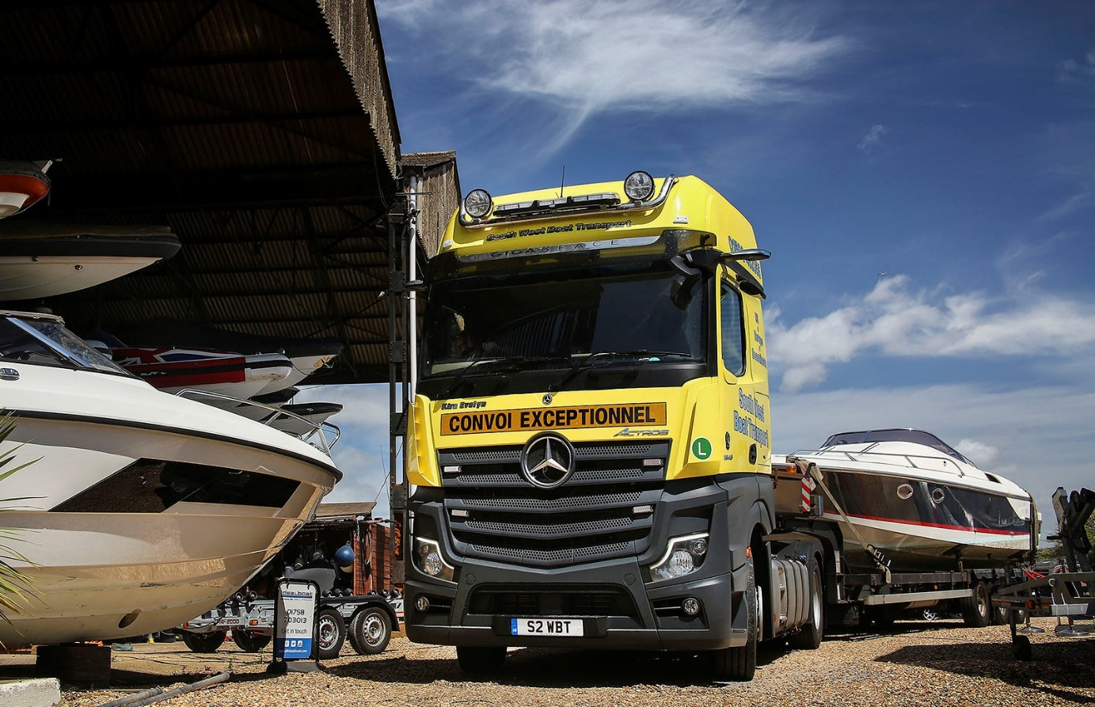



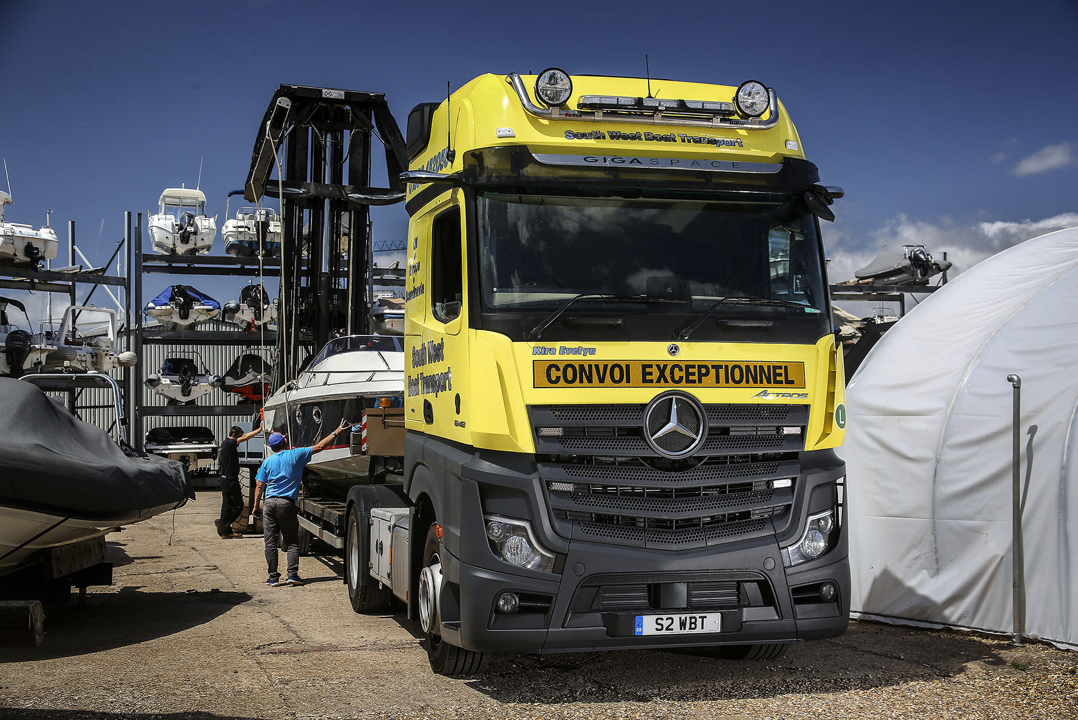

ends

For more information, or to request bigger/higher-res image files, please contact:
Steve Warren or John Ripley
Impact Communications, 01926 842126
Steve: 07770 470251, steve@impactcom.co.uk
John: 07771 484595, john@impactcom.co.uk

