

Date: 26 June 2020

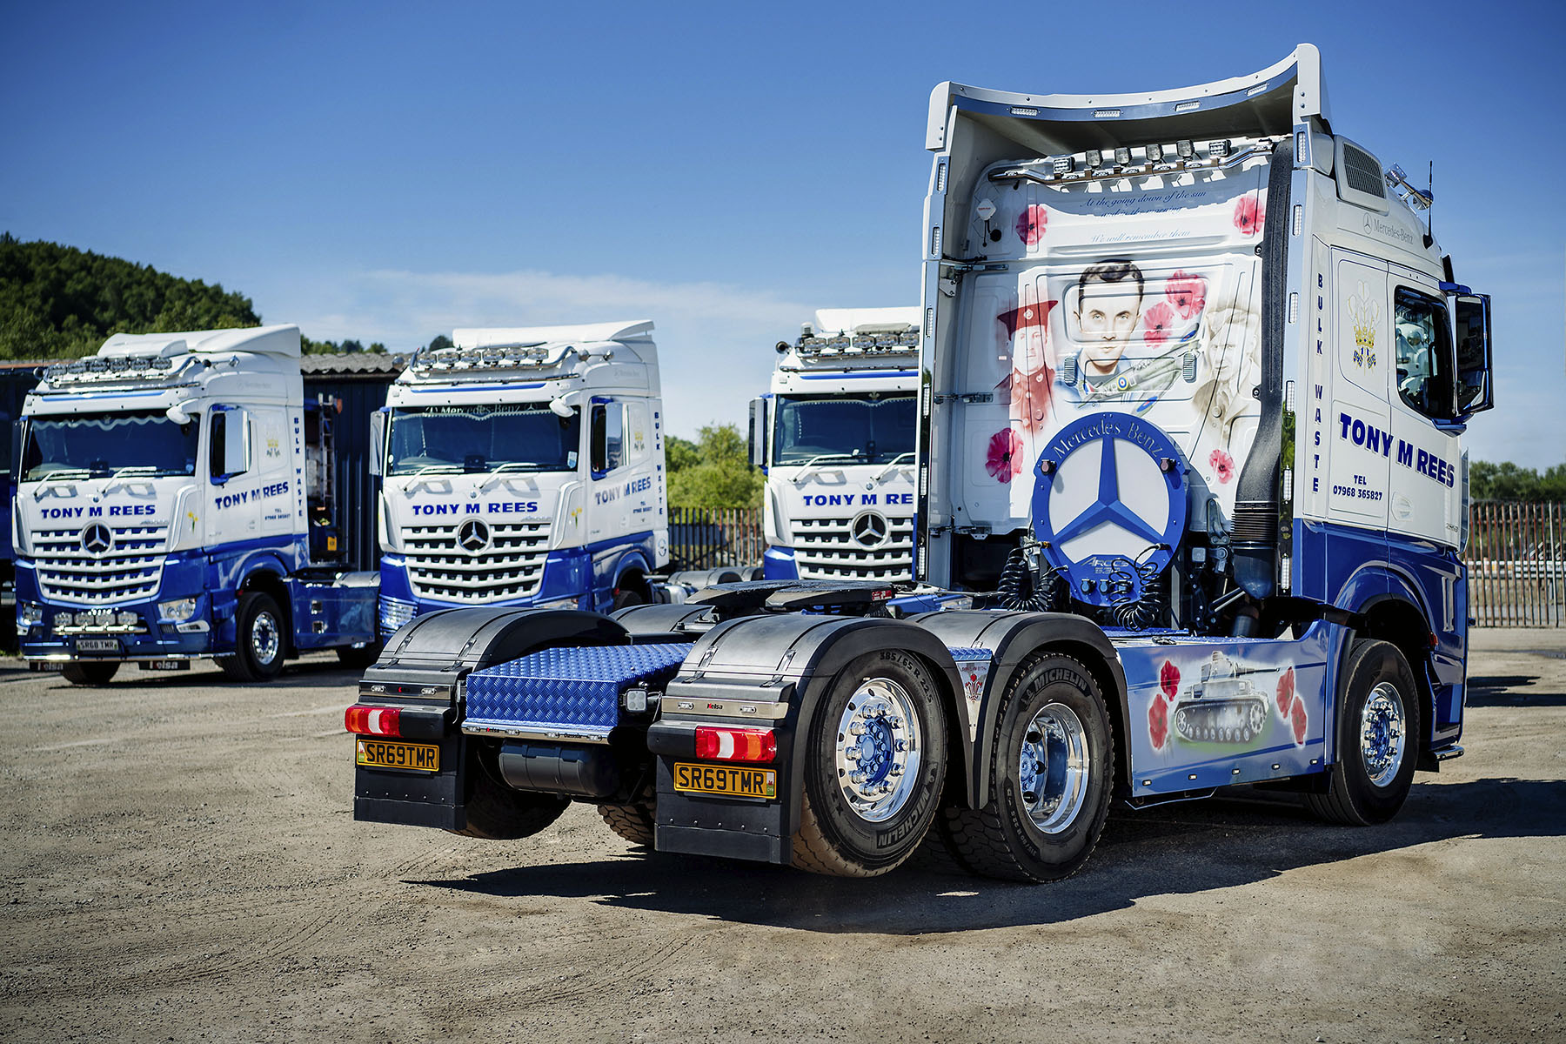

Tag along for the ride: Like most of its Mercedes-Benz Arocs, Tony M Rees’s VE Day anniversary truck has a lifting back axle which increases manoeuvrability

Bulk haulier’s smart new Mercedes-Benz Arocs delivers a fitting tribute to grandfathers who served

As a self-confessed Formula 1™ addict, Tony Rees usually decorates his Mercedes-Benz trucks with airbrushed artwork celebrating the sport’s stars and their cars. Instead of Lewis Hamilton and Valtteri Bottas, however, the latest bears an image of his grandfather, alongside pictures of his wife’s and driver’s grandfathers.
All three are depicted in uniform on the back wall of his new-generation Arocs 2553’s StreamSpace cab, each having served during World War II in a different branch of the Armed Forces. The design, which also features a Spitfire and, on the sideskirts, a naval vessel and a tank, was commissioned as a personal tribute to mark the 75th anniversary of VE Day.

Established by Mr Rees in 2004, the company that bear his name is based in Porthcawl, Bridgend, and specialises in the transportation of a broad variety of scrap, including everything from carpets and electrical items, to metals and plastics. It collects material from commercial clients nationwide and takes it either to recycling centres or to landfill sites.

Tony M Rees runs a fleet of eight tractors, which work with bulk ejector trailers. Seven are by Mercedes-Benz – five muscular Arocs models and a pair of older Actros – and were supplied by South Wales Dealer Euro Commercials. The sole exception is a 17-year-old Foden Alpha, which is the proprietor’s own ‘daily driver’.

Its first truck from the new-generation Mercedes-Benz Arocs range launched last year, the latest, eye-catching addition to the fleet has a flat-floored StreamSpace cab, and replaced a French-built unit. Highlights include the stylish and intuitive Multimedia Cockpit, which features twin screens – one with ‘touch’ functionality – in place of traditional switchgear; enhanced versions of the established Actros Brake Assist emergency braking, and fuel-saving Predictive Powertrain Control systems; and ground-breaking Uptime predictive maintenance technology.

As a 2553 variant, the Arocs is powered by a 12.8-litre in-line six-cylinder engine which produces 390 kW (530 hp). This output is transmitted to the road via the middle axle. While Tony M Rees’s oldest trucks are both 4x Actros models, all of the Arocs it has since purchased have had lifting tag axles. The operator prefers this configuration for its increased fuel-efficiency and reduced turning circle, a boon on sites with restricted access.

The truck has a painted chassis and grille, no fewer than four Kelsa light bars, and rides on Alcoa alloy wheels. Its side skirts and cab roof deflector were fitted by SB Components, of Wisbech, which also added a microwave oven to complement the Mercedes-Benz fridge.

Meanwhile, the airbrushed livery, which also includes the most famous lines from Laurence Binyon’s Great War poem For the Fallen, and the heraldic Prince of Wales feathers badge, is the work of artist Alan Smallwood. Appearing either side of Mr Rees’s grandfather Eifion Evans, are his wife Sarah-Jayne’s grandfather William Johnson, and driver Paul Evans’ grandfather Gwynfor Evans.

“I’m a proud Welshman, so the three feathers appear on all of my trucks,” explained Mr Rees. “As a huge fan of Grand Prix motor racing I’d usually choose an F1-themed design, but given that each of us had a grandfather who served in the Forces during the Second World War, I thought it would be appropriate on this occasion to mark the 75th anniversary of victory in Europe in a very personal way. My wife and I are both delighted with the result, as is Paul.”

Mr Rees reported: “The Arocs is a first-class piece of kit, and very cost-effective to run. Our trailers are heavy – unladen we’re still grossing at upwards of 22 tonnes – so the trucks are working hard all the time. Yet they’ve proved to be robust and reliable enough to cope. They’re also well-liked by our drivers, who can be away all week, which is why we endeavour to make their cabs as comfortable as possible.”

As with its previous vehicles, Tony M Rees’s latest Arocs is now being inspected and maintained at Euro Commercials’ Swansea workshop, under a four-year Mercedes-Benz Complete Service Contract. The operator’s usual practice, on completion of the agreement, is then to add a fifth year.

Mr Rees continued: “Euro Commercials’ Truck Sales Executive Steve Bastin sold me my first Mercedes-Benz 12 years ago and continues to provide brilliant support to this day. Whatever I need, he’ll always do whatever he can to help.

“The same is true of its Swansea Service Manager Kevin Bacon and his team. They remain open four nights a week and even when we give them little or no notice can invariably be relied upon to fit us in at times that suit us. Assuming one’s available they’ll also provide our driver with a courtesy vehicle to go home in, which also make life easier from our point of view.”

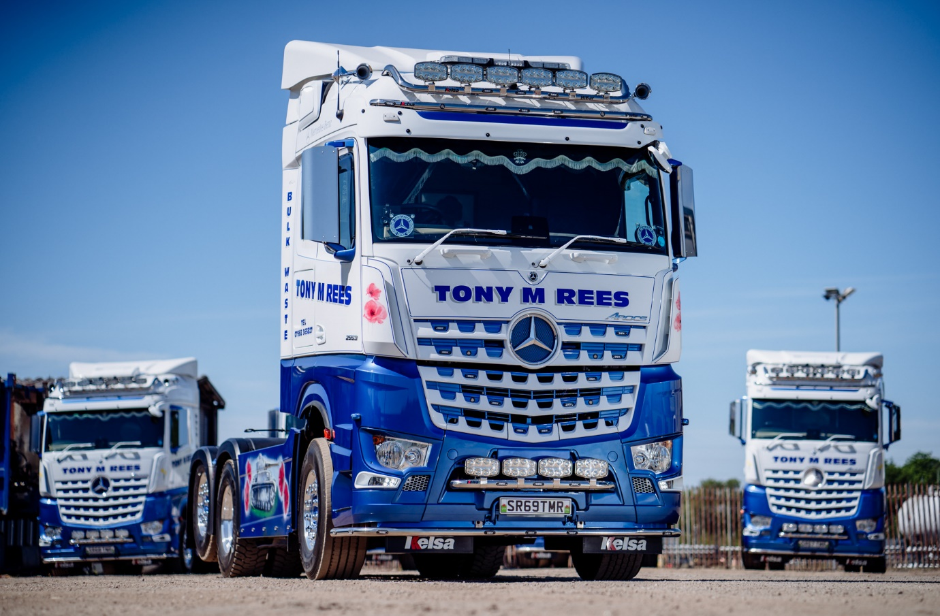
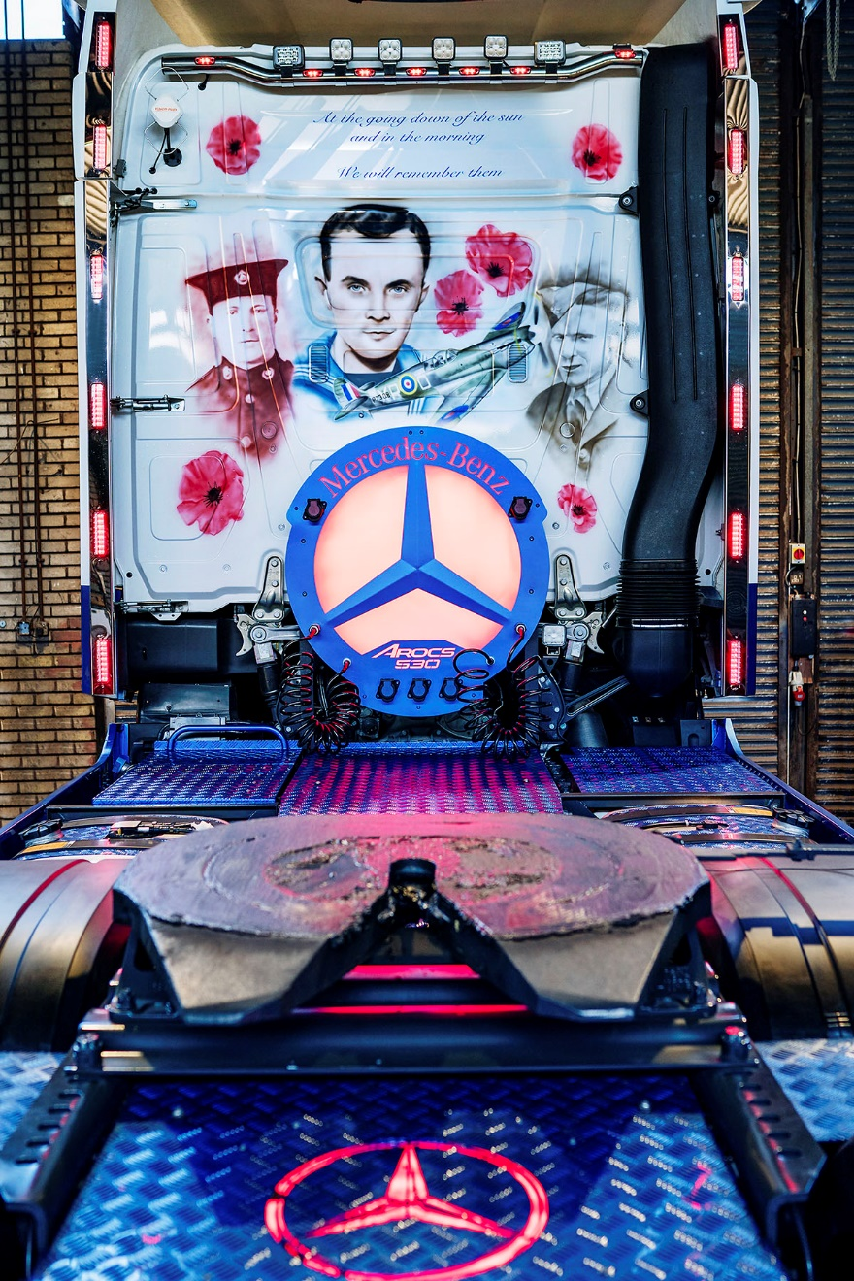

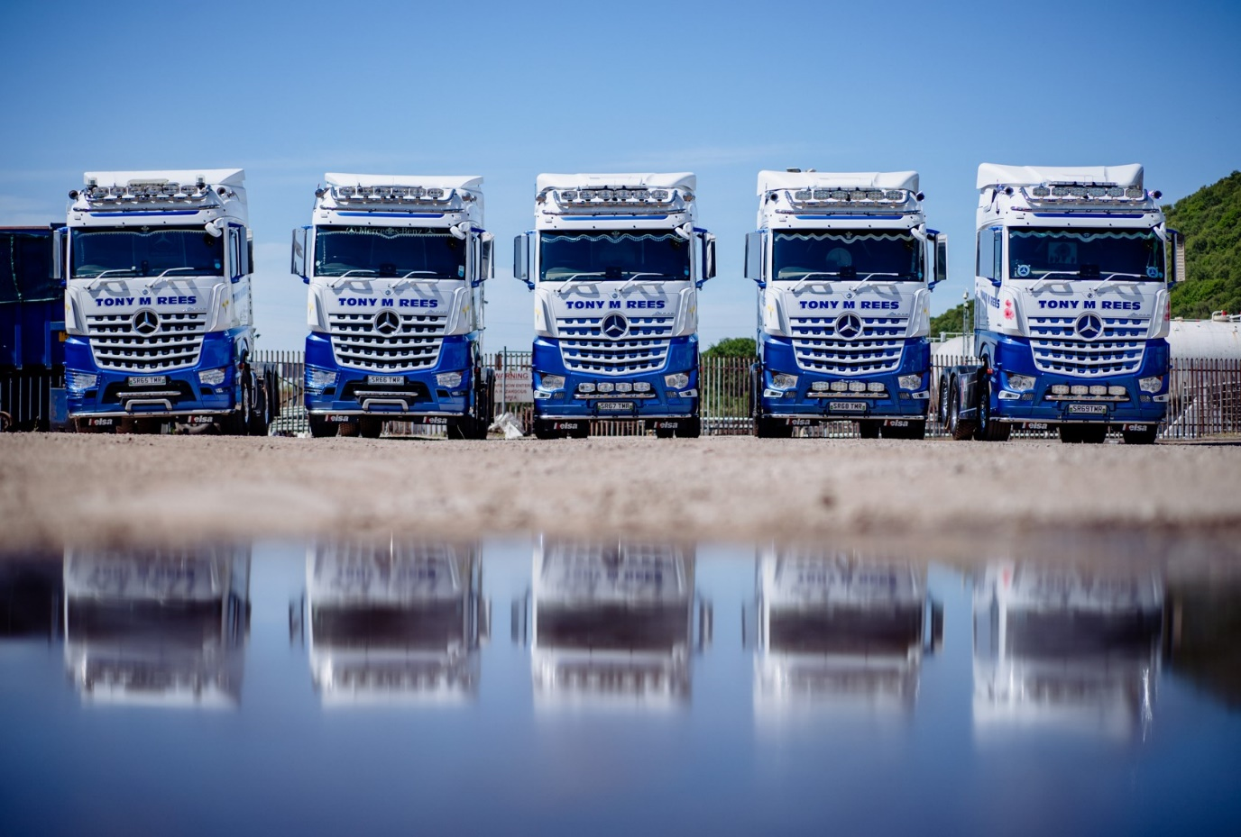

Line of duty: Tony M Rees’s latest, 69-registered Arocs, right, and its 65-, 66-, 67- and 68- registered stablemates

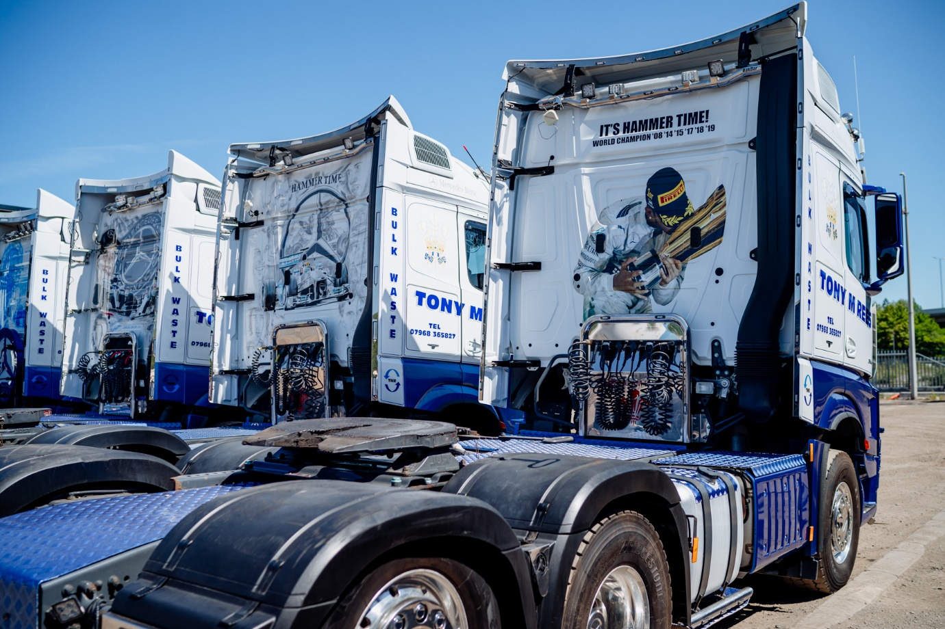

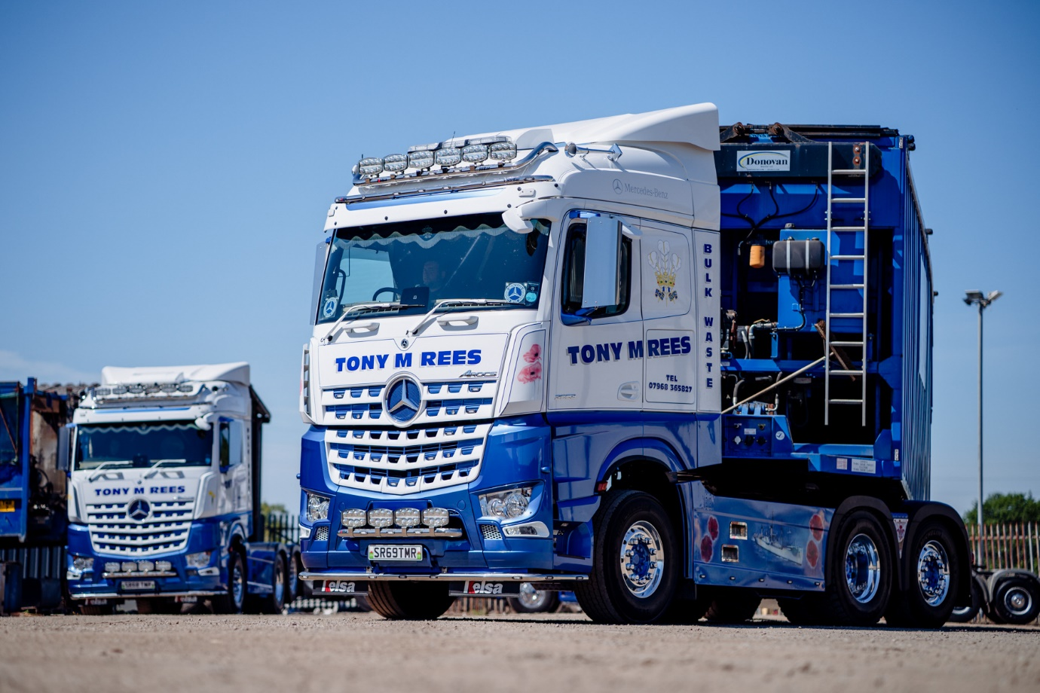

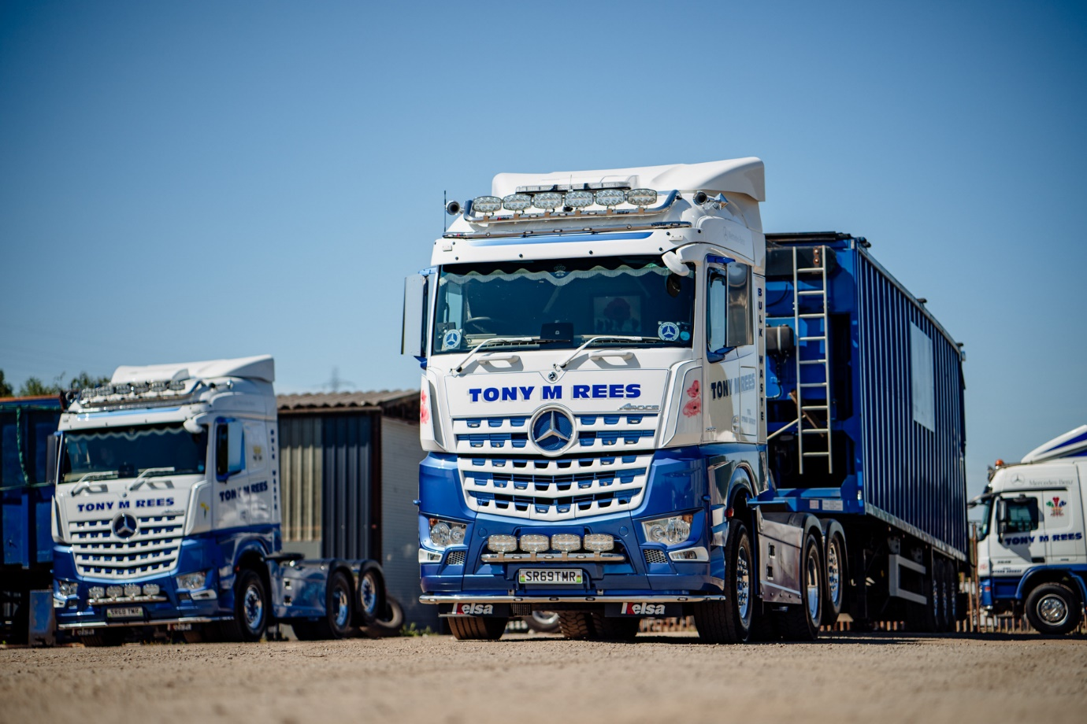

ends

For more information, or to request bigger/higher-res image files, please contact:
Steve Warren or John Ripley
Impact Communications, 01926 842126
Steve: 07770 470251, steve@impactcom.co.uk
John: 07771 484595, john@impactcom.co.uk



