

Date: 19 October 2020

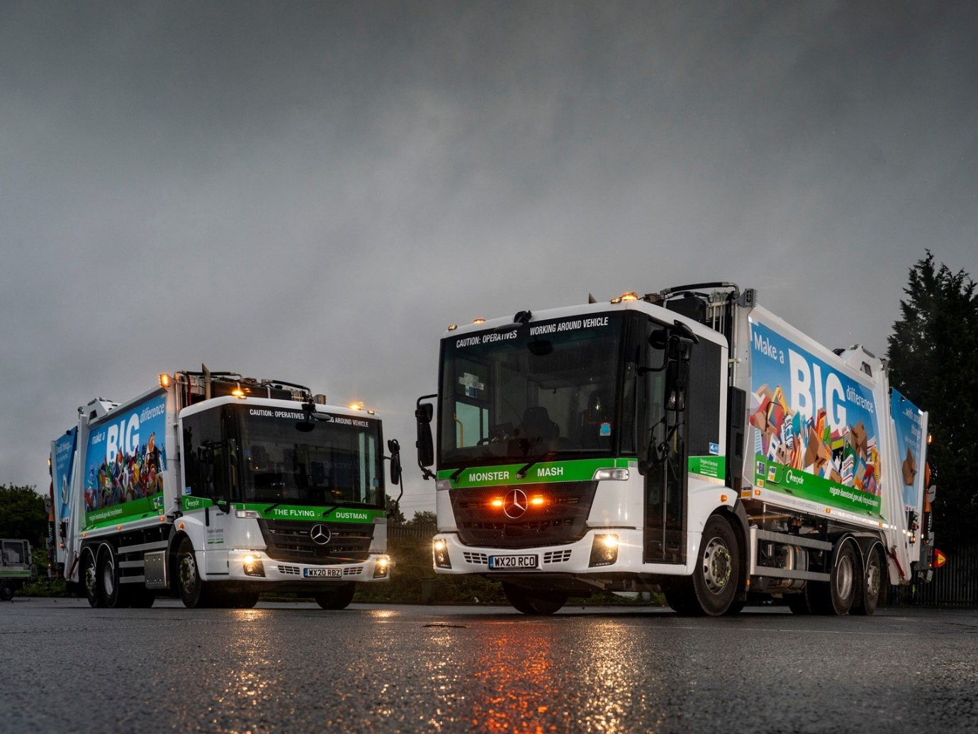

Reigate & Banstead invests £3.6m in ‘cleaner, greener’
Mercedes-Benz Econics from City West Commercials

Residents in the Surrey borough of Reigate & Banstead are now receiving waste and recyclables collection services from 11 new Mercedes-Benz Econics fitted with Dennis Eagle Olympus Twin Pack compaction bodies.

Supplied by Dealer City West Commercials, the low-entry 26-tonners are significantly cleaner in terms of emissions than the seven-year-old vehicles they have replaced. Their OmniDEL triple bin lifts, meanwhile, are electrically operated – not only are they quieter than the lifts used on previous refuse collection vehicles, but they also hold out the promise of a 12% reduction in fuel usage.

The trucks already in service represent the greater part of a £3.6-million investment in its new waste and recycling fleet by Reigate & Banstead Borough Council. The remaining four will be delivered next year.

City West Commercials liaised closely with primary contractor Dennis Eagle, which won the order following a comprehensive, fair and transparent tender process. All 2630 L models, the Econics are powered by 220 kW (299 hp) 7.7-litre in-line six-cylinder engines which are paired with six-speed Allison automatic transmissions specifically designed for stop-start applications. Steered rear axles ensure optimum manoeuvrability.

The chassis were also specified with Pre-installation for Reversing Assist. This meant Dennis Eagle could fit Wabco’s TailGUARD™ Rear Blind Spot Detection System, which monitors stationary and moving objects behind the vehicle, and activates vehicle brakes to help prevent collisions.

The dual compartments (65/35 split) on Dennis Eagle’s high-volume Olympus bodies have separate operating systems and tailgates. Two different waste streams can be collected in a single trip without risk of cross-contamination, thereby minimising the number of rounds.

Like Terberg Matec UK, manufacturer of the electric bin lifts, Dennis Eagle is part of the Terberg RosRoca Group. Its smooth-sided bodies are wrapped with colourful designs bearing the message that recycling the smallest of items can make a big difference to the environment. Residents were also encouraged to take part in a competition to name the new vehicles – ‘Dusty Bin’, ‘Monster Mash’ and ‘The Flying Dustman’ were among the winning entries.

Reigate & Banstead Borough Council operates a total fleet of 35 refuse collection vehicles – others are on trade and green waste duties. With the exception of a single 64-registered Econic purchased second-hand, the new trucks are its first by Mercedes-Benz.

Transport Manager Anthony Hathaway commented: “Emissions and fuel-efficiency were key to this order, and the Econic engine is the right size for our application. The vehicle also enjoys an excellent reputation for reliability and competitive running costs, while I know from previous experience that Mercedes-Benz Trucks’ Service 24h emergency roadside back-up is fantastic.”

The Council maintains its trucks in-house but relies on the local Mercedes-Benz Dealer for parts support. “The delivery service is very good, and the minor warranty issues that have cropped up were all dealt with very promptly,” he confirmed.

As with all Mercedes-Benz trucks, safety is another Econic attribute. Reigate and Banstead’s new trucks are equipped with Active Brake Assist 4 emergency braking technology. This is programmed to recognise other vehicles at higher speeds, as well as pedestrians when moving more slowly, and is capable of bringing the truck to a complete stop.

The Econic’s deep, panoramic windscreen, coupled with the full-height, glazed folding side door and low seating position that allow the driver to make direct eye contact with vulnerable cyclists and pedestrians at junctions or in traffic queues, have also earned it a top, five-star Direct Vision rating from Transport for London.

Mr Hathaway added: “Dennis Eagle and City West Commercials have worked really well together, so that from our perspective this order has been managed very smoothly.”

Councillor Natalie Bramhall, Portfolio Holder for Neighbourhood Services, commented: “Introducing a more sustainable fleet is an important step in the Council’s five-year plan to proactively tackle climate change and reduce the Borough’s environmental impact. Having vehicles the crews can rely on will help them to continue to collect household waste, even during these uncertain times.”

reigate-banstead.gov.uk

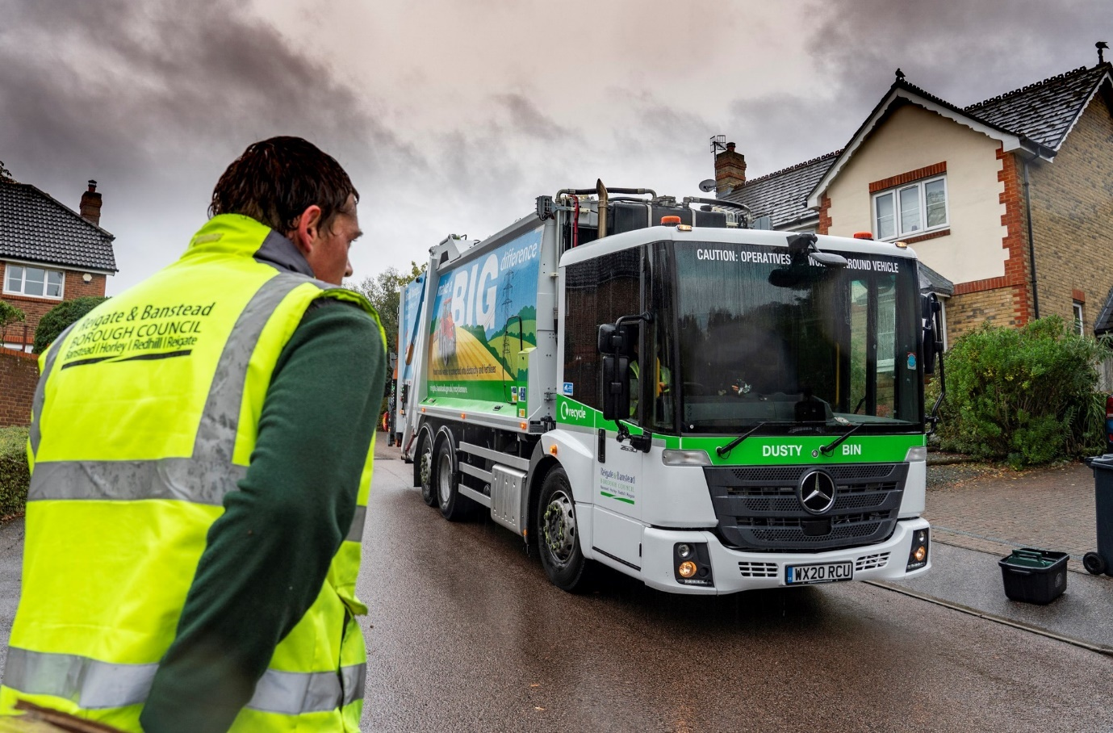

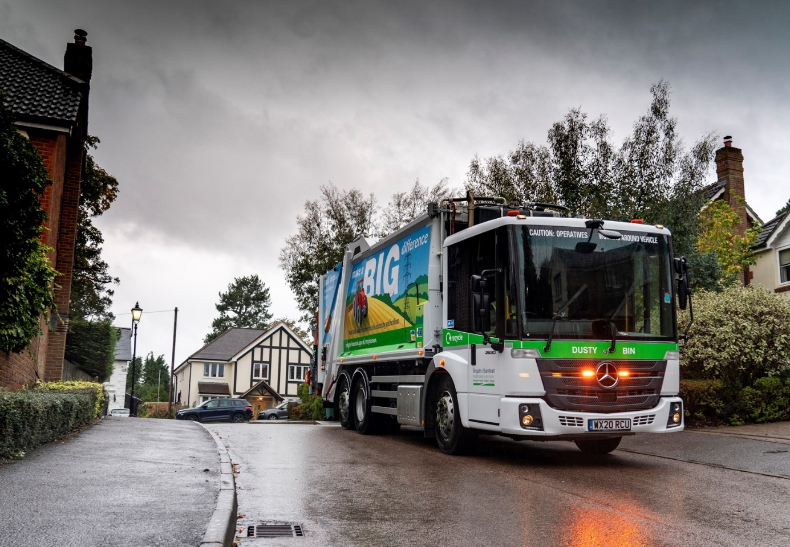

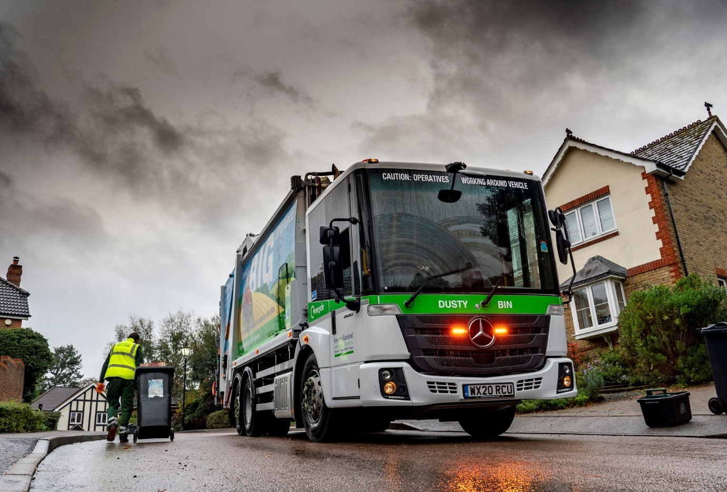

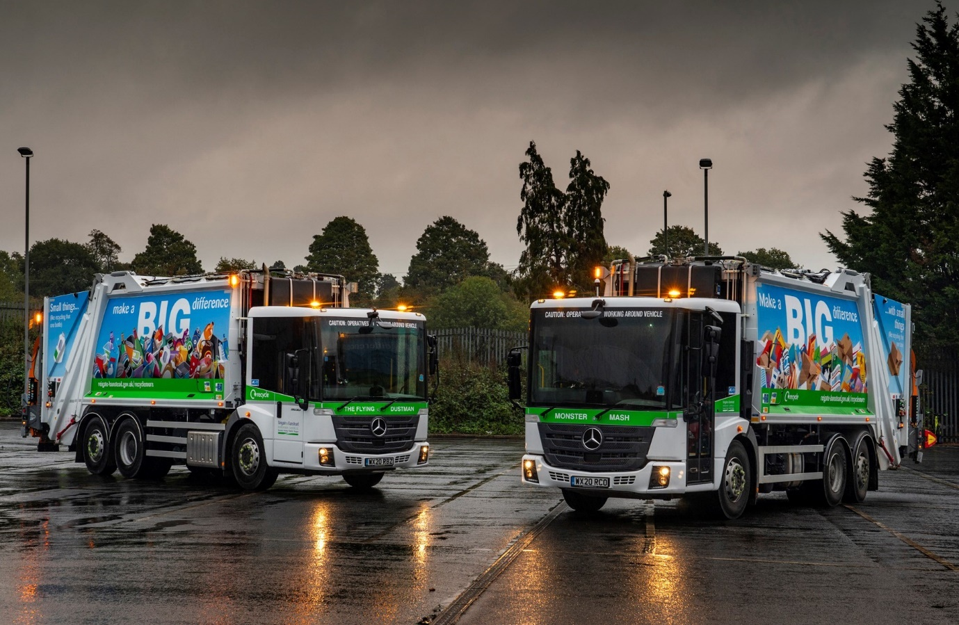

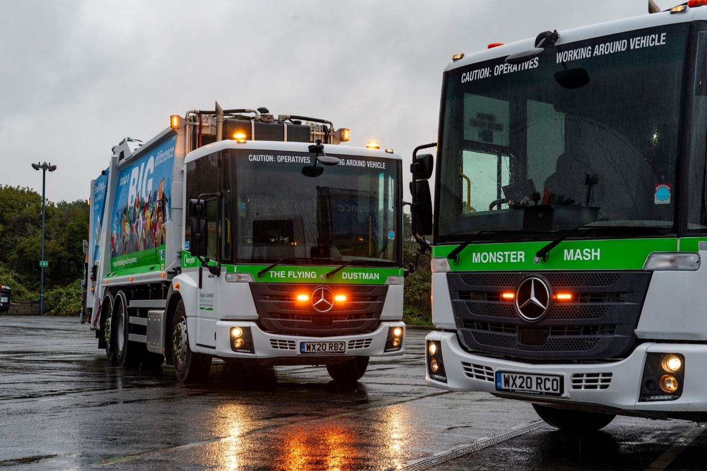

ends

For more information, or to request bigger/higher-res image files, please contact:
Steve Warren or John Ripley
Impact Communications, 01926 842126
Steve: 07770 470251, steve@impactcom.co.uk
John: 07771 484595, john@impactcom.co.uk

