

Date: 12 June 2023

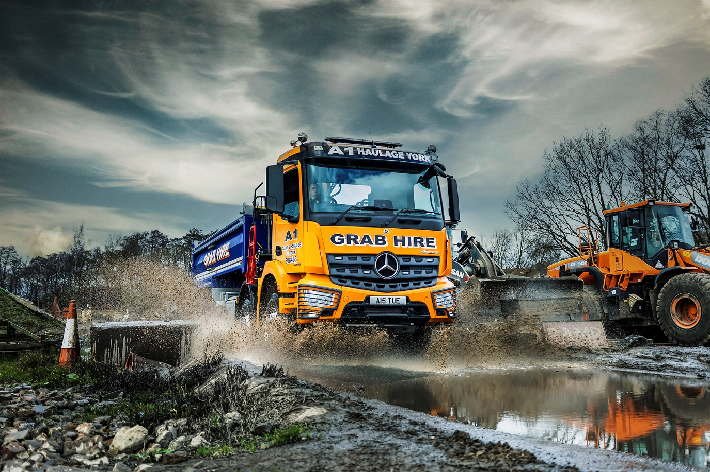

A1 Plant & Haulage grabs another reliable Arocs from BLS Truck & Van

Proven reliability and superior handling meant another Mercedes-Benz Arocs was at the top of the list when A1 Plant & Haulage needed a new truck.

Mercedes-Benz vehicles already make up the bulk of the York-based company’s eight-strong line-up, and Director Stuart Handley was adamant he wanted another – especially as he would be driving it himself.

A1 Plant & Haulage was established in 1973 by Mr Handley’s grandfather, Roy. Today the company provides tipper and tipper/grab haulage and hire services, with vehicles – which still wear the same original colours – available from 18 to 32 tonnes GVW. It also provides a range of aggregate products from its own construction rubble recycling plant.

Supplied by Dealer BLS Truck & Van, the new Arocs 3246 has a ClassicSpace S-Cab, decked out with a colour-coded bumper and mudguards, protective headlamp grilles, air horns and a light bar. The 320 mm engine tunnel allows the driver’s seat to be set lower than higher-riding variants, and means fewer steps are required for entry and exit. Power comes from the top-rated 355 kW (455 hp) version of Mercedes-Benz Trucks’ 10.7-litre in-line six-cylinder engine.

The chassis is fitted with a robust Governor all-steel tipping body by L Townend, of Holmfirth, with Harsh underfloor tipping gear, and had a Palfinger Epsilon M125 crane arm with Kinshofer clamshell grab installed behind the cab by TH White, of Devizes.

“We’ve been very well served by the Arocs tippers we already run,” revealed Mr Handley. “They don’t give us any problems, and have been noticeably more reliable than vehicles we’ve tried from rival brands. They’re popular with our drivers too, and I can see why. The cabs are extremely well designed and comfortable.”

He had praise too for BLS Truck & Van’s attentive service. “Sales Executive Chris Dyer looked after us very well throughout the ordering process, taking the time to understand our exact requirements and ensure all the details of specification were just right,” said Mr Handley. “This was our first experience of dealing with BLS and I’ve been very impressed.” A1 has taken out a Mercedes-Benz ExtendPlus warranty that provides cover for five years.

The muscular Mercedes-Benz Arocs is purpose-designed for construction-related applications. “It’s extremely robust and ideally suited to our kind of work, and great to drive too,” said Mr Handley. “Eight-wheelers often tend to sway a bit but the Arocs is really well planted, very steady when cornering and feels totally secure, both off-road and on the tarmac. The auto gearbox is smooth and effective; overall it’s an excellent package and looks smart in our historic livery.”

www.a1haulageyork.co.uk
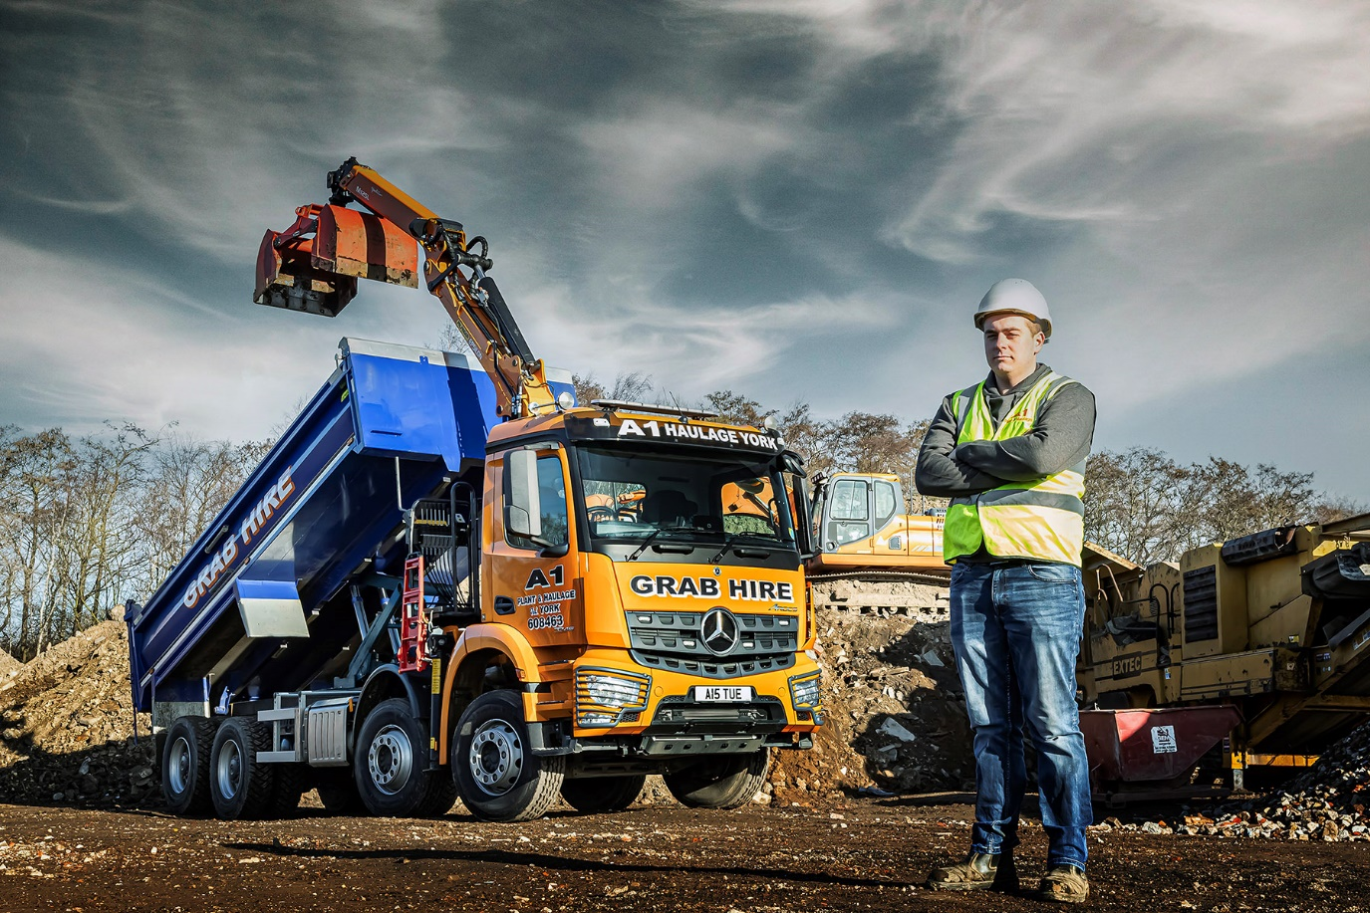

Impressed: Stuart Handley of A1 Plant & Haulage with his new Mercedes-Benz Arocs

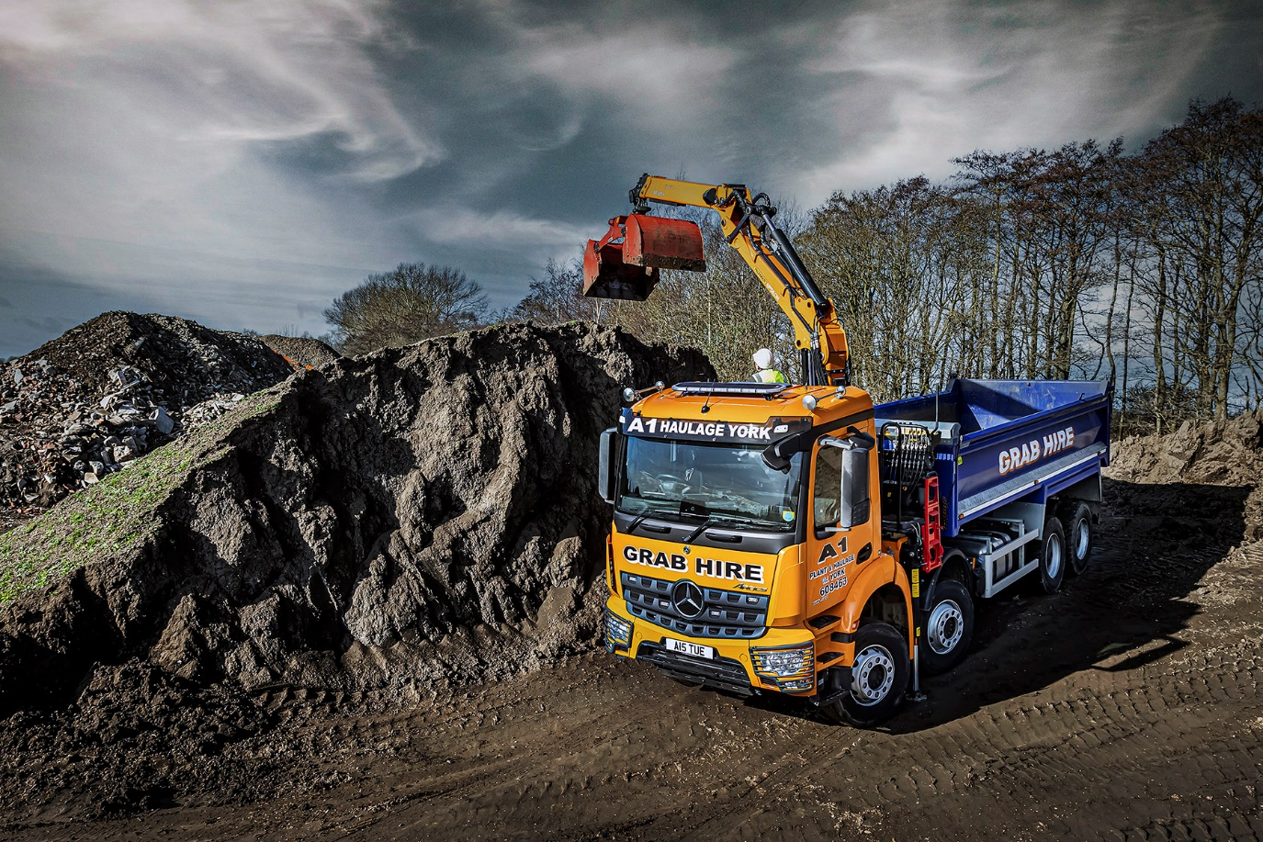

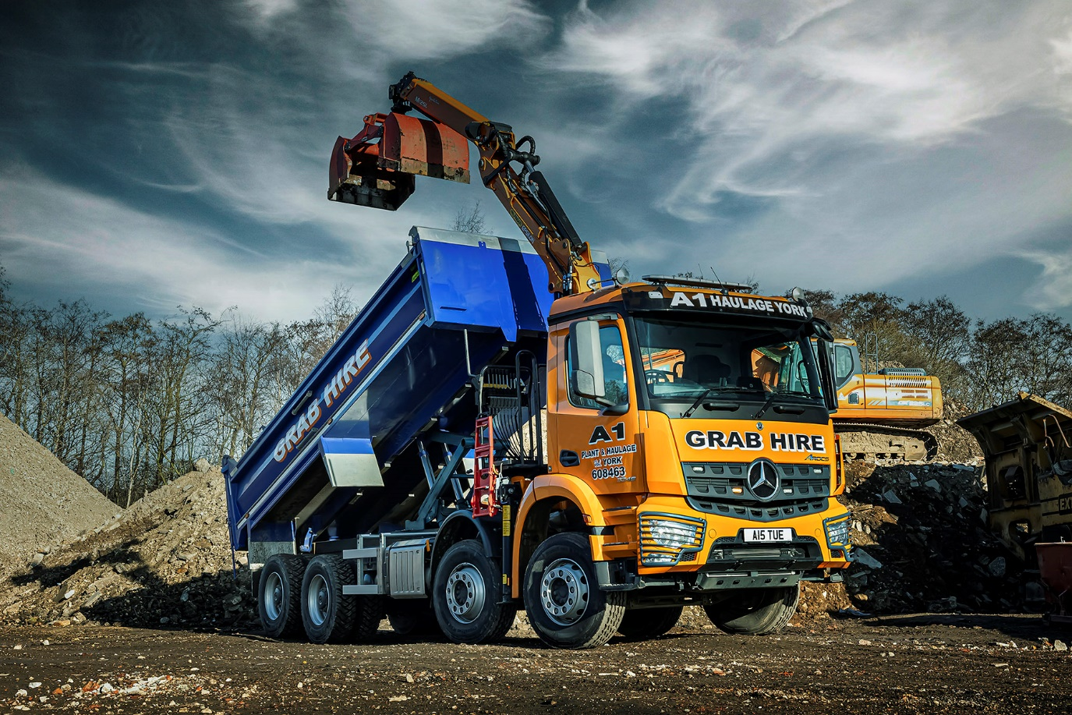

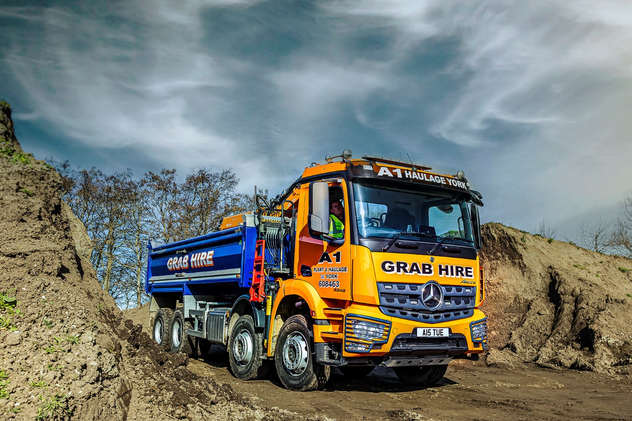

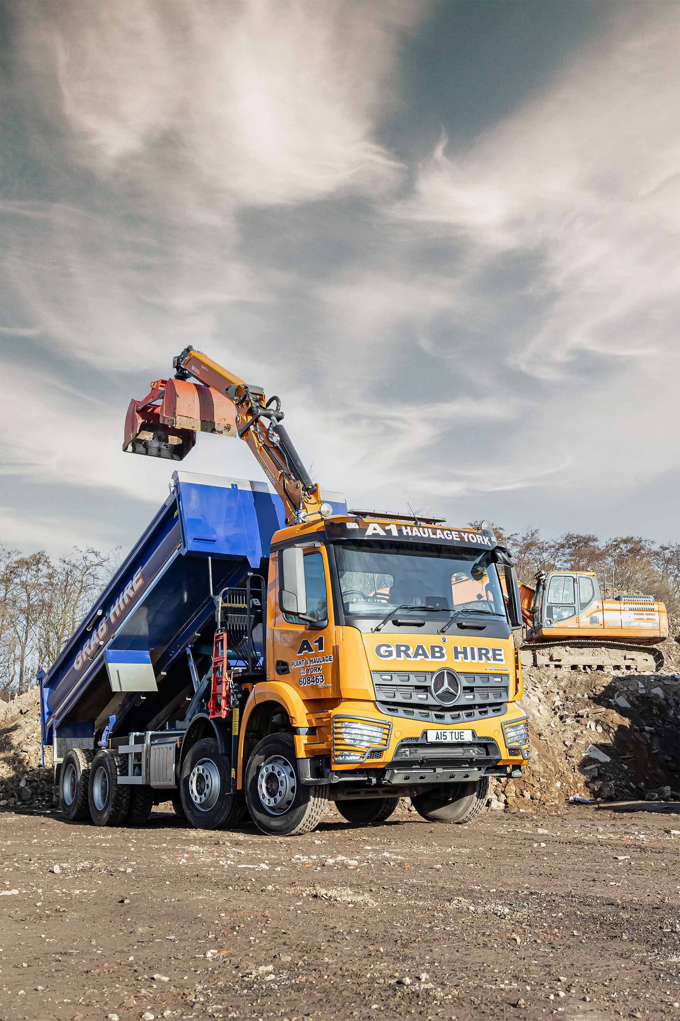

ends

For more information, or to request bigger/higher-res image files, please contact:
John Ripley: 07771 484595, john.ripley@loopagency.co.uk



