

Date: 8 November 2019

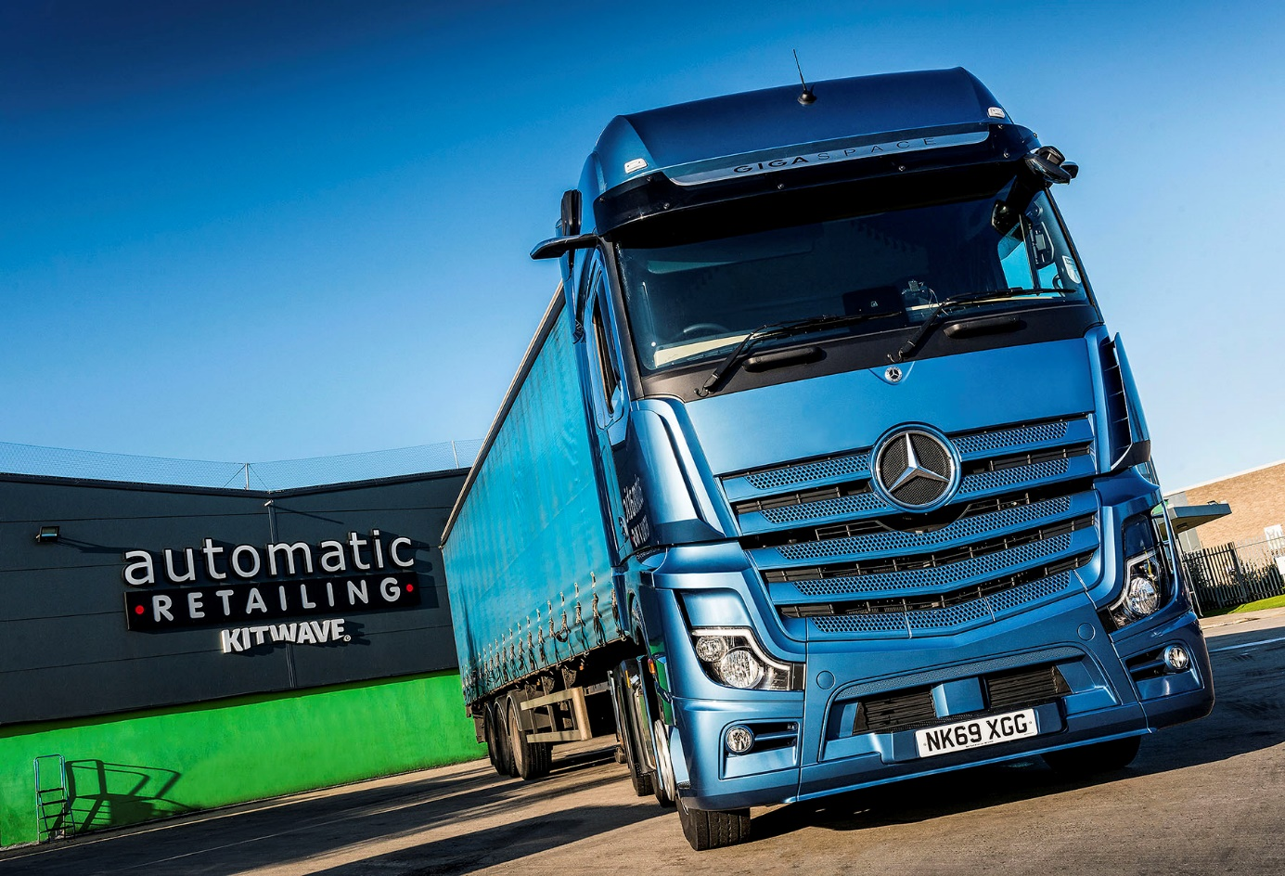

Snack specialist looks forward to some tasty fuel savings from its two new Mercedes-Benz Actros

The Mercedes-Benz Actros has long been a winner at the pumps for Automatic Retailing – but the Newcastle-Upon-Tyne-based snack specialist is confidently anticipating the best fuel performance yet from its latest trucks.

That’s because the two tractor units are from the new-generation Actros range, which boasts a raft of innovations designed to boost economy, as well as enhancing safety and driver appeal.

Supplied by north-east Dealer Bell Truck and Van, both are 2545 models with range-topping GigaSpace cabs and 12.8-litre ‘straight-six’ engines which produce 330 kW (450 hp). They are now working alongside Automatic Retailing’s 15 other tractor units, nine of which also wear three-pointed stars.

“Our Actros have consistently returned between 10.5 and 11 mpg,” said Transport Manager James Elliott. “These are fantastic figures, but we fully expect our new trucks to do even better. It’s not only about fuel, though, because they also represent a big step forward in terms of safety and cab comfort.”

Automatic Retailing supplies a wide range of snack and drink products, plus ancillaries, to vending machine operators. Its articulated combinations typically leave base at gross weights of around 35 tonnes, and do not back-haul – it prefers 6x2 tractors, however, because of the flexibility they offer to tackle heavier loads when necessary. The company also relies on three 26-tonne curtainsiders, two of which are also by Mercedes-Benz, to undertake smaller deliveries to sites with restricted access.

The new-generation Actros incorporates more than 60 innovations, among them MirrorCam, the Multimedia Cockpit and enhanced versions of the established Active Brake Assist and Predictive Powertrain Control systems.

MirrorCam does away with conventional door mirrors. Instead, rear-facing cameras display images of the view down each side of the vehicle on screens inside the cab. This ground-breaking technology contributes to Mercedes-Benz Trucks’ Greater Safety commitment by offering a wider and clearer field of rearward vision, and eliminating previous blind spots. The compact, more aerodynamic profile of the camera housings also improves mpg returns by reducing wind resistance.

Automatic Retailing’s Actros are equipped with the stylish, high-tech Multimedia Cockpit, which sets a new benchmark for connectivity and intuitive operation. It features two interactive screens, and permanently connects the vehicle to the Cloud via a new Truck Data Centre. As well as choosing the biggest cabs available, Automatic Retailing treated its drivers to optional StyleLine interiors which include luxury design touches such as leather-trimmed steering wheels and extensive chrome trim.

The Active Brake Assist 5 emergency braking system represents another important step forward thanks to its improved pedestrian recognition capability, while the latest version of Predictive Powertrain Control – which uses 3D GPS mapping to ‘read’ the road ahead, then responds by managing speed, braking and the transmission to maximise fuel efficiency – offers much increased functionality.

Automatic Retailing serves customers throughout the UK and Ireland. “Good drivers are hard to come by, and ours are out on the road all week,” continued Mr Elliott. We feel it’s important, therefore, to provide them with a comfortable, high-quality working and living environment. The GigaSpace cab is extremely spacious and offers loads of storage, while the new Multimedia Cockpit has already been very well received.

“The new trucks look fantastic too,” he added. “Our drivers and their vehicles are the visible face of the company to our customers, so it’s vital that they present an image of quality and professionalism. Like Mercedes-Benz, we’re not a ‘bargain basement’ supplier. Instead, we offer top-quality products backed by first-class customer service, and our new Actros are now helping us to deliver on that promise.”

automaticretailing.wordpress.com

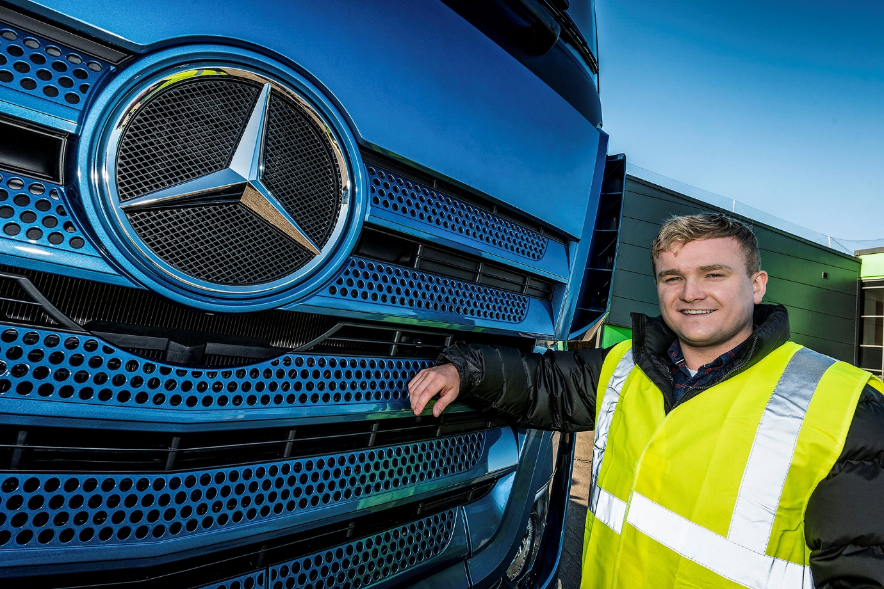

Automatic choice: Transport Manager James Elliott with one of his latest Actros tractors

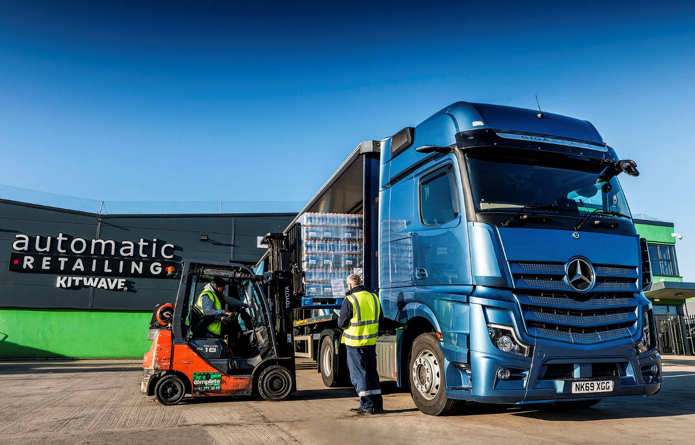

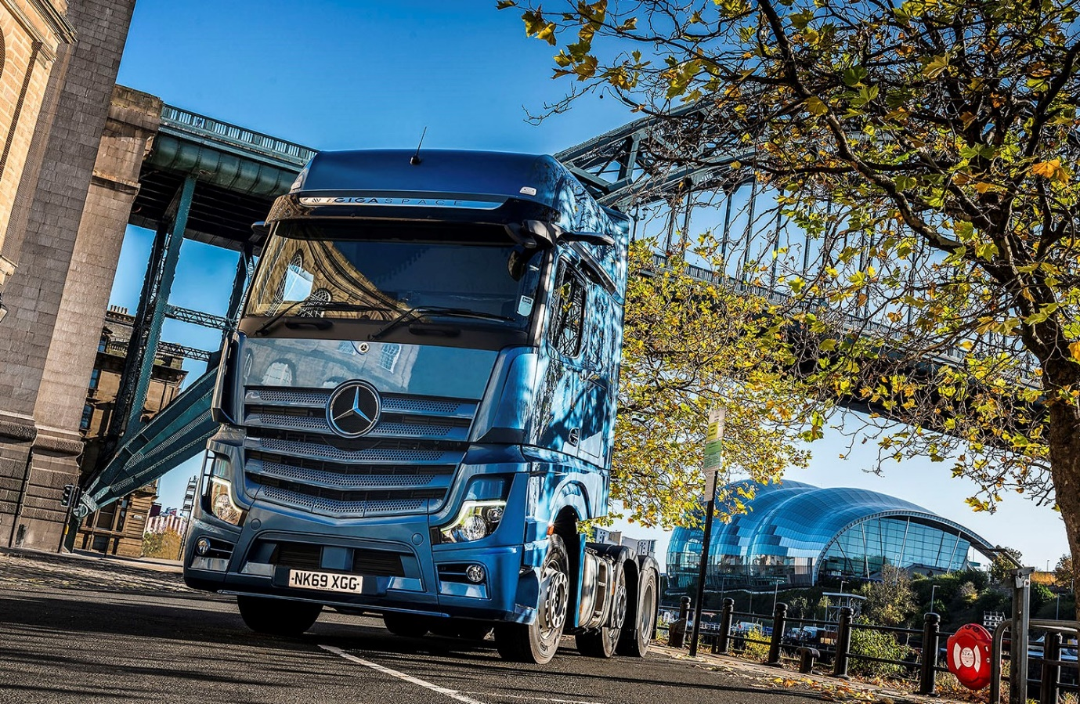

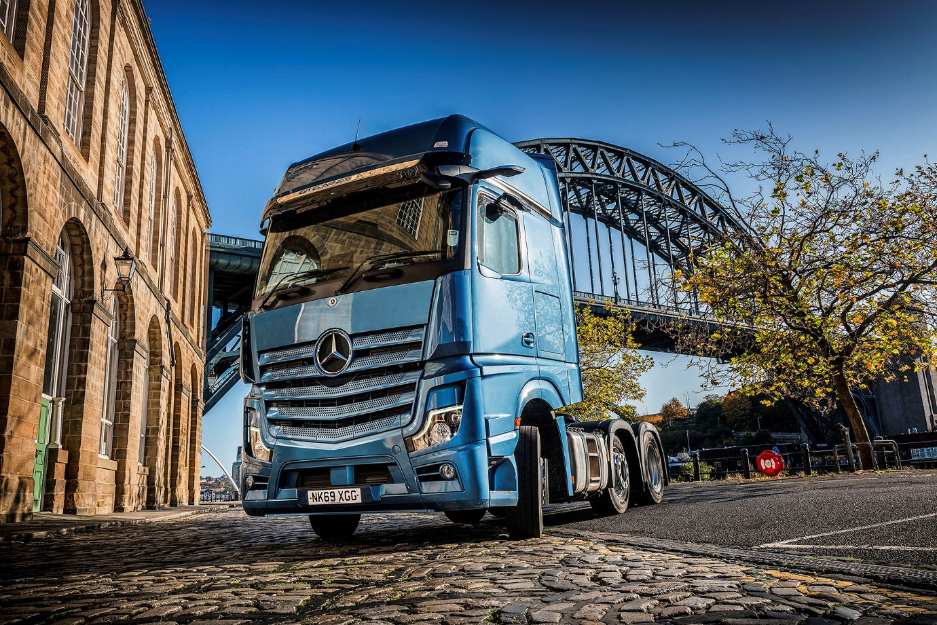

ends

For more information, or to request bigger versions of image files, please contact:
John Ripley or Steve Warren
Impact Communications, 01926 842126
John: 07771 484595, john@impactcom.co.uk
Steve: 07770 470251, steve@impactcom.co.uk

