

Date: 22 June 2023

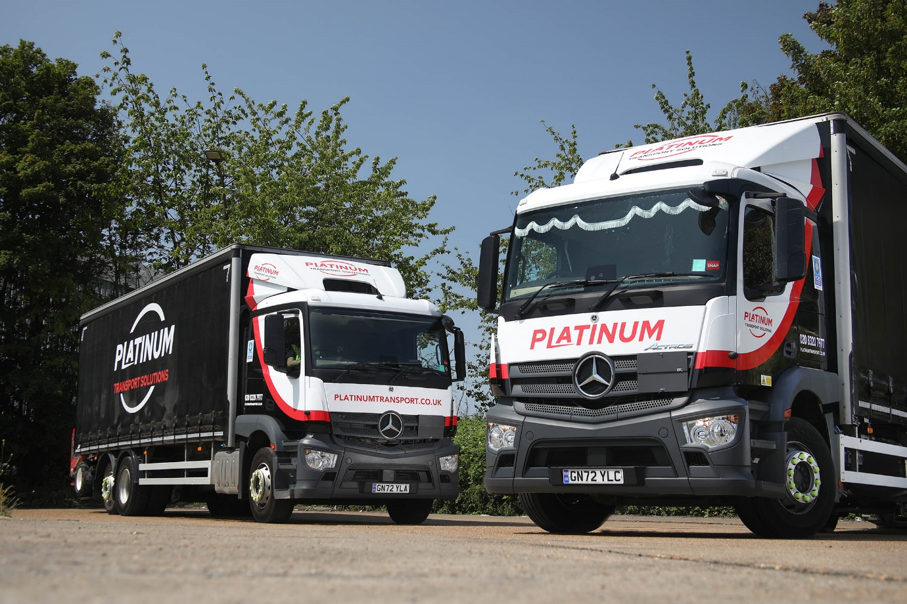

Platinum goes for growth with Mercedes-Benz Actros

Platinum Transport Solutions invested in some precious metal, in the shape of three new Mercedes-Benz Actros rigids – the Kent-based operator’s first trucks to wear the famous three-pointed star.

The trucks were delivered to FORS Gold-accredited Platinum’s head office in Belvedere, on the south bank of the Thames, by Dealer Sparshatt Truck & Van. Two are 18-tonne GVW 1824 models, with 7.7-litre ‘straight six’ engines each generating 175 kW (238 hp); the third is a 26-tonne 2530, with a 220 kW (300 hp) version of the same powerplant.

All have ClassicSpace sleeper cabs with 320 mm engine humps – which allow for a lower floor and driving position, improving both vision and ease of access for their drivers. The specification helps them to meet Transport for London’s three-star Direct Vision Standard requirement.

The trucks all represent expansions of Platinum’s line-up, which now numbers 30 vehicles. “We’ve been increasingly busy in recent times so have been forced to grow the fleet to cope with demand,” said Operations Director Martin Webb.

“Our older trucks date back to before the start of enforcement of the Direct Vision Standard, in 2021, so they are zero-star rated. For these latest vehicles we looked around at the various three-star options available on the market and were most impressed with what we saw from Mercedes-Benz – both in terms of the quality and design of the Actros and the response from Sparshatt Truck & Van.

“Sales Executive Nick Fuller was very attentive from the start,” Mr Webb continued. “Every question we asked was answered promptly, and once we’d placed the order he put in a lot of work liaising with our chosen bodybuilder to ensure the finished vehicles were exactly as we required.”

The rigids all have curtainside bodies by Fred Smith & Sons, of West Bromwich – the 18-tonners also have tail lifts while the six-wheeler carries a Moffett Mounty forklift.

“A high proportion of our work involves deliveries to customers in central London, where access is tight and there are no offloading facilities, so all our 26-tonners are equipped with Moffetts,” Mr Webb added.

“Like any operator we look for the best performance and reliability from our fleet vehicles, and the lowest overall running costs. These are early days of course but the signs are certainly promising – we’ve had no issues whatsoever with these trucks. Our runs are so varied that it’s difficult to make fuel consumption comparisons but, anecdotally, the mpg returns we’re seeing from the Actros are an improvement on what we’ve been used to. They’ve also been well received by our drivers, who like the smart and modern cab design.

“Sparshatt have given us every assurance that the back-up will be there if we ever need it, and the rates for the Service Contract we signed up to are highly competitive. As a total package, we’re delighted with our choice of vehicle and the support from Sparshatt Truck & Van.”

www.platinumtransport.co.uk



Delighted: That’s Platinum Transport Solutions Operations Director Martin Webb, with his new Mercedes-Benz Actros rigids

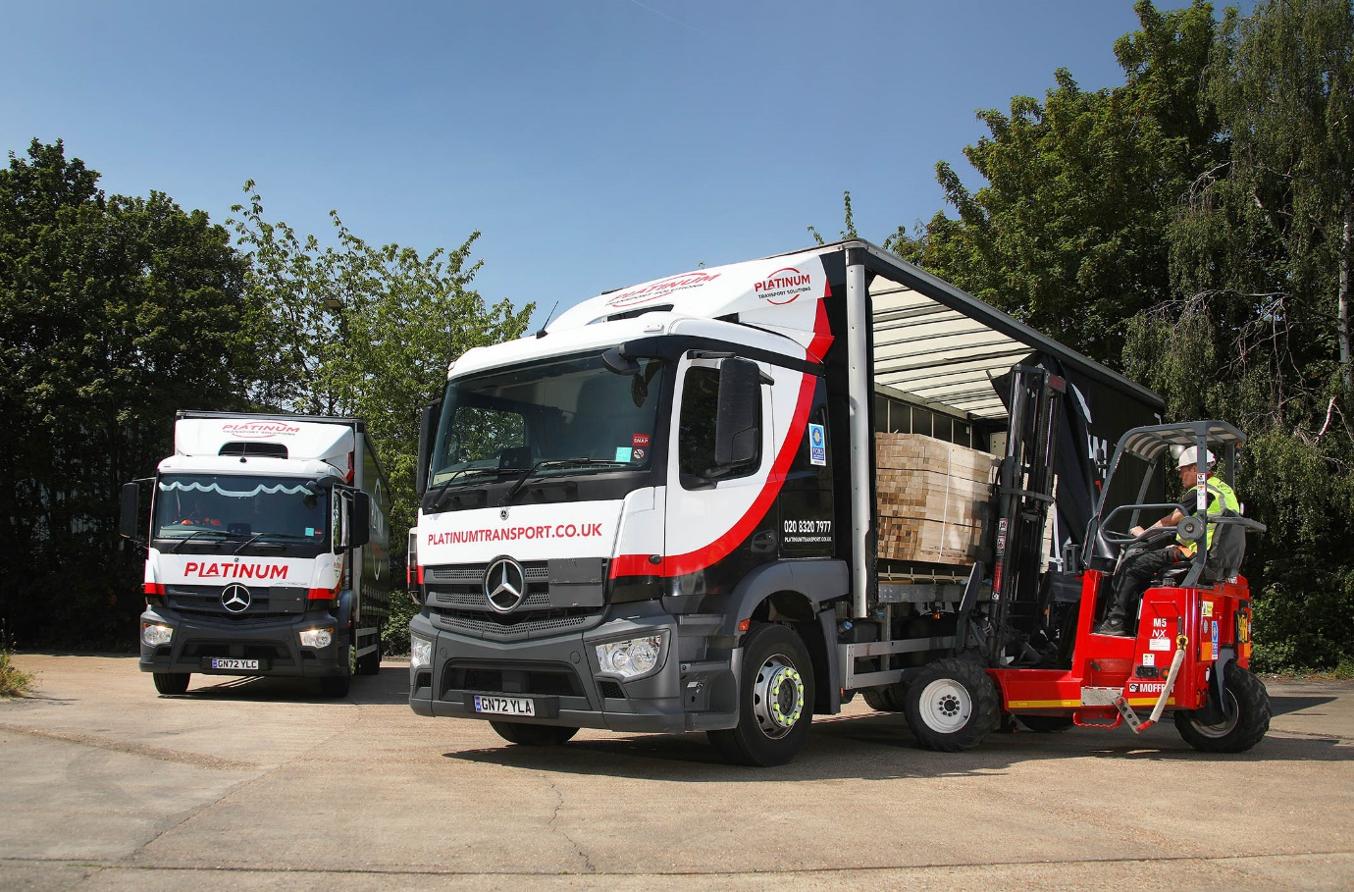

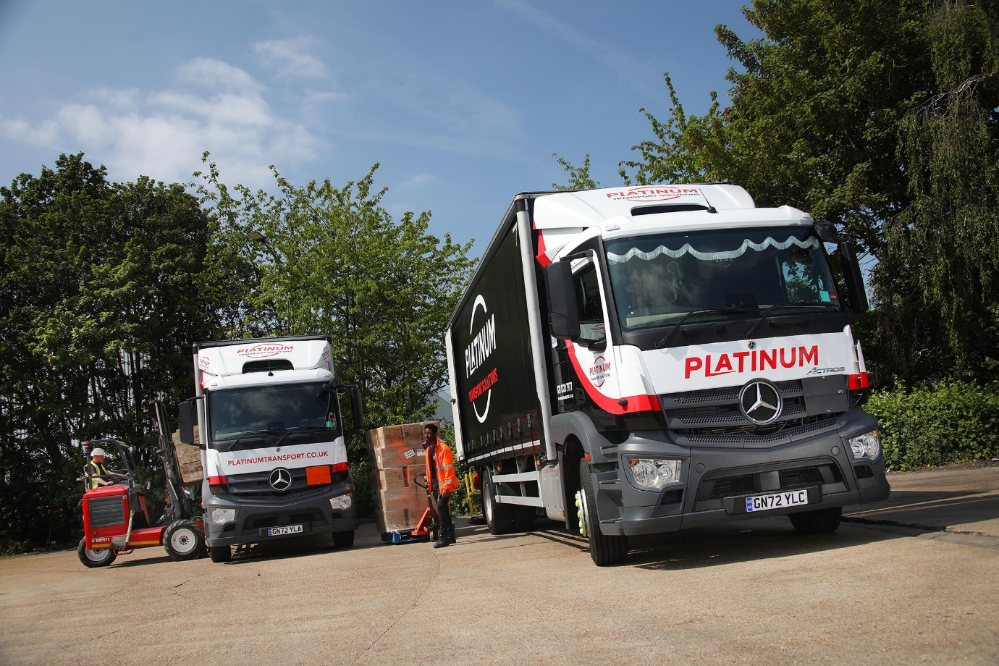

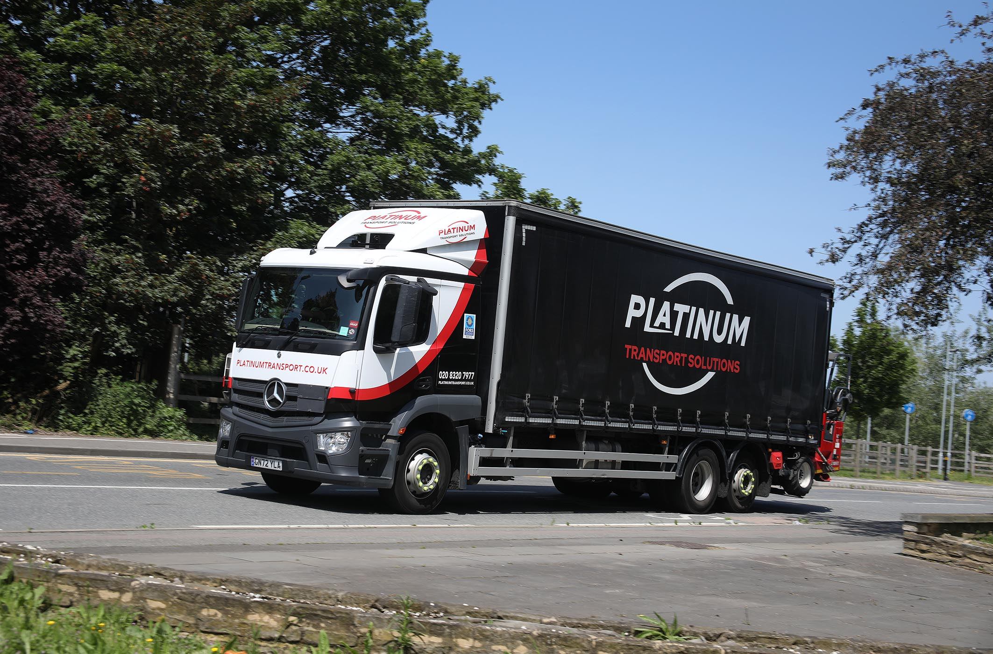

ends

For more information, or to request bigger/higher-res image files, please contact:
John Ripley: 07771 484595, john.ripley@loopagency.co.uk

