

Date: 18 April 2019



Relative values: The Heaver family, from left, Barrie, Mark, Tracey, Kevin and Maurice

Heaver Brothers feels the pull of Approved Used Mercedes-Benz Actros

Small margins make all the difference when Heaver Brothers chooses its trucks. Once fuel economy, reliability performance, back-up and driver appeal have all been factored in, the family-owned haulier invariably comes up with the same answer... Mercedes-Benz.

Exeter-based Heaver Brothers often buys pre-owned vehicles, when high-quality, low-mileage examples are available – and an Approved Used tractor unit from local Dealer City West Commercials will always fit the bill.

The latest arrivals are a pair of three-year-old Actros 2545s with flat-floored StreamSpace cabs and 330 kW (450 hp) straight-six engines. They have joined a fleet of 27 tractors, all but one of which wears a three-pointed star, and seven eight-wheeled drawbar rigids with cranes.

The company is run by brothers Maurice and Barrie Heaver, while Maurice’s sons Kevin and Mark are both Directors too. Kevin is Fleet Engineer, Mark runs the transport operation, and their sister Tracey oversees much of the administration. Qualified accountant Jean Hannan, meanwhile, has been looking after the finances for well over 30 years.

“An Approved Used Mercedes-Benz Actros ticks all our boxes, and represents excellent value for money,” said Maurice Heaver, who is well served by City West Commercials’ Tim Sutcliffe, winner in 2018 of the manufacturer’s Used Truck Sales Executive of the Year title.

“The Actros are always superbly presented, and virtually indistinguishable from new trucks. They’ve done us proud down the years, so it makes sense to keep buying more.”

Mr Heaver continued: “We cover the entire UK and our vehicles are sometimes double-shifted, so can rack up some big distances. They stand up to the work extremely well, though, and only very rarely do we get a problem. Fuel performance is good, too. We’re not in a position to benchmark the Actros against other makes of truck, but we do keep abreast of the competition through the media and by talking to other operators. The returns on our vehicles are always where we’d want them to be.”

The company’s drivers are every bit as enthusiastic about their trucks. “Some have been with us for 30 years or more, and they’re all part of the ‘family’,” explained Maurice Heaver. “Their feedback is important, and when it comes to the Actros it’s overwhelmingly positive. We equip the cabs with extra features to make nights away as comfortable as possible. All in all, they’re lovely trucks to drive.”

Among those long-serving drivers is Mick Stevens, who has worked for Heaver Brothers since 1988, and was rewarded for his loyalty with one of the company’s latest tractor units.
“All of the lads love the Actros,” he enthused. “It’s obviously designed with the driver in mind, and is a great place to spend time, either out on the road or parked up for the night. The bed is brilliant, I’m never short of storage space, and with a microwave and fridge on board my cab is a real home from home.

“I make frequent trips to Plymouth, Southampton, Purfleet, Tilbury and London, and in a typical week might cover 3,000 km. The fact that the Actros is such a relaxing drive is therefore a big plus – it just eats up the motorway miles, which makes my job so much easier.”

Heaver Brothers maintains its tractor units and six rigid trucks, as well as 50 semi-trailers, in its own workshop. The facility has a full-length inspection pit and three bays, and is the centrepiece of the impressive new headquarters at Lodge Trading Estate, Broad Clyst, which the company opened in March.

Kevin Heaver leads the workshop team. “Our fitters have grown used to the Actros, and find it a really easy vehicle to work on,” he confirmed. “City West Commercials efficiently manages an imprest stock at our premises, so I never have to worry about whether a part is on the shelf. And should we ever need any technical advice the Dealer’s service advisors are just a phone call away, although we know the trucks so well now I can’t remember the last time we had to do so.”

The 5.5-acre Broad Clyst site also has plenty of room for the many shipping containers which Heaver Brothers buys, refurbishes and sells, and also converts into buildings for site offices, storage, or even living accommodation.

“We’ve been in business for more than 50 years but the move to our new home has given us all a new lease of life,” added Maurice Heaver. “We’re now looking forward to the next 50 years, and to building on our partnership with City West Commercials and Mercedes-Benz.”

Tim Sutcliffe added: “Barrie, Maurice and the Heaver Brothers team are highly professional operators with a long track record of success, and know exactly what they want from their vehicles. I was delighted to be able to source their latest, nicely specified, low-mileage trucks, which look great in their livery.”

Mercedes-Benz Approved Used Trucks offer an unrivalled combination of quality and value. All are under seven years old and have covered less than 700,000 km. Prior to sale they are subjected to thorough, multipoint inspections by certified technicians, and come with a minimum six months’ MoT, as well as six months’ mechanical breakdown insurance.

www.heaverbros.co.uk

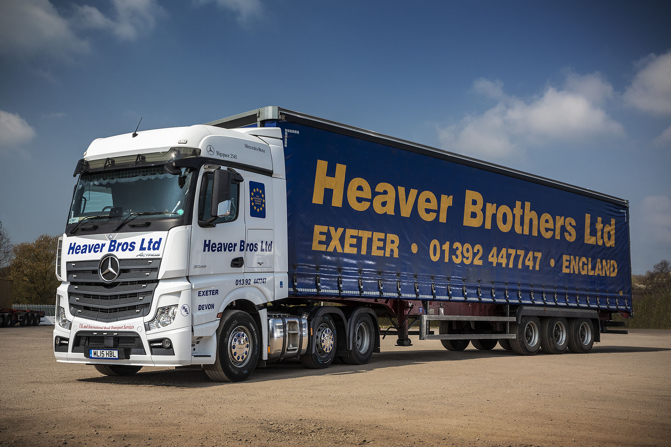

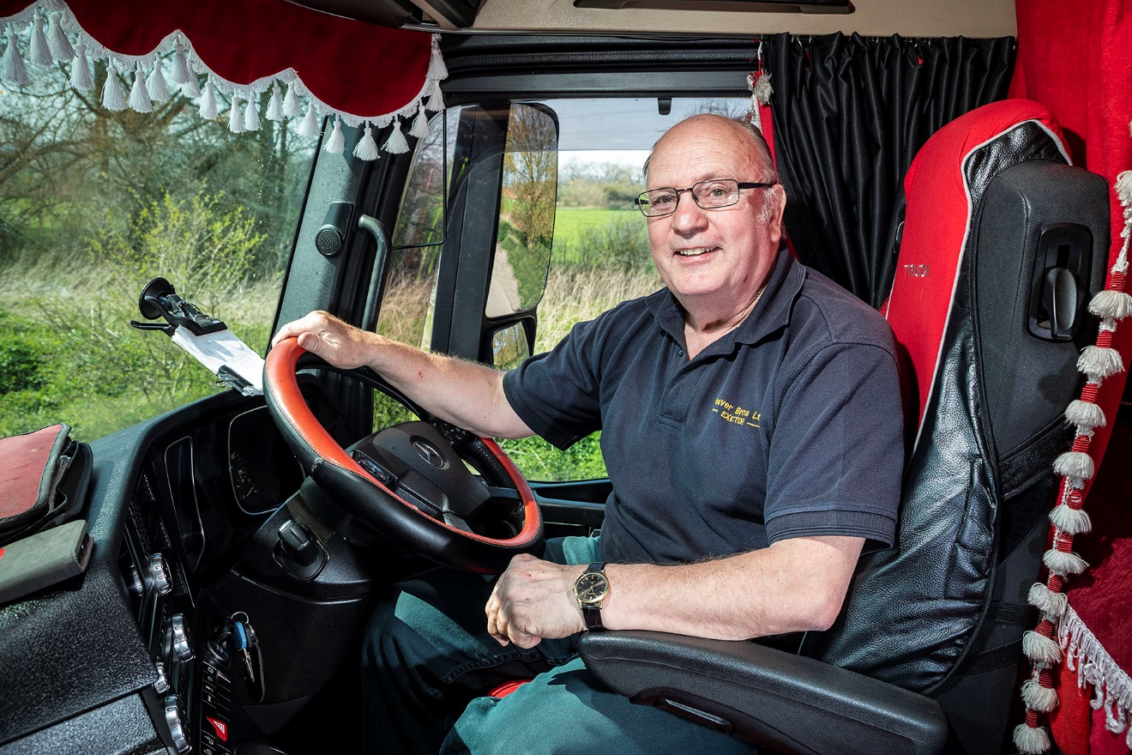

Red leader: Heaver Brothers driver Mike Stevens added his own finishing touches to his Actros cab

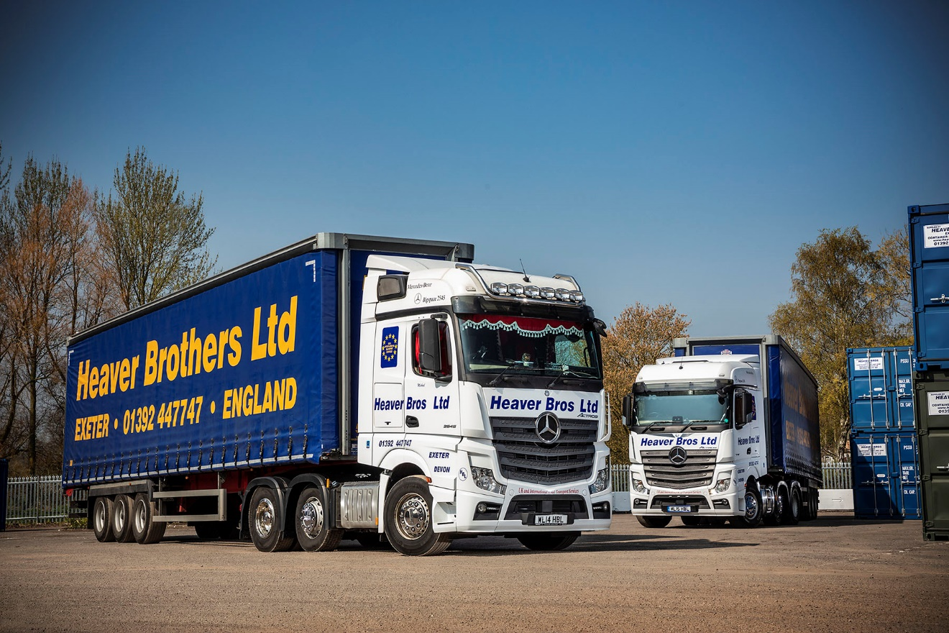

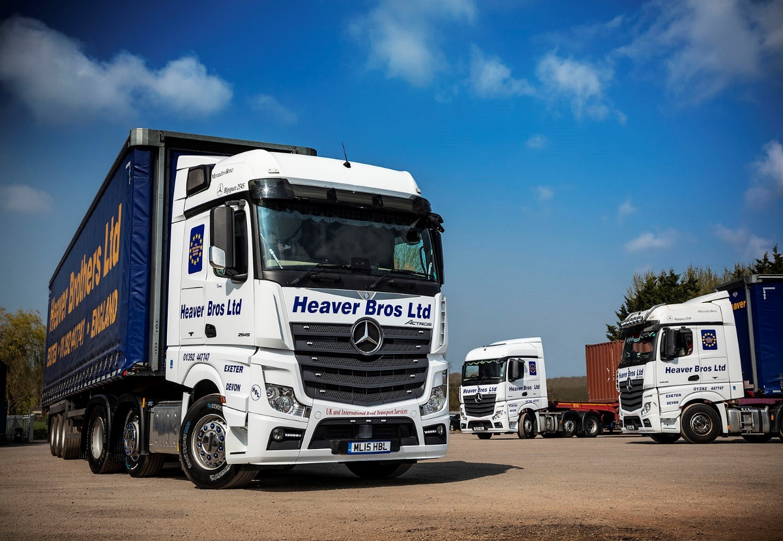

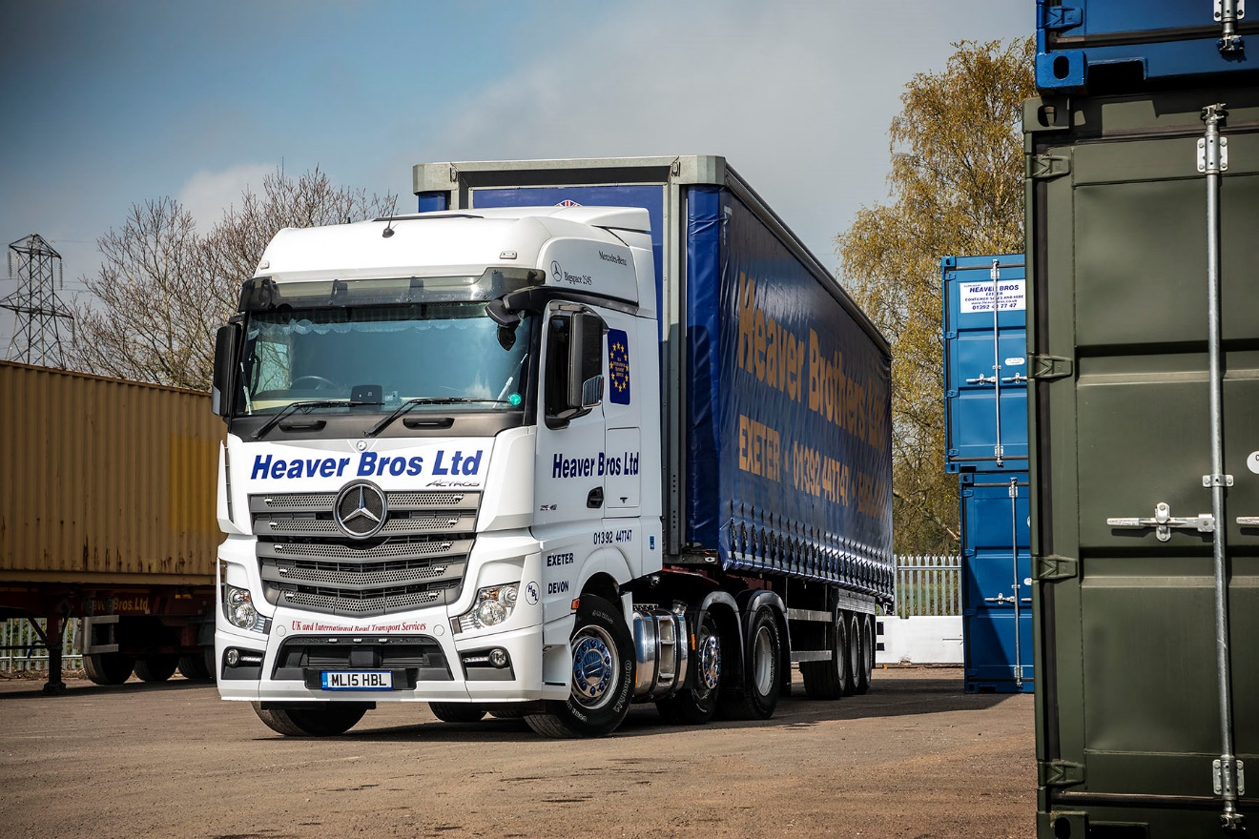

ends

For more information, or to request bigger/higher-res image files, please contact:
John Ripley or Steve Warren
Impact Communications, 01926 842126
John: 07771 484595, john@impactcom.co.uk
Steve: 07770 470251, steve@impactcom.co.uk

