

Date: 25 November 2019

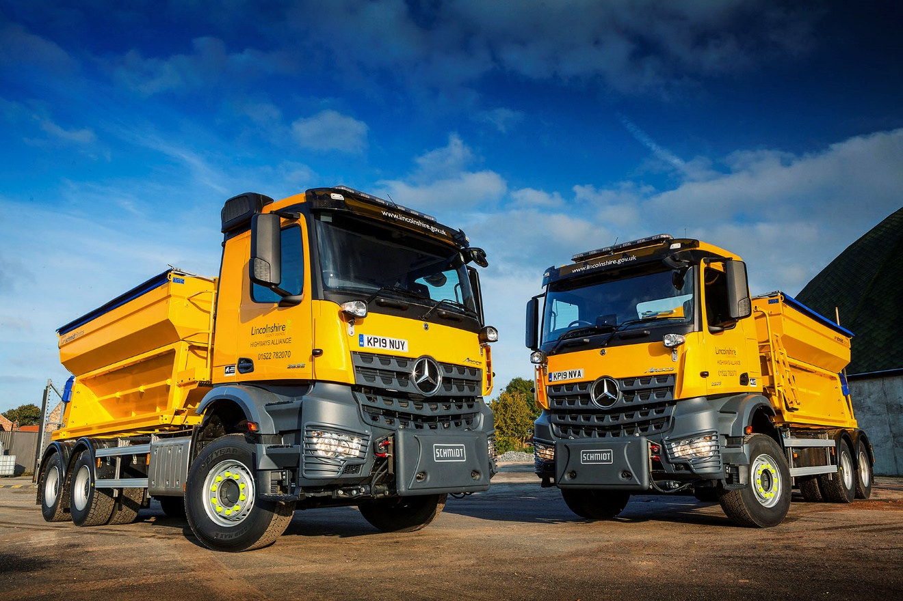

Mercedes-Benz Arocs gritters stand ready to take the ‘cold call’ in Lincolnshire

Lincolnshire County Council has turned once again to the Mercedes-Benz Arocs for one of the toughest jobs in transport – clearing the roads of snow and ice through the winter.

The authority has boosted its fleet in preparation for the onset of the cold season, by taking delivery of four new 26-tonners from Dealer Intercounty Truck & Van.

All Arocs 2635 models, they are powered by 7.7-litre ‘straight-six’ engines which generate 260 kW (354 hp) and drive both rear axles via Mercedes PowerShift automated manual transmissions. The new trucks are fitted with Schmidt Stratos grit hoppers and spreading equipment, as well as mounts for plough blades.

Lincolnshire County Council’s gritting fleet now extends to 47 vehicles, approximately two thirds of which are based on Mercedes-Benz chassis. In a break from its previous acquisition method of leasing, however, the authority has purchased its latest trucks.

The 6x4 Arocs are lighter than the Mercedes-Benz eight-wheelers they have replaced. “While most of our county is quite flat,” explained Darrell Redford, the Council’s Network Resilience Manager, “the Lincolnshire Wolds area of hills and steep valleys is not far from the North Sea and prone to very bad weather conditions in winter.

“We’ve previously relied on 32-tonne gritters with 10m³ hoppers to keep these roads open. Those trucks employed a ‘pre-wet’ salt system, which meant they also had to carry heavy liquid tanks.

“We’ve now switched to an alternative method which entails using salt impregnated with molasses. This helps it stick to the road, and is highly resistant to being blown or washed away. It therefore negates the need for water tanks and means we can put the same size of body on a smaller, 6x4 chassis – which results in a welcome cost saving.”

The vehicles are equipped with computer-controlled spreading systems, into which their routes can be programmed in advance. The spreaders then deposit the correct amount of salt onto each section of road automatically. As well as improving efficiency, the fact that this frees up the driver to concentrate fully on the road and traffic conditions enhances safety.

“The double-drive 26-tonne Arocs is the perfect truck for this demanding role,” continued Mr Redford. “Salt and machinery are not natural allies, but we know from experience that Mercedes-Benz gritters are extremely reliable, and are engineered to stand up to the job extremely well.

“They’re also very good value in terms of their total cost of ownership – even after a long working life of 10-15 years we anticipate having no difficulty in selling them on for a good price. Like all local authorities our priority is to achieve the most cost-effective solution for our Council Tax-payers’ money, and when it comes to gritting trucks Mercedes-Benz is our preferred chassis.”
The muscular Mercedes-Benz Arocs is purpose-designed for construction and related applications, offering high ground clearance and excelling in the toughest of working conditions. The comprehensive model range includes rigids from 18-32 tonnes GVW – or even higher, for off-road applications – as well as tractor units in various drive configurations and mighty SLT heavy haulers capable of working at up to 250 tonnes.
www.lincolnshire.gov.uk

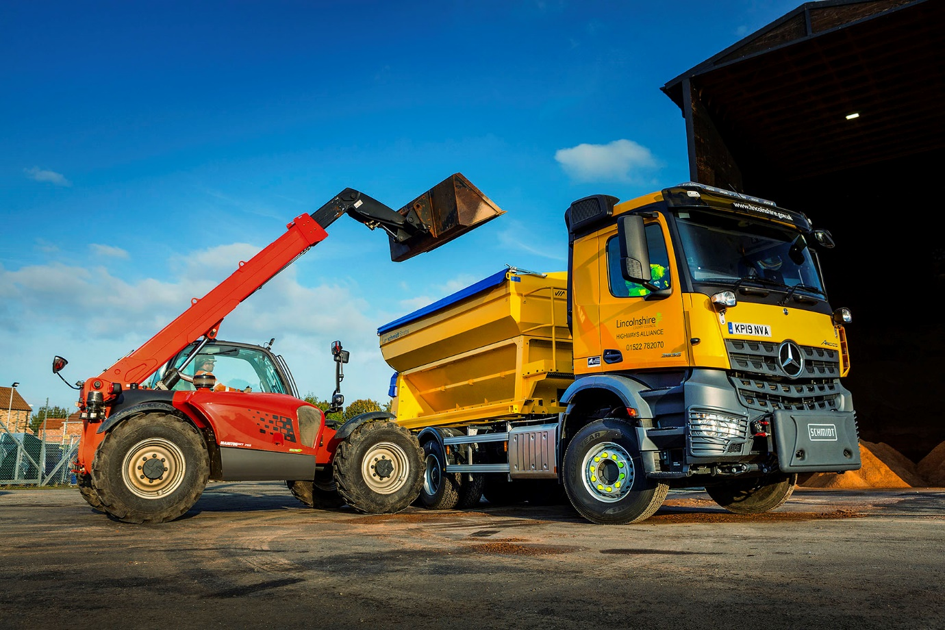

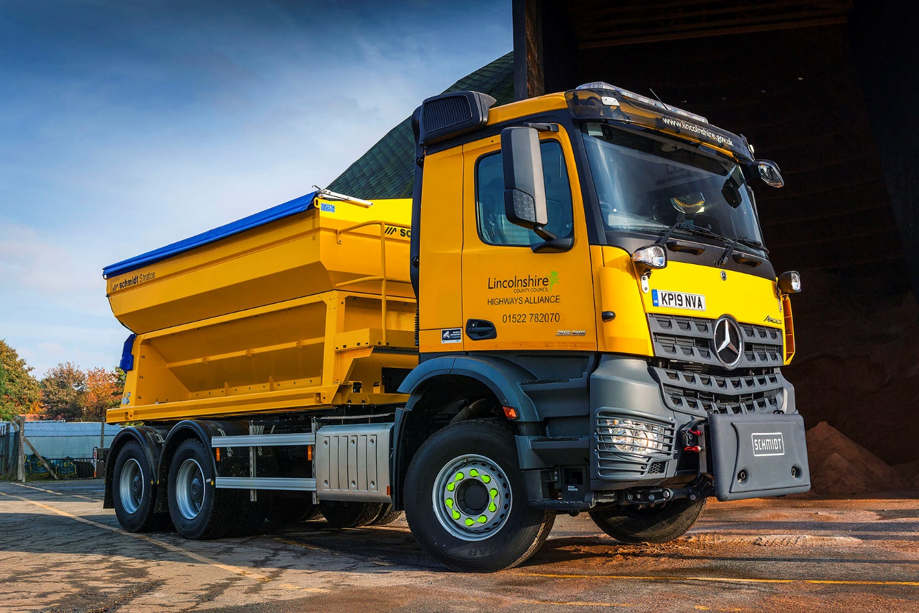

ends

For more information, or to request bigger/higher-res image files, please contact:
Steve Warren or John Ripley
Impact Communications, 01926 842126
Steve: 07770 470251, steve@impactcom.co.uk
John: 07771 484595, john@impactcom.co.uk

