

Date: 16 April 2021

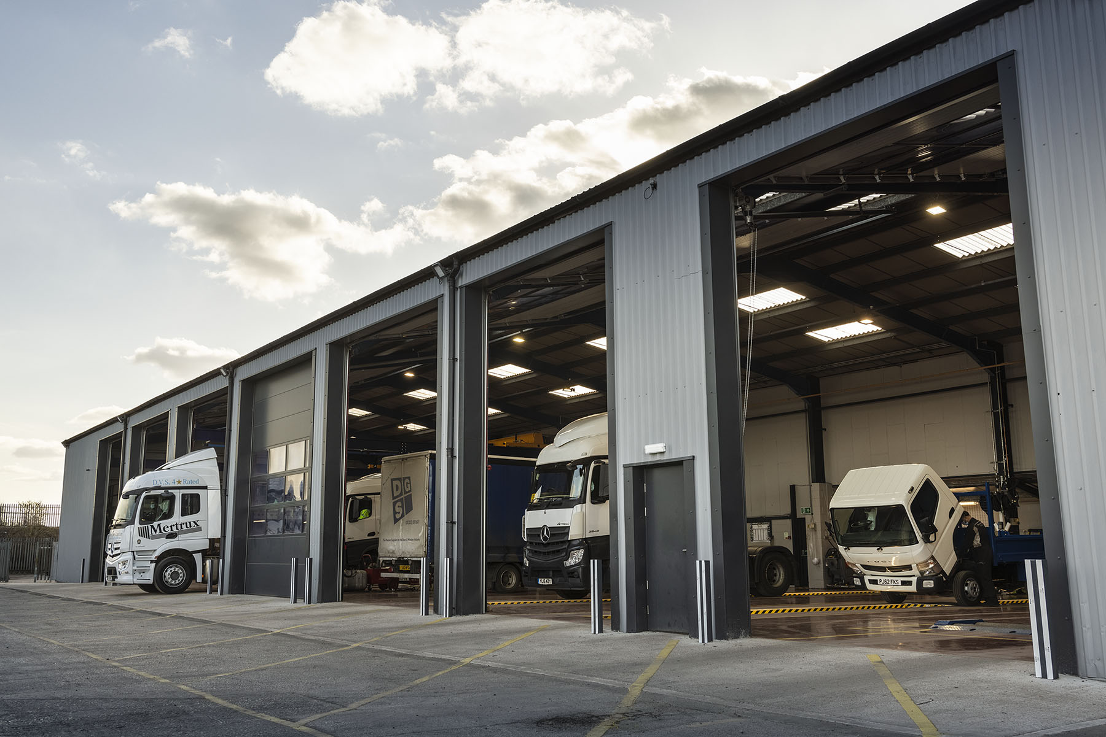

Mercedes-Benz Dealer Mertrux delivers ‘Gold standard’ truck back-up from its new, £2m workshop

The UK’s oldest Mercedes-Benz commercial vehicle Dealer has marked its 50th anniversary by opening a new, truck-dedicated workshop at its headquarters in Derby.

Mertrux Truck & Van has invested some £2 million in the project, which is already delivering tangible benefits for operators. Not only has it increased capacity and improved efficiency, but the large area of hardstanding in front of the building also provides plenty of space in which to manoeuvre and park tractor-and-trailer combinations.

Drivers of Mercedes-Benz and FUSO trucks arriving at the Dealer’s premises on the West Meadows Industrial Estate are directed by a yardman and clear signage to the new workshop at the rear of the site – the scheme has also entailed the removal of fencing and a gate. Originally a warehouse, it was then rented out as a bodyshop and occupied more recently by a recovery firm before Mertrux resolved to undertake the conversion.

Smartly finished with cladding and roller shutter doors, the building incorporates seven full-length truck bays, two of which have pits. The comprehensive inventory of equipment includes new column lifts and brake roller testers, while truck parking bays are clearly marked outside.

Like the long-established maintenance facility on the same site, in which both trucks and vans were previously serviced and repaired, but which is now being used solely for lighter vehicles, the new workshop is currently open until midnight on weekdays, and on Saturday mornings. A return to 24-hour operation may follow as Covid restrictions are lifted and the economy gathers pace again.

Mertrux Truck & Van has represented the three-pointed star in the East Midlands since 1971. In addition to Derby, it operates from locations in Leicester, Mansfield and Nottingham. Like other Mercedes-Benz Trucks Dealers in Britain, it also sells and supports the FUSO Canter light truck range.

Dealer Principal Andrew Kerrane commented: “Coming as it does in the year of our Golden Anniversary, this latest investment represents another important milestone for Mertrux. Once again, we have underlined our commitment and determination to provide customers with the industry-leading aftersales support they’re entitled to expect.

“Demand for our maintenance and repair support was extremely high when we embarked on this project, and despite the challenges presented by the pandemic we’ve remained busy throughout the last year. The overall increase in the number of available bays is assisting with throughput and means we can get both trucks and vans back on the road more quickly than ever before.”

He continued: “The new facility also provides a much better workspace for our technicians, not least because the ceiling is a good bit higher than they’ve been used to – trucks have become taller over the years, and the latest Actros GigaSpace cab presented an issue previously. This has now been overcome.

“Plus, of course, we’ve addressed the question of space outside, which is a key element of the manufacturer’s network development strategy. There’s more room in front of the new workshop for drivers to turn, and there are dedicated spaces in which they can park, so the whole experience of dropping their vehicles for inspections and maintenance is a great deal easier now.”

Mertrux founder Don Marshall built something of an ‘empire’ – in addition to its
Mercedes-Benz franchise the company has a number of other interests within the road transport sector. Don died in 2011, having handed over the reins to his son Ian six years earlier, but his legacy lives on through his children and grandchildren.

Ian remains as Managing Director, while his sisters Judith and Sarah, and their younger brother Matthew, also work for the family business. So, too, do Ian’s daughters Lucie and Chloe, and Judith’s daughter Annabelle.

Mertrux Truck & Van employs 176 sales, service and parts specialists, as well as administrative colleagues, across its four locations, and has always taken great pride in the loyalty of its workforce and an impressively low rate of staff turnover.

Added Ian Marshall: “This company has come a long way over the last five decades. If my father taught me one thing, it’s that this is a ‘people’ business, always has been and always will be. That’s why we ascribe so much importance not only to the quality of our facilities and of the products we supply and support, but also to the quality of our relationships with customers and colleagues alike.”

Mercedes-Benz Trucks Managing Director Wolfgang Theissen commented: “Mertrux has been a fantastic ambassador for the Brand over the last five decades, during which our longest-serving Dealer partner has never wavered in its commitment to outstanding customer service.

“By investing in this impressive, truck-dedicated workshop, Mertrux has demonstrated once again that it can be relied upon by operators to do whatever it takes to restrict downtime and keep their Mercedes-Benz and FUSO vehicles out on the road and earning.”

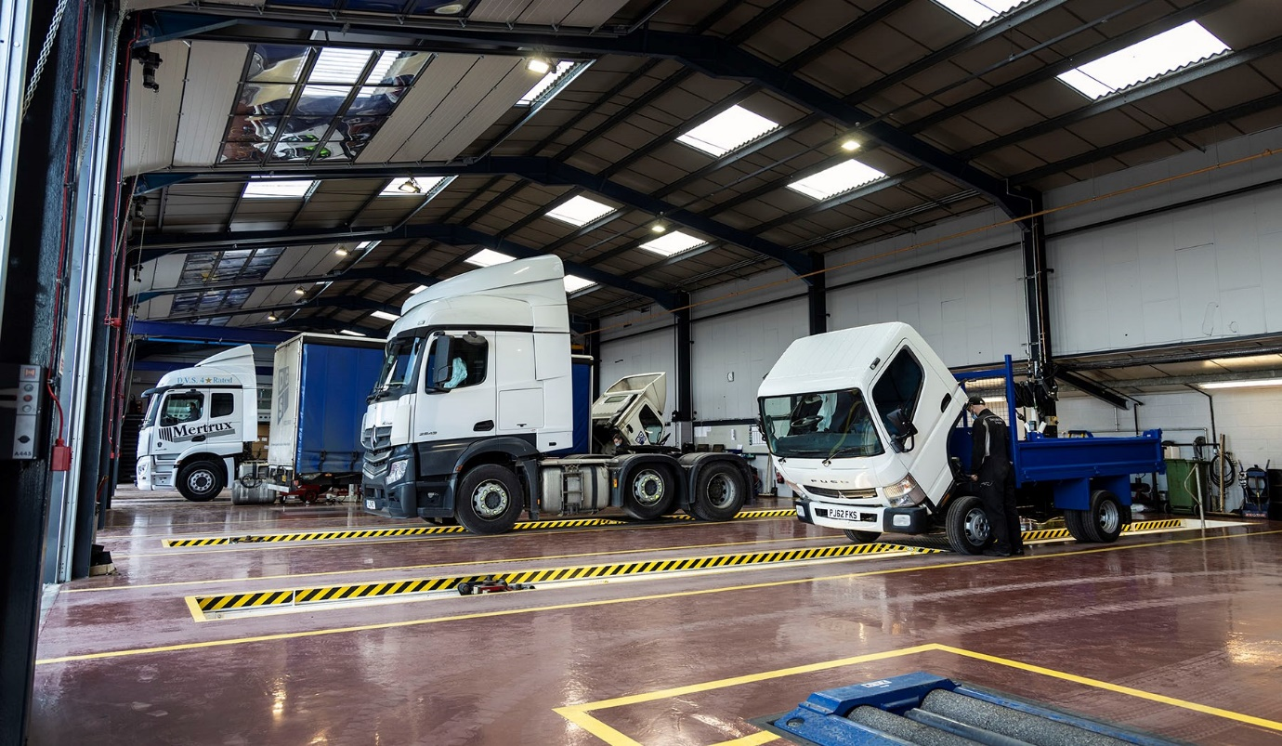

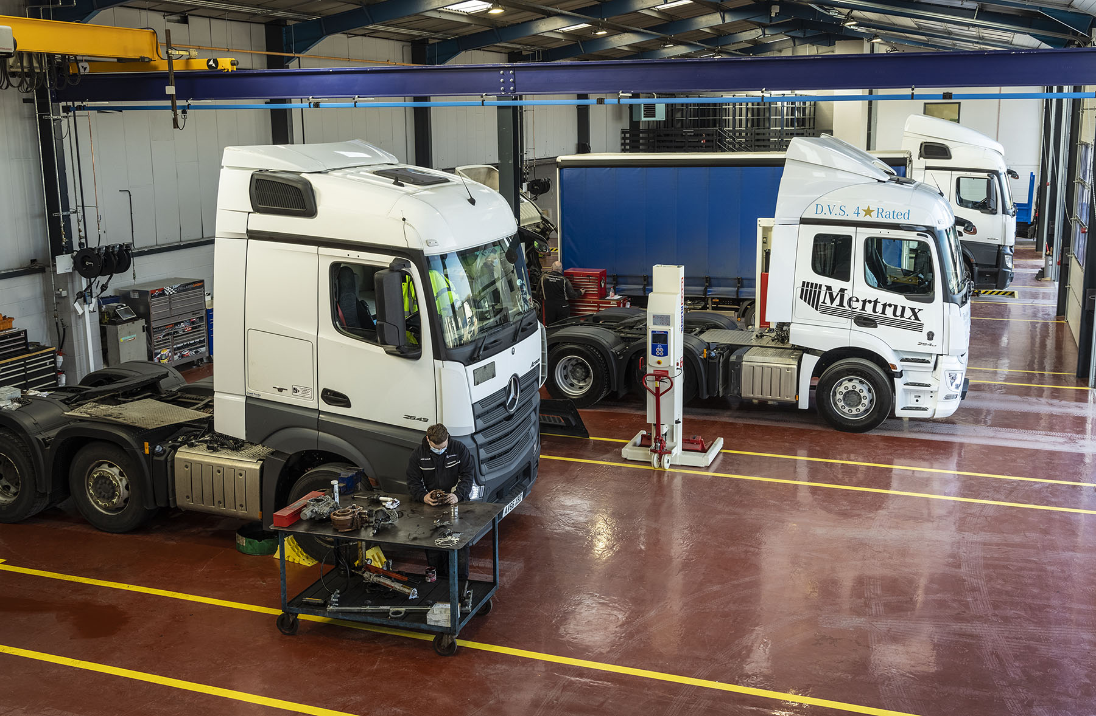

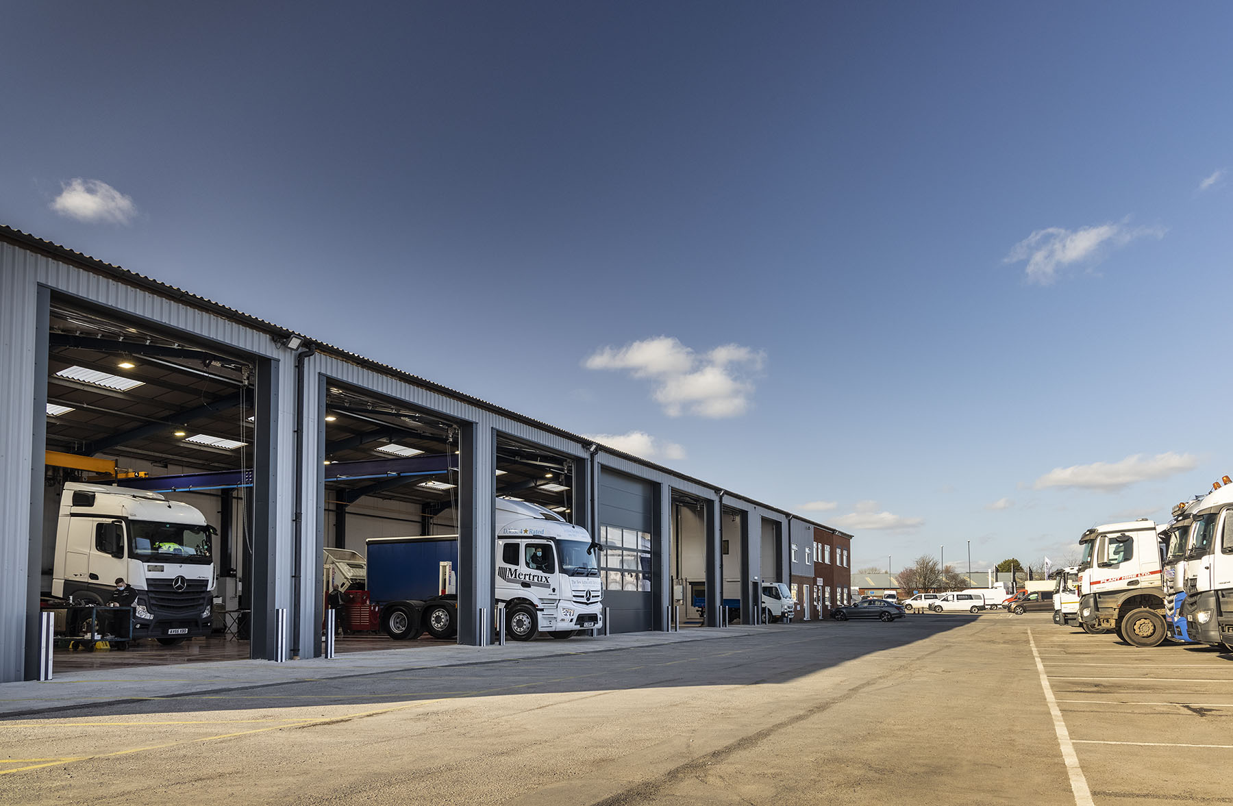

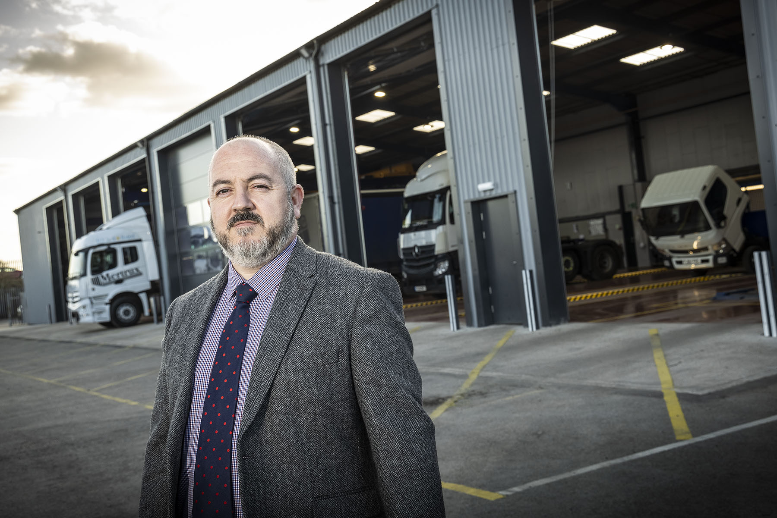

Committed to customer service: Mertrux Truck & Van Dealer Principal Andrew Kerrane said the new workshop represented another important milestone for a company now celebrating the year of its Golden Anniversary

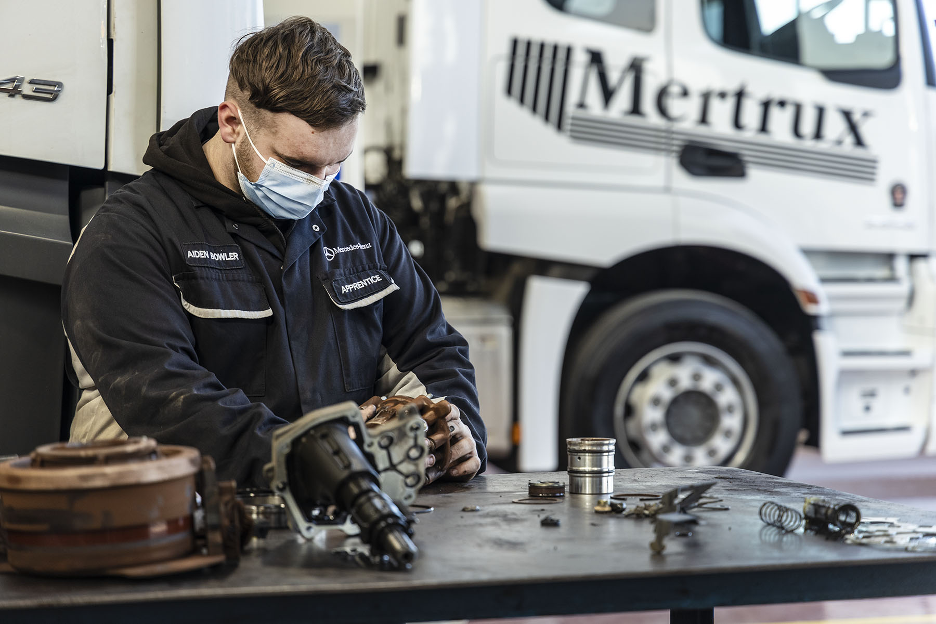
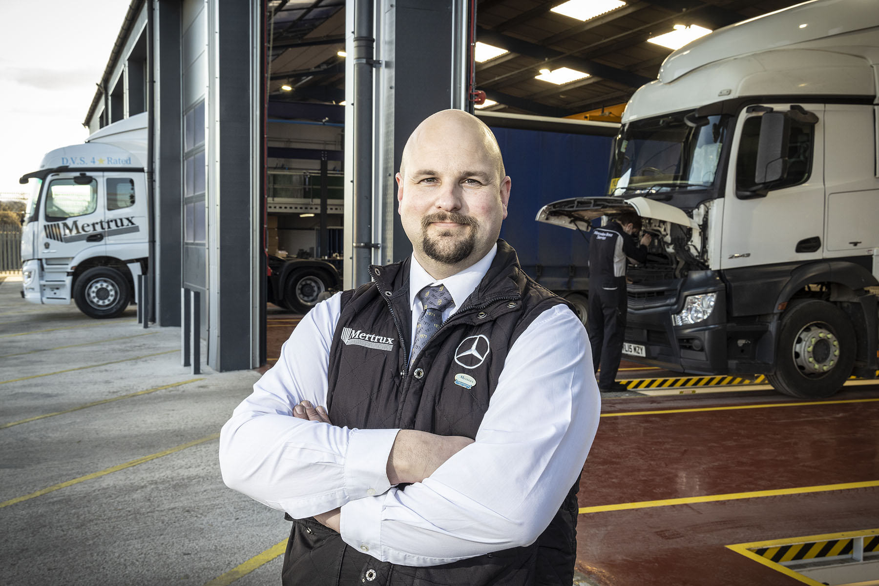

Time-served: Aftersales Manager Jon Burridge, who has worked for Mertrux Truck & Van since 1994, leads the team in the Dealer’s new truck workshop

ends

For more information, or to request higher-res image files, please contact:

Jamie Fretwell at Mercedes-Benz Trucks UK Ltd
07712 519230, jamie.fretwell@daimler.com

or

Steve Warren or John Ripley
Impact Communications, 01926 842126
Steve: 07770 470251, steve@impactcom.co.uk
John: 07771 484595, john@impactcom.co.uk

About Mercedes-Benz Trucks UK Ltd
Mercedes-Benz Trucks UK Ltd is the sales and marketing organisation responsible for all Daimler truck products in the UK, including FUSO Canter. In 2019, the company registered 6,963 new trucks. Mercedes-Benz accounted for 6,188 new trucks registered in 2019, making it the third-biggest truck brand in the UK. Meanwhile, FUSO registrations hit 775 – including 580 new trucks over 6.0-tonnes. The flagship new Mercedes-Benz Actros which won the 2020 International Truck of the Year award, features seven core innovations including MirrorCam, Multimedia Cockpit and Active Brake Assist 5. Our premium range of innovative trucks – Actros, Arocs, Atego, Econic and Unimog – draw upon more than 125 years of exceptionally high standards of quality, backed up by our promise of Trucks You Can Trust.
www.mbtrucks.co.uk

