

Date: 1 December 2020

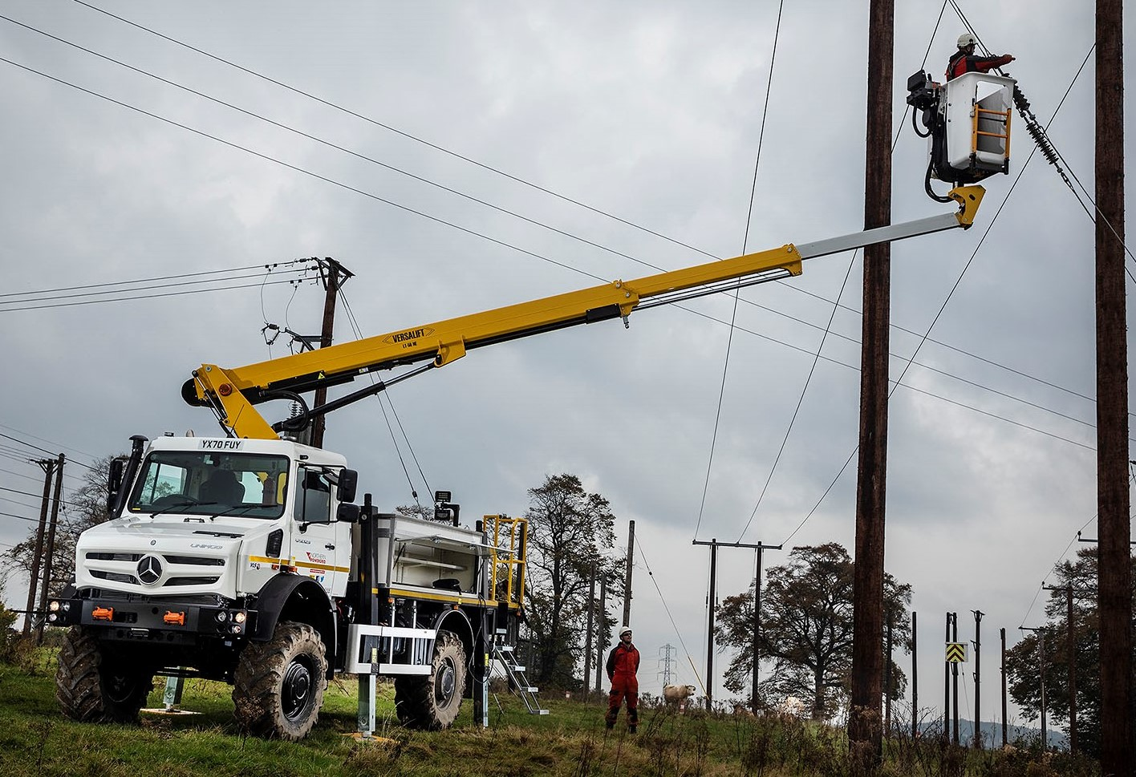

Northern Powergrid energises fleet with £1.75m investment in Versalift-equipped Mercedes-Benz Unimogs to support customers

Northern Powergrid is fulfilling its mission to power customers’ lives, homes, businesses and communities across the North East, Yorkshire and northern Lincolnshire with the help of seven new all-terrain Mercedes-Benz Unimogs.

The vehicles, which represent an investment of £1.75 million by Northern Powergrid, were supplied by specialist Dealer South Cave Tractors, of Brough, East Yorkshire. All are U5023 UHE Extreme Off-road Unimog models, and fitted with Versalift hydraulic access equipment.

They are used by highly trained teams at Northern Powergrid responsible for the repair and replacement of overhead electricity lines suspended from wooden poles across the electricity distributor’s network. Each lift has a ‘basket’ big enough to accommodate two engineers working at a height of up to 20 metres.

Northern Powergrid is a long-established Unimog customer – its latest are the subject of a fully serviced contract hire agreement with sister company Vehicle Lease & Service (VLS). Representatives of both worked closely with their counterparts from South Cave Tractors and Versalift in drawing up the specifications, and as a result the finished vehicles are perfectly tailored to their role.

Expert members of the South Cave Tractors and Versalift teams also delivered comprehensive handover sessions at Northern Powergrid’s training centre near Leeds, during which they provided operating teams with detailed introductions to the chassis and ancillary equipment.

Alistair Walton, Programme Manager – Overhead Lines for Northern Powergrid’s South Yorkshire & North Lincolnshire region, said: “These vehicles are deployed daily across our operations and are used by our teams of Overhead Linesmen to access wood pole overhead power lines which can carry anything from 240 to 66,000 volts.

“Many of these are in difficult-to-reach locations but the Unimog’s fantastic off-road capability allows us to traverse the most challenging of terrains. The access platform’s 20-metre maximum reach, meanwhile, represents a big improvement on the 15 metres achieved by the vehicles we were using previously for the same task.

“While considering the design we also asked our teams for their input and as a result have included extras like heated lockers and additional working lights, which will be a great help if they are called out at night or in difficult weather conditions to restore power for our customers.”

All Unimogs have 4x4 chassis with single rear wheels, while gross weights vary from 7.5 to 16.5 tonnes. Ultra-high mobility variants like Northern Powergrid’s U5023s – which are rated at 12.7 tonnes GVW – offer unrivalled traction thanks to their strong yet torsionally flexible frame and a torque tube suspension system that provides extreme levels of axle articulation.

The U5023 is powered by a 5.1-litre four-cylinder engine producing 170 kW (230hp). Standard equipment includes the innovative Central Tyre Inflation system, which allows the driver to drop the pressures from the cab when the vehicle is off-road. In addition to increasing grip, this also brings an environmental benefit by minimising damage to the ground. Tyres can then be reinflated when back on a hard surface for greater safety and fuel efficiency at normal road speeds.

In addition to its impressive maximum height, the Versalift LT-56-NE telescopic boom offers a nine-metre outreach, which allows engineers to overcome obstacles when accessing overhead lines. Each basket will lift up to 230 kg.

VLS Commercial Manager Justin Bower commented: “These are highly specialised vehicles and with its unique set of capabilities the Mercedes-Benz Unimog is by a long margin the best base chassis for such a demanding application.

“Its off-road ability is legendary, of course. No less important, though, given that these vehicles can be called upon at any time of the day or night, and in all weathers, is the superb, and well proven reliability of the chassis and the access platforms.

“The first-class customer service we receive from South Cave Tractors and Versalift is another major benefit – we’ve been working with both for around 20 years now, and have developed excellent professional relationships.”

Northern Powergrid manages the electricity network that powers everyday life for eight million customers across 3.9 million homes and businesses, and operates 24 hours a day, 365 days a year. “Now more than ever our customers need us and recognise the essential role we play in powering their homes, businesses, local hospitals and communities,” added Alistair Walton.

“This significant investment in these hugely capable vehicles demonstrates our commitment to being there for our customers and ensuring our teams have what they need to work safely, quickly and efficiently to keep the power flowing and respond to any electrical emergencies.”

northernpowergrid.com

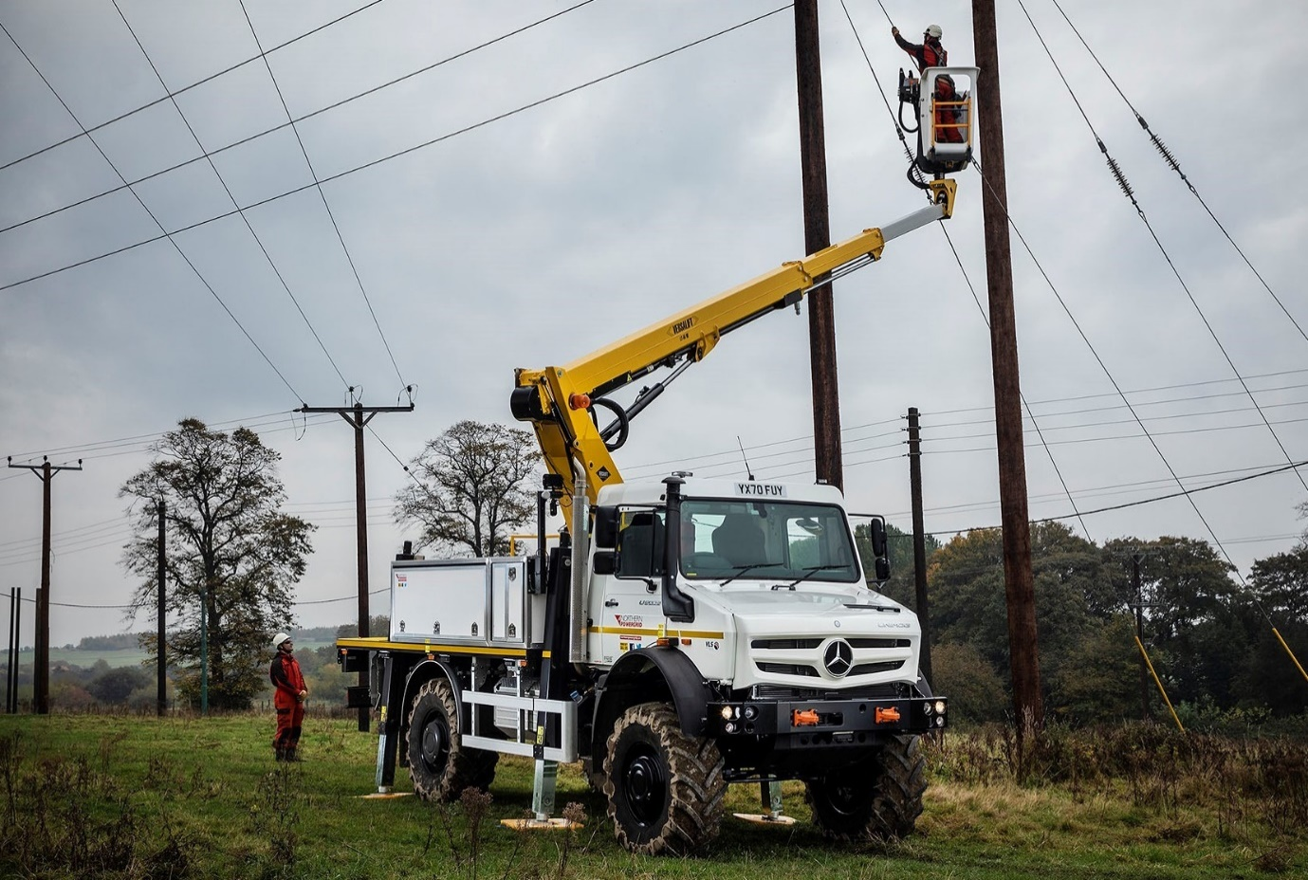
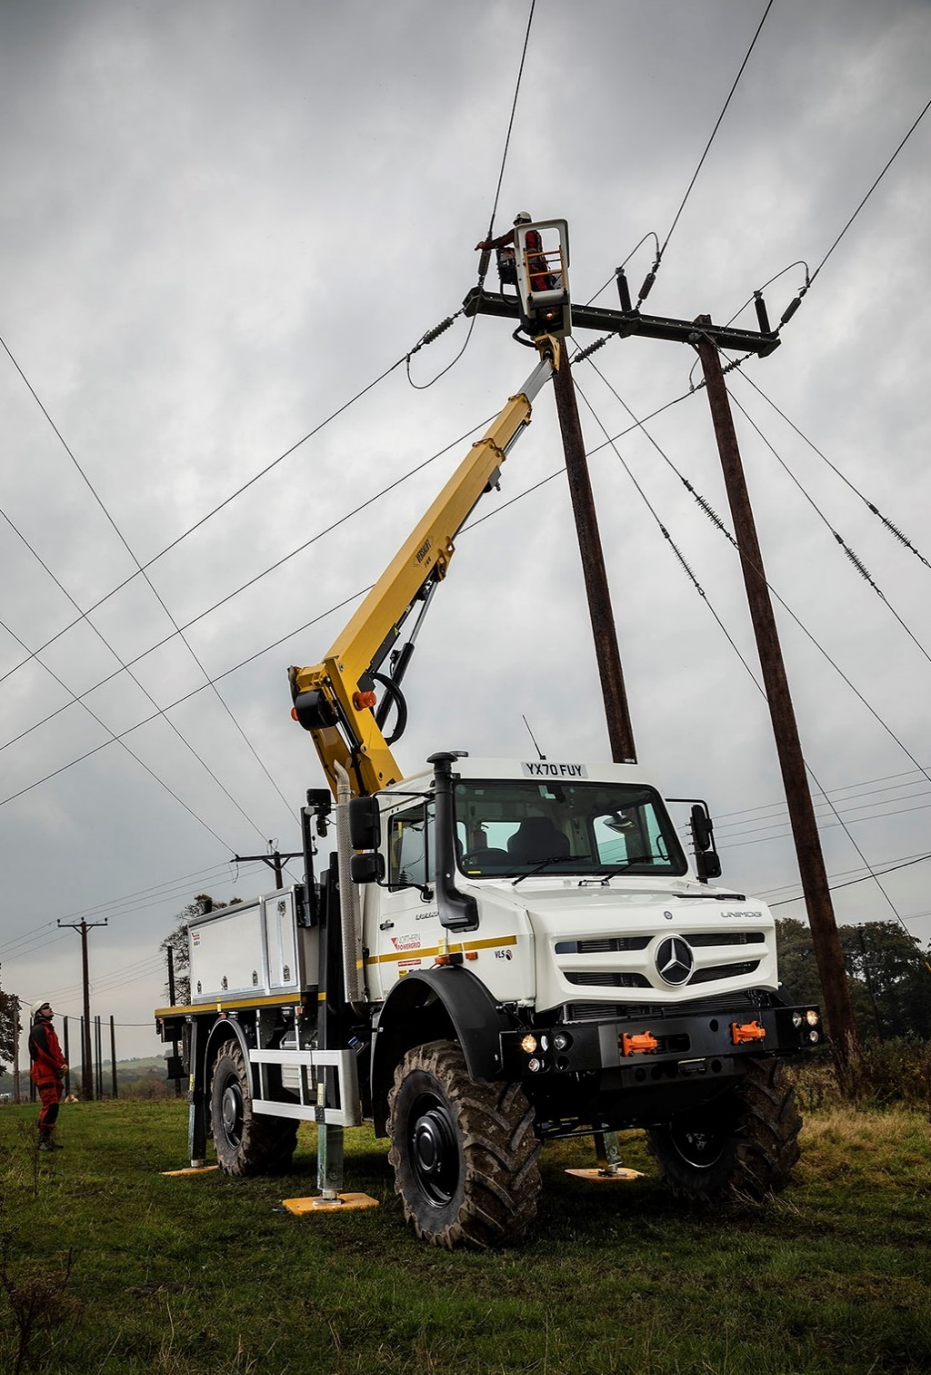

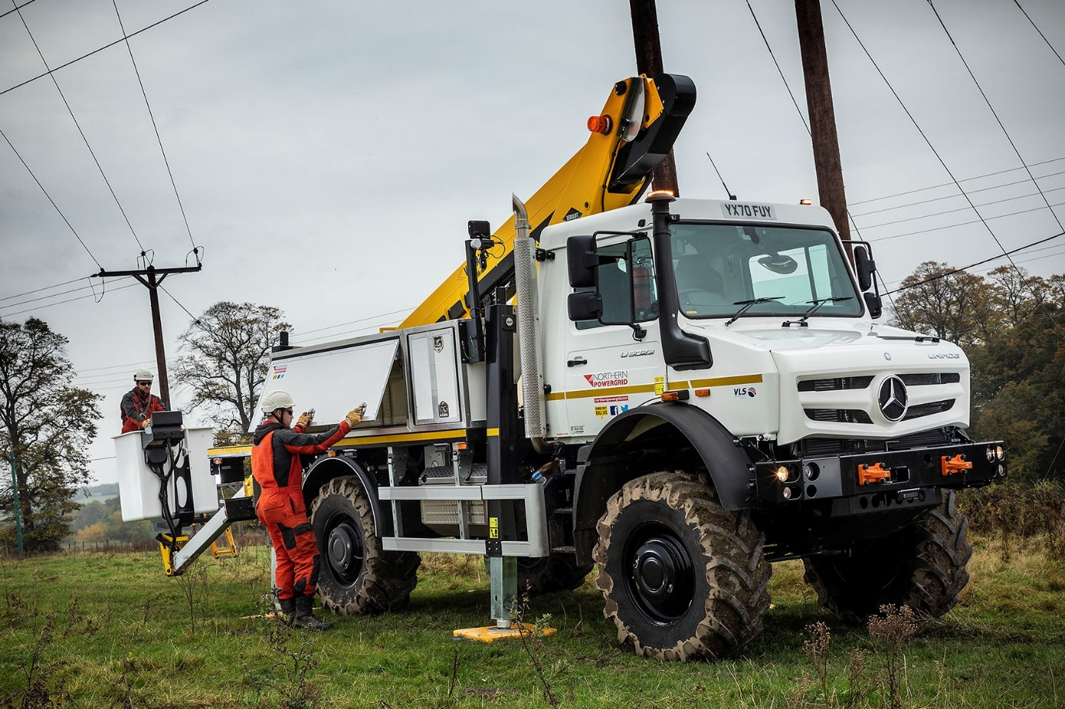

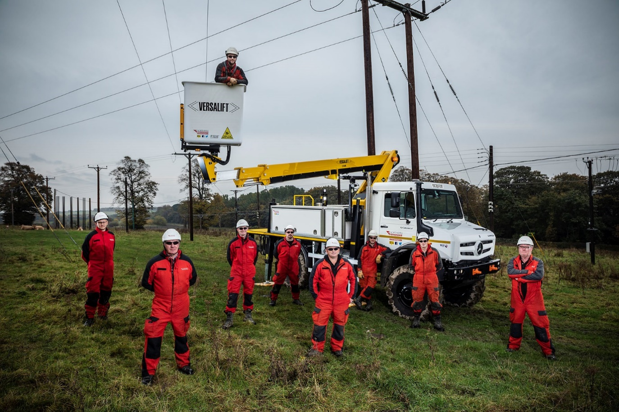

Rising stars: Alistair Walton, front left, with Northern Powergrid engineers and one of the electricity network operator’s new Mercedes-Benz Unimogs

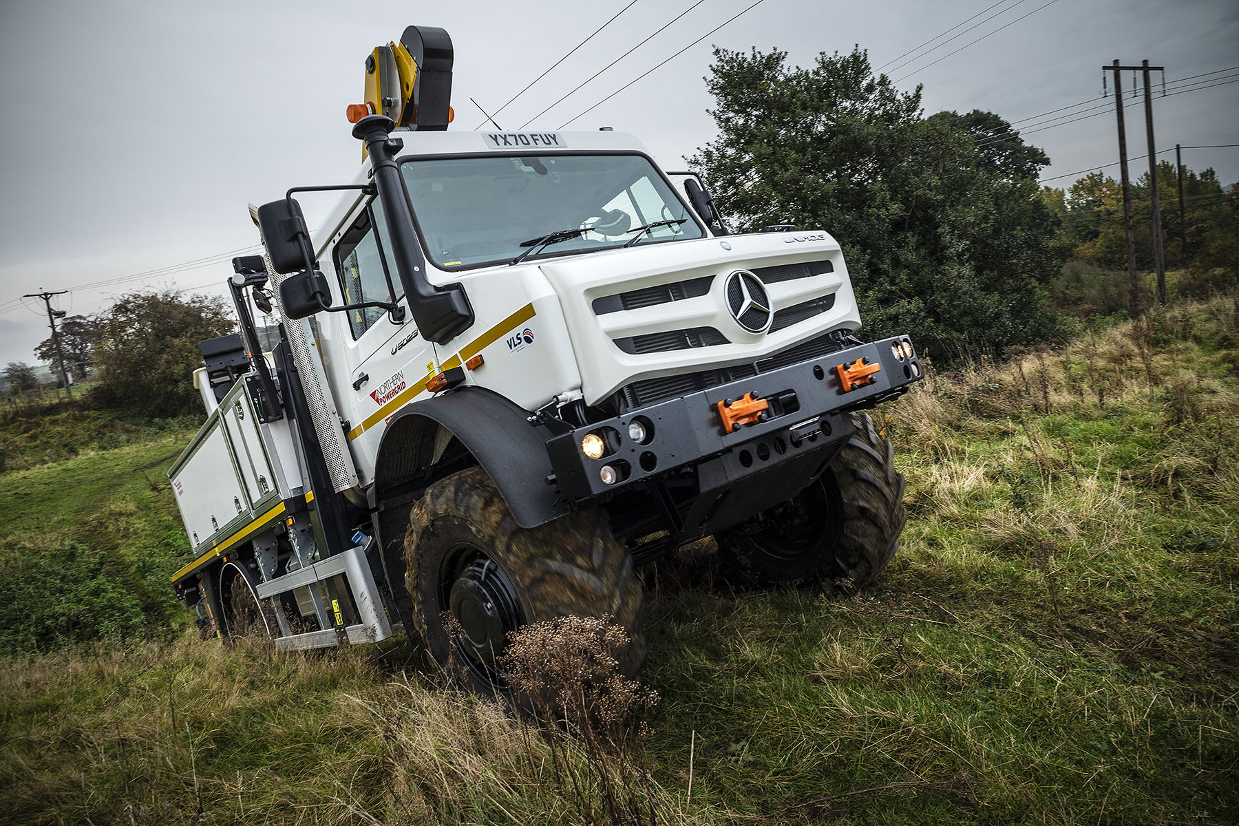

ends

For further information, please contact:
John Ripley or Steve Warren
Impact Communications, 01926 842126
John: 07771 484595, john@impactcom.co.uk
Steve: 07770 470251, steve@impactcom.co.uk

Notes to Editors – Northern Powergrid:
Northern Powergrid is the electricity distribution business for the North East, Yorkshire and northern Lincolnshire. The company delivers power safely and reliably to 8 million customers across 3.9 million homes and businesses. Its network consists of more than 63,000 substations and 60,000 miles of overhead power lines and underground cables, spanning some 9,650 square miles.

For further information on Northern Powergrid, please contact:
Joanne Kerrigan, Communications Manager, joanne.kerrigan@northernpowergrid.com
Dawn Parlett, Communications Advisor (External), dawn.parlett@northernpowergrid.com
24-hour press office: 0800 500 3175


