

Date: 10 December 2021

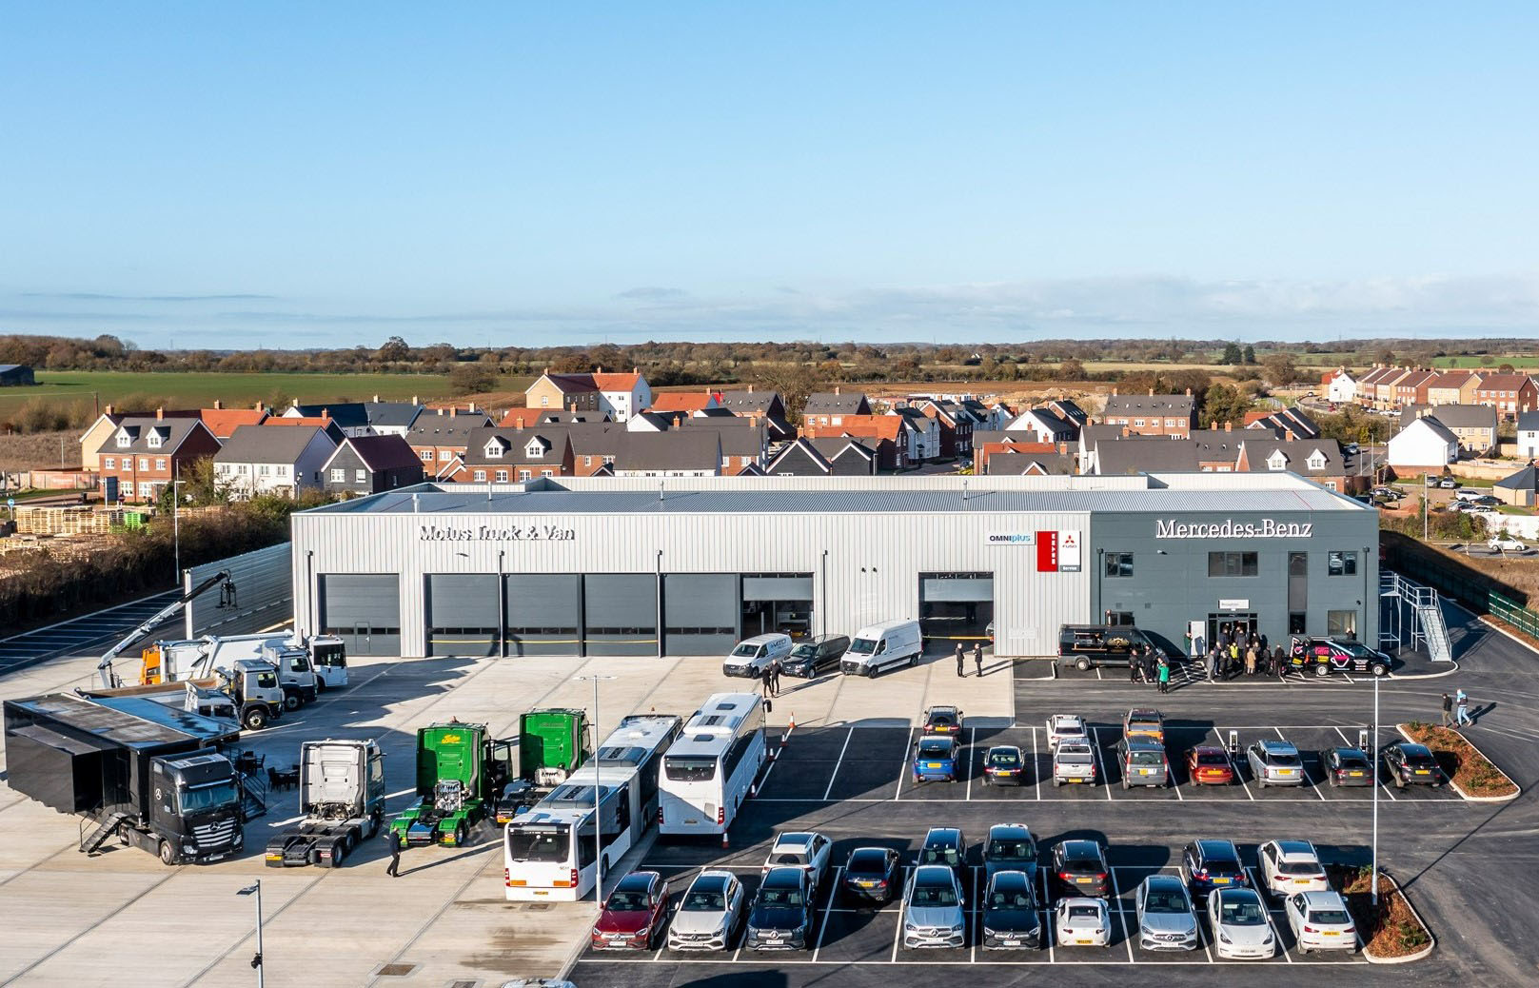
Showcase event: Motus Truck & Van welcomed guests to an open day at its Witham branch

Motus Truck & Van launches flagship Mercedes-Benz service and parts centre

Christmas came early for Essex-based operators of Mercedes-Benz and FUSO commercial vehicles with the opening on Monday (6 December) of Motus Truck & Van’s state-of-the-art aftersales centre at Witham.

The latest addition to the Dealer’s branch network is perfectly located alongside a stretch of the A12 trunk road that runs between Chelmsford and Colchester. This is the primary route by which vehicles working in and out of the docks at Felixstowe and Harwich, reach London and the M25.

Motus Truck & Van hosted established and prospective customers, and representatives of the manufacturer, at a pre-launch showcase, during which they were able to tour the facilities and meet key members of its team. The feedback from those attending was resoundingly positive – all welcomed the Dealer’s progression as evidence of its commitment to keeping operators’ vehicles up and running.

The new centre is now open round-the-clock, from 6am on Mondays until 10pm on Fridays, and on Saturday mornings. Crucially, the three-acre site offers ample space for drivers to manoeuvre and park their vehicles.

The smart and airy reception area includes comfortable rest and meeting facilities, while the 700 sq m Parts department carries broader and deeper stocks of Mercedes-Benz GenuineParts than has previously been possible.

The heart of the 2,500 sq m building, though, is its fully equipped workshop. This has nine full-length truck and trailer bays – three of which have 22-metre pits – with another eight set aside for van maintenance and repairs. There is an Authorised Testing Facility in which inspectors from the Driver and Vehicle Standards Agency will carry out truck MOT tests.

Speaking at last week’s open day event, Motus Truck & Van Managing Director Lee Seward recalled: “We began construction work just under a year ago, but this project has been a lot longer in the planning. We’re delighted, therefore, to be welcoming our guests today, and to give them this opportunity to see for themselves a flagship development of which we’re all very proud.”

Lee said that while the new centre had been built and equipped to the highest standards, its single biggest attribute was its location. “This is an important area in which Mercedes-Benz has not previously been represented,” he explained. “It sits between our dealerships in East Anglia and at West Thurrock, and is going to play a big part in our growth strategy.

“The very substantial development here at Witham, and those underway at other branches, reflect our determination to provide customers with an experience and a level of service that matches the reputations of the brands and the quality of the products we represent.”

Wilkin & Sons, the world-renowned producer of Tiptree jam, presented its exclusive Actros Edition 1 and Edition 2 tractor units at the launch event. Among those touring the new aftersales centre was the company’s Transport Manager Kevin King, who was accompanied by Assistant Transport Manager Lawrence Cook.

“This facility is only 10 minutes’ drive from our distribution centre, so it’s a real ‘game-changer’ for us,” enthused Kevin King. “The set-up here is fantastic, and very reassuring. It proves that Motus Truck & Van is really committed to providing operators like ourselves with the timely, customer-focused back-up we need.”

A driver for 21 years, Clive Wrathall, of Witham-based Crittall Windows, arrived in his Actros 2545 tractor unit. “I have a great rapport with the technicians at the Dealer’s Ipswich branch,” he declared. “This new facility will make life a lot easier, though, as it’s so close to us. I’ve had a walk around and it’s all state-of-the-art… absolutely fantastic. I’ll certainly miss the guys at Ipswich, but I’m sure the service here will be every bit as good.”

Dunmow-based SRC Aggregates runs more than 120 trucks, most of which are by a Swedish manufacturer. However, the fleet also includes a dozen Mercedes-Benz Arocs eight-wheelers, a combination of mixers and tippers – these have been maintained under Complete Service Contracts at Motus Truck & Van, Ipswich.

The operator’s Transport Manager Matt Parker and Service Administrator Nicole Todd welcomed the Witham development, which they said would have a positive impact on their business. “All very impressive, and a lot more convenient for us,” commented Mr Parker, while Ms Todd added: “It’s great to see the Dealer opening in such a prime location, while given the size of the workshop I’d like to think we’ll be able to get a truck in at short notice if we need to.”
C&W Fencing, of Wix, near Harwich, is awaiting delivery of an 18-tonne Mercedes-Benz Actros dropsider with crane. Like its seven Atego 7.5-tonners, the company’s new truck will be maintained under a Complete Service Contract at the Witham service centre.

Director Jason Kettle attended Motus Truck & Van’s open day with C&W Fencing’s Workshop Manager Karl Giles, and explained: “We’ve relied on the Dealer’s Colchester branch previously, but compared to this it was a very tight squeeze. Not only is the new workshop much bigger, but with so much room outside for manoeuvring and parking, it’s going to be a lot easier for our drivers to get in and out.”

Four fully-equipped Sprinter vans based at Motus Truck & Van, Witham, are allocated to highly trained technicians who provide emergency roadside breakdown assistance, 24 hours a day, 365 days a year.

Meanwhile, as the company’s new trade hub the Witham Parts team also makes urgent and other deliveries to own account and independent maintenance facilities, garages, mechanics and others throughout Essex, Suffolk, and parts of Hertfordshire.

Mercedes-Benz Trucks Head of Network Development Mark Williams said: “It’s great to see Motus Truck & Van opening this exceptional facility, which underscores its commitment to operators and represents another big step forward for our ever-improving network.
Mercedes-Benz Trucks’ Customer First strategy is focused on ensuring that points of representation are in the right locations and easily accessed. Witham ticks both boxes admirably.”

Motus Truck & Van represents the Mercedes-Benz Trucks and Mercedes-Benz Vans brands from a network of nine branches in Norfolk, Suffolk, Essex and Hertfordshire. Like other members of the manufacturer’s franchised network, it also sells and supports the FUSO Canter light truck range.

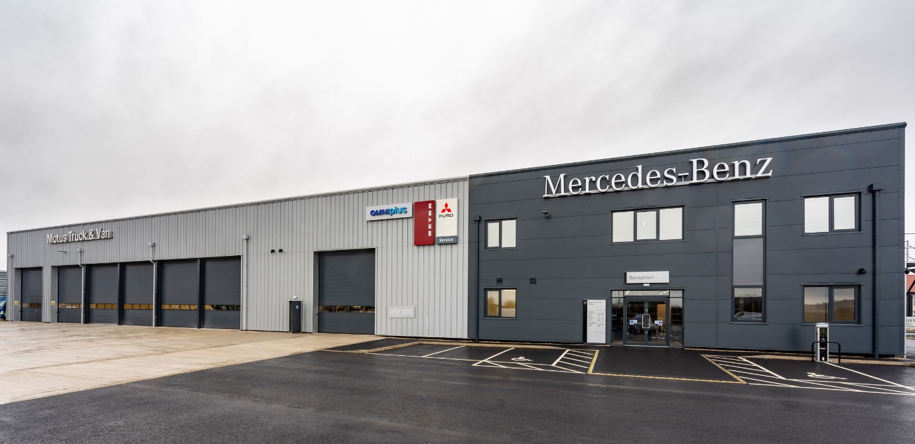

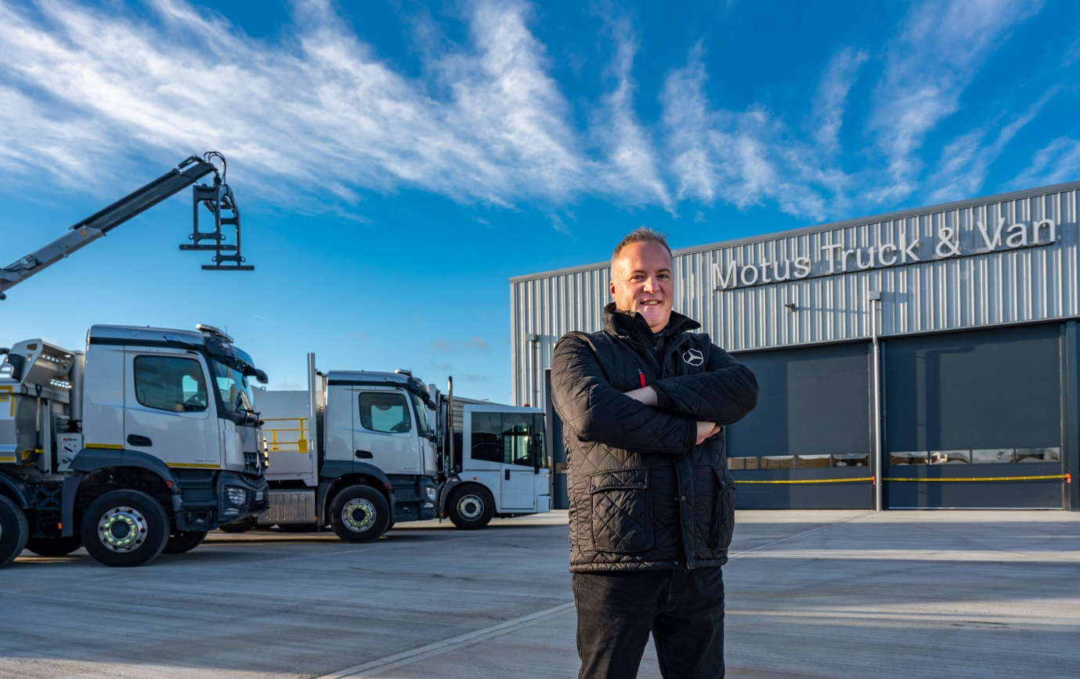

Platform for growth: Managing Director Lee Seward said the new aftersales centre had plugged an important gap in terms of representation, and was confident it would help to attract new customers to the Mercedes-Benz and FUSO brands

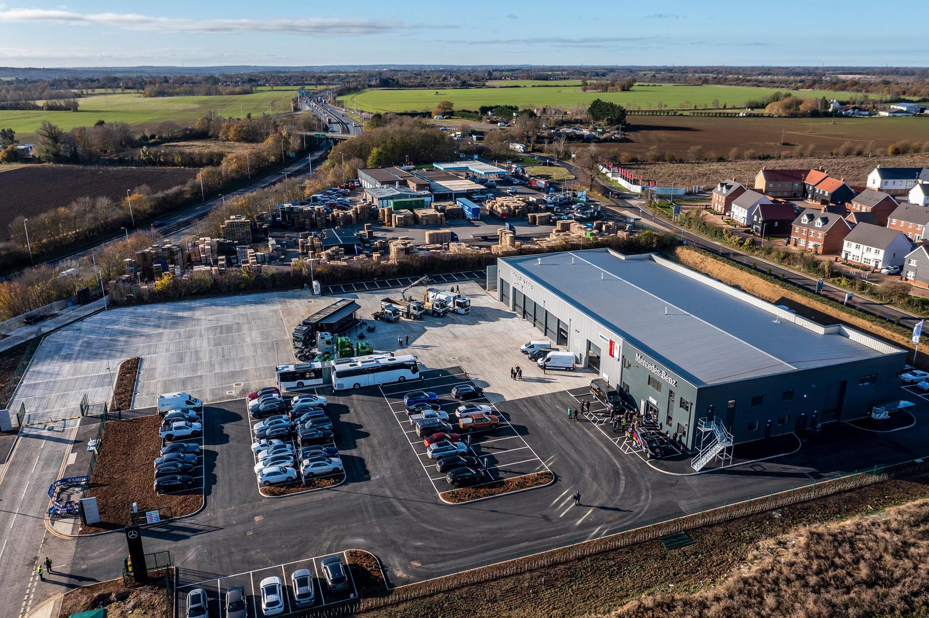

Perfect location: The new development is situated alongside the busy A12 trunk road

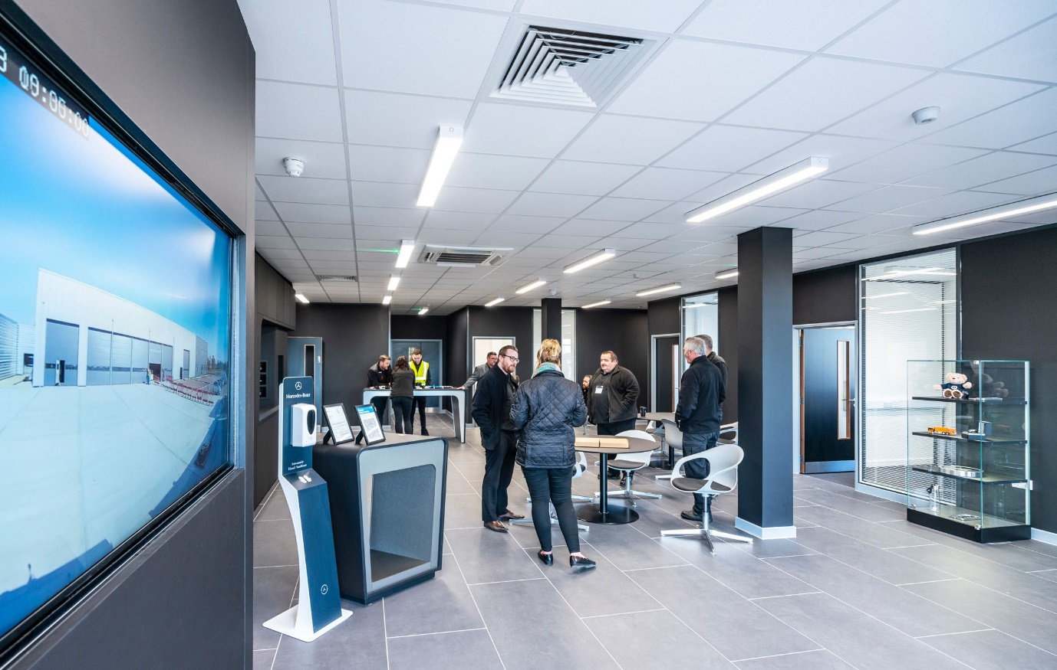

A warm welcome is assured: Guests were impressed with the stylish and airy reception area

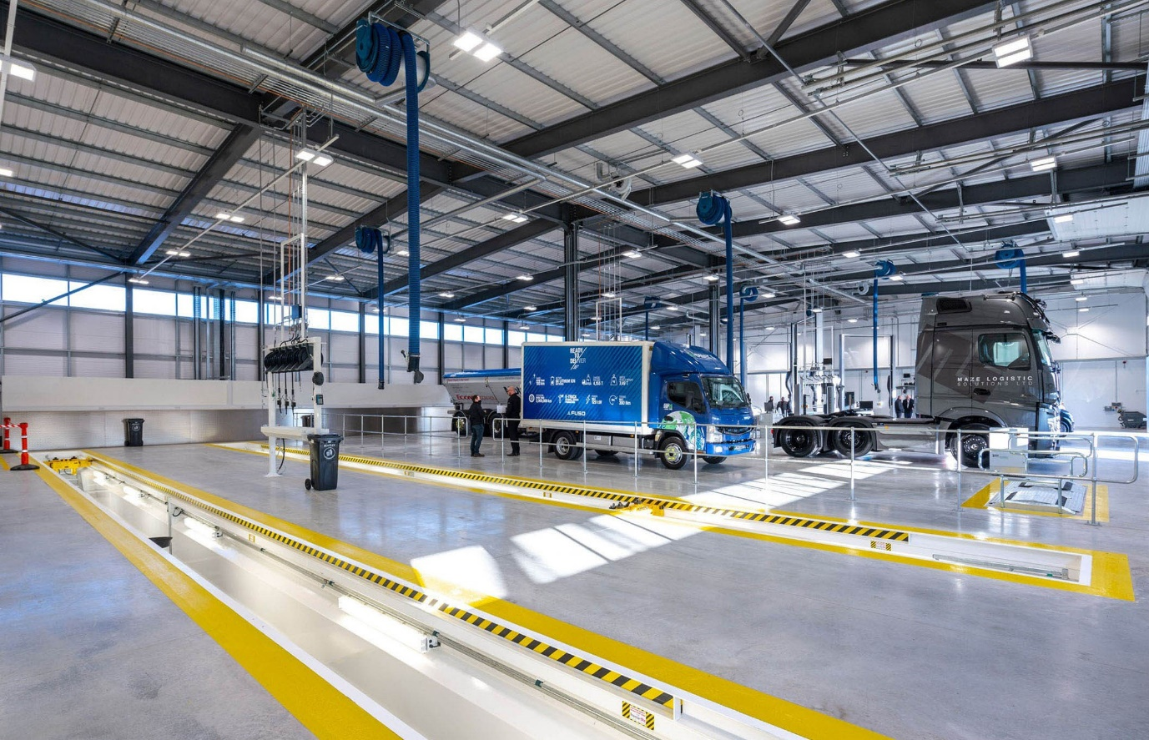

Fit for purpose: The new workshop has nine full-length truck bays and eight for vans, and is comprehensively equipped

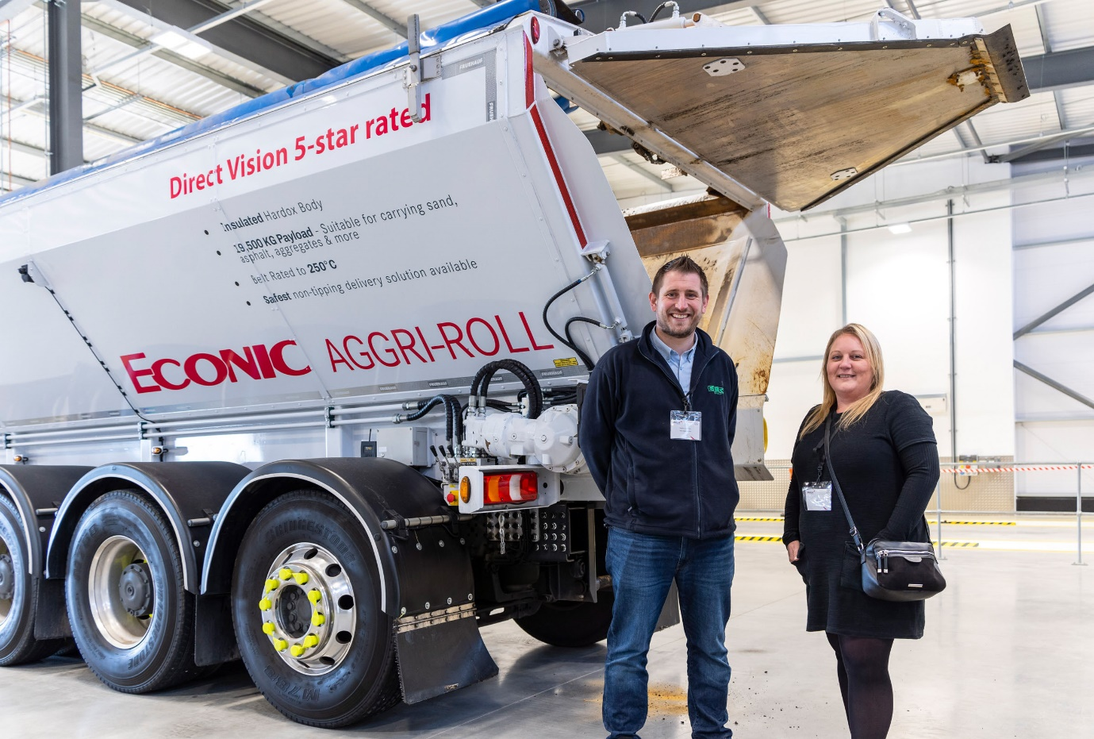

Impressed: Matt Parker and Nicole Todd, of SRC Aggregates, liked what they saw
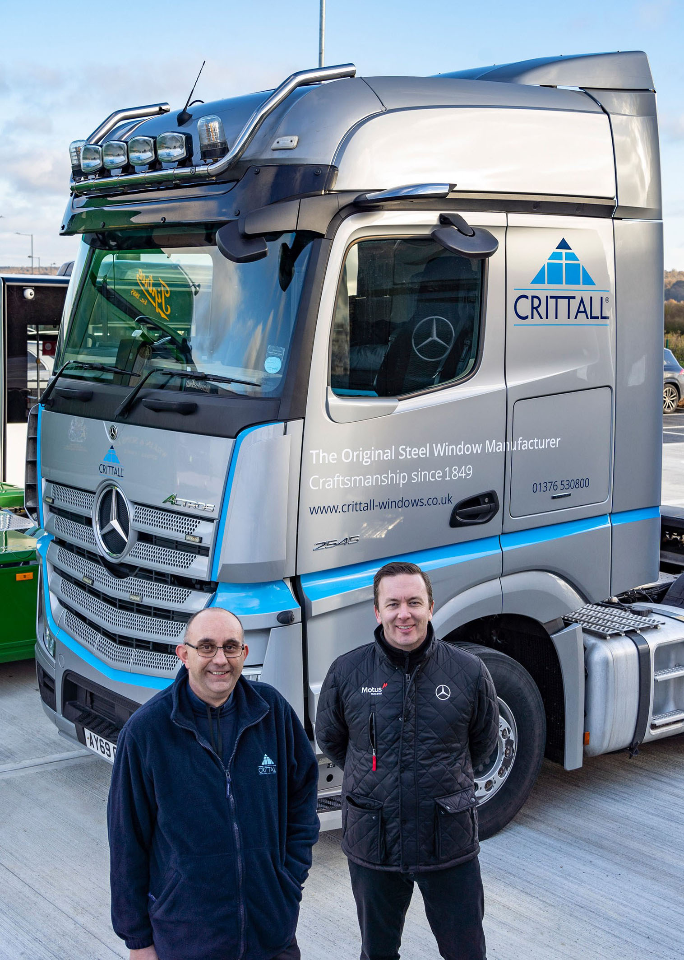

Miles more smiles: The new facility’s convenient location will bring time and cost saving for Crittall Windows driver Clive Wrathall, left, with Motus Truck & Van Sales Executive Ben Sheldrake
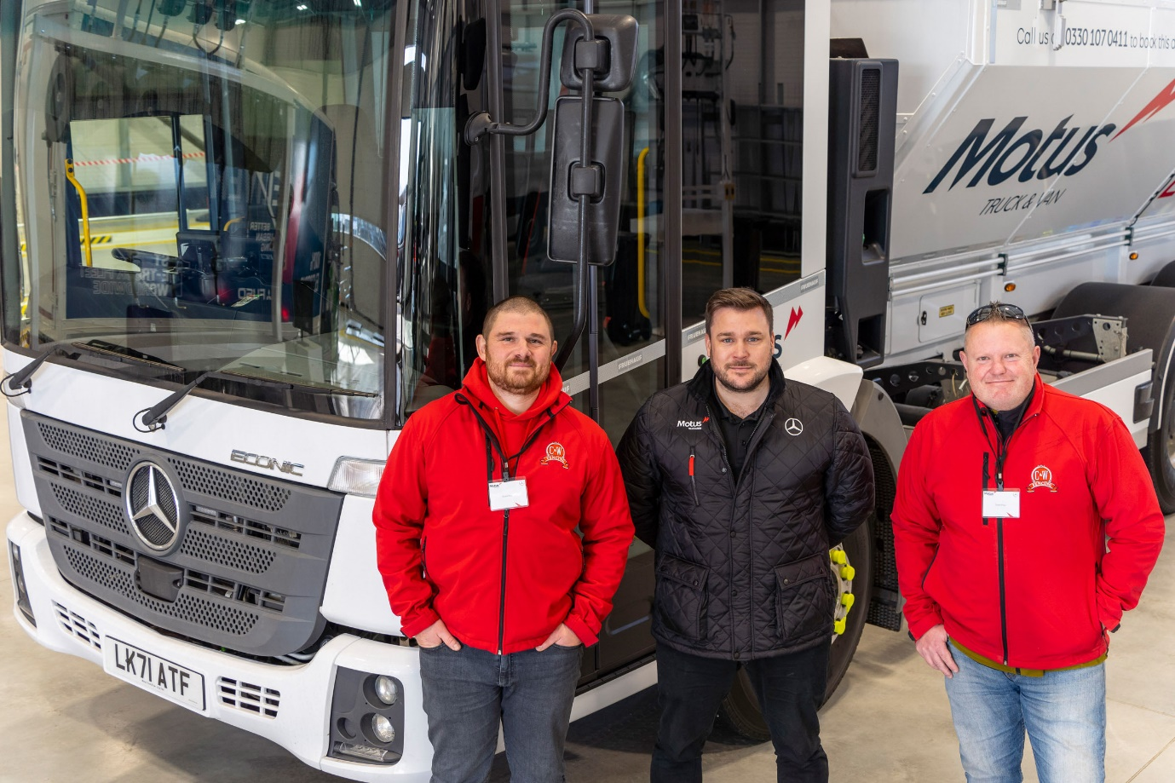

Easy access: Jason Kettle, left, and Karl Giles of C&W Fencing said their drivers would appreciate having so much space for manoeuvring and parking; they are pictured with Truck Sales Executive Darren Nunn

ends

For more information, or to request bigger/higher-res image files, please contact:
Steve Warren or John Ripley
Impact Communications
Steve: 07770 470251, steve@impactcom.co.uk
John: 07771 484595, john@impactcom.co.uk

