

Date: 26 February 2019

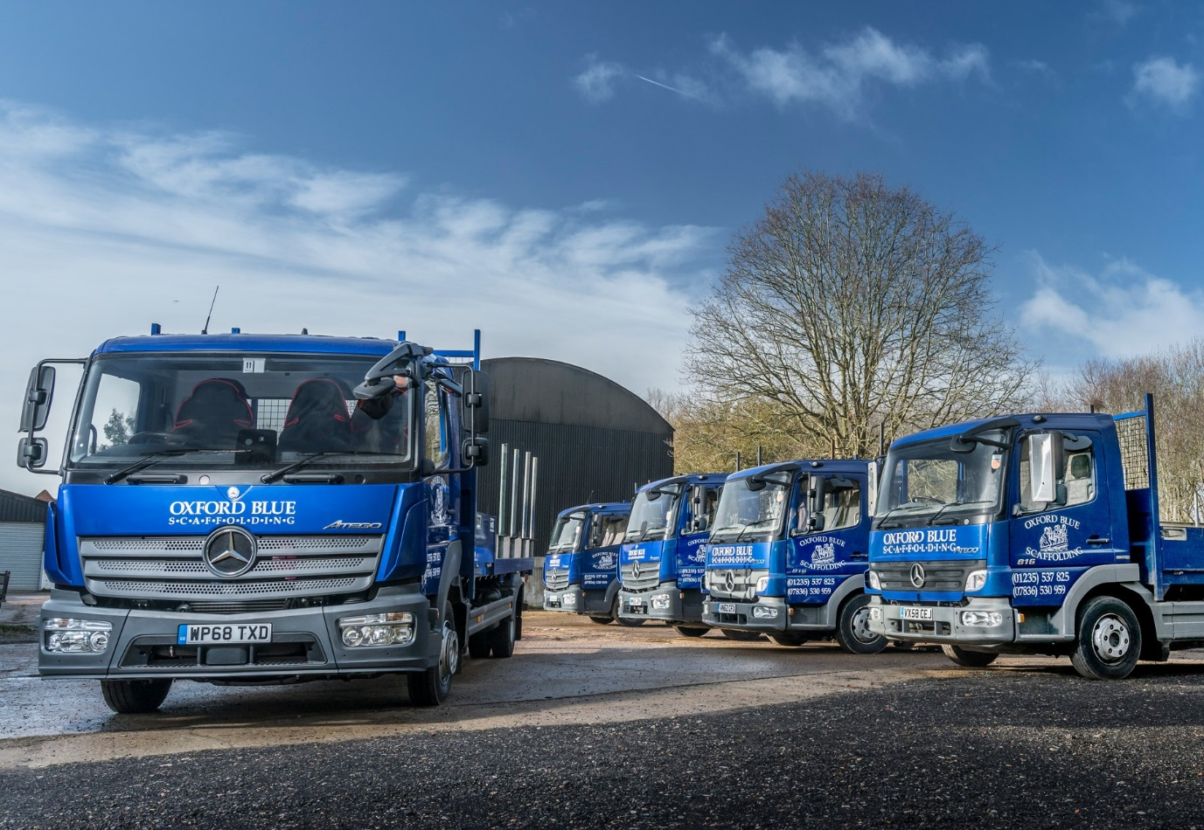

Proven performers: Oxford Blue runs 7.5-tonne scaffold trucks from three Mercedes-Benz Atego model generations

Mercedes-Benz Atego stands the test of time for Oxford Blue

Breakdowns are simply not an option for Oxford Blue Scaffolding, which explains why it has trusted for a quarter of a century to the reassuring durability of Mercedes-Benz 7.5-tonners.

The firm, which is based in Abingdon, Oxfordshire, is currently running five Atego 816s from three model generations. The oldest entered service in 2009, while another has been on the road for more than six years. Both have proved unstintingly reliable.

Director Andy Durkin confirmed: “We purchased our first Mercedes-Benz trucks in 1994 and have been buying them ever since. I can honestly say that in those 25 years we’ve never had one break down on us.

“It’s all about money. Given the commitments we make to our customers, I cannot afford to have guys stood at the side of the road waiting for recovery trucks. With the Atego, that never happens – it’s a fantastic product.”

Acquired with competitive funding support from Mercedes-Benz Finance, the latest addition to the line-up arrived in January, via the Oxford branch of Dealer Rygor Commercials. It has a ClassicSpace day cab and a scaffolding body which was built to the operator’s own design specification by Atech Coachbuilders, of Westbury, Wiltshire, to carry tubes of up to six metres in length, as well as boards and other fixtures.

The new Atego is powered by a fuel-efficient 5.1-litre engine which produces 115 kW (156 hp) and is paired with a six-speed Mercedes PowerShift 3 transmission – it is Oxford Blue Scaffolding’s first experience of the manufacturer’s smooth-shifting automated manual gearbox, which also contributes to economy.

To match the operator’s previous vehicles, the Atego was specified with a wheelbase of 4,820 mm, one of a range of wheelbase options available ex-factory. “It means the truck carries the load really well, and makes for a more comfortable drive” explained Andy Durkin.

Oxford Blue sends out its fully-trained and qualified scaffolders in gangs of three, and they work on a combination of residential and commercial projects, including public sector developments such as hospitals and schools. Established by Mr Durkin in 1992, the company has worked as far afield as London and Bristol in the past, but now restricts its operations to within a 60-miles radius of base.

“This means we’re not covering great distances – our oldest truck has only done 146,000 km,” he said. “It’s hard work, though. Some of the sites we’re on and off can be pretty rough, and the trucks get plenty of punishment, but they take whatever we can throw at them and keep on coming back for more.”

Mr Durkin continued: “The other thing we love about our Atego is the strong residual values they command. We try to keep them as smart as possible, and when the time finally comes to stand them down we always get a very good price.”

Commenting on the 2009 truck, he observed: “It’s still a great tool, and it certainly doesn’t owe us anything, but we’ll sell it on within the next few months. I know it will do OK because I already have a buyer lined up.”

Mr Durkin added: “Each time we buy an Atego 816 we see it evolve, and getting better and better. The auto’ transmission has the added benefit of freeing up useful space on the cab floor, while the new one also came with Lane Keeping Assist technology, which is a definite plus.

“We could buy cheaper trucks, of course, but as everyone knows, a Mercedes-Benz is a premium product, the best on the market. As well as offering the reliability that is so crucial to the smooth running of our business, when you sit in an Atego cab there’s a real feeling of quality and safety. What more could you ask for?”

www.oxford-blue-scaffolding.co.uk

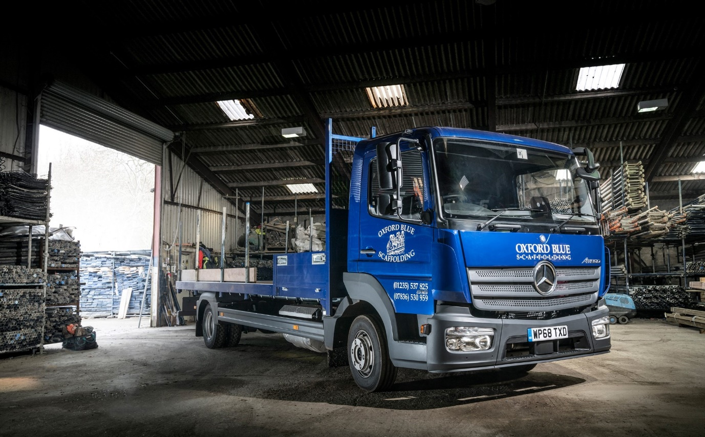

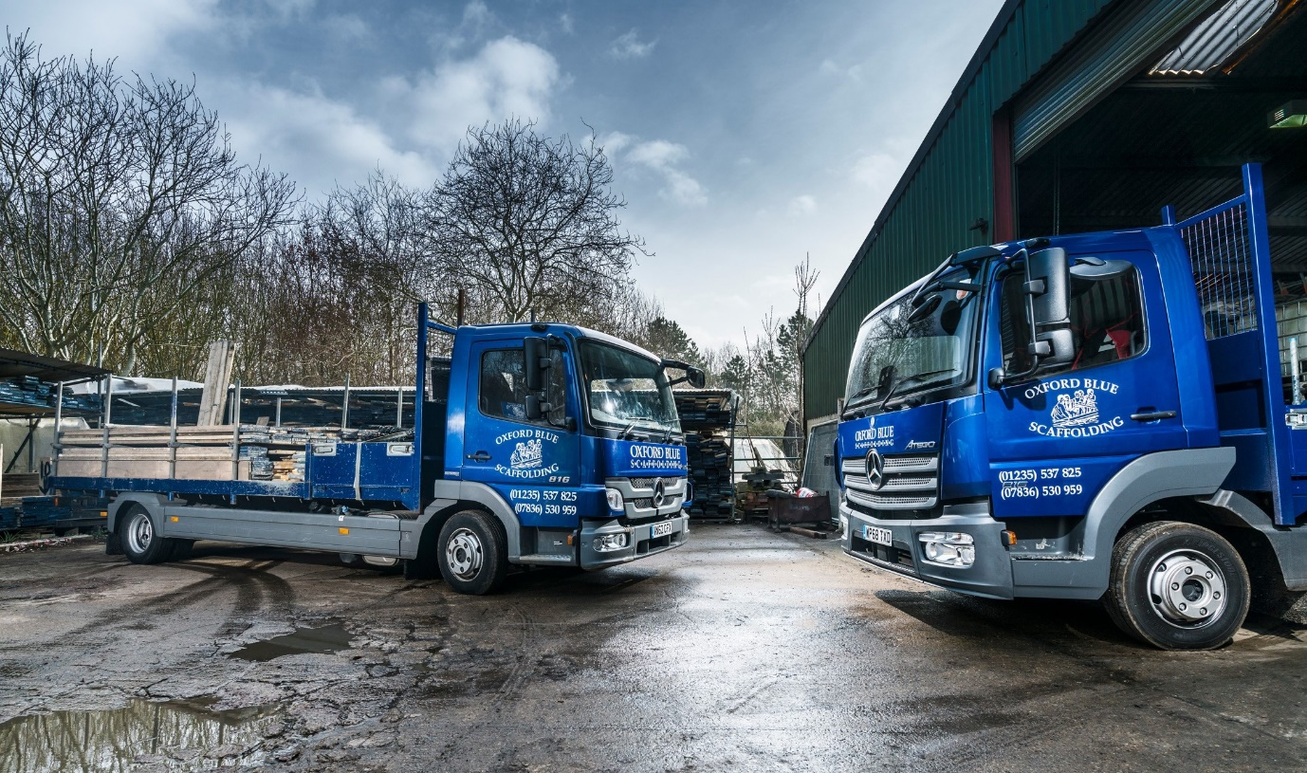

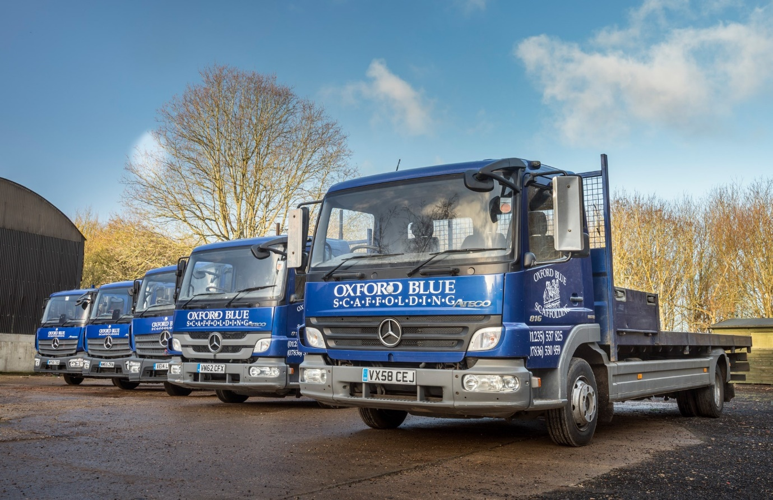

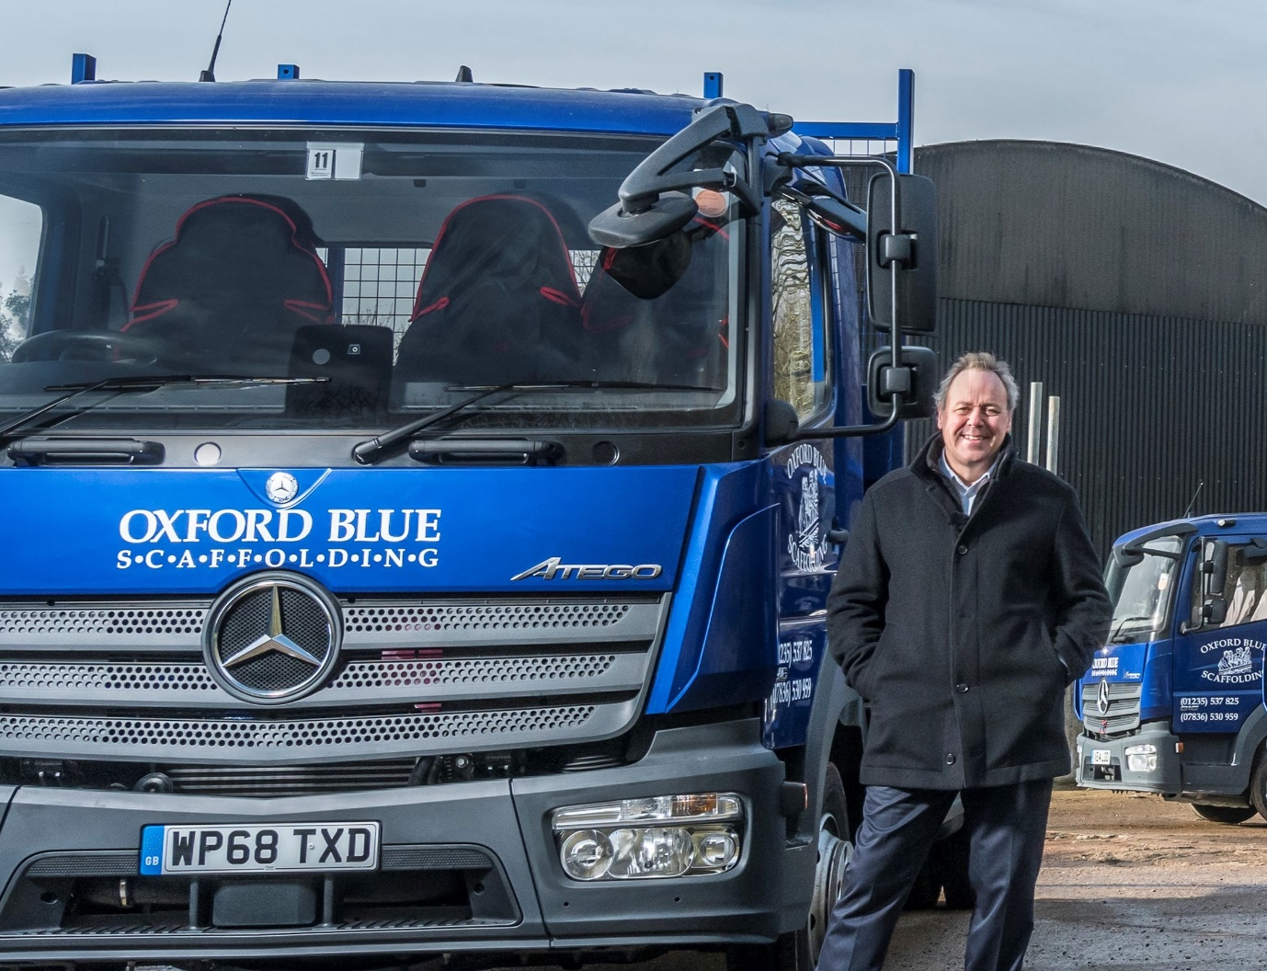

Reaching new heights: That’s Oxford Blue Scaffolding’s Andy Durkin, with his firm’s latest Mercedes-Benz Atego

ends

For hi-res image files, please visit:
media.mbtrucks.co.uk

For further information, please contact:
Jamie Fretwell, PR & Internal Communications
Mercedes-Benz Trucks
07712 519230, Jamie.Fretwell@daimler.com
or

Steve Warren or John Ripley
Impact Communications, 01926 842126
Steve: 07770 470251, steve@impactcom.co.uk
John: 07771 484595, john@impactcom.co.uk

About Mercedes-Benz Trucks UK Ltd

Mercedes-Benz Trucks UK Ltd is the sales and marketing organisation responsible for all Mercedes-Benz truck products in the UK, including FUSO Canter.

In 2018, the company registered 8,061 new trucks. After growth in 2017, Mercedes-Benz registrations levelled off to 7,223 trucks in 2018, ensuring it retained its title as the second-biggest truck brand in the UK. Meanwhile, FUSO made great strides to reach 838 registrations – including 675 new trucks over 6.0-tonnes.

For more than 125 years, Mercedes-Benz has stood for innovative vehicles that meet exceptionally high standards of quality. Our claim to perfection, sustainability and avant-garde design is now embodied in the next generation of trucks: Actros, Arocs, Atego, Econic and Unimog.

www.mbtrucks.co.uk

