

Date: 27 January 2021

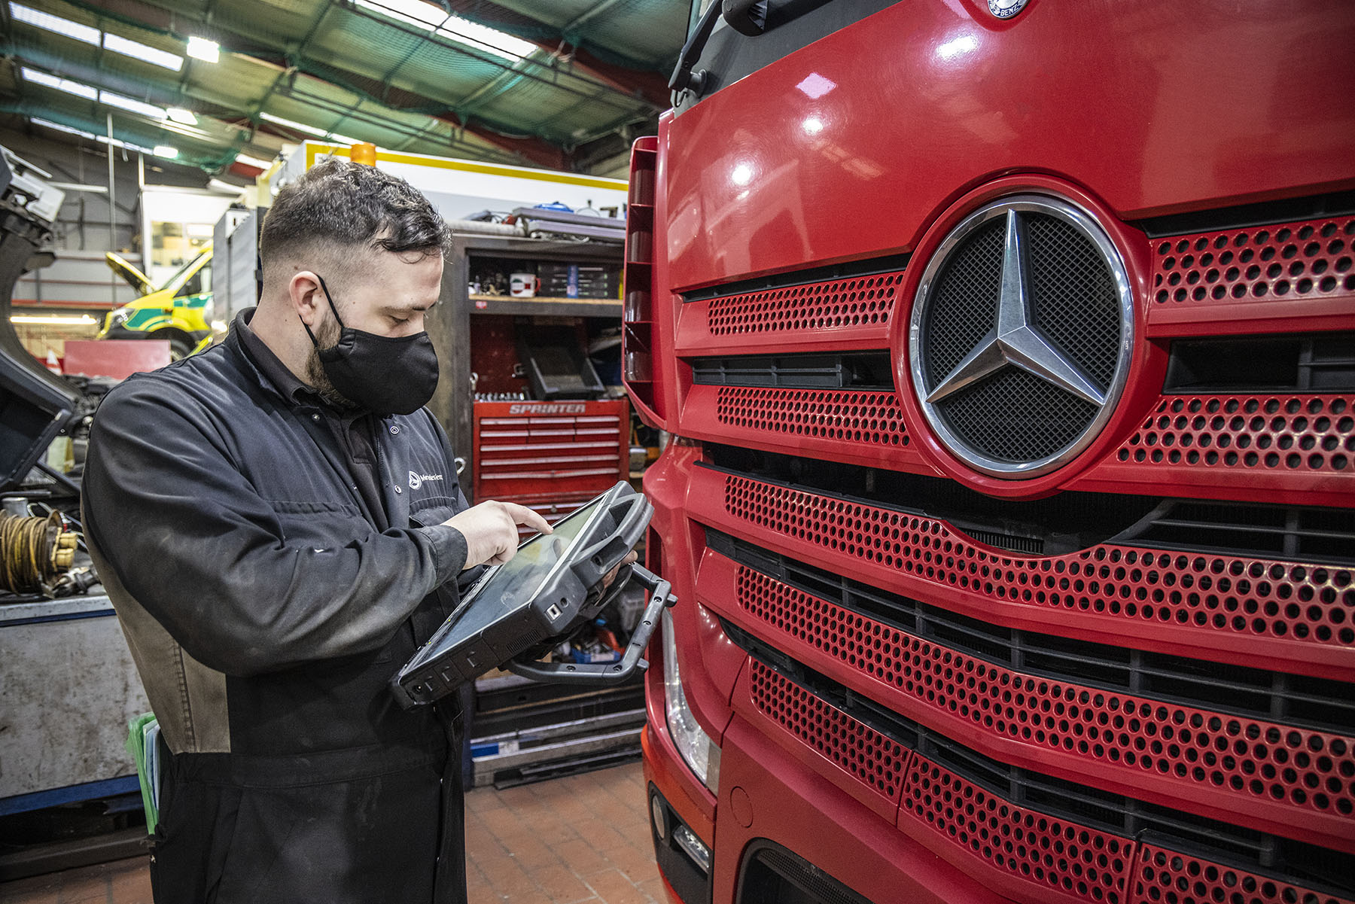

Mercedes-Benz Trucks continues to deliver customer service in the face of new pandemic restrictions

Operators of Mercedes-Benz and FUSO trucks can be assured of continued timely and efficient aftersales back-up in the face of the pandemic.

That’s the message from Mercedes-Benz Trucks UK Managing Director Wolfgang Theissen, who said: “COVID-19 continues to affect our everyday lives, but we have adapted our working behaviours and are proud to say that every one of our 79 sites remains open to inspect, maintain and repair our customers’ trucks.”

With England in its third lockdown, and similar measures in force in Scotland, Wales and Northern Ireland, vehicles bearing the three-pointed star are in the front line of the battle to beat the virus.

In addition to trucks that work in the liveries of supermarkets, online retailers and parcels delivery specialists, others are delivering COVID-19 vaccines. Leading commercial vehicle contract hire and leasing provider Asset Alliance, for example, owns 125 Actros which are in service with three high-profile operators from the pharmaceuticals sector – these tractor units are assigned to the task of vaccine distribution, and serviced within the Mercedes-Benz network.

“Of course, we’re keeping a close eye on these vehicles,” confirmed Wolfgang Theissen. “This means ensuring that their six-weekly inspections are arranged and undertaken as efficiently as possible, with optimum parts availability, so we can get them back on the road and performing their vital duties with the minimum of delay.

“However, we monitor every other truck we maintain too, because we recognise and appreciate the heroic roles that all of our customers are playing in keeping the country moving during these challenging times.”

Latest figures from the manufacturer confirm that the ‘first pick’ parts availability level across its Dealer network remained stable last year, despite nationwide restrictions and lockdowns. Wolfgang pledged: “We are open for business – many of our workshops continue to operate on a round-the-clock basis, parts availability is good, and our Service24h roadside assistance teams stand ready to respond to breakdowns.”

Wolfgang said that following Government advice Mercedes-Benz Truck UK sales and head office teams were working from home wherever possible, and all business travel and non-essential face-to-face meetings had been cancelled. “The COVID-secure measures we and our franchised partners have implemented are designed to stem the spread of the virus and provide our teams with safe working environments,” he added.

“Operators can also be assured that we are still here for them. Whatever their role, be it delivering vaccines, food or home shopping consignments, or any one of the myriad other tasks in which Mercedes-Benz and FUSO trucks are employed, together with our network of Dealers and Authorised Repairers we remain totally committed to keeping our customers moving.”

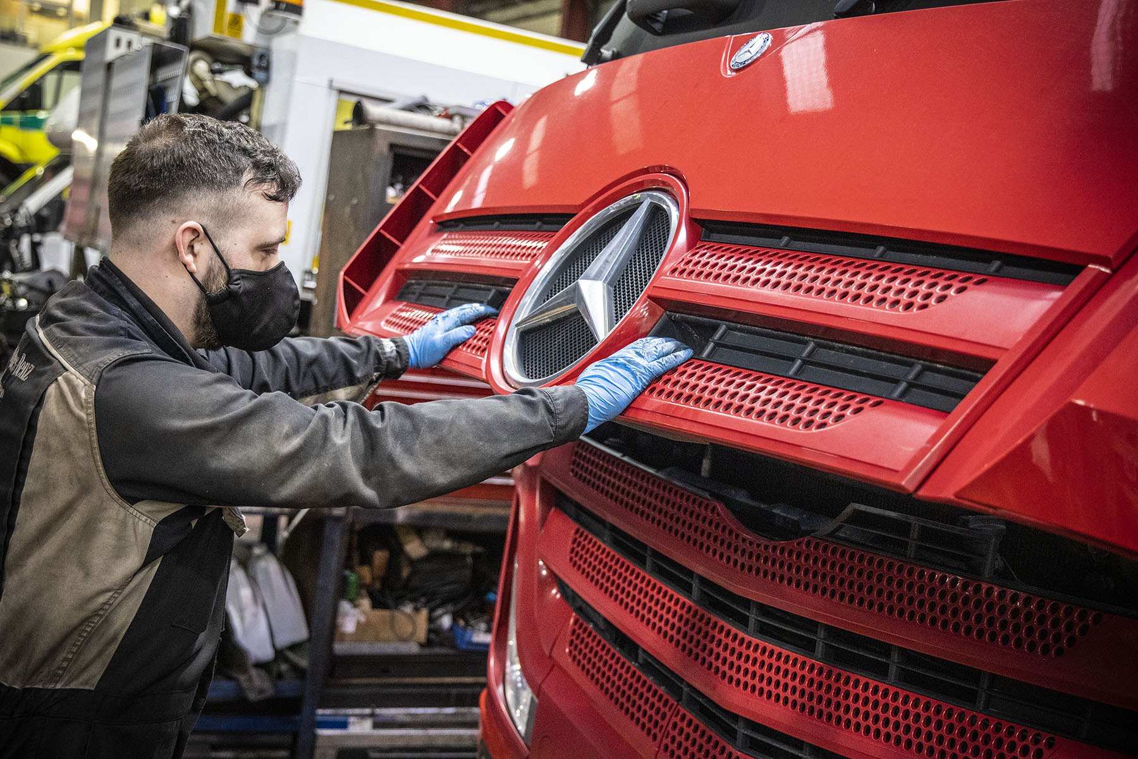

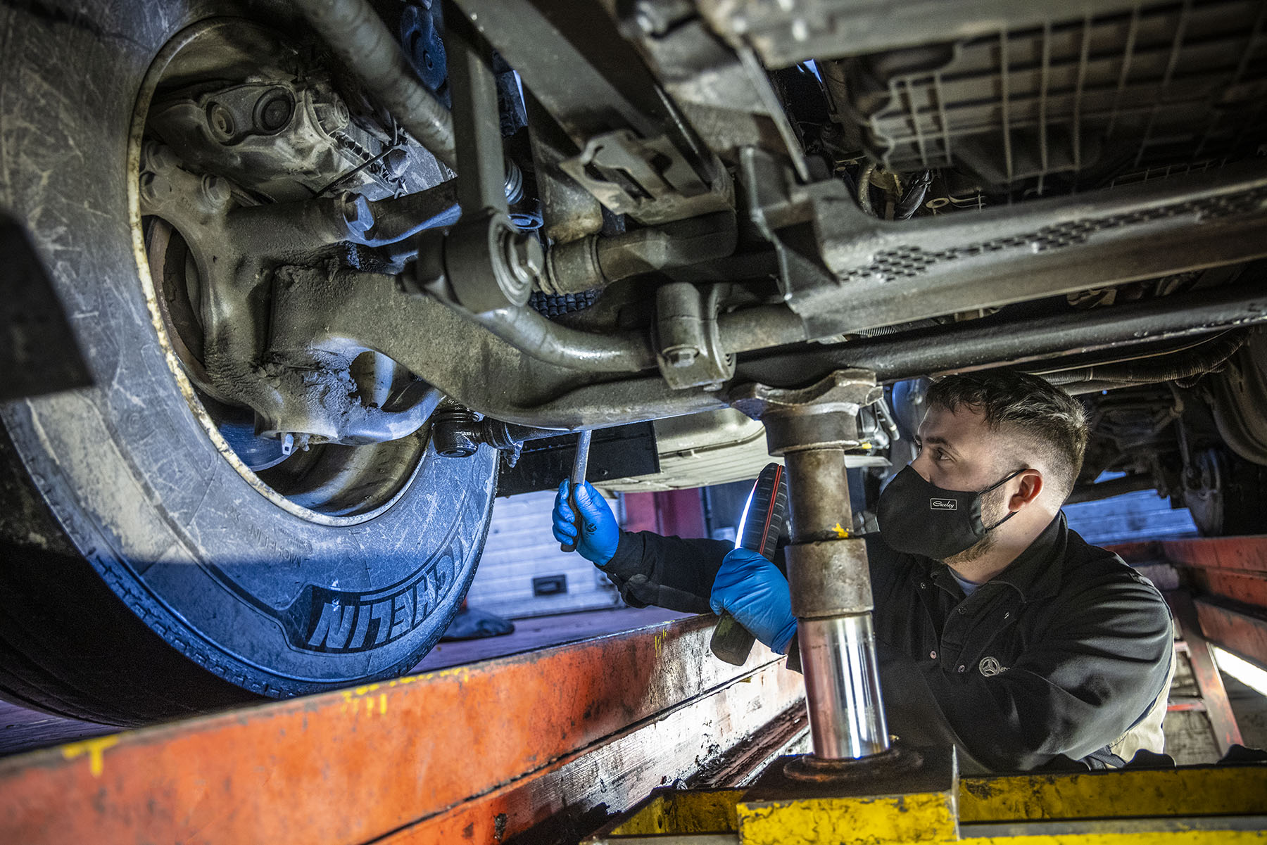
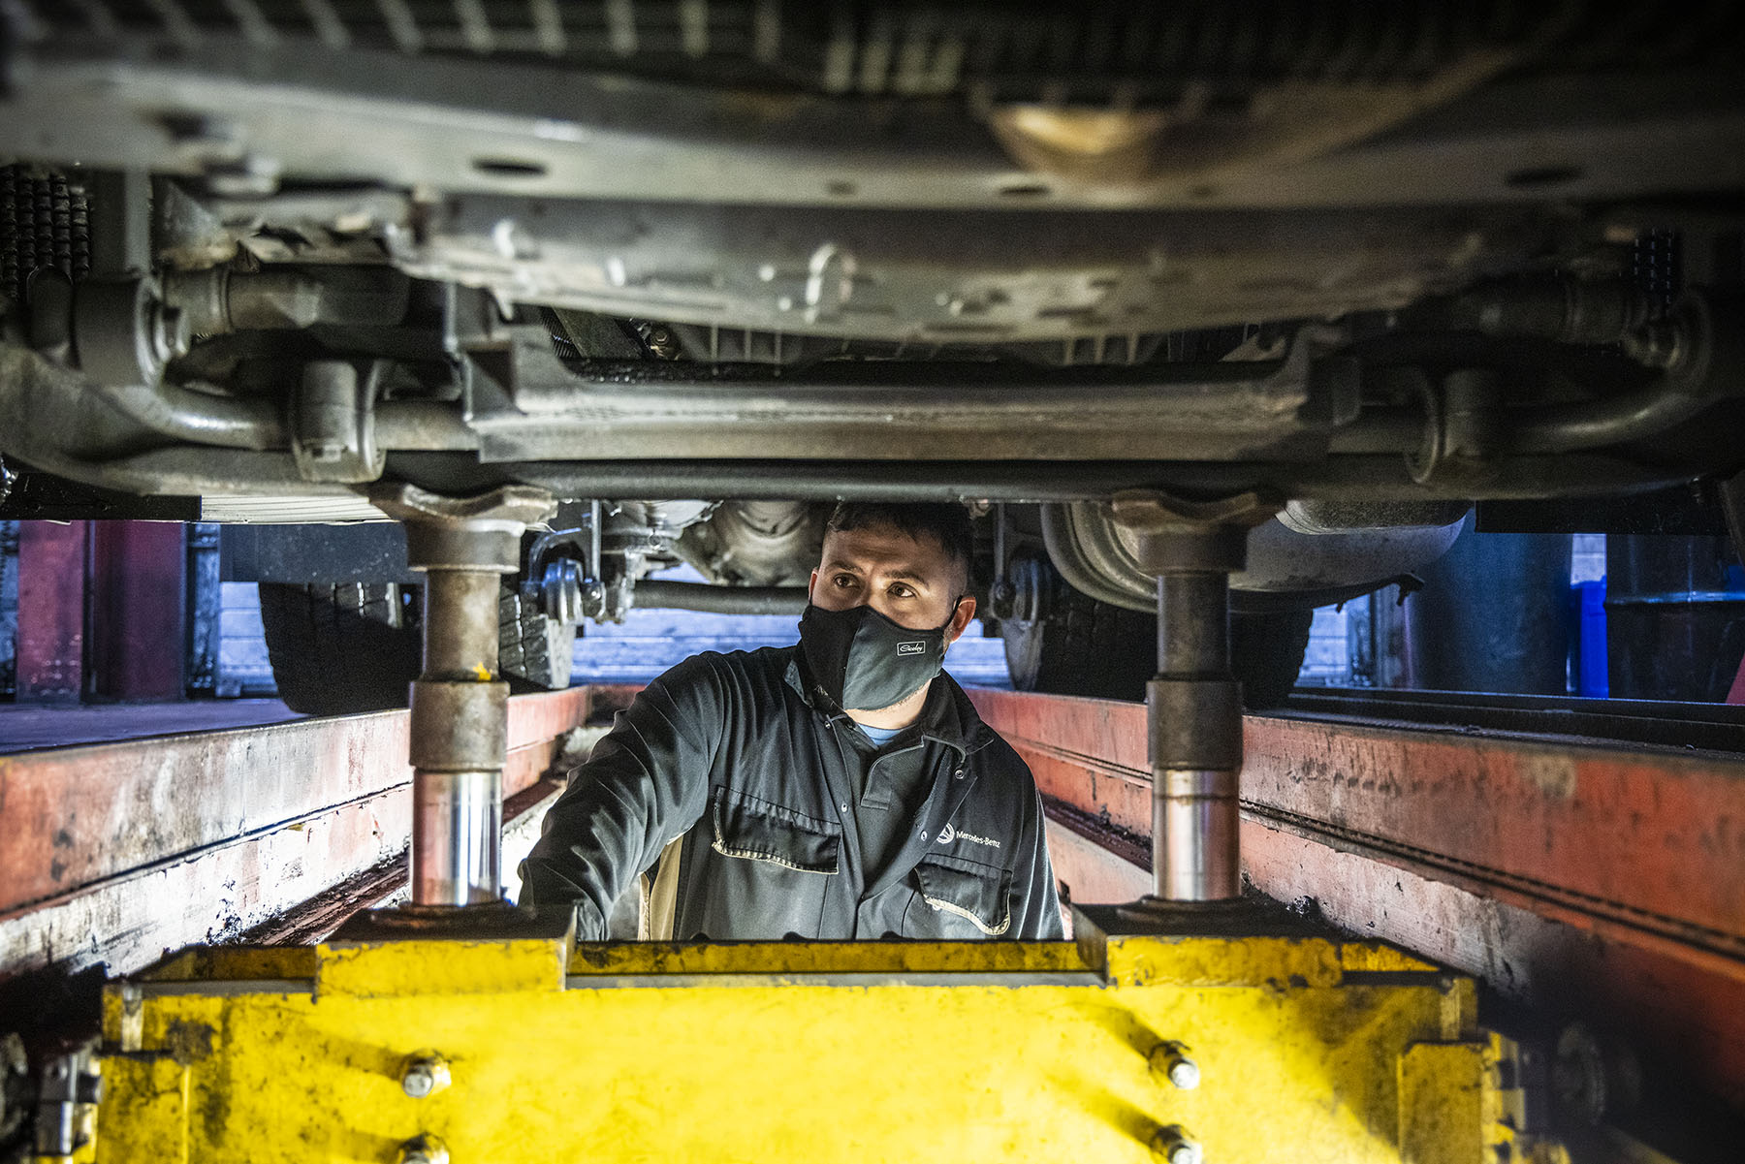

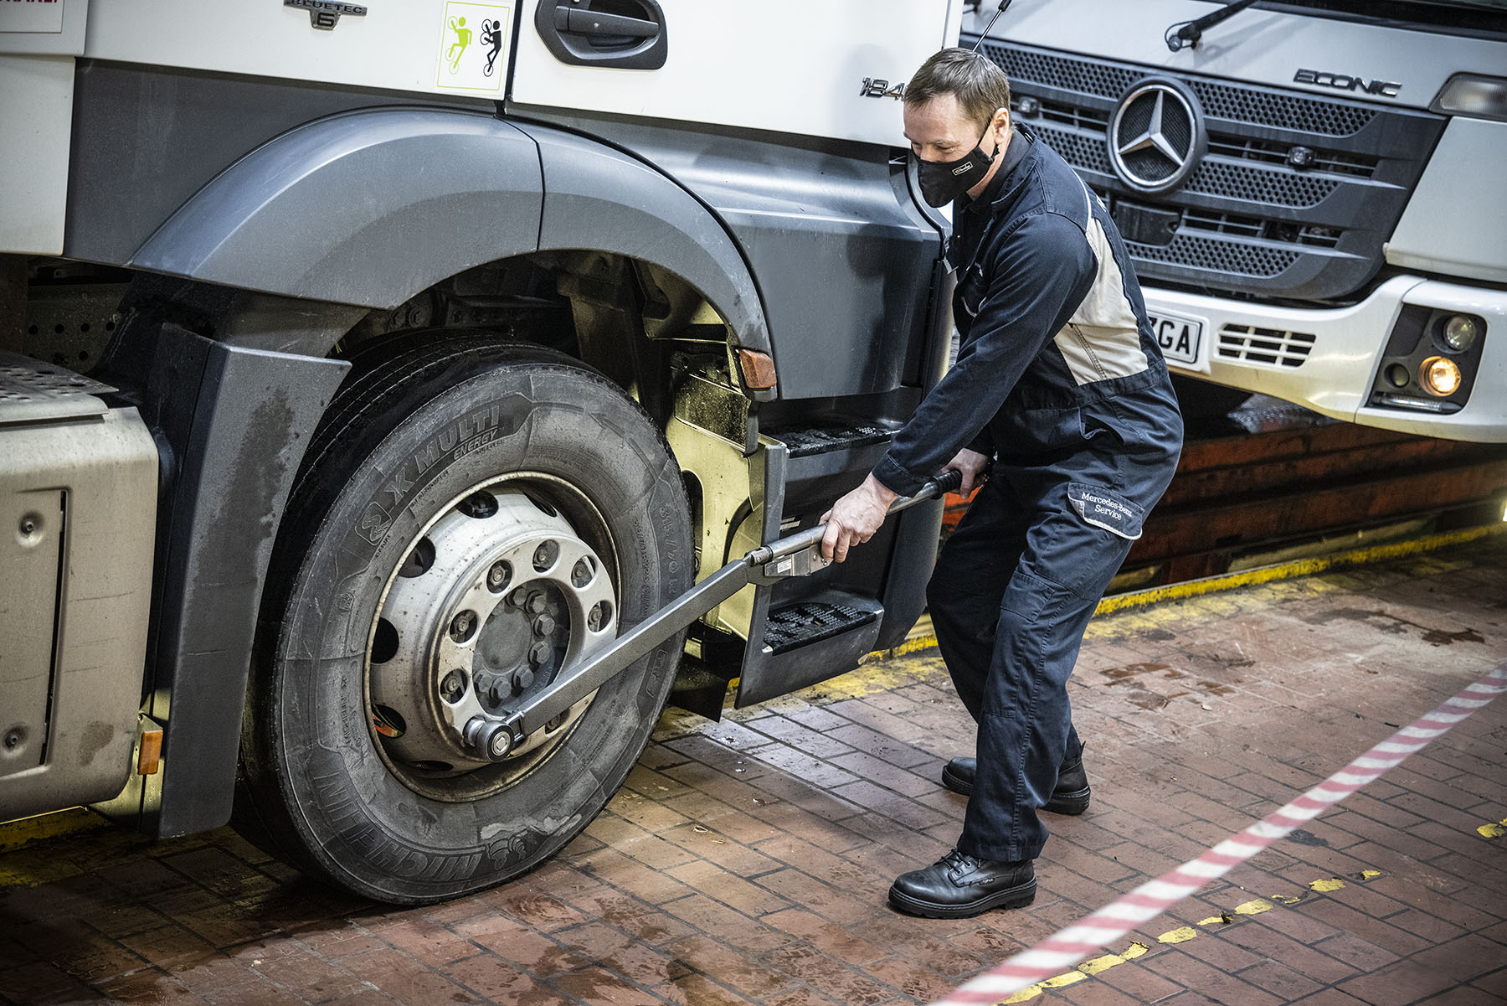

ends

For more information, or to request higher-res image files, please contact:

Jamie Fretwell at Mercedes-Benz Trucks UK Ltd
07712 519230, jamie.fretwell@daimler.com

or

Steve Warren or John Ripley
Impact Communications, 01926 842126
Steve: 07770 470251, steve@impactcom.co.uk
John: 07771 484595, john@impactcom.co.uk

About Mercedes-Benz Trucks UK Ltd
Mercedes-Benz Trucks UK Ltd is the sales and marketing organisation responsible for all Daimler truck products in the UK, including FUSO Canter. In 2019, the company registered 6,963 new trucks. Mercedes-Benz accounted for 6,188 new trucks registered in 2019, making it the third-biggest truck brand in the UK. Meanwhile, FUSO registrations hit 775 – including 580 new trucks over 6.0-tonnes. The flagship new Mercedes-Benz Actros which won the 2020 International Truck of the Year award, features seven core innovations including MirrorCam, Multimedia Cockpit and Active Brake Assist 5. Our premium range of innovative trucks – Actros, Arocs, Atego, Econic and Unimog – draw upon more than 125 years of exceptionally high standards of quality, backed up by our promise of Trucks You Can Trust.
www.mbtrucks.co.uk

