

Date: 2 September 2019

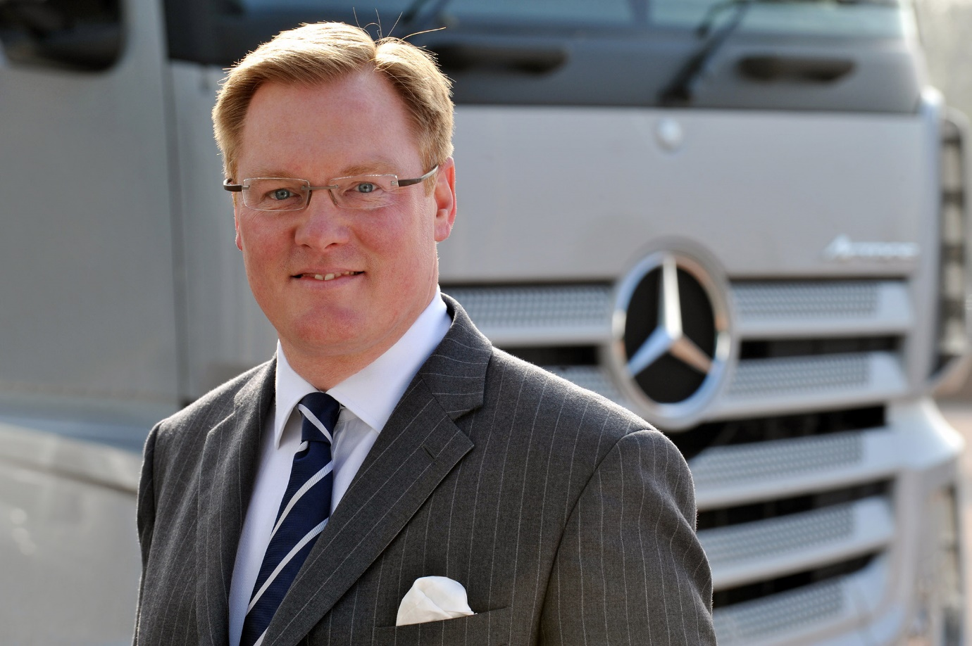

Mercedes-Benz Trucks appoints Sam Whittaker to the position of National Sales Director

Sam Whittaker is the new National Sales Director at Mercedes-Benz Trucks UK.

Sam joined Mercedes-Benz UK as a trainee in 1992, and since 1997 has worked for the Truck business unit in a succession of increasingly senior management positions covering all aspects of vehicle sales, marketing, key account management and aftersales. His most recent role was that of Customer Service & Parts Director.

As National Sales Director Sam will be responsible for all Mercedes-Benz and FUSO new truck sales and used truck remarketing activities. He will also oversee the manufacturer’s rapidy developing Truck Connectivity business, as well as its TRUCKTraining and Product Demonstration operations, and the new Mercedes-Benz Truck Experience Centre at Wentworth Park, near Barnsley.

Sam continues to report to Mercedes-Benz Trucks UK Managing Director Mike Belk, who commented:“With his extensive UK market experience in both sales and operations, Sam is ideally placed to drive the Mercedes-Benz Truck sales business to further success. His background, coupled with our structure, means we are ideally placed to provide a holistic and fully integrated sales support set-up for both established customers and new prospects.”

Reflecting on his appointment, Sam said: “In my time at Mercedes-Benz it has been my goal to have an extensive network of trusted relationships with customers, suppliers, our Dealers and colleagues. I’m passionate about delivering on our ‘Trucks You Can Trust’ brand promise, and looking forward to getting stuck into my new role.”

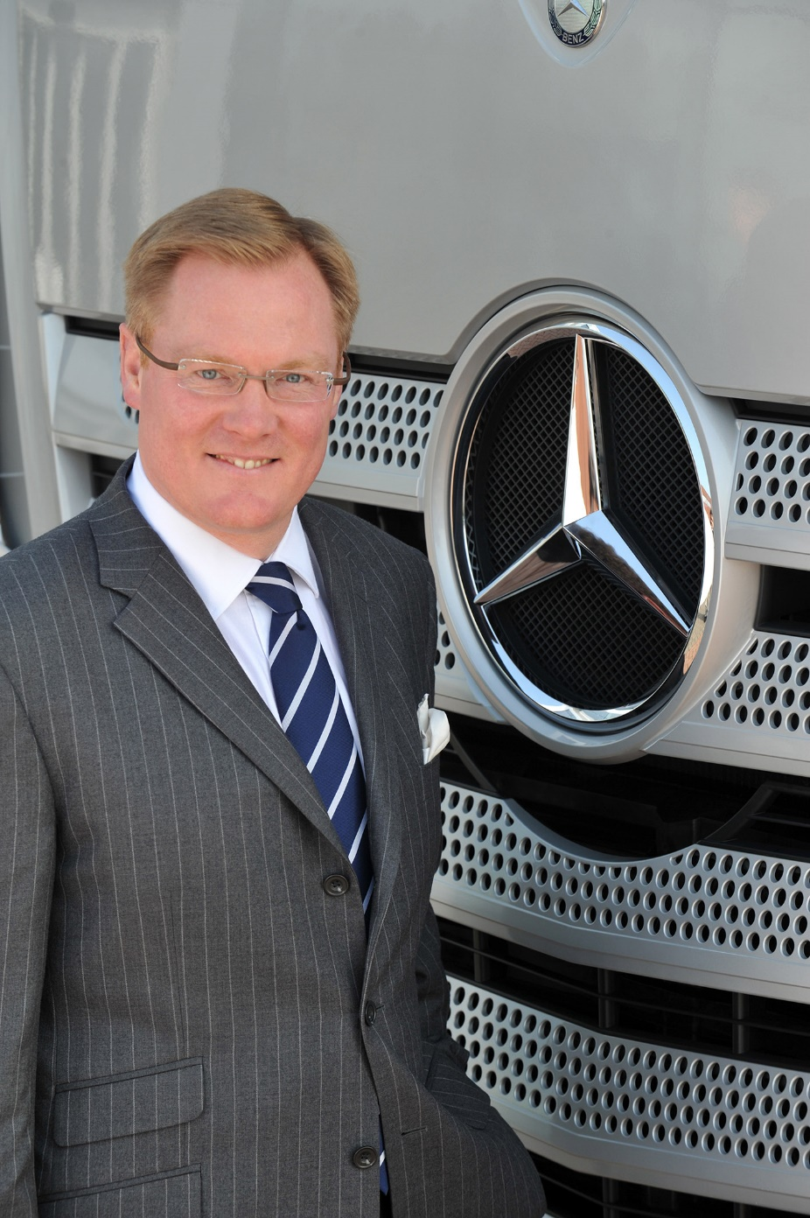

ends

For more information, or to request higher-res image files, please contact:
Jamie Fretwell at Mercedes-Benz Trucks UK Ltd
07712 519230, jamie.fretwell@daimler.com

About Mercedes-Benz Trucks UK Ltd
Mercedes-Benz Trucks UK Ltd is the sales and marketing organisation responsible for all Mercedes-Benz truck products in the UK, including FUSO Canter.

In 2018, the company registered 8,061 new trucks. Of them, 7,223 were Mercedes-Benz trucks, ensuring the brand retained its title as the second-biggest truck marque in the UK.
Meanwhile, FUSO registrations reached 838 – including 675 new trucks over 6.0-tonnes.

For more than 125 years, Mercedes-Benz has stood for innovative commercial vehicles that meet exceptionally high standards of quality. Our claim to perfection, sustainability and avant-garde design is now embodied in the next generation of trucks: Actros, Arocs, Atego, Econic and Unimog.
www.mbtrucks.co.uk

