

Date: 25 October 2022

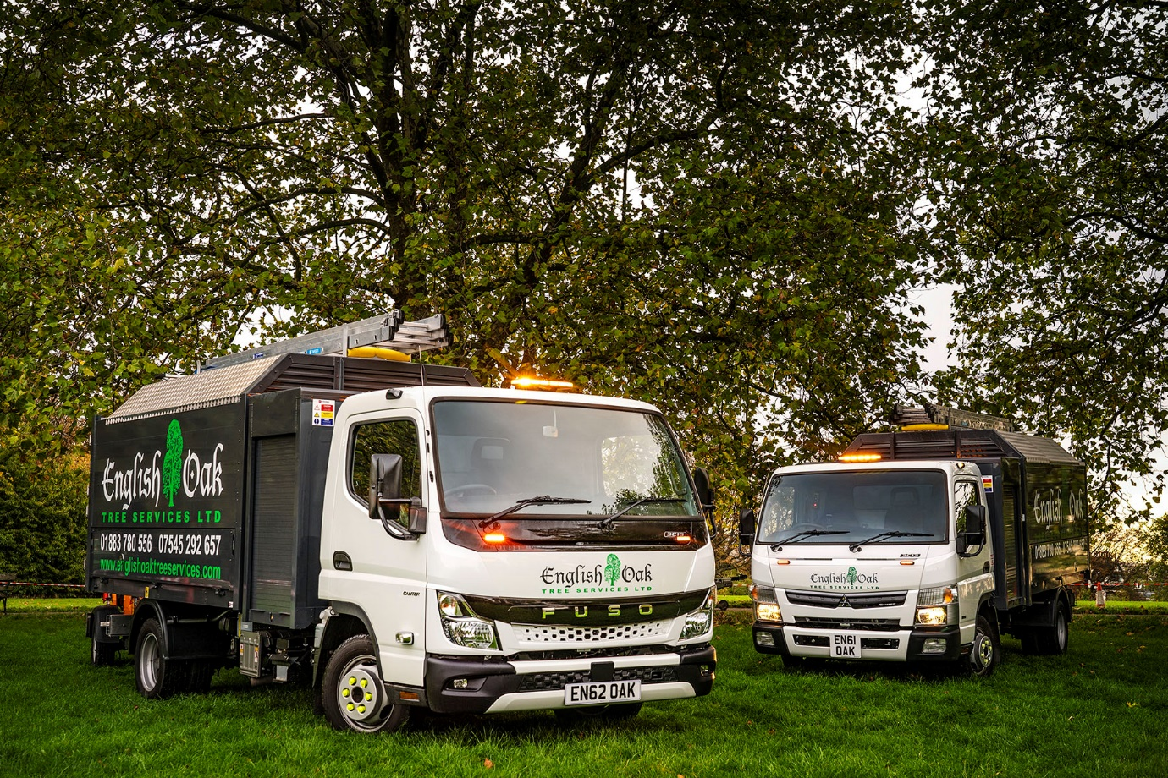

English Oak goes for growth with the first all-new FUSO Canter to be sold by Mertrux Truck & Van

Husband-and-wife team Paul and Karen Taylor have twigged a simple truth – only one truck meets the needs of their Surrey-based arboricultural business, and that’s the FUSO Canter.

The proprietors of English Oak Tree Services purchased both of their 3.5-tonne Canters this year, from Mertrux Truck & Van. The latest, which has just arrived, is the first from the all-new Canter range that the East Midlands Dealer has supplied.

Clearly distinguished from the outgoing model by its redesigned cab and striking new ‘face’, the truck is more comfortable than the version it replaces, thanks in part to the improved interior insulation that reduces noise. Reinforced rear underrun protection also minimises the effects of an impact in the event of an accident.

Both trucks are 3C13 variants and powered by the same fuel-efficient 3.0-litre turbodiesel engine, which produces 96 kW (130 hp) and 350 Nm of torque. However, a newly developed, compact exhaust system means the 2022 model also meets the EURO VI – STEP E emission standard.

The two Canters are fitted with bespoke, high-sided tipping bodies by PD Stevens & Sons, of Market Drayton, Shropshire. They have lockable toolboxes with roller shutter doors on both sides behind the cabs, second toolboxes beneath the chassis, and split, side-hinged back doors.

The truck bodies also have fixed roofs fabricated from chequer plate – this unusual feature, insisted upon by Paul Taylor, means they can also be used to carry ladders. The roofs, which are angled at both sides to prevent corners catching on vegetation, are slightly shorter than the bodies, leaving an open section at the rear into which wood chippings can be projected.

The Taylors established their Caterham company in 2013. Its fully insured and highly experienced team of tree surgeons provide a comprehensive service that includes 24-hour emergency call-outs, and work for local authorities as well as private clients.

Mertrux Truck & Van last year celebrated its 50th anniversary as a Mercedes-Benz Trucks Dealer. It is the longest-serving member of a franchised network that also sells and supports the FUSO light truck range in Britain – both brands are part of the Daimler Truck family.

Paul Taylor contacted Mertrux after spotting its online advertisement for a 3.5-tonne Canter that had been pre-built to arboricultural specification. However, on speaking to Mr Taylor, Retail Truck Sales Manager Bob Holt quickly realised that rather than adapting the stock vehicle to conform with his precise requirements, it would be easier and more cost-effective to commission an entirely new body.

Mertrux delivered English Oak Tree Services’ first Canter in January, at which point the operator stood down its only previous truck. The decision by Mr and Mrs Taylor to invest so soon in a second Canter, reflects the strong demand for their company’s services.

English Oak Tree Services has taken advantage of the competitive funding support arranged by Mertrux to acquire both Canters – the latest is the subject of an agreement with Daimler Truck Financial Services, which was launched to the domestic market as recently as August.

Although the two trucks are English Oak Tree Services’ first Canters, Paul Taylor has previous experience of the product. “My first vehicle, when I was just 21 years old, was an old, Y-registered Canter. I loved it.”

Nevertheless, when he and Karen started their company, they did so with a used 3.5-tonne truck by a rival Japanese manufacturer – “not the best” – before progressing to a new vehicle from another brand, which would also disappoint.

“I’ve always had a soft spot for the Canter,” said Paul Taylor. “Business is good and I was so pleased with the first that I went back to Mertrux shortly afterwards and ordered a second.”

Key to the FUSO’s appeal at 3.5 tonnes GVW, is its rugged strength and reliability. In a segment dominated by van-based vehicles, the Canter is lauded by those working in the most demanding applications as “a proper truck”. This reputation for durability owes much to its tough, ladder-frame chassis.

“For heavy work such as tree surgery the Canter is definitely built for the job,” continued Mr Taylor. “Not only does it feel very sturdy, but the load capacity is better than most trucks out there.

“It also has a fantastic turning circle, which is another big advantage, in that we’re now able to get through gates and into tight spots when working off-road that we’d never have managed with our previous vehicle. In fact, I’d say the Canter is pretty well perfect for what we do.”
Commenting on the service provided by Mertrux Truck & Van, he added: “Bob has been brilliant throughout. The fact that we’re in Surrey and he’s in Derby has never been a problem, as from our first exchange of emails it was reassuringly clear that he knows what he’s doing.

“Bob’s arranged the finance, recommended and liaised with the bodybuilder, helping to resolve one or two issues on the first truck that weren’t exactly as I’d wanted them; the second sailed through without a hitch. He’s also sorted the signwriting. We really couldn’t have asked for more.”

englishoaktreeservices.com

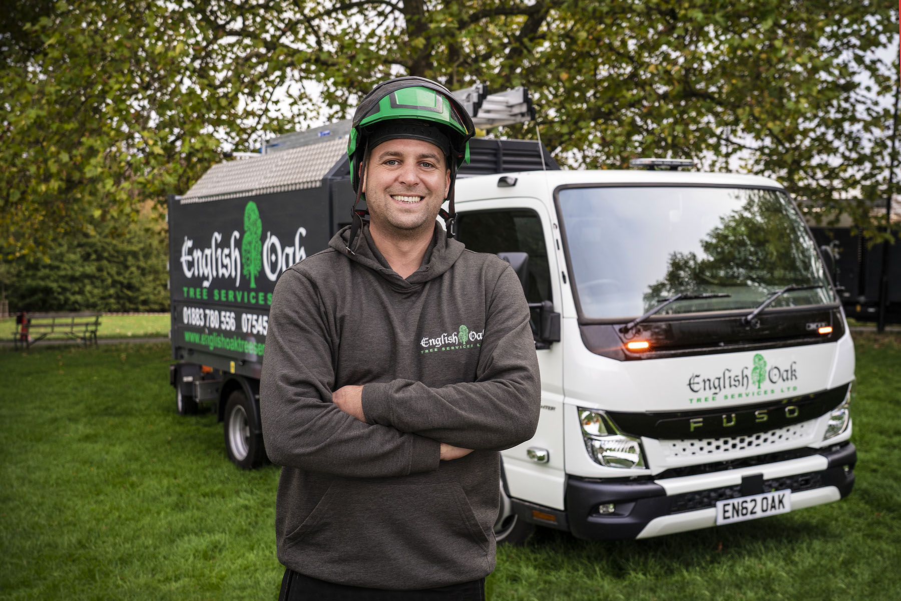

Turning over an all-new leaf: English Oak Tree Services’ Paul Taylor is pictured with the first vehicle from the latest FUSO Canter range to be supplied by Mertrux Truck & Van

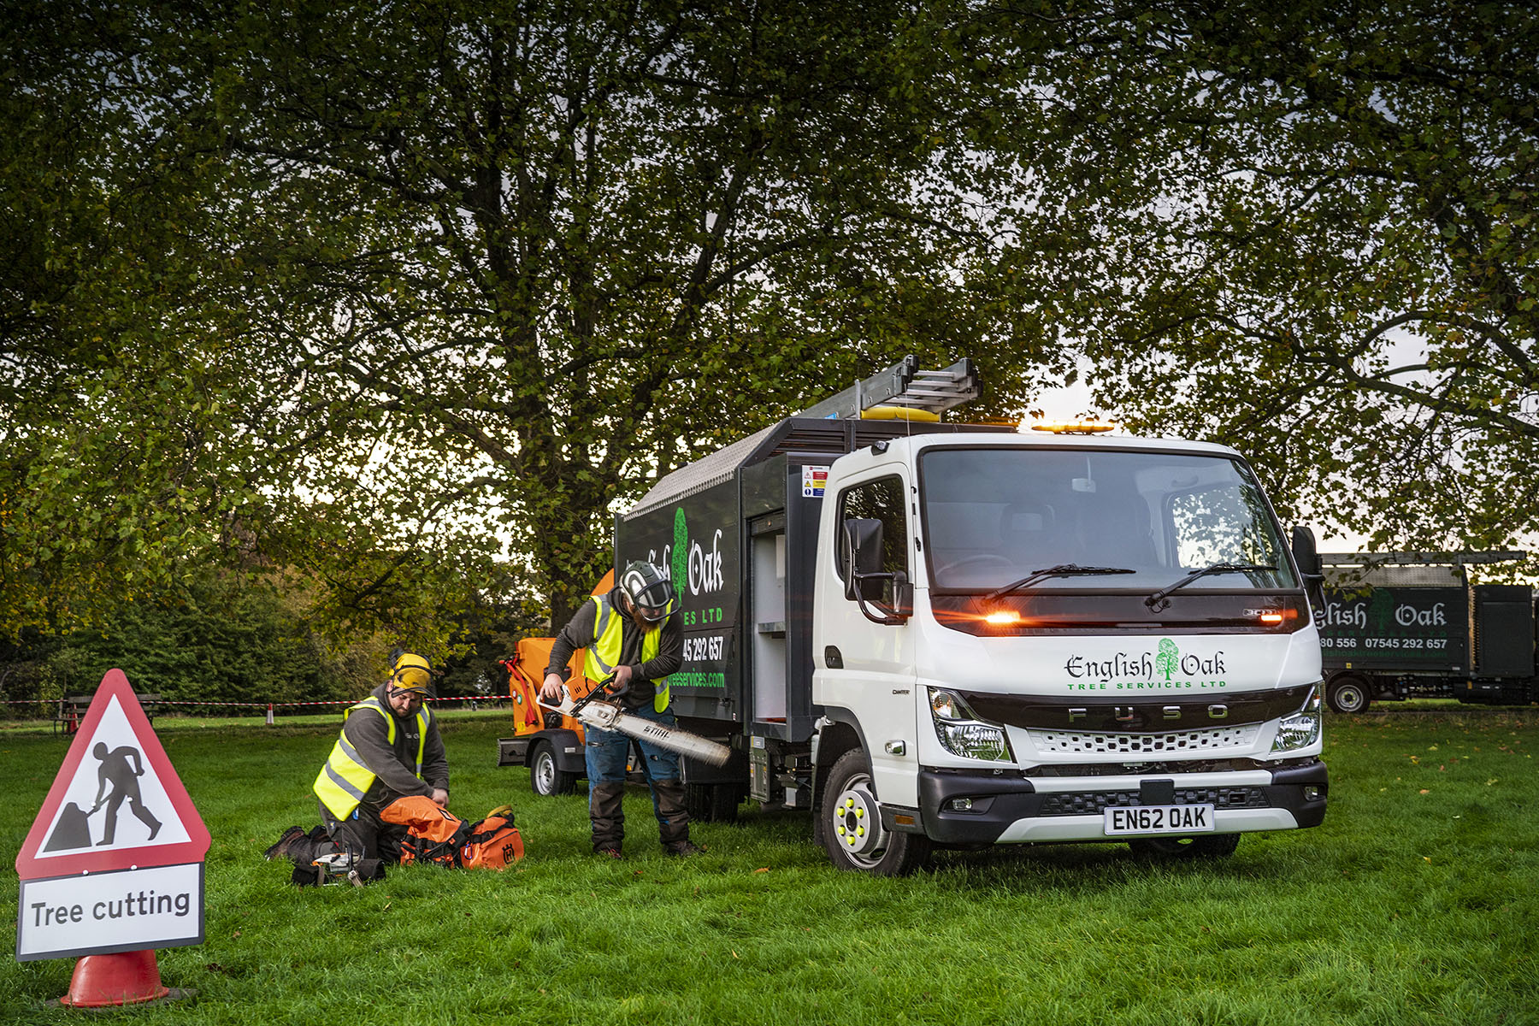

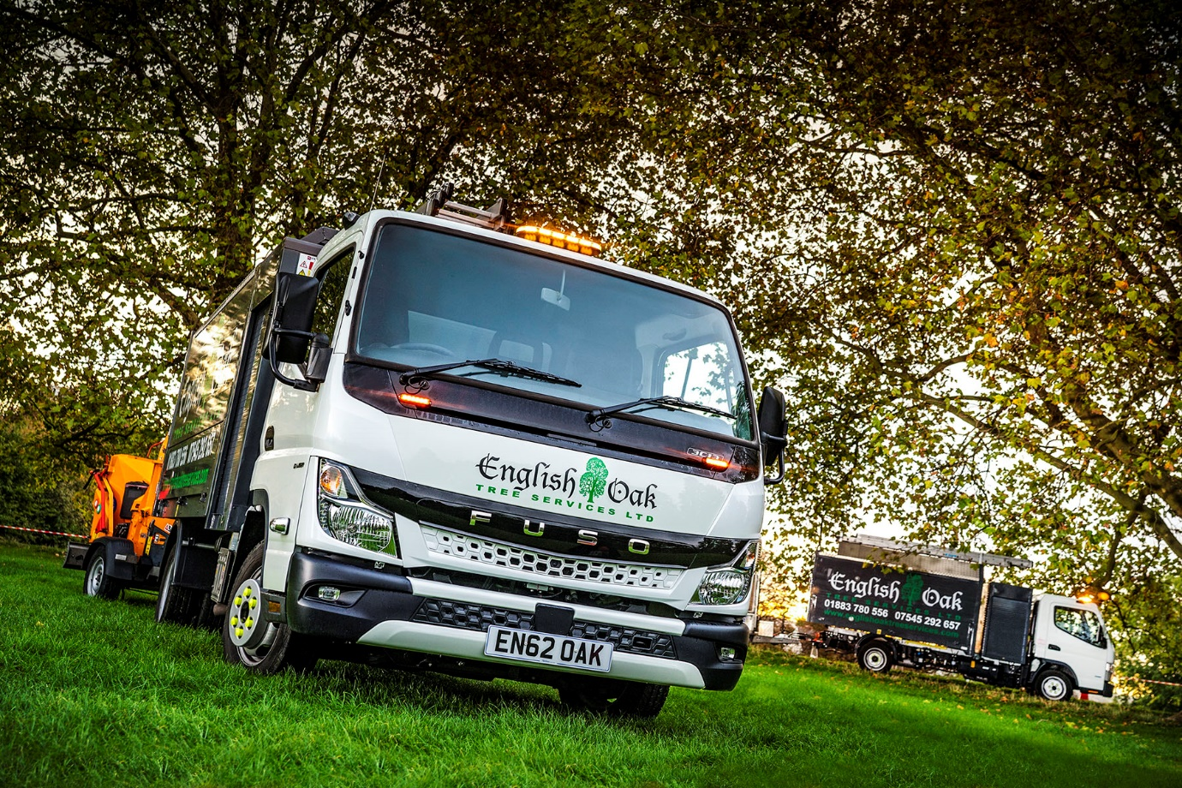

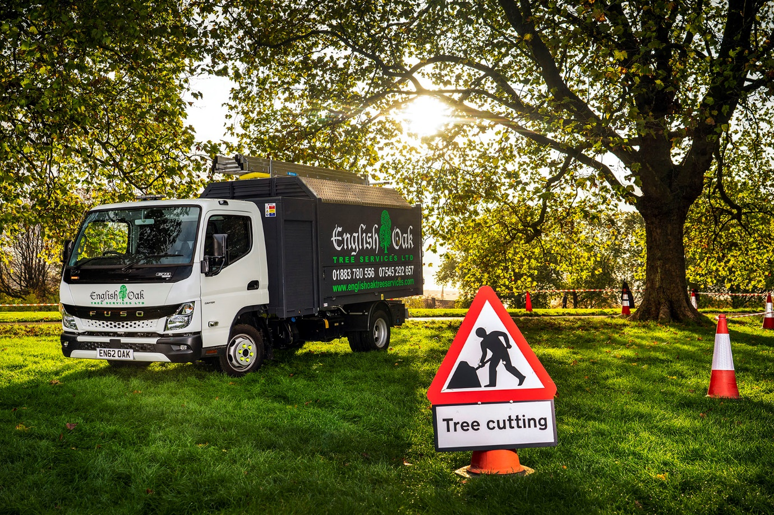

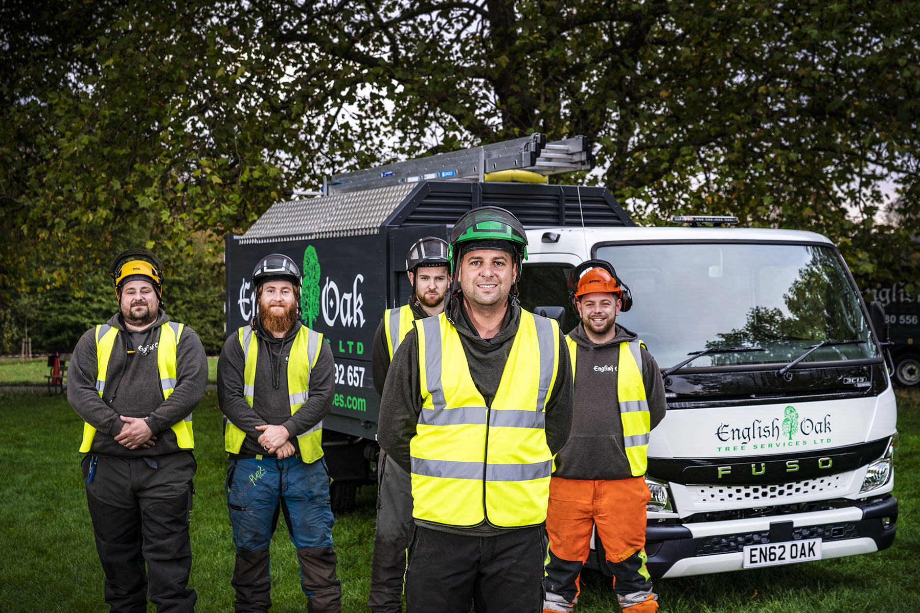

Branch line-up: Paul Taylor and members of English Oak Tree Services’ experienced team, from left, John Taylor, Sam Harcourt-Ellis, Jack Tidman and Simon Armstrong
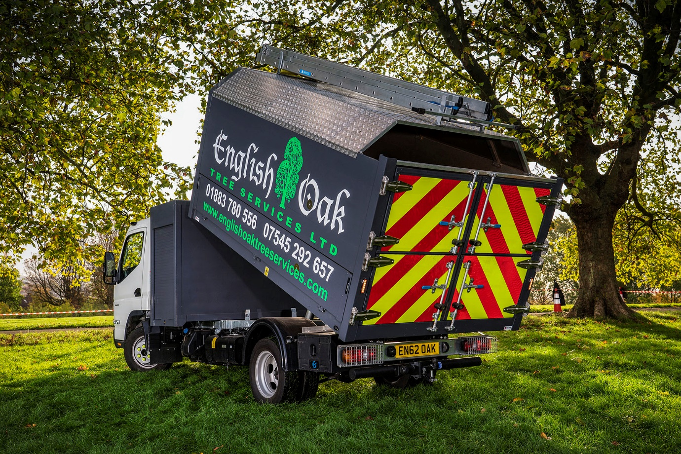

ends

For more information, or to request bigger/higher-res image files, please contact:
Steve Warren or John Ripley
Impact Communications
Steve: 07770 470251, steve@impactcom.co.uk
John: 07771 484595, john@impactcom.co.uk



