

Date: 12 August 2019

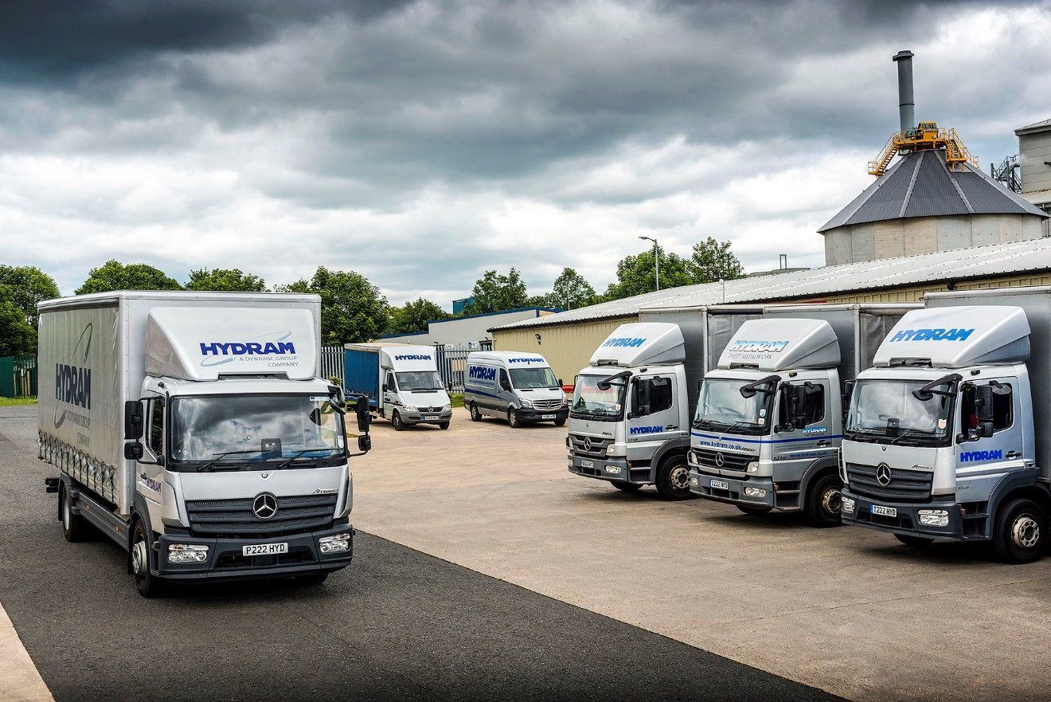

Proven performer: Hydram operates Mercedes-Benz Atego rigids from three model generations

Hydram raises its game with 16-tonne Mercedes-Benz Atego from Bell Truck and Van

Metal fabrications specialist Hydram Engineering has responded to increased demand from customers by commissioning its biggest truck yet, a 16-tonner from the Mercedes-Benz Atego range which has been providing reliable service for upwards of 20 years.

Based in Chilton, County Durham, the company is a leading provider of subcontract services covering all aspects of precision sheet metal profiling, forming and fabrication, as well as powder coating and assembly.

The new rigid arrived, like the six other vehicles on the Hydram fleet, via North-East Dealer Bell Truck and Van. At 16 tonnes, its gross weight is the highest in the Atego portfolio.

The truck is smartly finished in the operator’s distinctive silver livery, with the ‘personalised’ registration plate P222 HYD. It has a ClassicSpace S-cab and, as a 1521 model, is powered by a 5.1-litre four-cylinder engine which produces 155 kW (211 hp) and is paired with a six-speed manual transmission. Its 26 ft curtainside body, meanwhile, is by Robinsons Truck Bodyworks, of Newcastle upon Tyne.

Acquired in 2018 by the US-owned Dynamic Aerospace and Defense Group, Hydram is committed to implementing world class standards across all of business functions, including its transport operation.

The company has previously relied on 13.5-tonne trucks. Underlining the Atego’s unrivalled reliability and durability, Hydram is still running a 14-year-old example which has clocked-up 970,000 km, as well as others from 2010, 2013 and 2015. Completing the fleet are a pair of Mercedes-Benz Sprinters, a 4.6-tonne curtainsider and a 3.5-tonne panel van.

Purchasing Manager David Lowes explained: “We’re very busy and some of our products are heavy, so we felt a vehicle which offered a higher payload would beneficial in helping us to meet the rise in customer demand.

“The new truck’s footprint is no bigger than previous versions, but it has enabled us to increase efficiency and improve cost and other controls by reducing the extent to which we rely on third-party transport providers to support our in-house operation.”

He continued: “We like to run vehicles which stand out from the crowd, and feel the Mercedes-Benz brand complements our own company’s image and reputation for quality.

“We pride ourselves in going ‘above and beyond’ in terms of the service we provide to our customers. This means the avoidance of unplanned vehicle downtime is crucial. The Atego has proved over the years to be exceptionally reliable, and has given us the flexibility we need to respond quickly to changing requirements.”
Hydram’s trucks undertake nationwide deliveries so the round-the-clock support provided by members of Mercedes-Benz Trucks’ Dealer network is also key to the Atego’s appeal. “There have been very few occasions when we’ve needed to call on the manufacturer’s Service24h back-up, but when we’ve done so it’s performed well,” confirmed Mr Lowes.

Purpose-designed for light- and medium-duty distribution work, the Mercedes-Benz Atego range offers advanced truck technology for the 7.5 to 16 tonnes segment, with outstanding dynamics, comfort, safety and manoeuvrability.

www.hydram.co.uk

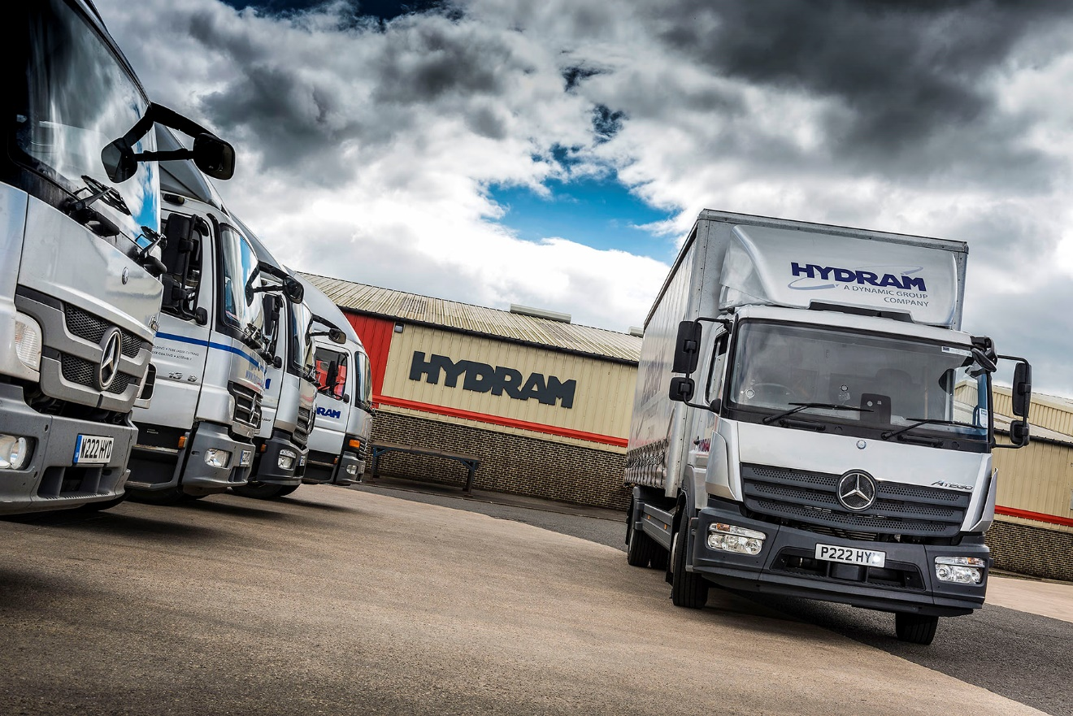

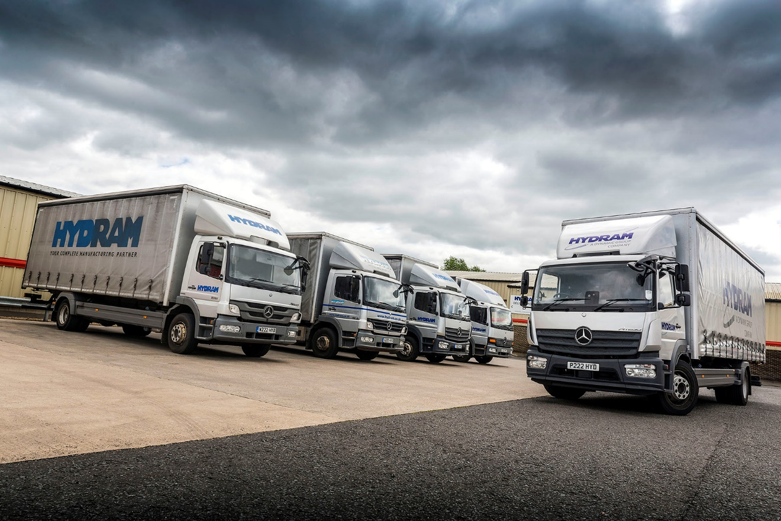

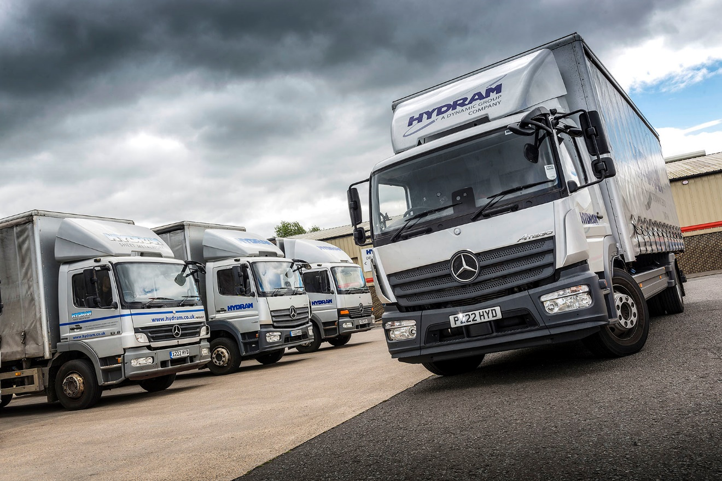

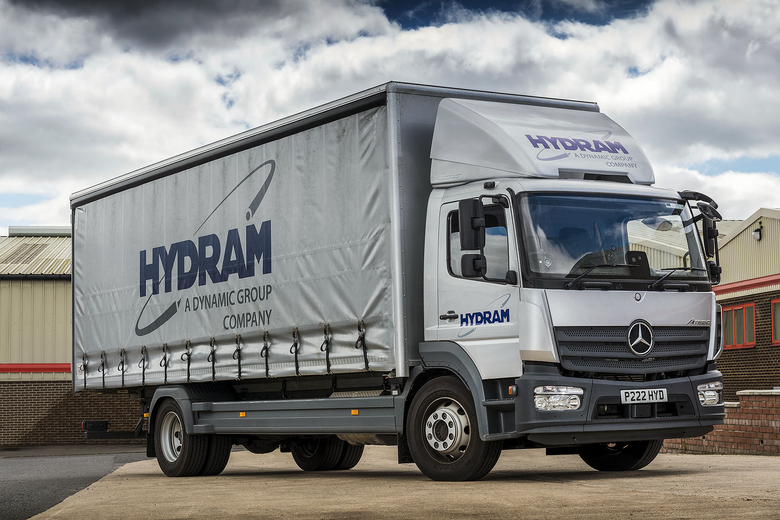

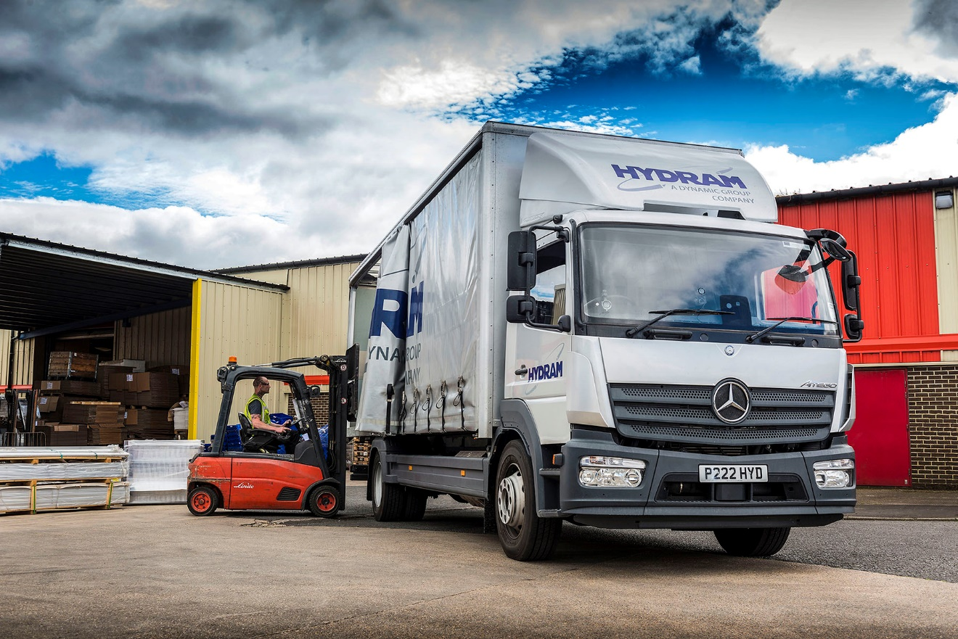

ends

For more information, or to request bigger/higher-res image files, please contact:
Steve Warren or John Ripley
Impact Communications, 01926 842126
Steve: 07770 470251, steve@impactcom.co.uk
John: 07771 484595, john@impactcom.co.uk

