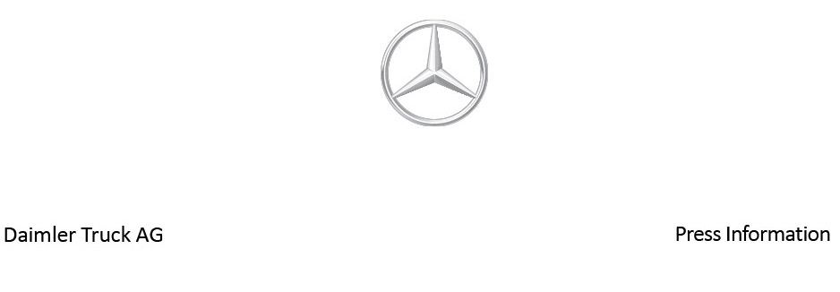

Date: 30 May 2022

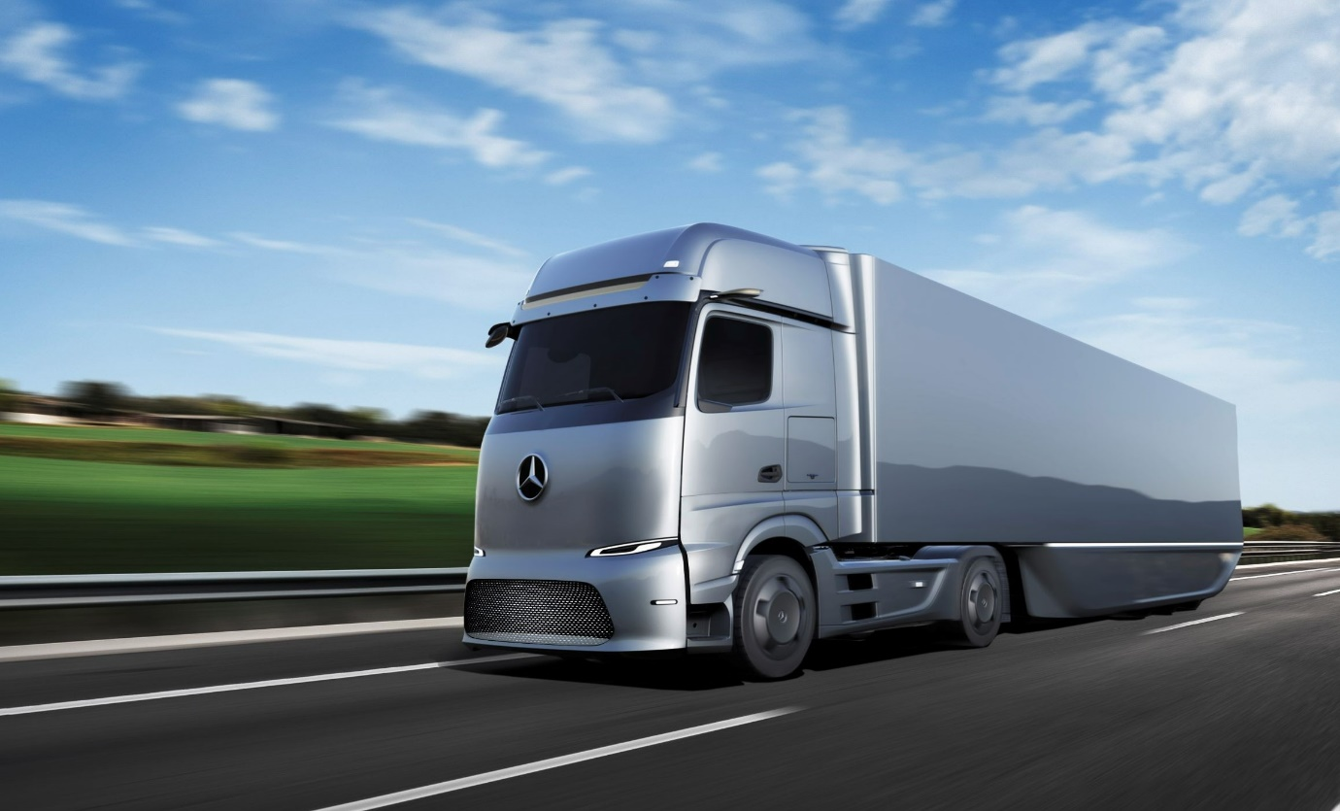

Coming soon: Trials of the eActros LongHaul on public roads begin this year, with the battery-powered truck scheduled to enter series production in 2024

Mercedes-Benz Trucks continues to drive electrification forward – eActros LongHaul to hit the road in 2022

- Introduction of numerous new battery-powered trucks in 2022 and the coming years

- First prototypes of the eActros LongHaul truck built for testing

- Additional variants of the eActros 300 and eActros 400 in development

- Series production launch of the eEconic for municipal applications in July 2022

- Customer event for some 1,000 participants from all over Europe on e-mobility in Wörth in June

- Karin Rådström, CEO Mercedes-Benz Trucks: “The tremendous interest in our eActros driving event in Wörth is further proof of the popularity e-mobility is already gaining with customers. Customers are thus sending a strong signal to all stakeholders to combine efforts and quickly put more and more electric trucks on the road, expand the charging infrastructure and create cost parity.”

Stuttgart/Wörth - Following the market launch of the eActros for heavy-duty distribution transport in 2021, Mercedes-Benz Trucks is systematically pressing ahead with the introduction of additional battery-electric models for this and coming years. For the important long-haul segment the eActros LongHaul, with a range of around 500 kilometres on one battery charge, is scheduled to be ready for series production in 2024. The first prototypes of the 40-tonne truck are already undergoing internal tests and Mercedes-Benz Trucks’ engineers are planning to start trials of the e-truck on public roads this year. The eActros LongHaul will enable high-performance charging – so-called “megawatt charging”. Mercedes-Benz Trucks is also preparing additional variants of the eActros – specifically of the eActros 300 and the eActros 400 – and, as early as July, the eEconic for municipal use is scheduled to roll off the production line at the Wörth plant as the second all-electric series production vehicle. The goal of Mercedes-Benz Trucks is to increase the share of locally CO₂-neutral new vehicles in Europe to more than 50% by 2030.

In order to further introduce truck customers from all over Europe to e-mobility, the manufacturer is organising an event lasting several weeks around the Wörth site starting in early June. Experts from Mercedes-Benz Trucks will inform a total of some 1,000 participants on the central aspects of e-mobility, from infrastructure and services to electric models. In addition, customers will have the opportunity to drive the eActros 300 on demanding routes and with realistic payloads.

Karin Rådström, CEO Mercedes-Benz Trucks: “The tremendous interest in our eActros driving event in Wörth is further proof of the popularity e-mobility is already gaining with customers. Customers are thus sending a strong signal to all stakeholders to combine efforts and quickly put more and more electric trucks on the road, expand the charging infrastructure and create cost parity.”

Engaging with partners for charging infrastructure

In depot charging, Mercedes-Benz Trucks is working together with Siemens Smart Infrastructure, ENGIE and EVBox Group. In terms of public charging for long-distance transport, Daimler Truck, TRATON GROUP and the Volvo Group have signed a binding agreement to establish a joint venture. This will provide for the development and operation of a public, high-performance charging network for battery-electric heavy-duty long-haul trucks and coaches in Europe. The charging network of these three parties will be available to fleet operators in Europe regardless of brand.

The goal of the ‘High-Performance Charging in Long-Haul Truck Transport’ (HoLa) project, with the participation of Daimler Truck and under the aegis of the German Association of the Automotive Industry (VDA), is to plan, erect and operate a select high-performance charging infrastructure for battery-electric long-haul truck transport. Two high-performance charging points with the Megawatt Charging System (MCS) are to be erected at each of four locations in Germany and tested in real-world applications. Various other consortium partners from industry and research are involved in the project.

Mercedes-Benz eEconic at IFAT

The battery-electric eEconic will mark its trade show premiere on May 30 at IFAT, the world’s leading trade show for water, sewage, waste and raw materials management, in Munich. The eEconic scores particularly well in urban applications in the early morning hours thanks to its lower noise emissions. The eEconic’s vehicle architecture benefits from Daimler Truck's global platform strategy: The powertrain of the low-floor truck is based on the Mercedes-Benz eActros, which has been in series production at the Wörth plant since October 2021. Since May 2022, FES Frankfurter Entsorgung- (Waste Management) and Service GmbH has already been using a near-series eEconic in Frankfurt am Main for municipal waste collection.

Second-generation MirrorCam for eActros

As of April of this year, Mercedes-Benz Trucks has been equipping the eActros with the enhanced second-generation MirrorCam, which features improvements in terms of display and safety in particular. Externally, the camera arms on both sides have been shortened by ten centimetres each. One of the advantages of these new dimensions is that drivers immediately find it easier to drive in reverse than with the first-generation MirrorCam, as the MirrorCam’s perspective is now even more similar to that of the familiar glass mirror.

Ultimate goal: CO₂-neutral transport on the road by 2050

Daimler Truck’s ambition is to only offer new vehicles in Europe, Japan, and North America that are CO₂-neutral in operation (‘tank-to-wheel’) by 2039. The two battery-electric models Mercedes-Benz eCitaro and Mercedes-Benz eActros have already been rolling off the assembly line in series production since 2018 and 2021 respectively. The Mercedes-Benz eEconic, the FUSO eCanter and the Freightliner eCascadia will follow later this year, and additional locally CO₂-neutral vehicles are already planned. In the second half of this decade, the company plans to further supplement its range of vehicles with series-produced vehicles powered by hydrogen-based fuel cells. Putting CO₂-neutral transportation on the road by 2050 is the ultimate goal.

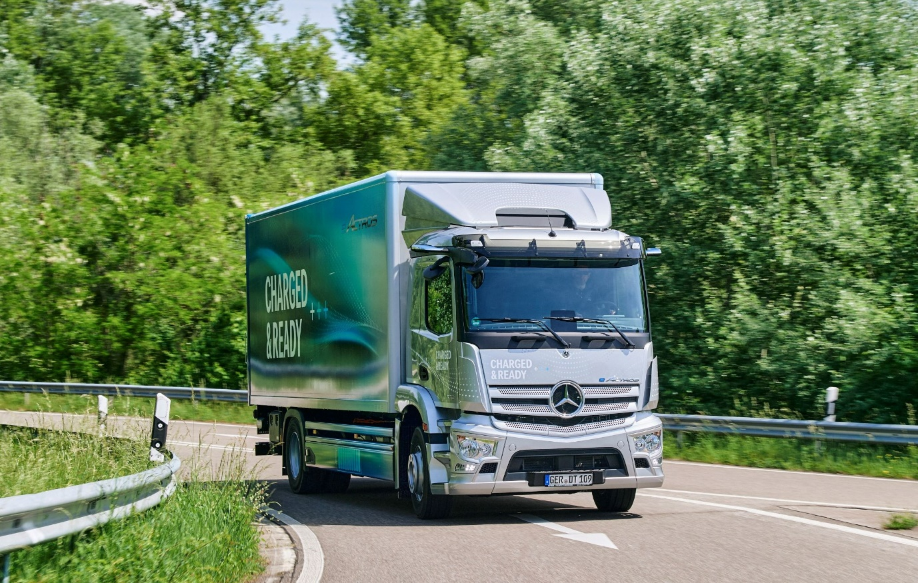

Available now: Mercedes-Benz Trucks UK is inviting orders for fully-electric right-hand drive eActros variants at 19 and 27 tonnes GVW

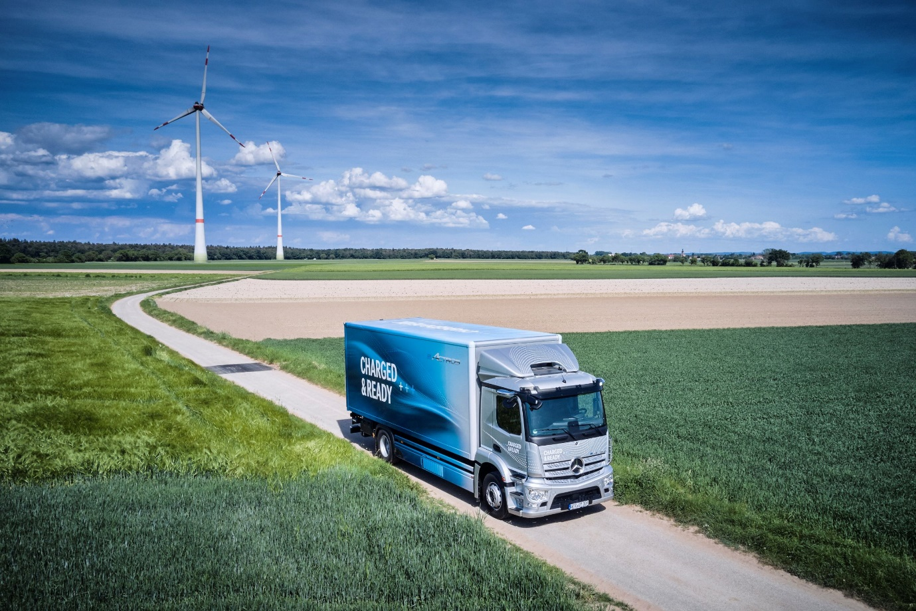

ends

For more information, please contact:

Jamie Fretwell at Mercedes-Benz Trucks UK Ltd
07712 519230, jamie.fretwell@daimler.com

or

Steve Warren or John Ripley
Impact Communications
Steve: 07770 470251, steve@impactcom.co.uk
John: 07771 484595, john@impactcom.co.uk

or

Akim Enomoto, +49 176 30995099, akim.enomoto@daimlertruck.com
Peter Smodej, +49 (0) 176 30936446, peter.smodej@daimlertruck.com

Further information on Daimler Truck is available at:
www.media.daimlertruck.com and www.daimlertruck.com

Forward-looking statements:
This document contains forward-looking statements that reflect our current views about future events. The words “anticipate,” “assume,” “believe,” “estimate,” “expect,” “intend,” “may,” ”can,” “could,” “plan,” “project,” “should” and similar expressions are used to identify forward-looking statements. These statements are subject to many risks and uncertainties, including an adverse development of global economic conditions, in particular a decline of demand in our most important markets; a deterioration of our refinancing possibilities on the credit and financial markets; events of force majeure including natural disasters, pandemics, acts of terrorism, political unrest, armed conflicts, industrial accidents and their effects on our sales, purchasing, production or financial services activities; changes in currency exchange rates, customs and foreign trade provisions; a shift in consumer preferences towards smaller, lower-margin vehicles; a possible lack of acceptance of our products or services which limits our ability to achieve prices and adequately utilize our production capacities; price increases for fuel or raw materials; disruption of production due to shortages of materials, labor strikes or supplier insolvencies; a decline in resale prices of used vehicles; the effective implementation of cost-reduction and efficiency-optimization measures; the business outlook for companies in which we hold a significant equity interest; the successful implementation of strategic cooperations and joint ventures; changes in laws, regulations and government policies, particularly those relating to vehicle emissions, fuel economy and safety; the resolution of pending government investigations or of investigations requested by governments and the conclusion of pending or threatened future legal proceedings; and other risks and uncertainties, some of which are described under the heading “Risk and Opportunity Report” in this Annual Report. If any of these risks and uncertainties materializes or if the assumptions underlying any of our forward-looking statements prove to be incorrect, the actual results may be materially different from those we express or imply by such statements. We do not intend or assume any obligation to update these forward-looking statements since they are based solely on the circumstances at the date of publication.

Daimler Truck at a glance
Daimler Truck Holding AG ("Daimler Truck") is one of the world's largest commercial vehicle manufacturers, with over 40 main locations and more than 100,000 employees around the globe. The founders of Daimler Truck have invented the modern transportation industry with their trucks and buses a good 125 years ago. Unchanged to this day, the company's aspirations are dedicated to one purpose: Daimler Truck works for all who keep the world moving. Its customers enable people to be mobile and get goods to their destinations reliably, on time, and safely. Daimler Truck provides the technologies, products, and services for them to do so. This also applies to the transformation to CO2-neutral driving. The company is striving to make sustainable transport a success, with profound technological knowledge and a clear view of its customers' needs. Daimler Truck's business activities are structured in five reporting segments: Trucks North America (TN) with the truck brands Freightliner and Western Star and the school bus brand Thomas Built Buses. Trucks Asia (TA) with the FUSO and BharatBenz commercial vehicle brands. Mercedes-Benz (MB) with the truck brand of the same name. Daimler Buses (DB) with the Mercedes-Benz and Setra bus brands. Daimler Truck's new Financial Services business (DTFS) constitutes the fifth segment, the product range in the truck segments includes light, medium and heavy trucks for long-distance, distribution and construction traffic and special-purpose vehicles used mainly in the municipal and vocational sector. The product range of the bus segment includes city buses, school buses and intercity buses, coaches and bus chassis. In addition to the sale of new and used commercial vehicles, the company also offers aftersales services and connectivity solutions.

