

Date: 17 January 2023

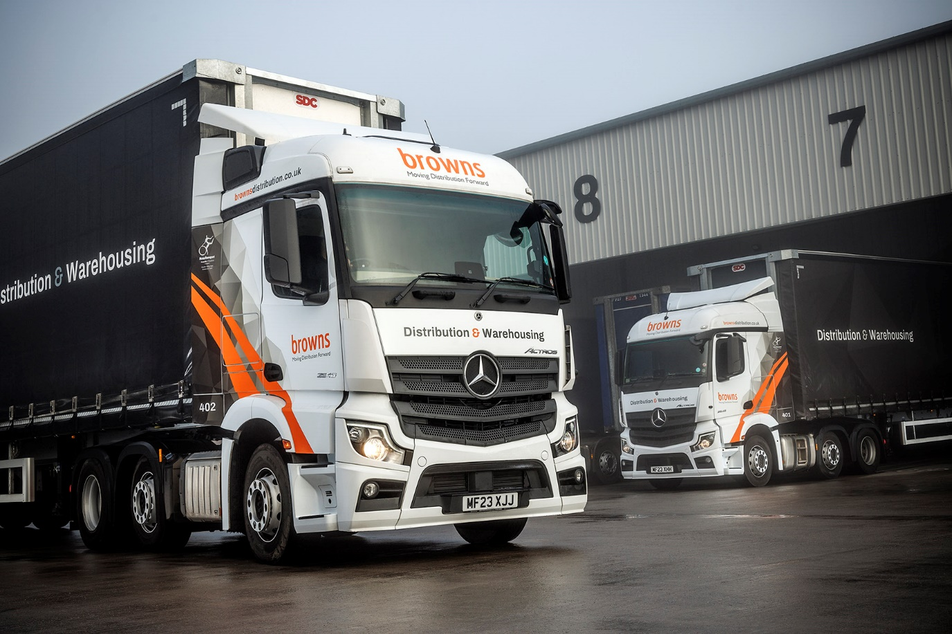

Browns looks no further than Mercedes-Benz Dealer eStar for trio of new fleet trucks

Driver appeal, competitive running costs – and the promise of top-quality back-up from the Dealer next door – persuaded Browns Distribution to invest in its first Mercedes-Benz trucks.

The three Actros tractor units were supplied eStar Truck & Van, whose site on Chemical Lane, Stoke-on-Trent, is just metres away from Browns’ own premises.

They have joined a fleet dominated by two rival brands but, says Managing Director David Brown, an approach from eStar’s Truck Sales Consultant Ryan Lockett came at the perfect moment.

“Ryan’s timing was spot-on,” he recalled. “He couldn’t have known, but he got in touch just as we were considering changes to our fleet purchase policy. We took a demo truck from eStar for a couple of weeks and were impressed enough to decide we would include Mercedes-Benz in the mix.

“The demonstrator was handed to one of our most experienced drivers, who gave us some very positive feedback. The cab was clearly well-designed and comfortable, the truck’s fuel returns were easily as good as anything else on our fleet, and overall it looked like a nice bit of kit.

“The most important thing with any vehicle, though, is its availability for work – uptime is everything,” he continued. “Having eStar’s round-the-clock workshop on our doorstep, and hearing the team there make all the right promises regarding how they’ll back us up, made the decision to invest in Mercedes-Benz a ‘no-brainer’. We also took up the offer of a five-year Service Contract, at a highly competitive rate, which will make budgeting for running costs much more predictable.”

The trucks are Actros 2546 models, powered by 10.7-litre six-cylinder engines that each produce 340 kW (460 hp). They have aerodynamic StreamSpace cabs with 170 mm engine tunnels – chosen in preference to flat floors, as the lower driving position helps the vehicles meet Direct Vision Standard requirements for working in London. They are assigned to general haulage duties all over the UK, working with SDC curtainside trailers, and are typically away from home for one or two nights at a time.

Browns Distribution is a third-generation family firm with a proud history, but also never stops looking forward. The company only moved into its new Chemical Lane home last year, having invested a total of £9 million in creating a state-of-the-art storage and distribution facility. At the same time it underwent a thorough re-brand, and the Mercedes-Benz tractors are among the first fleet trucks to wear its smart new design.

“These are very early days of course, but all our initial impressions of these Actros units and of eStar’s support are very positive.” said David Brown. “The trucks look great in our colours and project a very professional image. We couldn’t be happier with our choice.”

brownsdistribution.co.uk

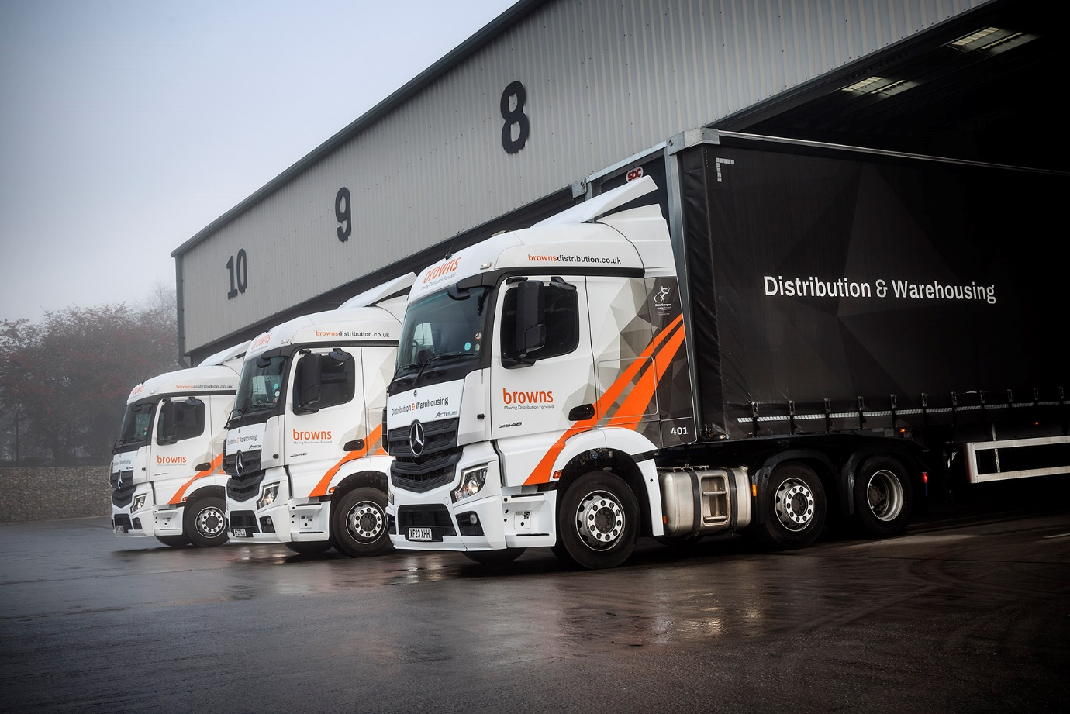

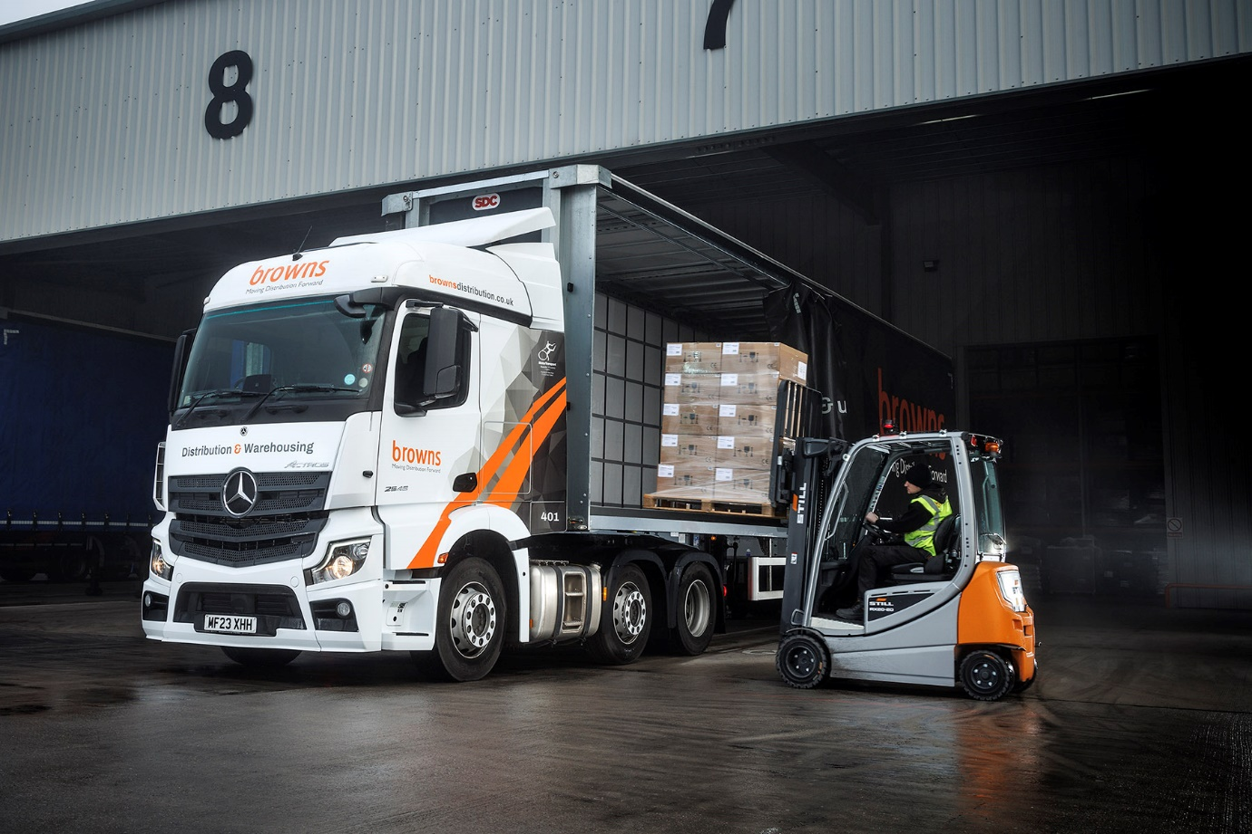
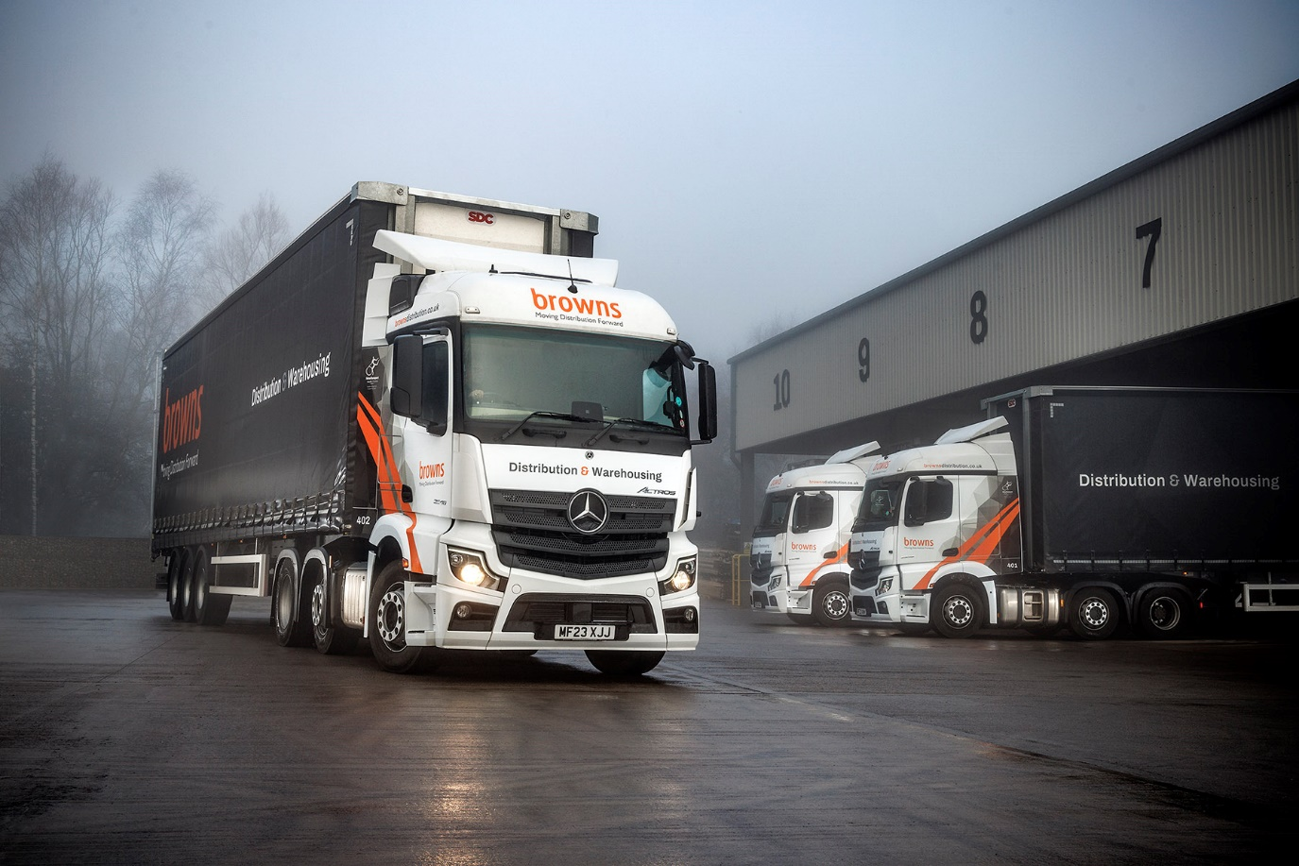

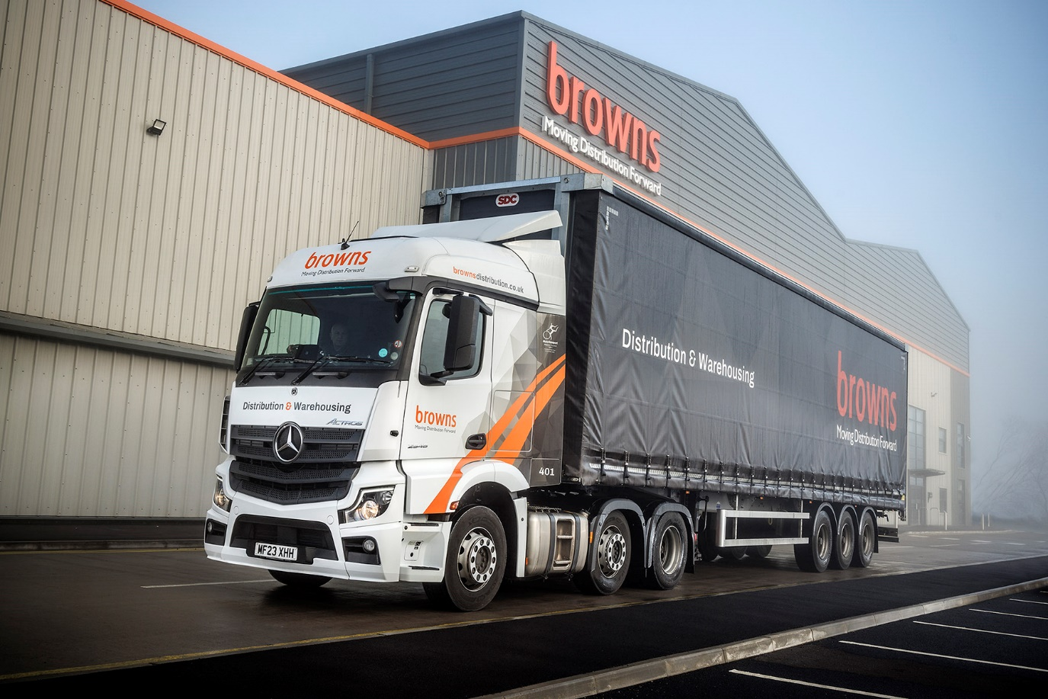

ends

For more information, or to request bigger/higher-res image files, please contact:
John Ripley: 07771 484595, john.ripley@loopagency.co.uk

