

Date: 1 March 2019

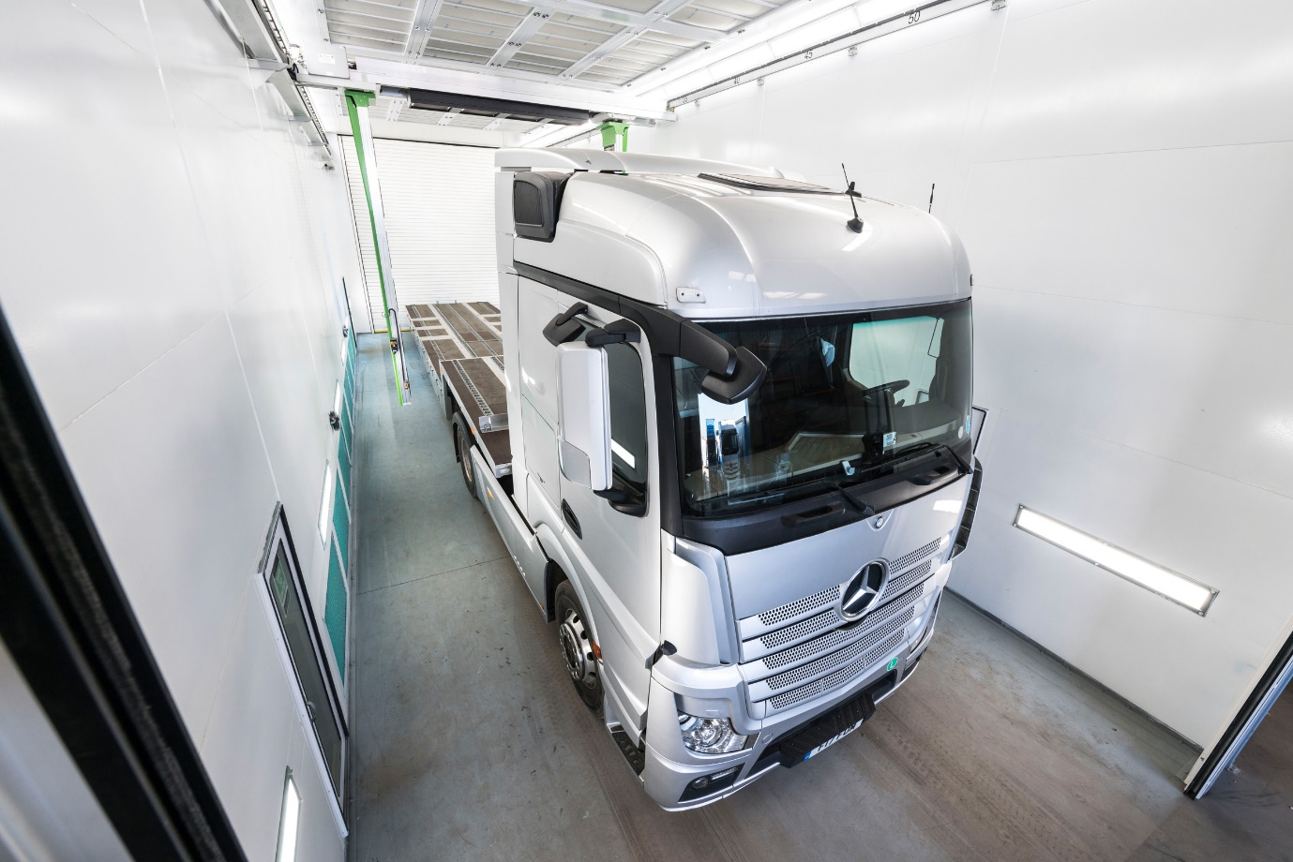

Sparshatt Truck & Van launches ‘same-day’ commercial vehicle paint service

Top-quality paint finishes and industry-leading turnaround times – that’s the offer from Sparshatt Truck & Van, following a major investment in state-of-the art spray booth technology.

The Mercedes-Benz Trucks Dealer for Kent and South-East London will be unveiling its new bodyshop facilities to prospective customers at an open day in Sittingbourne on Wednesday 3rd April.
The two Titan CV booths were supplied and installed at a cost of some £330,000, by Todd Engineering, of Rugeley, Staffordshire. At 18 metres, one is comfortably long enough to accommodate an articulated tractor unit and 13.6-metre semi-trailer combination, while the second, which is nine metres in length, is being used for vans and smaller rigid trucks.

Both booths are equipped with LED lighting that surpasses the highest standards required for the automotive refinishing sector, efficient extraction systems, and fully insulated roller shutter doors.

They also incorporate cutting-edge, robotic gas catalytic dryers by Italian manufacturer, Greentech. Automatically controlled, natural gas-powered panels in the form of an arch pass directly over the vehicle, transmitting safe, flameless, low-intensity infrared heat.

Surface temperatures of 420ºC on the heaters translate into ultra-fast curing times – paint is fully and uniformly dry within five minutes of exposure, so the vehicle can then be buffed. Meanwhile, because the system negates the need to heat hundreds of square feet of air, it is also environmentally-friendly, and highly cost-effective to operate.

A founding member in 1974 of the Mercedes-Benz UK commercial vehicle network, Sparshatt Truck & Van was acquired by a new ownership team in March 2018. As well as selling Mercedes-Benz and FUSO trucks, it provides comprehensive aftersales support for commercial vehicles of all sizes and brands.

The Dealer recently established a dedicated unit for van servicing at its headquarters on Sittingbourne’s Eurolink Industrial Estate. This entailed the relocation of its successful bodyshop operation to a new site, a short distance away on Bonham Drive; it anticipates securing Mercedes-Benz approval for this facility imminently.

Sparshatt Truck & Van is one of only two providers in the UK to apply Greentech’s technology – it has also commissioned a mobile version of the system – for the benefit of commercial vehicle operators. Underlining the quality of the work, some of the first vehicles to emerge from the larger booth were Actros tractor units, repainted in silver for operation by various Formula One™ teams.

A significant proportion of the vehicles that go through the bodyshop will have been returned by operators on completion of their contracts, prior to remarketing by Sparshatt. The Dealer also undertakes accident repairs on behalf of insurers, and recently embarked on a major refurbishment programme for a high-profile customer – it has identified major opportunities to win new orders in both segments.

Dealer Principal Steve Rooney explained: “It was our firm intention on purchasing this business just under a year ago, to focus on providing quality solutions, and on adding value at every opportunity.

“The new bodyshop demonstrates our commitment to this strategy, and represents a substantial capital investment. We’ve spent a lot more than we need have done for a conventional system, but Greentech’s eco-friendly drying technology holds out the promise of payback over time, through dramatic reductions in energy usage.

“More importantly, it also means we can offer an industry-leading level of service to customers for whom vehicle availability is a top priority – in the right circumstances, we can now paint their truck, van or trailer to an exceptionally high standard and get it back to them on the same day!”

Bodyshop Manager Andy Macrae added: “This is first time we’ve been able to offer a paint service covering trailers, while in terms of throughput we’ve taken a massive step forward. Previously, we’d have to wait up to 12 hours for the paint to cure. But we know of home delivery companies whose vans need refurbishing prior to return to their leasing providers, and who want to get them in and out in a day – that’s a service we can now provide.”

Greentech Dryers Srl manufactures its gas catalytic drying robotics near Padova, in the north-east of Italy; Todd Engineering was appointed last year, as its sole UK agent. Director Lee Todd commented: “Much like a Mercedes-Benz truck, ours is a premium product. Sparshatt Truck & Van is to be commended for looking beyond the ‘up front’ purchase price and focusing instead on the huge operational and environmental benefits which this remarkable technology offers.”
Operators wishing to attend the Dealer’s bodyshop open day on 3rd April should register their interest by emailing info@sparshatts.co.uk

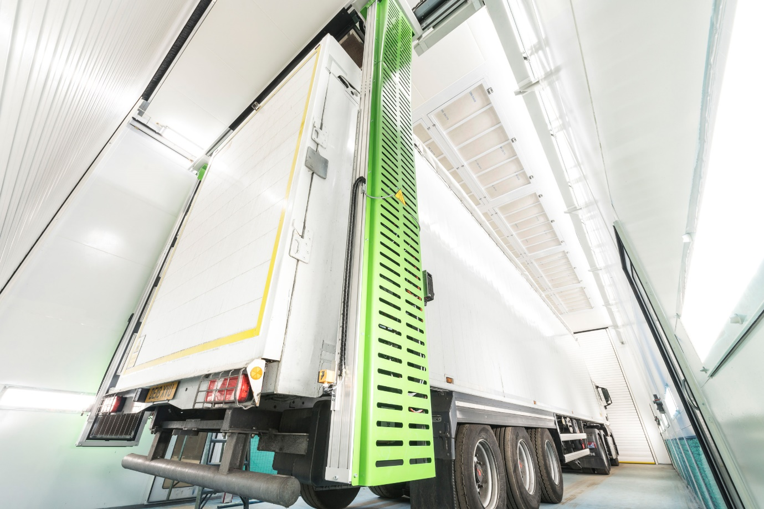

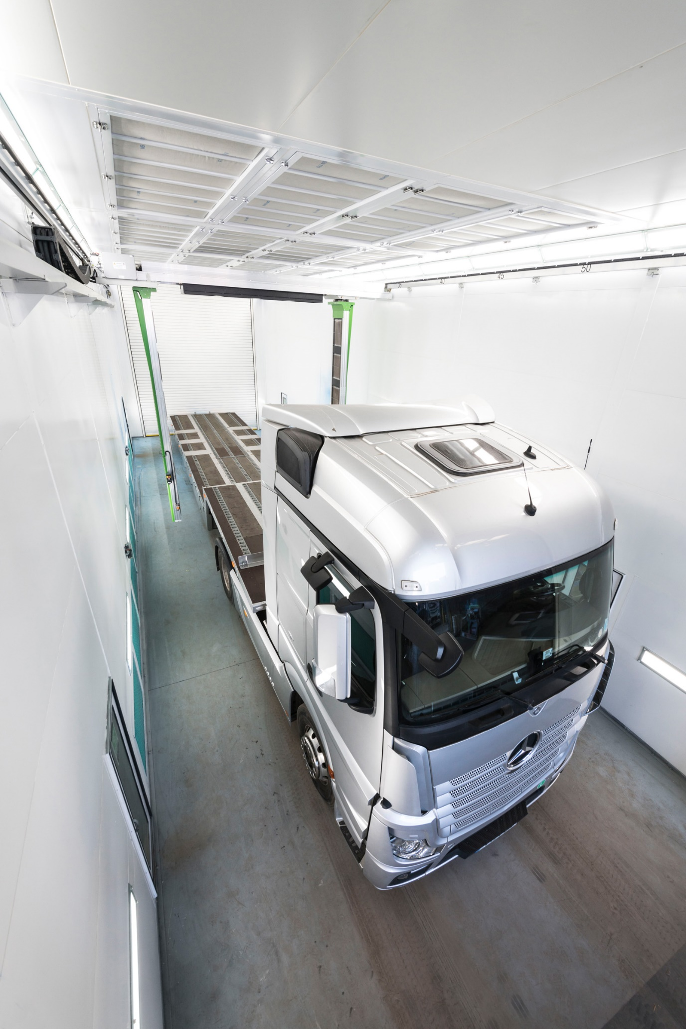

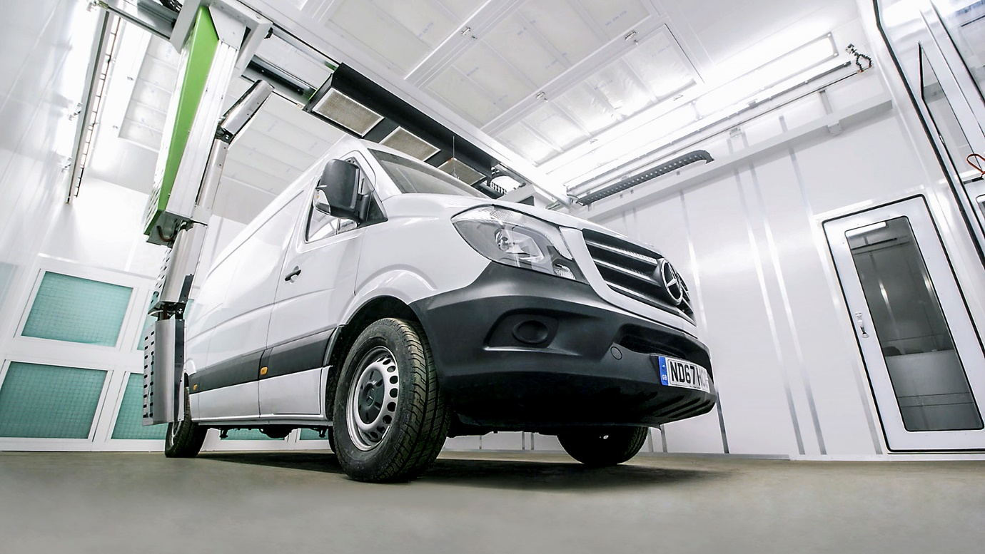

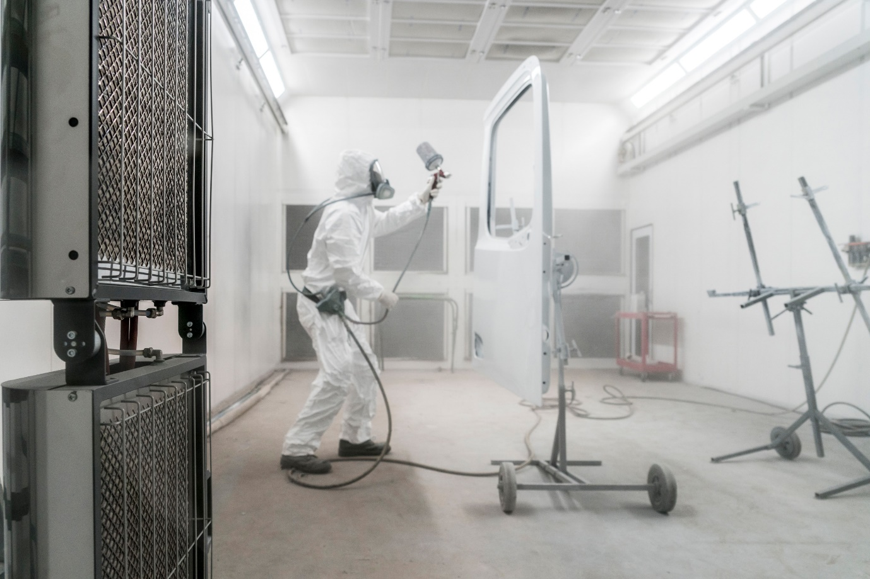

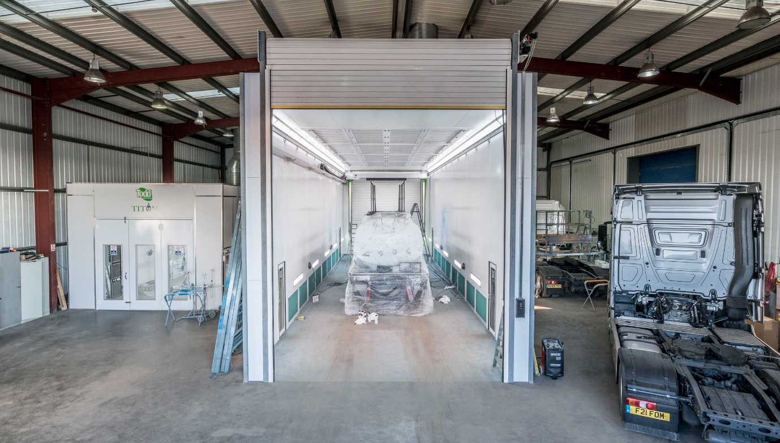

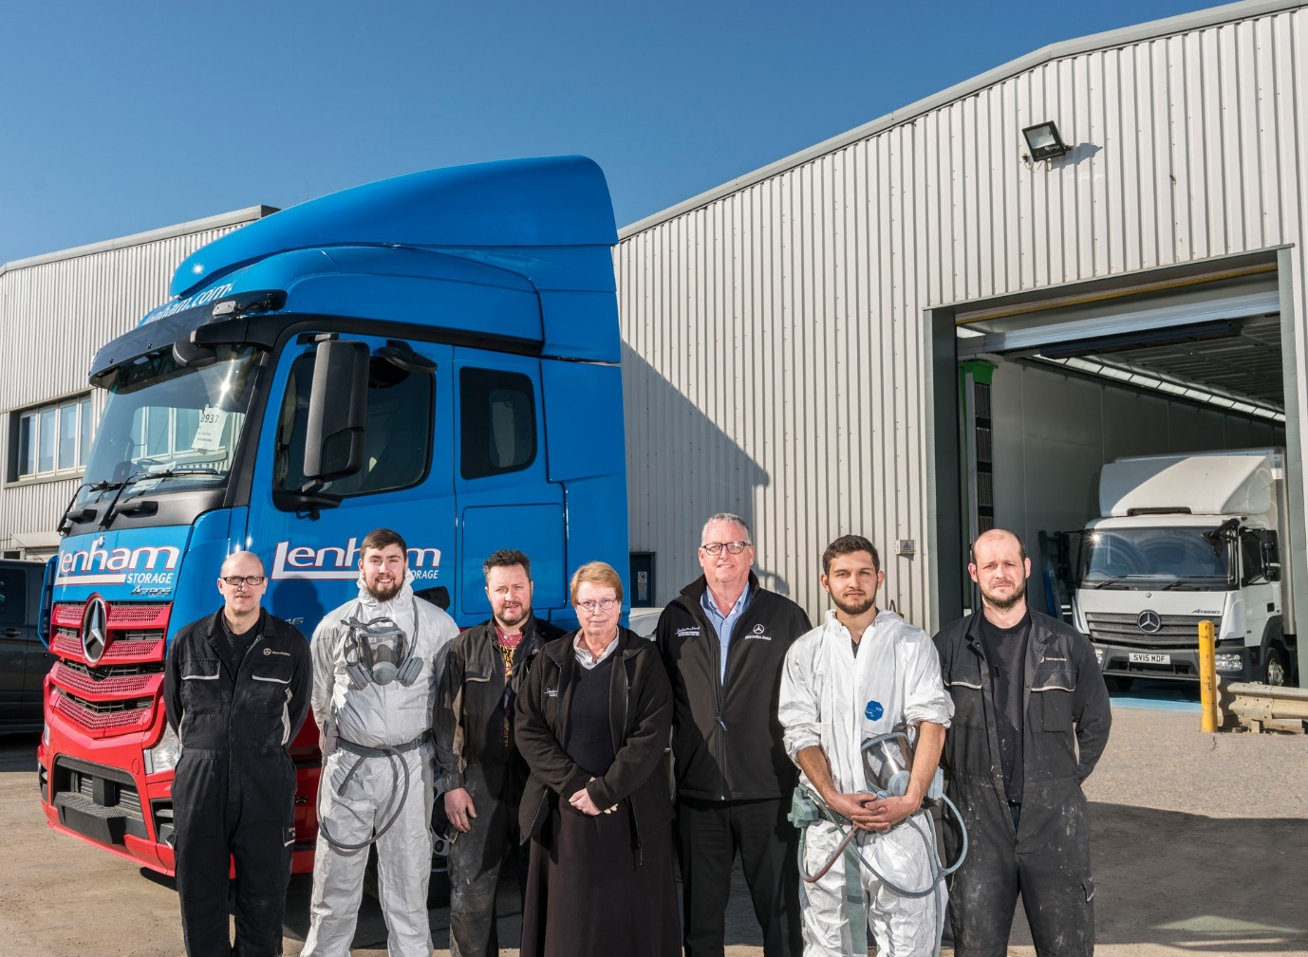

They’ll ‘paint your wagon’ in double-quick time: Members of the Sparshatt Truck & Van Bodyshop team, from left, Colin Vaughan, Charlie Barnes, Jamie Miles, Angela Shepherd, Andy Macrae, Declan Gogerly and Gavin Watson

Note to Editors
Please be advised that having previously done so as Sparshatts Truck & Van, from March 2019 the Mercedes-Benz Trucks Dealer for South-East London and Kent is trading as Sparshatt (without the final ‘s’) Truck & Van. This very minor change to the company’s name was a legal stipulation, arising from the acquisition of the business completed a year earlier.

For more information, or to request bigger/higher-res image files, please contact:
Steve Warren or John Ripley
Impact Communications, 01926 842126
Steve: 07770 470251, steve@impactcom.co.uk
John: 07771 484595, john@impactcom.co.uk

