

Date: 12 December 2019

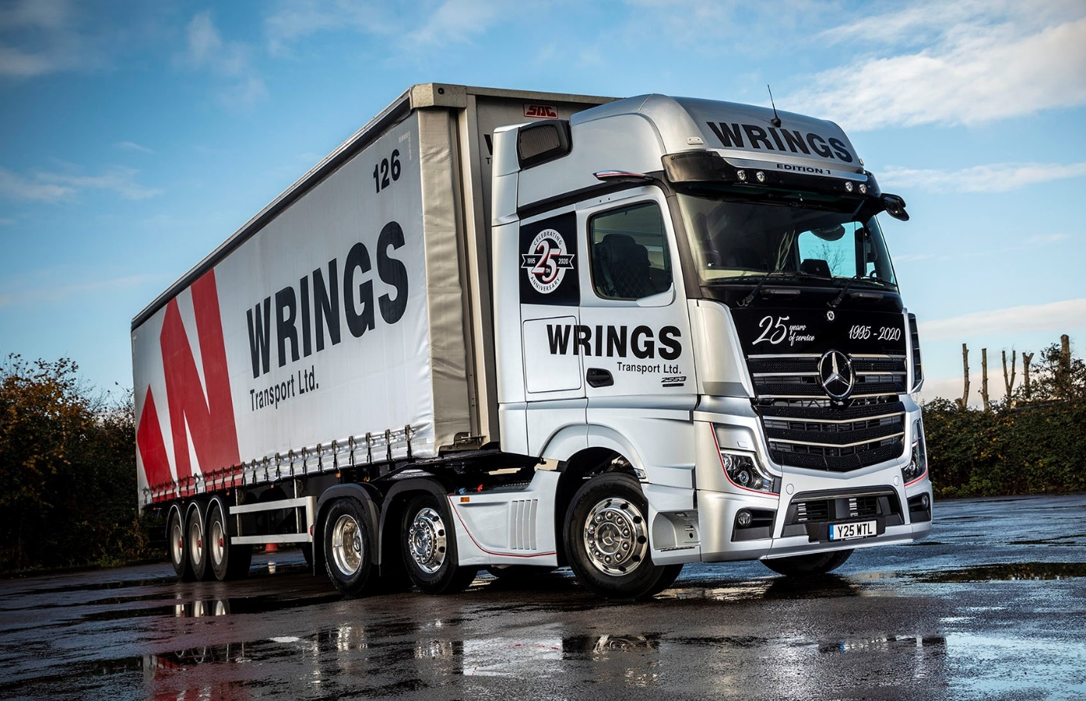

Wrings celebrates in style with anniversary Actros Edition 1 from Mercedes-Benz

What better way to tell the world it’s your Silver Anniversary than by announcing the fact on an awesome, limited edition flagship bearing the silver star of Mercedes-Benz.

Wrings Transport’s new Actros Edition 1 arrived as the largest privately-owned haulier in the Avonmouth area prepares to mark a quarter of a century in business. A message across the top of the truck’s distinctive gloss black grille proclaims ‘25 years of service 1995-2020’, while the theme is repeated with eye-catching motifs on either side of the GigaSpace cab.

Supplied by truck-dedicated south west Dealer City West Commercials, whose own headquarters are just three miles away from those of its high-profile customer, the Edition 1 is a stunning showcase for the Actros range. To the many technological advances which were so instrumental in helping Mercedes-Benz to win the coveted International Truck of the Year award for a record ninth time, it adds additional features, and sets new standards for comfort and driver appeal.

Just 400 examples of the Actros Edition 1 are being built, and of these only 35 will reach the domestic market. The truck is available with four engine output options. Mercedes-Benz expects the potent 460 kW (625 hp) version of its 15.6-litre in-line six-cylinder engine to be the most popular with Edition 1 customers in the UK – Wrings Transport, however, has opted for a 12.8-litre straight-six which produces 390 kW (530 hp) and offers an ideal combination of performance and economy.

Wrings can trace its roots back to 1927, when Sidney Joseph Wring began using a horse and cart to deliver coal to hospitals and schools throughout the Bristol area. In its current form, however, the company was founded in 1995, when Sidney’s youngest son Royston, and his two sons Stuart and Martin, began trading with a single 3.5-tonne dropsider.

Today, Wrings Transport operates 31 tractor units by three manufacturers – Mercedes-Benz claims the lion’s share of the line-up, with 14 vehicles. All but one of Wrings’ 27 rigid trucks of various sizes also wear three-pointed stars, as do three of its four vans. Last year alone, Wrings Transport acquired 10 Actros 2545 tractors from City West Commercials, together with 10 Antos at 18 tonnes GVW, and a pair of Atego 7.5-tonners.

Managing Director Stuart Wring resolved to purchase the Actros Edition 1 as his company’s anniversary truck, after attending a transport conference in Cardiff last year at which Sam Whittaker, now Sales Director at Mercedes-Benz Trucks UK, delivered a presentation on the new Actros.

“Until then I’d been torn between a Mercedes-Benz and a Swedish V8,” recalled Mr Wring. “But Sam’s introduction to the new Actros, together with the video he showed us, is what sold it to me. After that, my mind was made up.”

The Edition 1 incorporates ground-breaking features also seen in other models in the new Actros range. These include MirrorCam, which replaces conventional mirrors and represents a major safety advance, while also offering fuel savings due to the compact, streamlined profile of the camera housings; the state-of-the-art Multimedia Cockpit, which brings connectivity and intuitive operation to the fore; and enhanced versions of the Active Brake Assist emergency braking and fuel-saving Predictive Powertrain Control systems.

However, the limited edited model stands out from the rest thanks to its striking appearance – as well as its eye-catching grille, it also boasts darkened headlamp covers and rims, and an Edition 1-branded sun visor incorporating four extra LED main-beam headlamps.

Meanwhile, the black leather-trimmed cab interior – even the door handles have contrasting topstitching – features an aluminium dashboard badge that confirms the truck as ‘One of 400’ Edition 1s being produced. Drivers can choose from no fewer than eight colours of ambient ceiling lighting, while the bed measures an industry-leading 900 mm wide.

All new Actros models are offered as standard with a Mercedes-Benz Safety Package. This incorporates Active Brake Assist 5 system with improved pedestrian recognition capability, Proximity Control Assist and a driver’s airbag. Increasing safety still further, Edition 1 models come with the optional Sight Package, which provides for ‘best possible’ lighting and visibility by adding a rain sensor, bi-xenon headlamps, fog lamps, LED daytime running lights, cornering lights and LED tail lights. Other additional specification is bundled within the Driving, Comfort, Media and Stowage Packages.

Wrings’ Edition 1 is now on general haulage work, with driver Chris Ham the wheel. “He’s absolutely delighted, which is hardly surprising because it’s a very special truck indeed,” said Stuart Wring. “Our new flagship looks fantastic, ticks all the boxes in terms of technology, and underscores my admiration and respect for the brand.”

He continued: “We bought our first Mercedes-Benz, a 7.5-tonner, a couple of years after we started out, and we’ve been running them ever since. In my opinion Mercedes-Benz is the market-leader when it comes to research and development. Its trucks are reliable, very good on fuel, exceptionally safe, and the build quality’s great.”

Wrings either purchases or contract hires its tractor units. It has bought the Edition 1 and, said Mr Wring, “We’ll keep it forever”. He explained: “We’re proposing to open our own heritage centre, and that’s where the Edition 1 will be going when it finally reaches the end of its life, although that’s a very long way off yet.”

Two of the first three ‘milestone trucks’ to enter Wrings’ heritage centre will also be by Mercedes-Benz. “One is our only 4x2 tractor unit,” said Mr Wring. “One is a third-generation Actros from 2011, the other an Axor which the manufacturer had been using to deliver parts for five years before I bought it in 2014 – I’ve called it our ‘recession truck’, as it started life in 2009, but it’s still very smart so I kept it. We still have our first trailer too, a tri-axle 12-metre platform by Boalloy, with the swinging side posts that were popular back in the early 1990s; I had to chip in with £4,000 from my personal savings so we could buy it.”

Wrings’ Mercedes-Benz trucks are all inspected and serviced by City West Commercials. The tractors are the subject of Complete maintenance contracts, as are the rigids for their first two years on the road, after which the operator switches to pay-as-you-go arrangements. “The Dealer provides a pretty good service,” confirmed Mr Wring. “The product speaks for itself but where back-up is concerned it’s all about the people. We wouldn’t stay if we weren’t happy with them.”

He added: “Looking back over the last 25 years there are lots of thing I’d have done differently. We’ve made plenty of mistakes along the way but I’d like to think we’ve learned from them, and haven’t made the same one twice. One we definitely got right, though, was to align ourselves so closely to Mercedes-Benz.”

www.wrings.co.uk

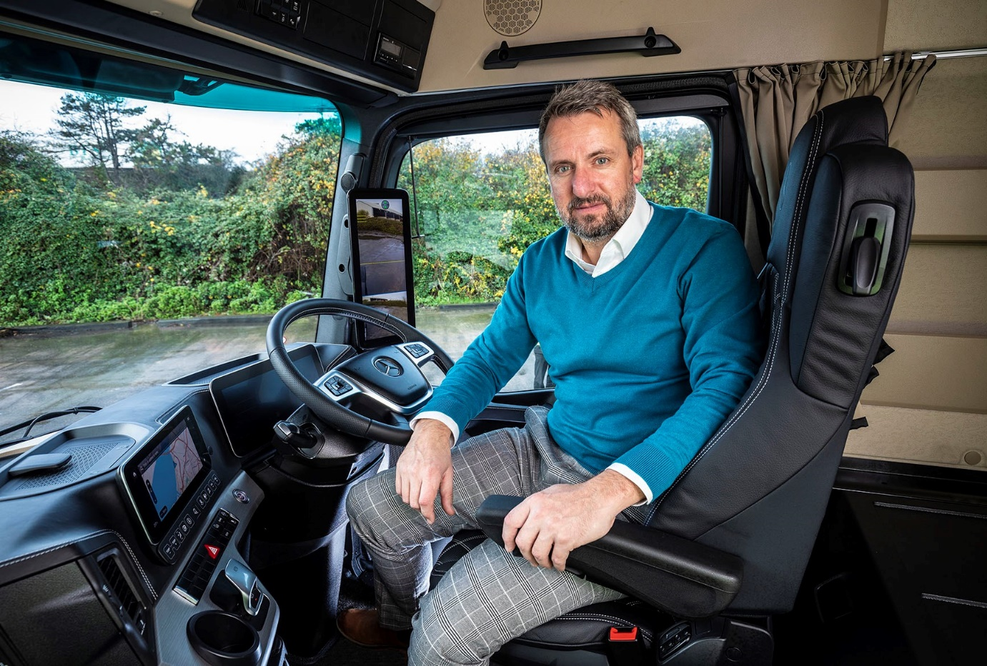

Seat of power: Managing Director Stuart Wring at the helm of Wrings Transport’s awesome new Mercedes-Benz Actros Edition 1 flagship

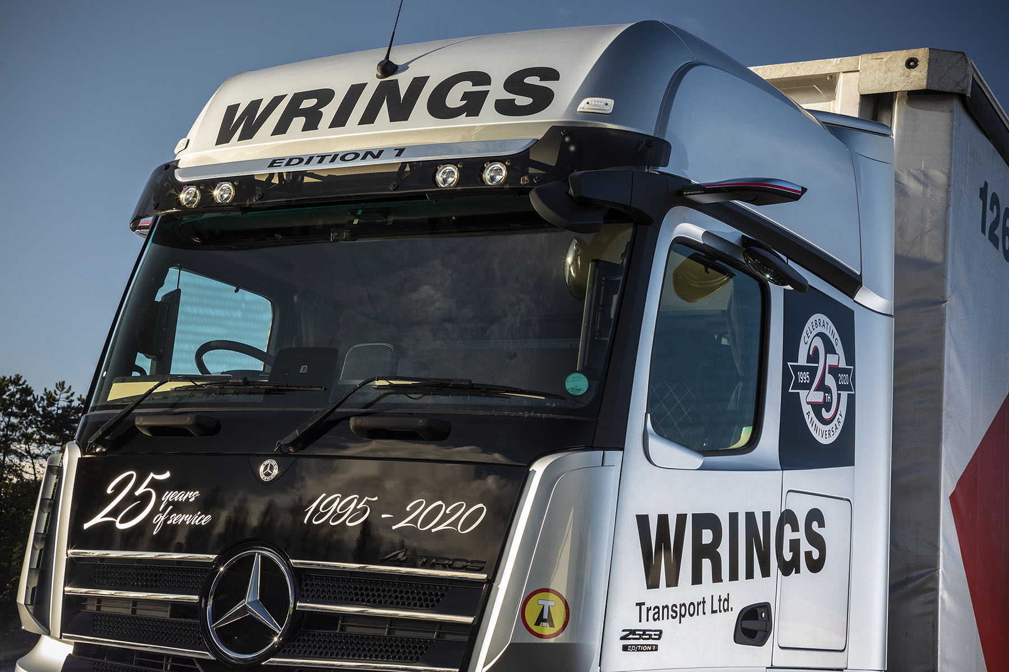

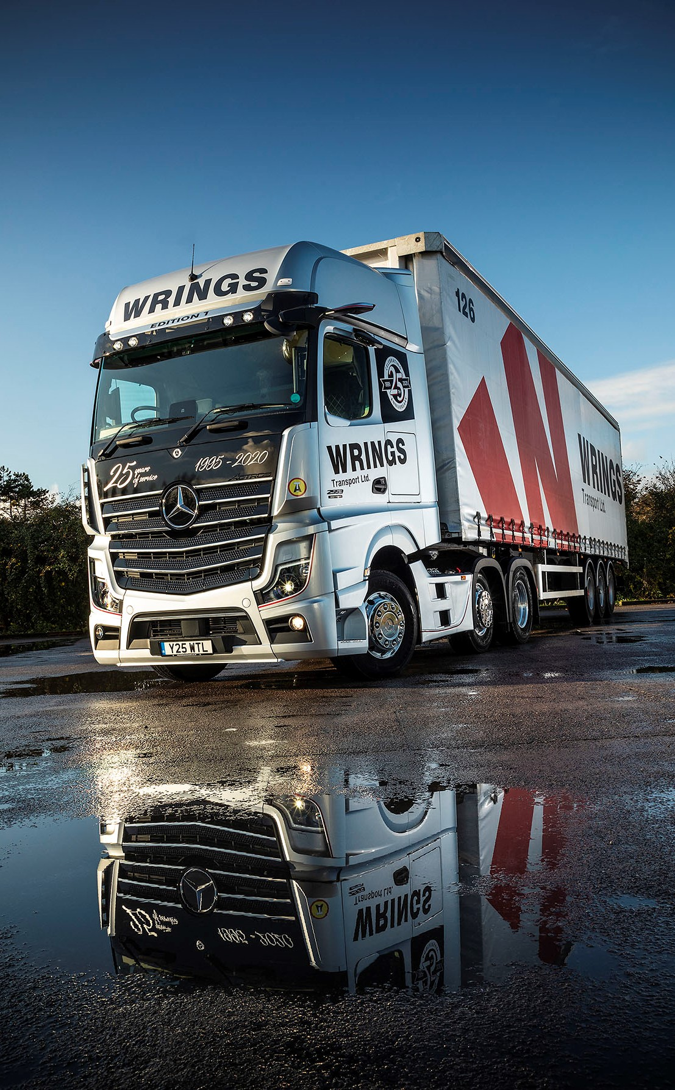
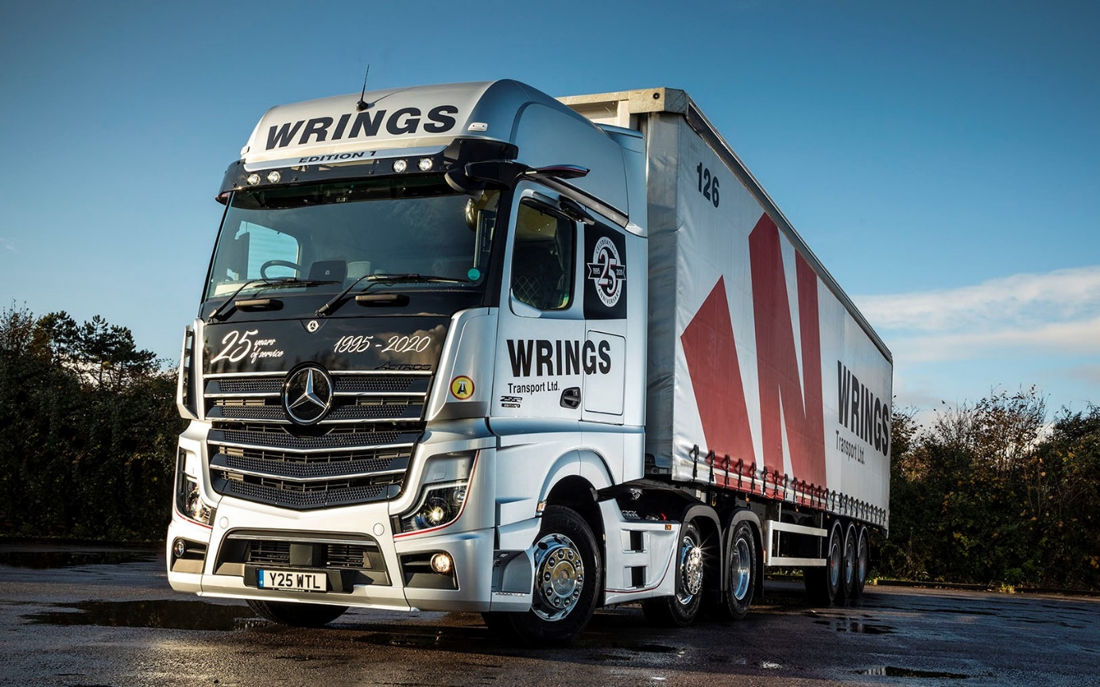

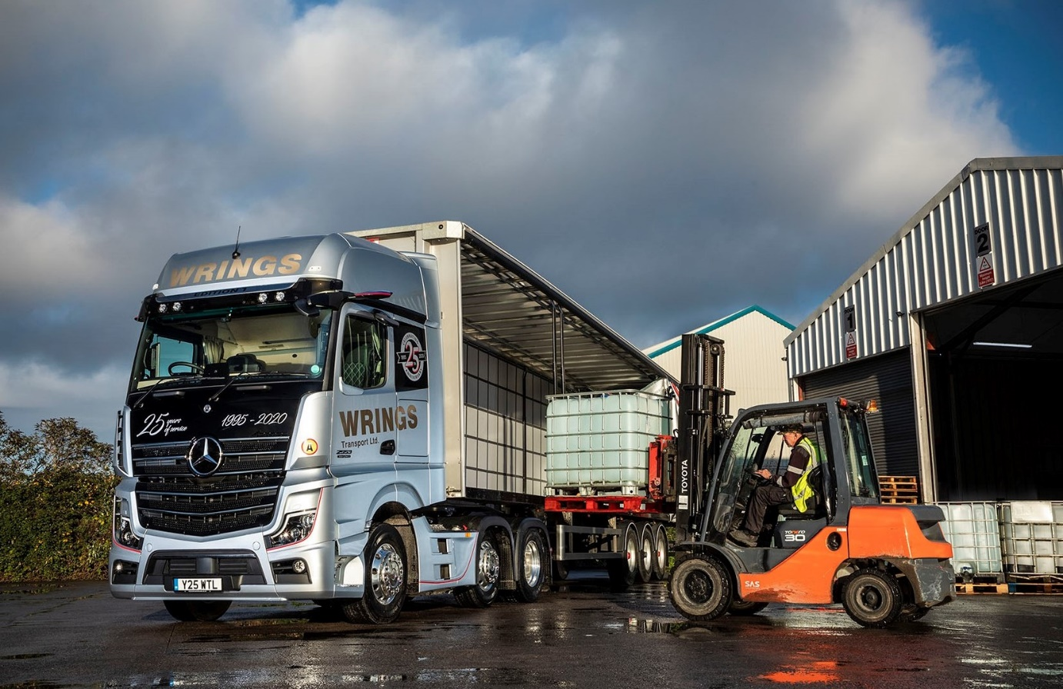

ends

For more information, or to request bigger/higher-res image files, please contact:

Jamie Fretwell at Mercedes-Benz Trucks UK Ltd
07712 519230, jamie.fretwell@daimler.com

or

Steve Warren or John Ripley
Impact Communications, 01926 842126
Steve: 07770 470251, steve@impactcom.co.uk
John: 07771 484595, john@impactcom.co.uk

About Mercedes-Benz Trucks UK Ltd
Mercedes-Benz Trucks UK Ltd is the sales and marketing organisation responsible for all Mercedes-Benz truck products in the UK, including FUSO Canter.

In 2018, the company registered 8,061 new trucks. Of them, 7,223 were Mercedes-Benz trucks, ensuring the brand retained its title as the second-biggest truck marque in the UK.
Meanwhile, FUSO registrations reached 838 – including 675 new trucks over 6.0-tonnes.

For more than 125 years, Mercedes-Benz has stood for innovative commercial vehicles that meet exceptionally high standards of quality. Our claim to perfection, sustainability and avant-garde design is now embodied in the next generation of trucks: Actros, Arocs, Atego, Econic and Unimog.
www.mbtrucks.co.uk

