

Date: 10 February 2020

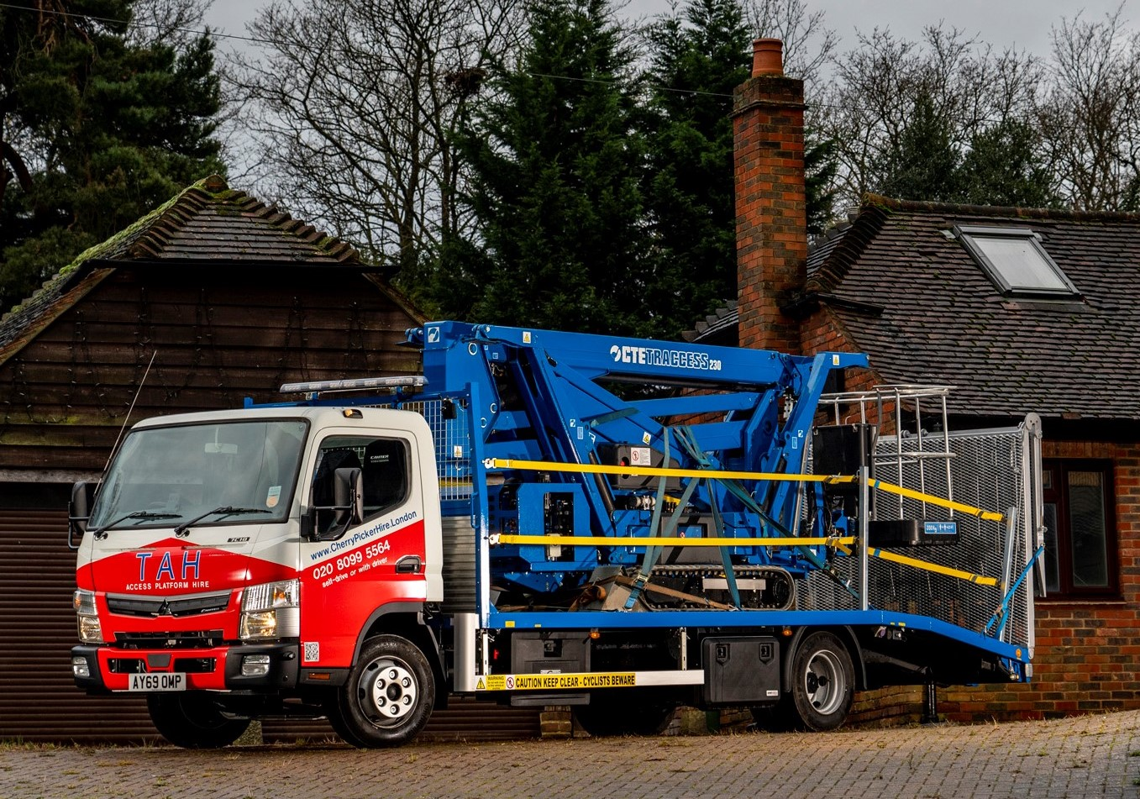

TAH remains on track with another ‘access all areas’ FUSO Canter

A south London-based mobile elevated work platform provider turned once again to the 7.5-tonne FUSO Canter when it needed a rugged and compact truck to transport one of its tracked machines.

Key to the Canter’s appeal for TAH Access Platform Hire are its market-leading body and payload allowance, and proven strength and durability. The fact that the truck has a smaller footprint than most other 7.5-tonners, and an exceptionally tight turning circle, are also advantages when negotiating tight streets and job sites in and around the capital.

A 7C18 model with Comfort day cab, the new Canter was supplied by Orwell Truck & Van, which also sells and supports Mercedes-Benz vehicles from five locations across East Anglia. Its beavertail body is by Shawtrack Services, of Mansfield.

The Canter is powered by a 3.0-litre common-rail turbodiesel which produces 129 kW (175 hp) and up to 430 Nm of torque across a broad engine speed range. A smooth-shifting, fully automated, dual-clutch DUONIC transmission with Eco Mode, Parking and Creep functions contributes to fuel-efficiency and helps to minimise maintenance costs. An engine brake is also fitted as standard.

Despite its extensive specification, the Canter offers a payload allowance of 3,410 kg, which is approximately 1,000 kg more than would be available from a similarly equipped, conventional 7.5-tonner. Not only does this allow it to transport the CTE mobile access platform, which weighs in the region of 3,000 kg, but it also means other tools and equipment can be carried too.

The vehicle is smartly finished in TAH Access Platform Hire’s red, white and blue colour scheme. The company also relies on another 7.5-tonne Canter to transport a tracked spider with 26-metre reach. However, it will shortly be replacing the latter with a 32-metre CTE platform, the first of its kind in the UK. This machine will require heavier-duty transport but TAH has stayed with the Daimler Trucks family by ordering an 18-tonne Mercedes-Benz rigid.

TAH Access Platform Hire is an offshoot of a property company, and General Manager Derek Mark is from the fourth generation of his family to be involved in the building trade. Based in West Norwood, it offers a range of self-drive and operated access equipment – the tracked CTE spiders are always provided with operators who have been trained and assessed by the International Powered Access Federation (IPAF).

Mr Mark recalled: “I’ve been relying on Canters in various roles for 20 years or more, and they’ve never let me down. We have to contend with a lot of weight restrictions on the roads in this part of the world, and 7.5 tonnes tends to be point at which these kick in.

“No other vehicle in this GVW class carries the weight as well as a Canter. It has an unrivalled payload capacity which we use to the full, and means we can get our 23-metre spider to just about any location we need to reach.”

Orwell Truck & Van’s Canter Sales Specialist Ray Braybrook liaised with Shawtrack Services, which fitted the vehicle with a full range of safety equipment, including LED work lamps and ramp markers, and a Crossrail/Fleet Operator Recognition System (FORS)-compliant safety package. Other features include an electric winch and radio remote control kit; a cab height ladder rack infilled with mesh and a lockable, chassis-mounted toolbox.

www.tahaccessplatforms.co.uk

www.cherrypickerhire.london

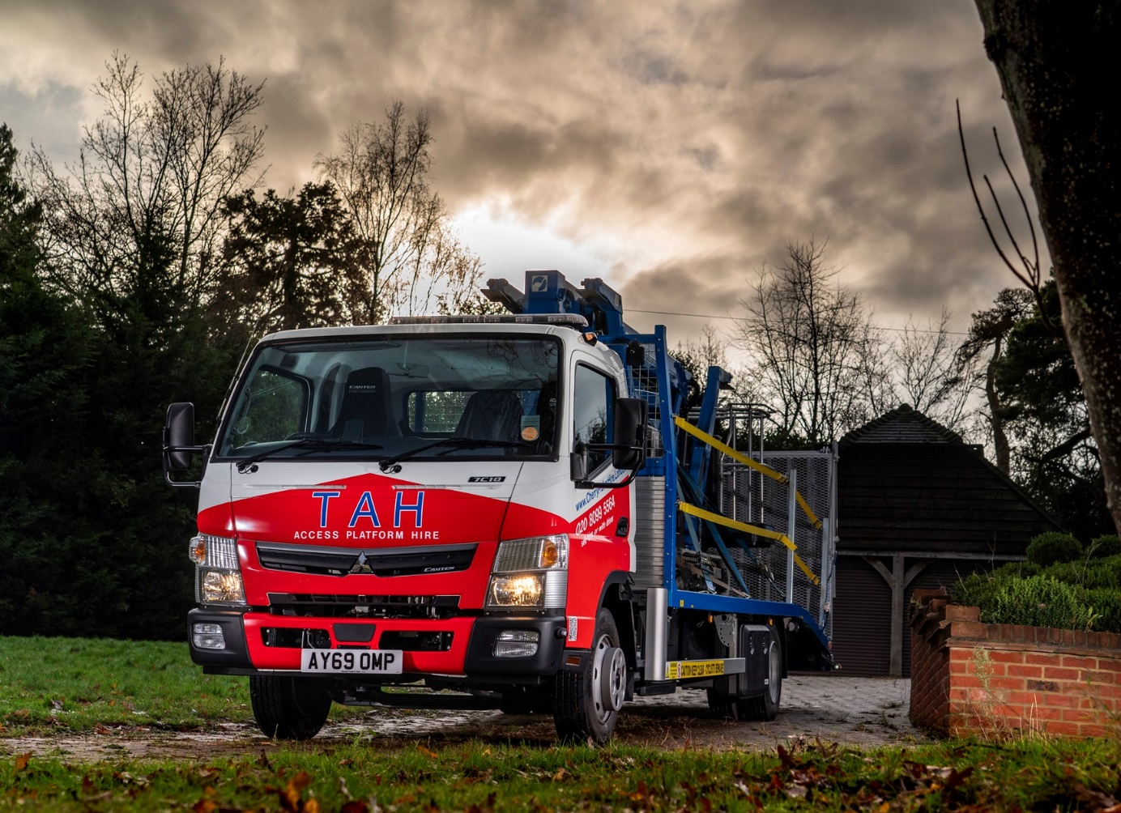

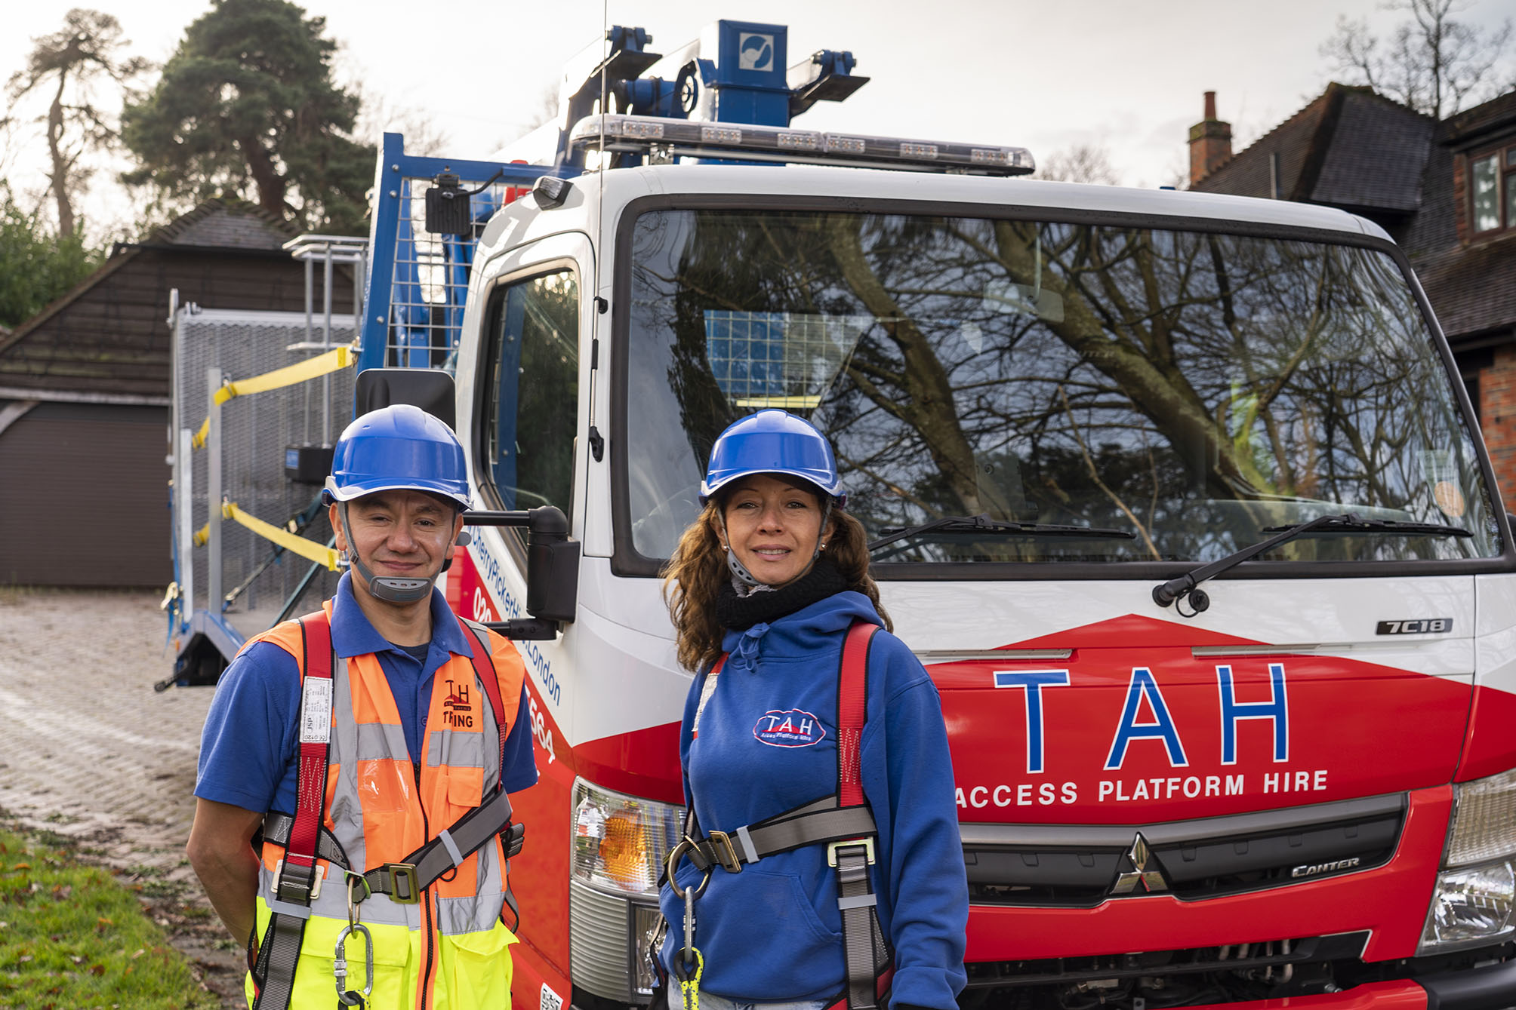

Heads for heights: Giovanni (Partner) and Cecilia (Operator) are both fully trained mobile elevated work platform operators

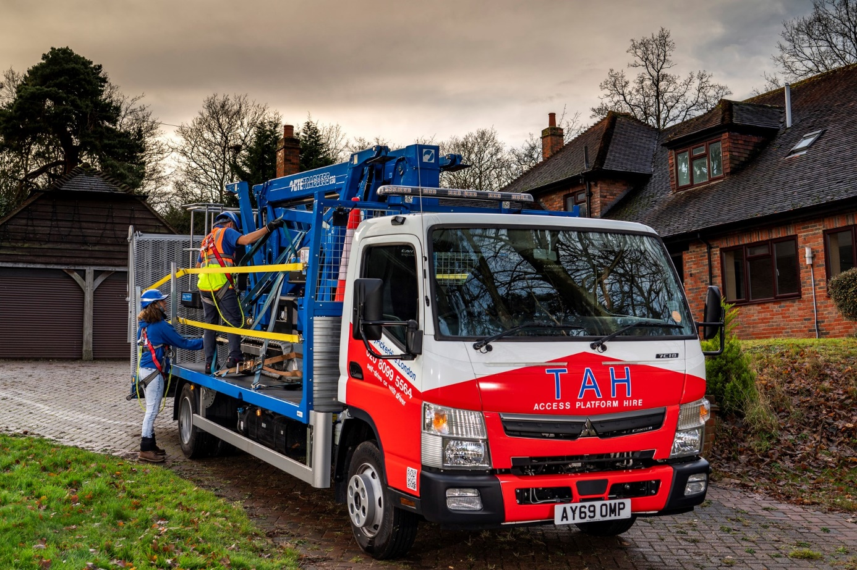

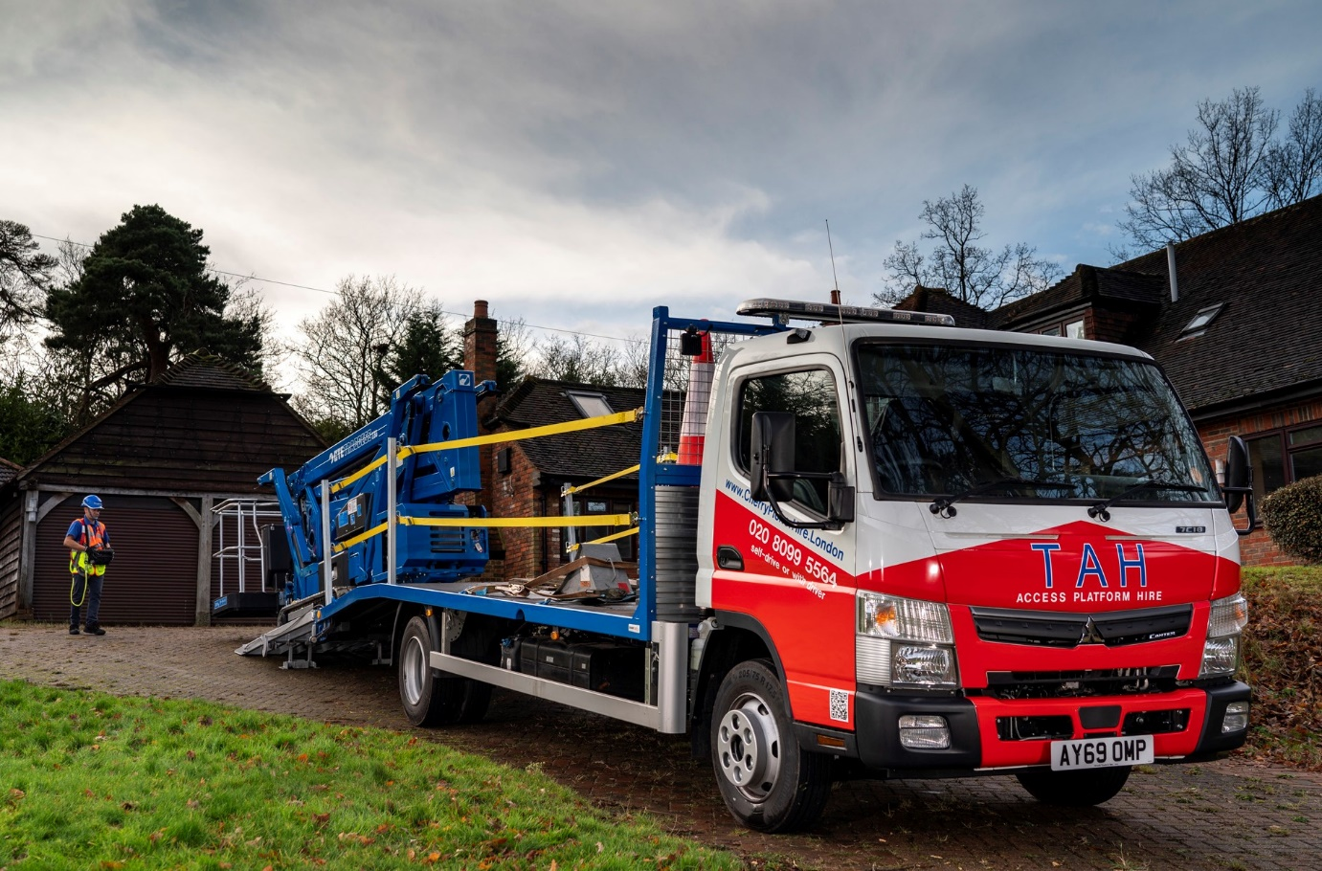

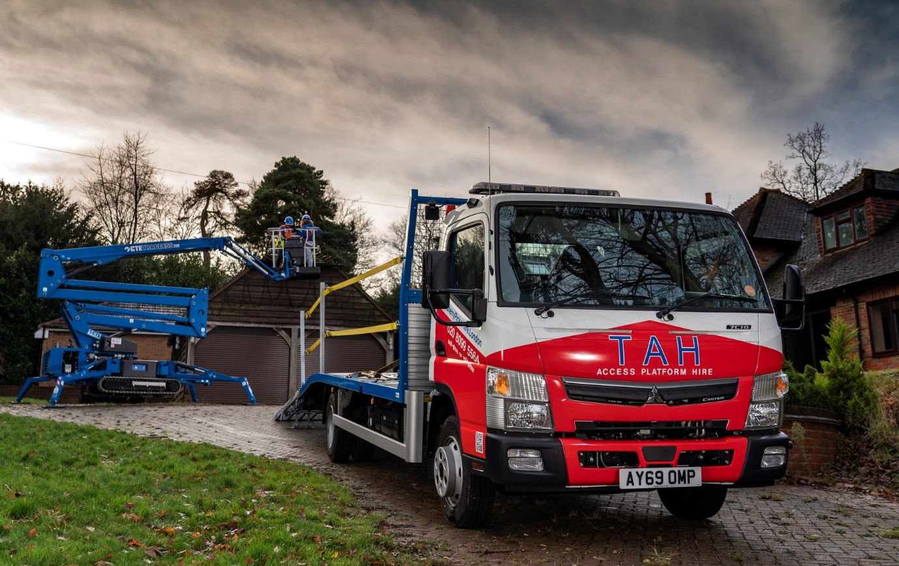

ends

For more information, or to request bigger/higher-res image files, please contact:
Steve Warren or John Ripley
Impact Communications, 01926 842126
Steve: 07770 470251, steve@impactcom.co.uk
John: 07771 484595, john@impactcom.co.uk

