

Date: 27 April 2020

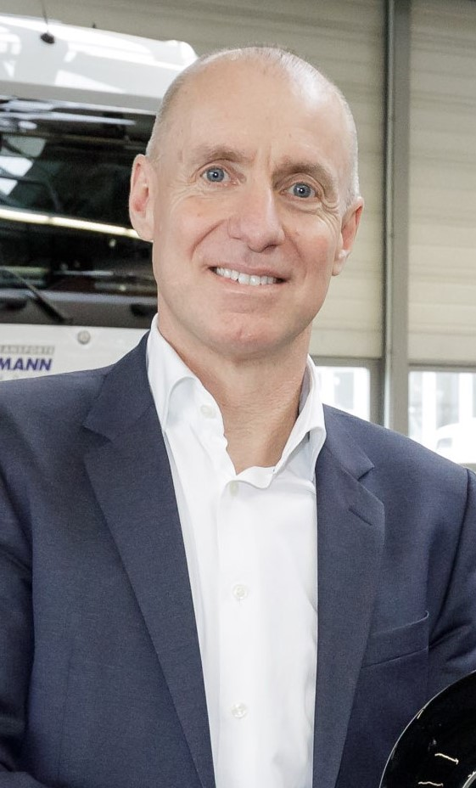

Proven performer: Experienced Wolfgang Theissen has an impressive track record of success in international markets

Wolfgang Theissen prepares to take the helm at Mercedes-Benz Trucks UK

Mercedes-Benz Trucks UK has announced the appointment of Wolfgang Theissen as its next Managing Director.

He succeeds Mike Belk, who is to retire before the end of the year, having served the Mercedes-Benz brand for 30 years.

Currently Head of Overseas Sales for Mercedes-Benz Trucks, Wolfgang Theissen takes up his new position on 1 August. He and Mike Belk will work together initially, to ensure a smooth transfer of management responsibilities.

Mr Theissen began his career with Mercedes-Benz Trucks in 1991. He worked in a variety of sales and procurement positions prior to 2010, when he took the market management lead in North America. In 2014 he was made Head of Europe Region, and by the end of 2017 his responsibilities had been extended to take in all Overseas markets.

Wolfgang Theissen played a major role in implementing Mercedes-Benz Trucks’ ‘Customer Dedication’ strategy, shaping and promoting the development of its truck-dedicated sales organisations. He also contributed to the brand’s strategic ‘Overseas Push’, and paved the way for further growth and the consolidation of sales processes outside Europe.

In a joint statement, Mercedes-Benz Trucks’ Head of Marketing, Sales and Services Andreas von Wallfeld, and Head of Sales Europe Jean-Marc Diss, said: “We are delighted to have appointed the internationally experienced Wolfgang to lead the team in the strategically important UK market.

“We would also like to express our heartfelt thanks to Mike for his unstinting commitment to the Mercedes-Benz brand, and also to wish him the very best for the next chapter in his life.”

Mike Belk had also served in Germany and the Middle East prior to his appointment to lead the Truck business for Mercedes-Benz in the UK in 2015. He said: “I have been fortunate to have enjoyed a successful career with one of the best companies in the world, in many different locations and functions.

“Thanks to the energy and engagement of colleagues we have made great progress in many areas of the business, and I will be proud to have drawn up the plans for the strong foundation that my successor can build on.”

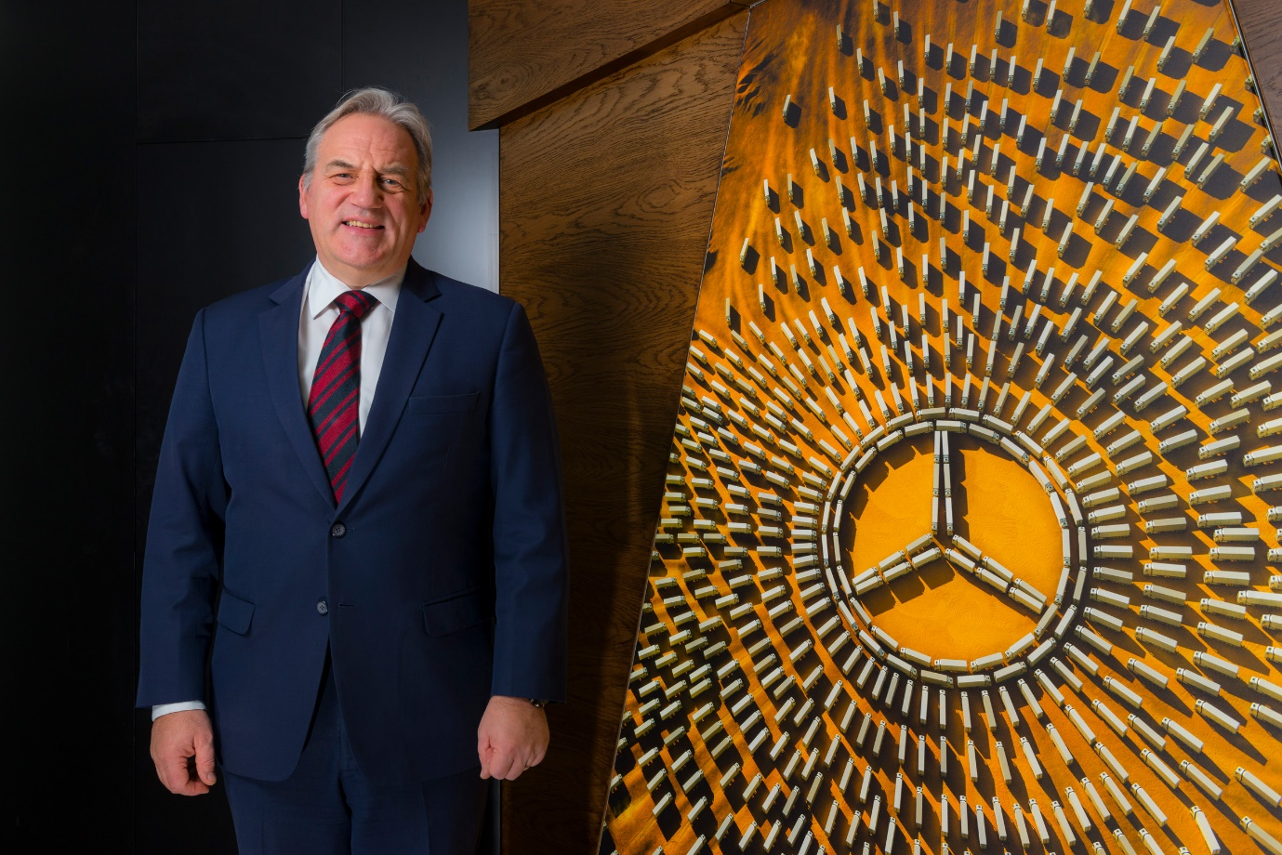

Loyal servant: Mike Belk will retire later this year, having spent more than half of his working life with the Mercedes-Benz brand

ends

For more information, please contact:

Jamie Fretwell at Mercedes-Benz Trucks UK Ltd
07712 519230, jamie.fretwell@daimler.com

Steve Warren or John Ripley
Impact Communications, 01926 842126
Steve: 07770 470251, steve@impactcom.co.uk
John: 07771 484595, john@impactcom.co.uk

About Mercedes-Benz Trucks UK Ltd
Mercedes-Benz Trucks UK Ltd is the sales and marketing organisation responsible for all Daimler truck products in the UK, including FUSO Canter.

In 2019, the company registered 6,963 new trucks. Mercedes-Benz accounted for 6,188 new trucks registered in 2019, making it the third-biggest truck brand in the UK. Meanwhile, FUSO registrations hit 775 – including 580 new trucks over 6.0-tonnes.

The flagship new Mercedes-Benz Actros which won the 2020 International Truck of the Year award, features seven core innovations including MirrorCam, Multimedia Cockpit and Active Brake Assist 5. Our premium range of innovative trucks – Actros, Arocs, Atego, Econic and Unimog – draw upon more than 125 years of exceptionally high standards of quality, backed up by our promise of Trucks You Can Trust.

www.mbtrucks.co.uk

