

Date: 15 May 2019

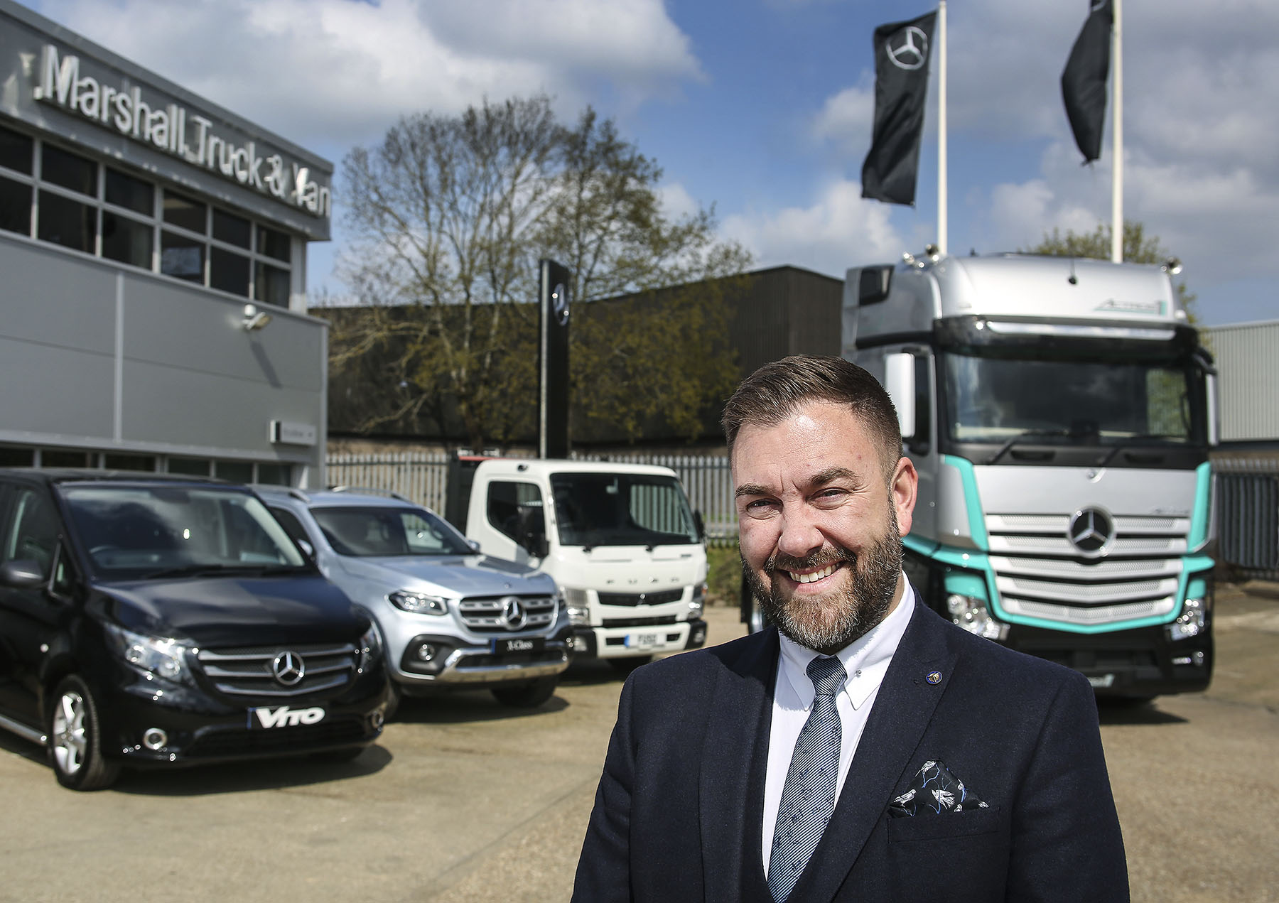

Relishing the challenge: Daniel Stone jumped at the opportunity to lead the Marshall Truck & Van team

Daniel takes the helm at Mercedes-Benz Dealer Marshall Truck & Van

There’s a new ‘hand on the tiller’ at south coast Mercedes-Benz Dealer Marshall Truck & Van – and Daniel Stone could not have taken up his latest position at a more exciting time.

Daniel’s promotion to Head of Mercedes-Benz Commercial Vehicles at Marshall Motor Group coincides with the beginning of construction work on a new, £4-million dealership in Southampton.

The development is taking place on the Nursling Industrial Estate, a stone’s throw from the company’s established 24-hour service centre, which it has now outgrown. The two-acre site offers scope for much-needed workshop expansion, and the new facility is scheduled to open in October.

Meanwhile, the Dealer is also preparing to retail vans from Marshall’s Mercedes-Benz of Portsmouth passenger car outlet on the Portsmouth Motor Park. Under this plan, a section of the showroom is to be set aside for up to three vans, with a further 15-20 Approved Used examples being displayed outside.

Marshall Truck & Van represents the three-pointed star in Dorset, most of Hampshire and parts of south London. The company sells and supports the award-winning Mercedes-Benz Trucks and Mercedes-Benz Vans product ranges, as well as FUSO Canter light trucks, from headquarters in Fareham, and other branches in Andover, Croydon, Poole, and Southampton.

Daniel joined the Marshall Motor Group in 2014, to run Mercedes-Benz car dealerships in Chichester and Winchester as General Manager. He spent the previous 16 years of his career working in a variety of sales roles for two other automotive groups.

Although Daniel’s cv includes some light commercial vehicle experience, he is happy to concede that this has been minimal, and that his new job represents his first real venture into the world of trucks and vans.

“That’s one of the reasons I jumped at this opportunity,” he explained. “I was looking for a new challenge, and the idea of broadening my horizons by working in a completely different sector is tremendously exciting. Best of all, I’ve been able to achieve this change of career tack without having to leave the Marshall Group, and while keeping a Mercedes-Benz star above the door

He continued: “I’ve inherited a fantastic team of colleagues, many of whom have worked for this business under previous owners. Several of my senior managers have chalked-up decades of loyal service and accumulated a huge amount of technical knowledge, which will be an invaluable resource to me.

“My task is to provide strategic direction and leadership as we embark on what is going to be a very important, exciting phase in the development of Marshall Truck & Van.”

Daniel observed: “My own background means that I’m able to bring the strong retail focus to my new position which will be essential if we are to achieve our ambitious van sales targets. We already perform strongly within the fleet van segment, but given the strength and appeal of our product range there’s definitely potential to grow our business with small- and medium-sized enterprises (SMEs).

“As for the truck side of our business,” he continued, “I appreciate that when a vehicle is not on the road it’s costing its owner money, which means that even the best trucks are only as good as the aftersales support behind them.

“I’m committed to an ethos of customer service, and will be striving to ensure that we provide the timely, efficient back-up which those who buy and run Mercedes-Benz trucks and vans are entitled to expect.

“I also understand the importance of relationships within the truck and fleet van sectors, so am looking forward to meeting as many of our customers as possible over the weeks and months to come.”

Marshall Truck & Van was established in 2016, following the £107-million acquisition by Marshall Motor Holdings of the previous Mercedes-Benz Trucks and Mercedes-Benz Vans franchisee’s parent company.

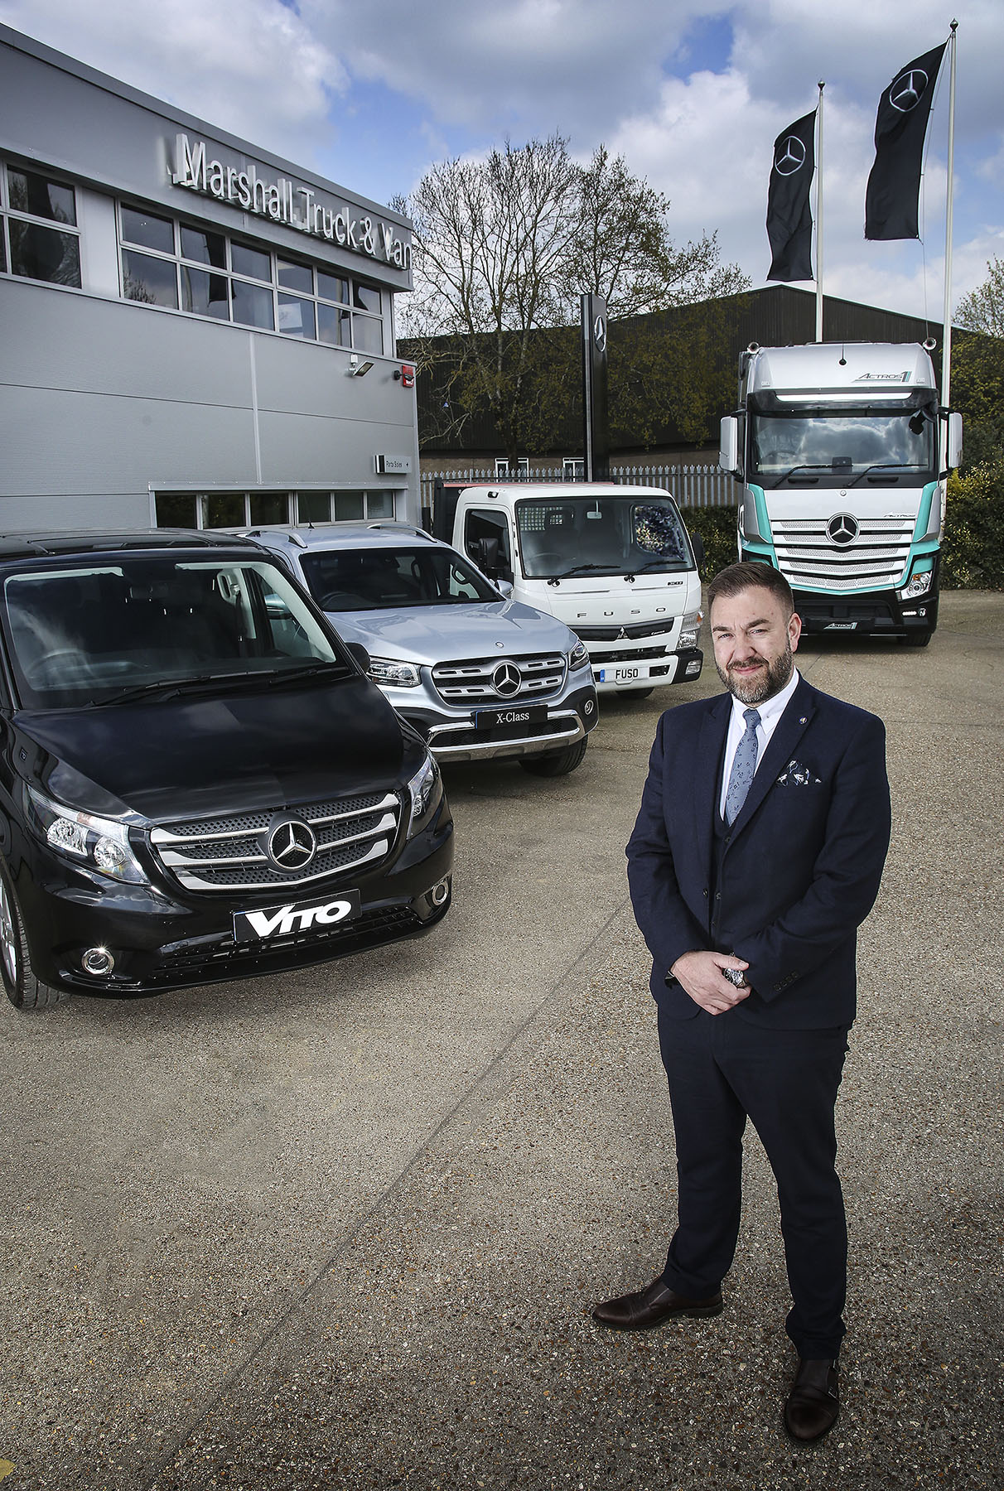

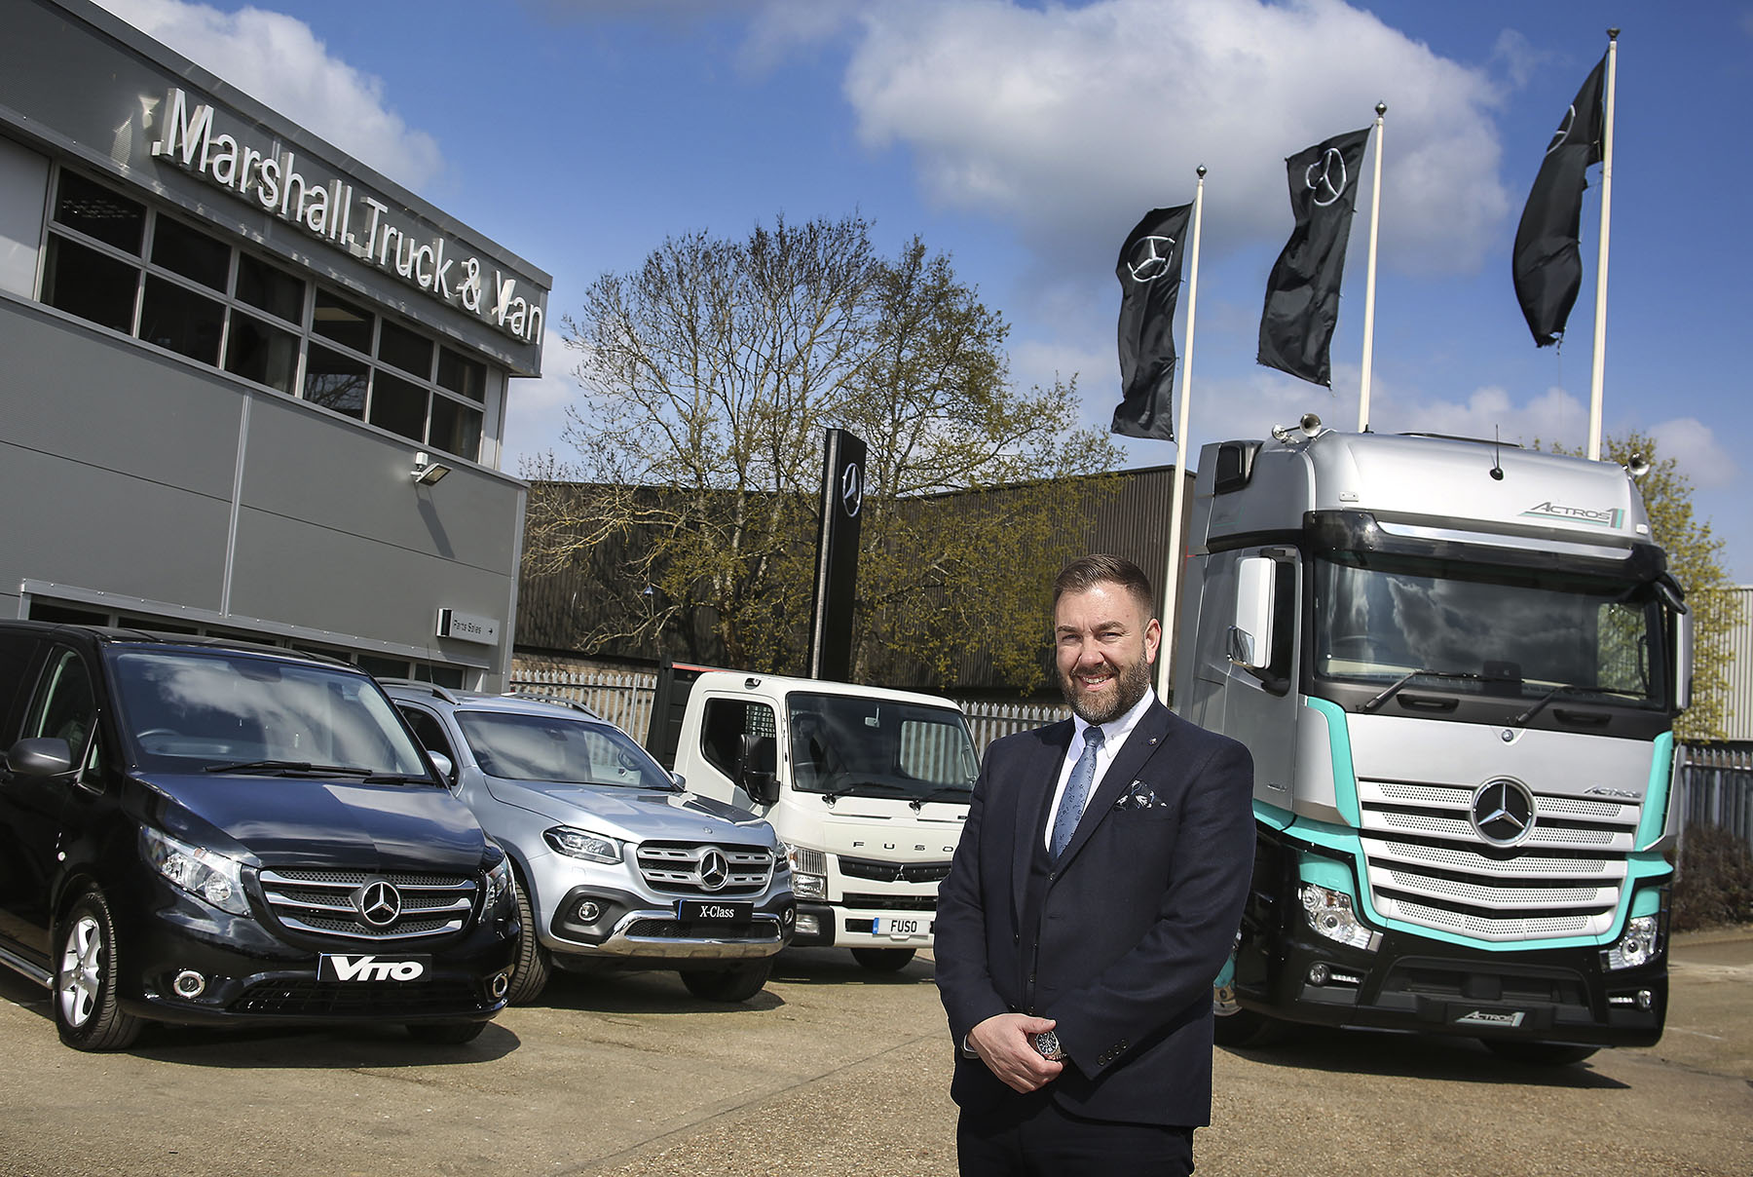

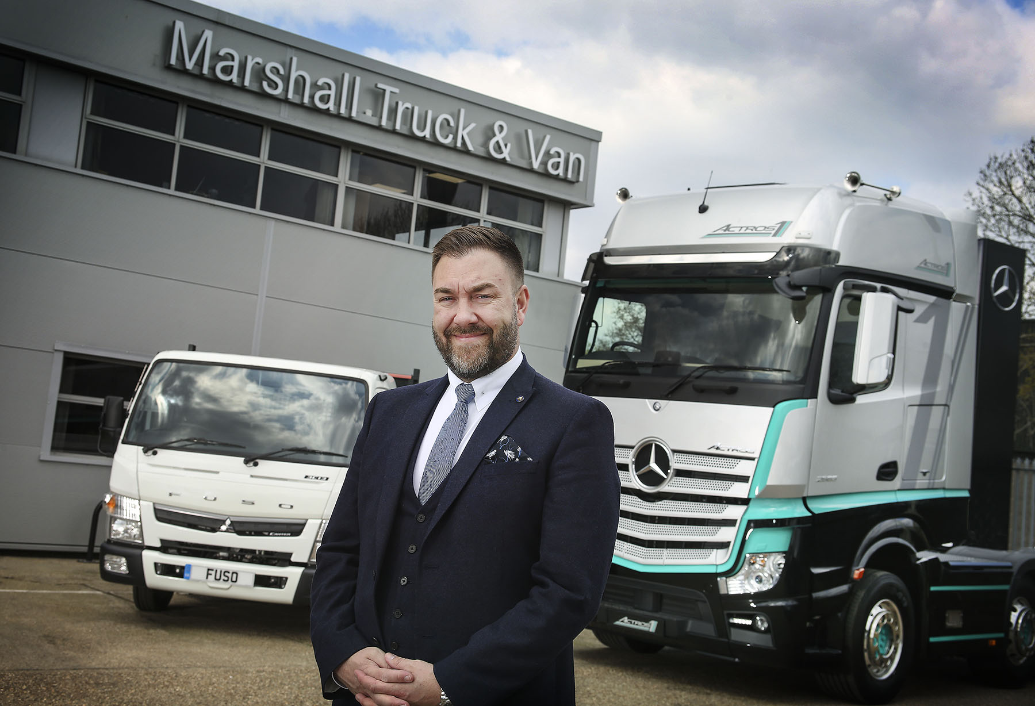

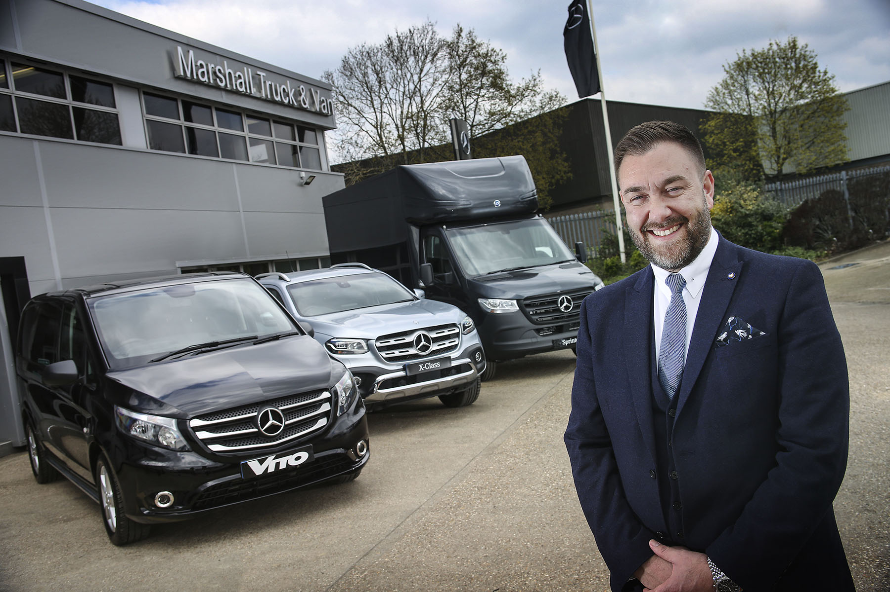

ends

For more information, or to request bigger/higher-res image files, please contact:
Steve Warren or John Ripley
Impact Communications, 01926 842126
Steve: 07770 470251, steve@impactcom.co.uk
John: 07771 484595, john@impactcom.co.uk

