

Date: 6 February 2020

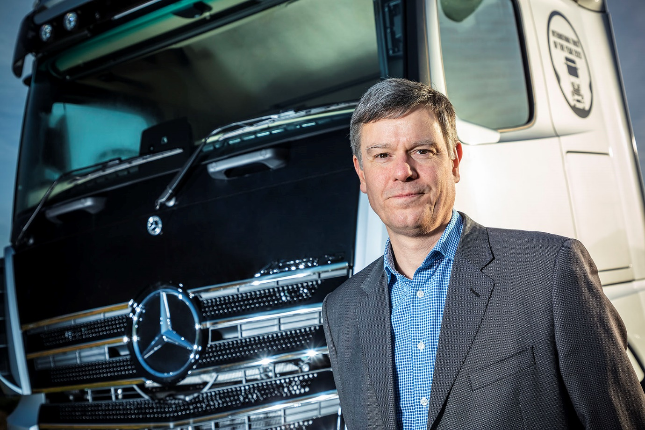

David Joyce: “What matters to our customers, above all else, is that their vehicles are always available when they need them”

Maximised use tops the list of priorities for
Mercedes-Benz Trucks’ new head of aftersales

Mercedes-Benz Trucks UK has a new Director Customer Service & Parts – but David Joyce is already steeped in the ethos of the three-pointed star, and passionate in his commitment to the manufacturer’s ‘Trucks You Can Trust’ brand promise.

David is a former After Sales Director for Mercedes-Benz Commercial Vehicles UK, a position in which he was responsible for both trucks and vans. When the process of Customer Dedication resulted in the separation of the two businesses in 2014, he was appointed Director Customer Service & Parts for Mercedes-Benz Vans UK.

A firm believer in building strong customer relationships, David brings an outstanding record of operational performance improvement to his latest role, as well as extensive knowledge of the Mercedes-Benz Trucks Dealer network, industry insight, and energy.

David began his career in the late 1970s as an apprentice truck technician with a rival brand. Following a 10-year stint in Formula One with Team Lotus, he joined Mercedes-Benz UK in 1995, working initially in the Technical Training department.

Over the years that followed he gained extensive experience in all aspects of customer service, parts and training. As the company’s Head of Training & Development, he oversaw the development of its acclaimed National Apprentice Programme, and introduced professional training programmes for Dealers.

David is now responsible for all Mercedes-Benz Trucks UK service and parts activities, including the workshop operation at its Wentworth Park Truck Experience Centre, and training. He succeeds Sam Whittaker, who became National Sales Director in November.

Maximised use – one of the three pillars of Mercedes-Benz Trucks’ all-encompassing RoadEfficiency strategy – will be the number one priority for David, and the team he leads. “Product availability is absolutely crucial for operators,” he said. “What matters to our customers, above all else, is that their vehicles are always available when they need them.”
While advanced technology such as the Uptime predictive maintenance system was proving increasingly effective in reducing downtime, David said further improvements in the efficiency and effectiveness of the Mercedes-Benz Trucks network were also essential.

“Consistency is key, and that often comes down to structure and processes,” he asserted. “We have numerous pockets of excellence, and Dealers that are performing at an exceptionally high level. The challenge facing us now, is to ensure that the rest deliver the same standard of customer service as the best.”
David said that as well as working with and supporting its franchised partners, not least through continued major investment in training, Mercedes-Benz Trucks also recognised the critical importance of forging ever closer links with operators.

“We have to better understand our customers’ businesses, and what they need from us,” he explained. “This applies just as much to the owner-driver or small family concern as it does to the mega-fleets. A ‘one size fits all’ approach won’t cut it, because no two customers are the same. Instead, we have to tailor our offer more precisely than we’ve ever done before.”

He added: “There is much to be positive about, but we have a job to do if we’re to deliver fully on our promise. I’m relishing this opportunity to ensure that every customer for a Mercedes-Benz or FUSO truck receives an industry-leading quality of aftersales support.”

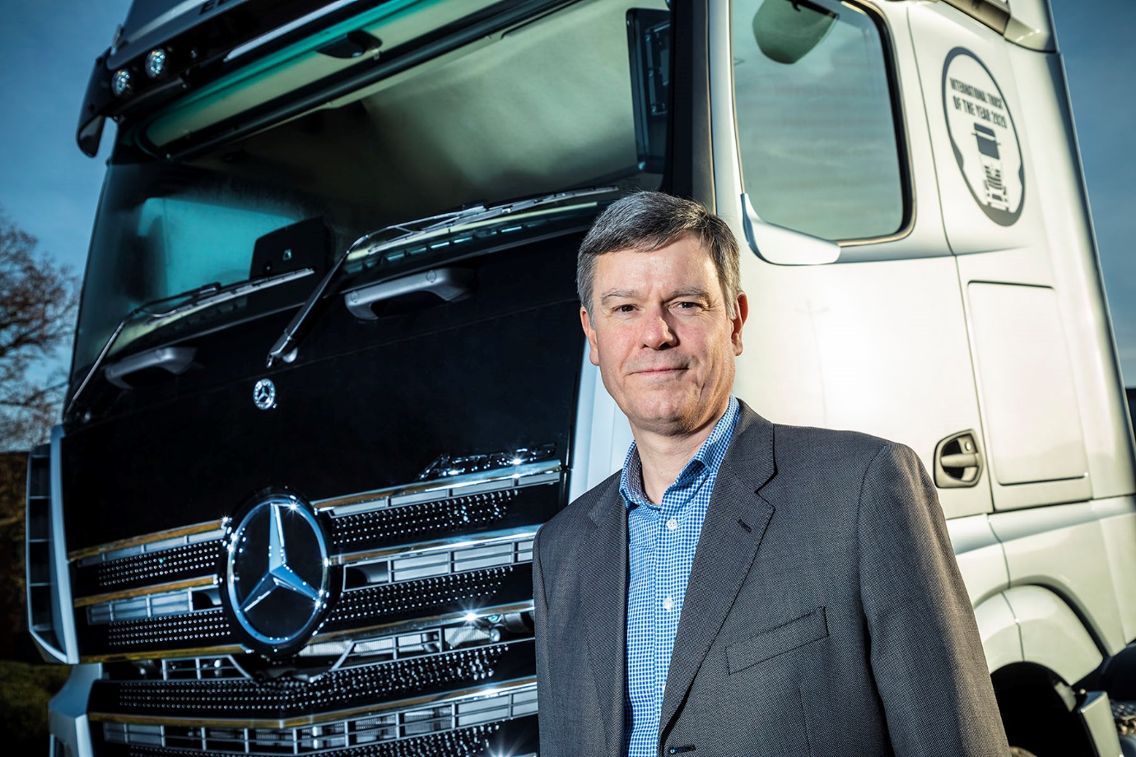

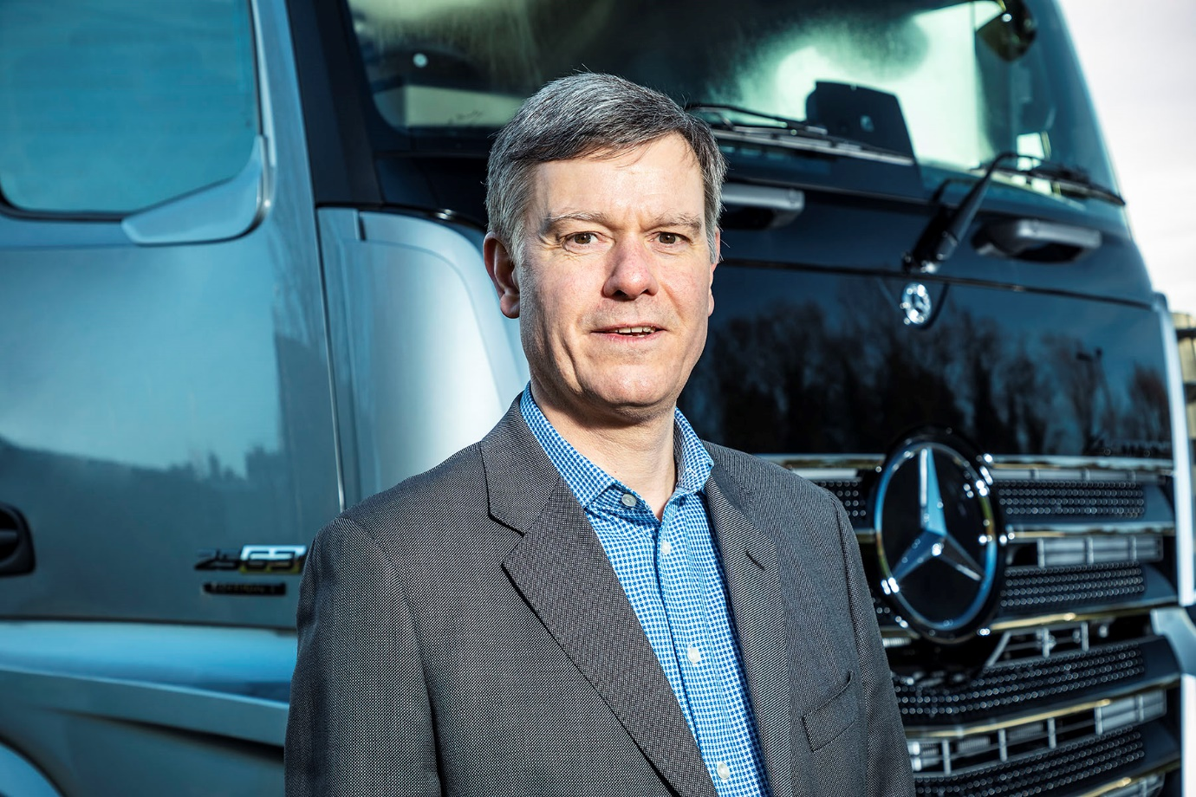

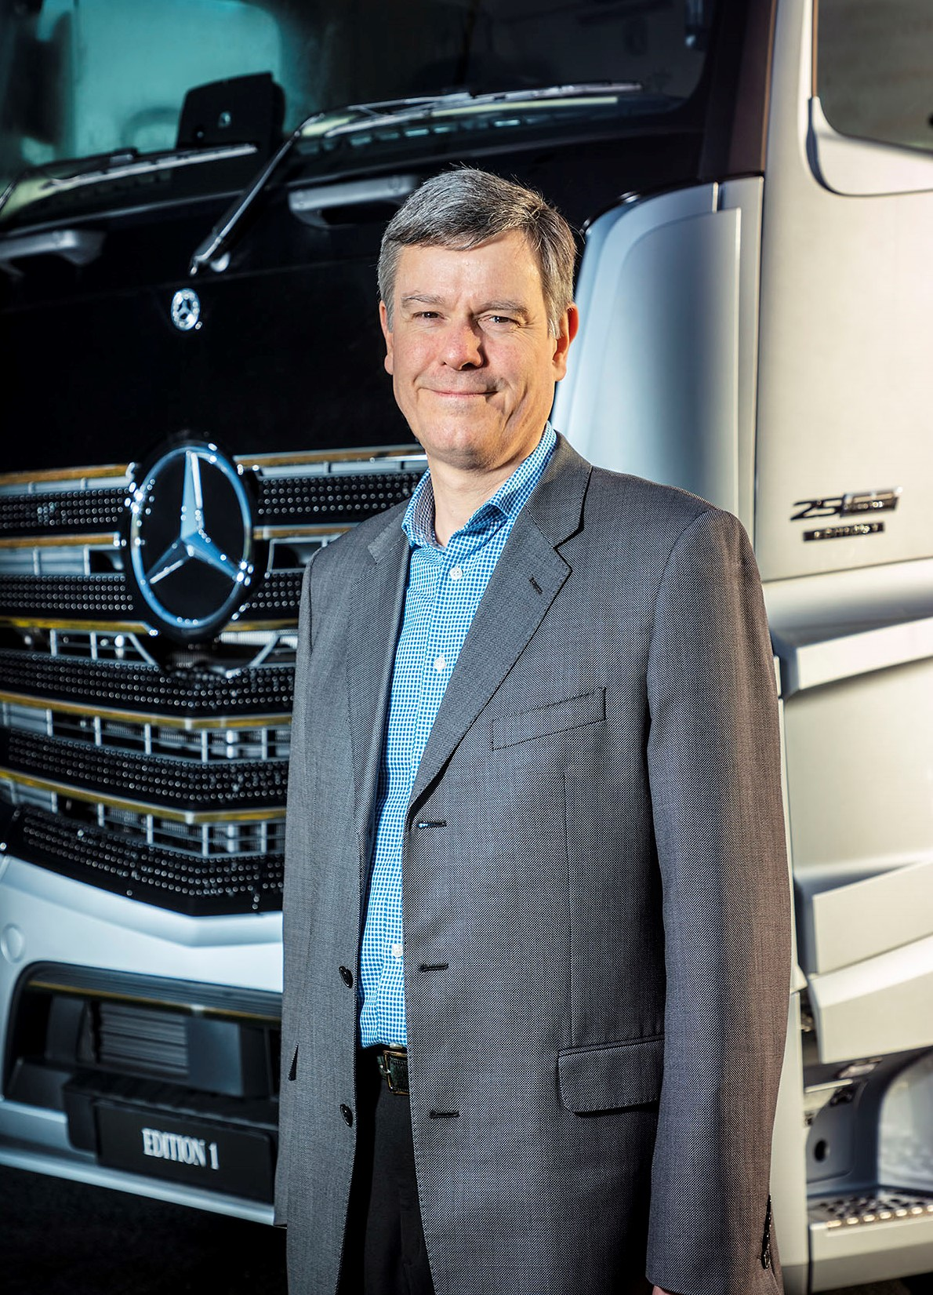

ends

For more information, or to request higher-res image files, please contact:

Jamie Fretwell at Mercedes-Benz Trucks UK Ltd
07712 519230, jamie.fretwell@daimler.com

or

Steve Warren or John Ripley
Impact Communications, 01926 842126
Steve: 07770 470251, steve@impactcom.co.uk
John: 07771 484595, john@impactcom.co.uk

About Mercedes-Benz Trucks UK Ltd
Mercedes-Benz Trucks UK Ltd is the sales and marketing organisation responsible for all Mercedes-Benz truck products in the UK, including FUSO Canter.

In 2018, the company registered 8,061 new trucks. Of them, 7,223 were Mercedes-Benz trucks, ensuring the brand retained its title as the second-biggest truck marque in the UK.
Meanwhile, FUSO registrations reached 838 – including 675 new trucks over 6.0-tonnes.

For more than 125 years, Mercedes-Benz has stood for innovative commercial vehicles that meet exceptionally high standards of quality. Our claim to perfection, sustainability and avant-garde design is now embodied in the next generation of trucks: Actros, Arocs, Atego, Econic and Unimog.
www.mbtrucks.co.uk

